5/2/22

# python docker自动化_pytest+requests+Python3.7+yaml+Allure+Jenkins+docker实现接口自动化测试...

<https://blog.csdn.net/weixin_39772652/article/details/111743635?utm_medium=distribute.pc_relevant.none-task-blog-2~default~baidujs_utm_term~default-1.pc_relevant_default&spm=1001.2101.3001.4242.2&utm_relevant_index=4>

1. Json file comparison

How about order

1. Pytest order
2. Pytest.ini
3. Pytest logging
4. Pytest request
5. Allure report
6. **Database schema, pytest – database**
7. **Performance test**
8. Pytest structure
9. **Json**
10. **Pytest order**

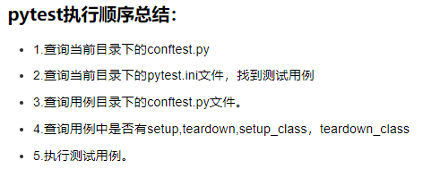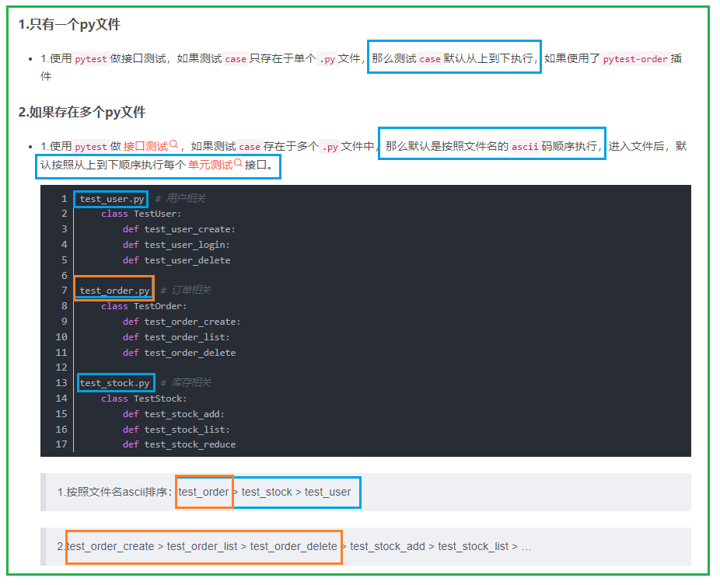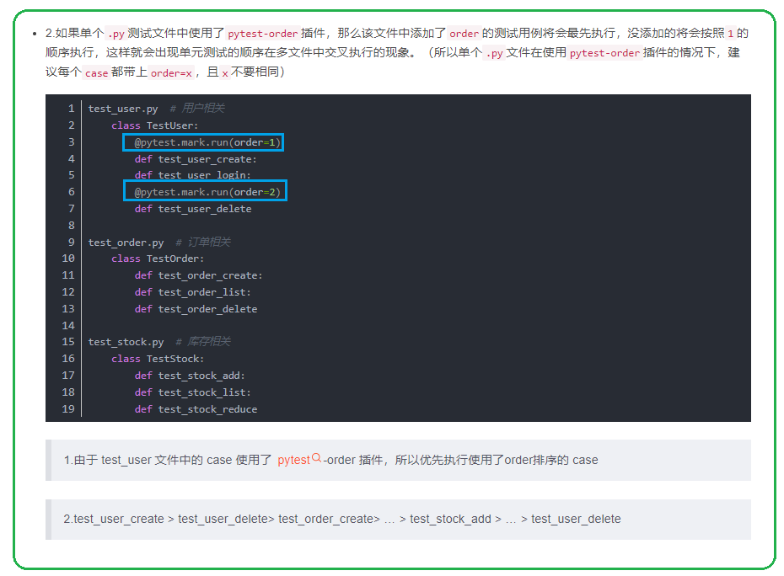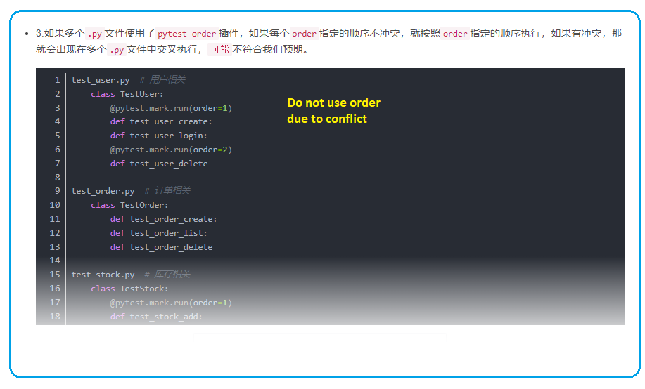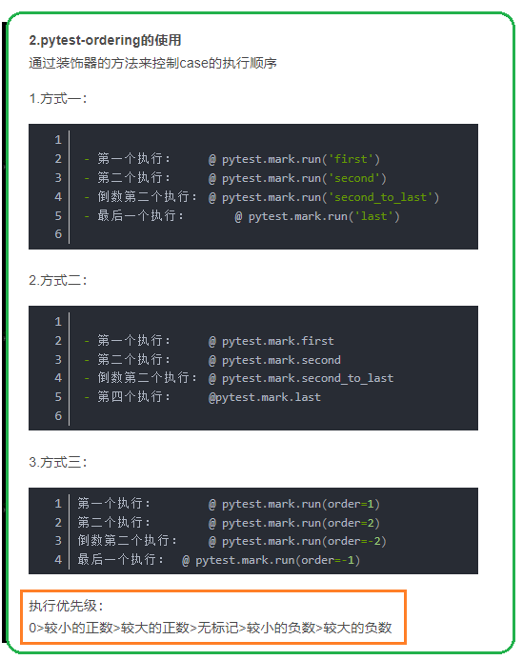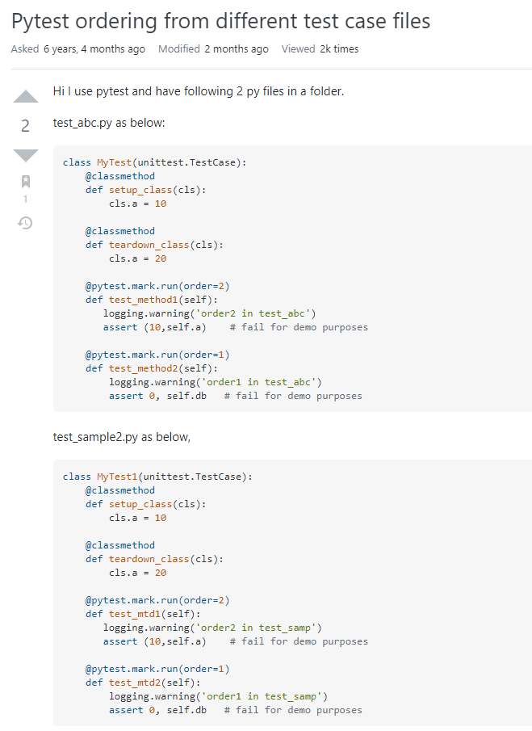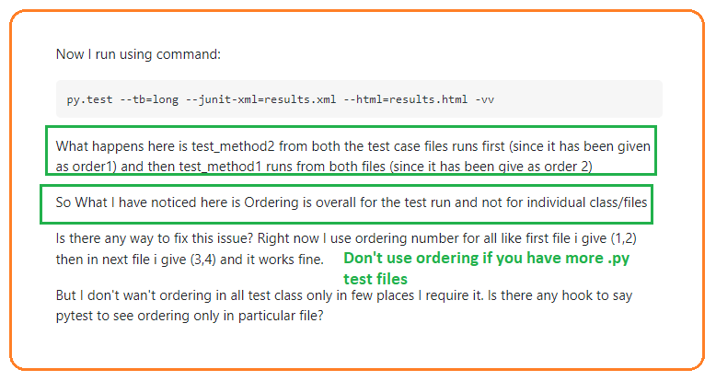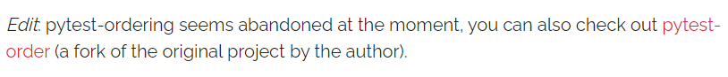

1. **Pytest logging**

**It seems to be hard to log in parallel pytest with pytest -n 2 (xdist)** 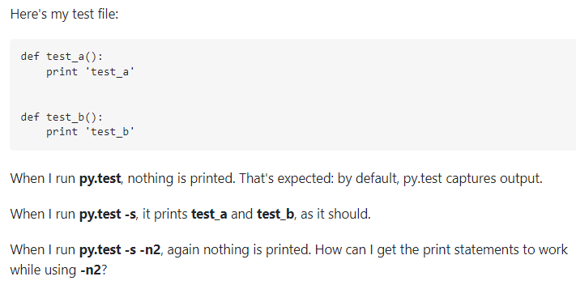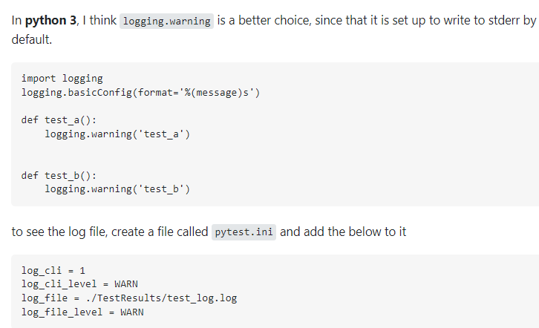

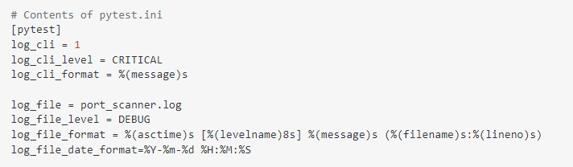

1. **Pytest requests**

# Python+pytest+requests 自动化测试框架

[**https://blog.csdn.net/weixin_42686892/article/details/122565101?ops_request_misc=%257B%2522request%255Fid%2522%253A%2522165152818316781683921069%2522%252C%2522scm%2522%253A%252220140713.130102334..%2522%257D&request_id=165152818316781683921069&biz_id=0&utm_medium=distribute.pc_search_result.none-task-blog-2~all~sobaiduend~default-1-122565101.142^v9^pc_search_result_control_group,157^v4^control&utm_term=pytest+requests&spm=1018.2226.3001.4187**](https://blog.csdn.net/weixin_42686892/article/details/122565101?ops_request_misc=%257B%2522request%255Fid%2522%253A%2522165152818316781683921069%2522%252C%2522scm%2522%253A%252220140713.130102334..%2522%257D&request_id=165152818316781683921069&biz_id=0&utm_medium=distribute.pc_search_result.none-task-blog-2~all~sobaiduend~default-1-122565101.142%5ev9%5epc_search_result_control_group,157%5ev4%5econtrol&utm_term=pytest+requests&spm=1018.2226.3001.4187)

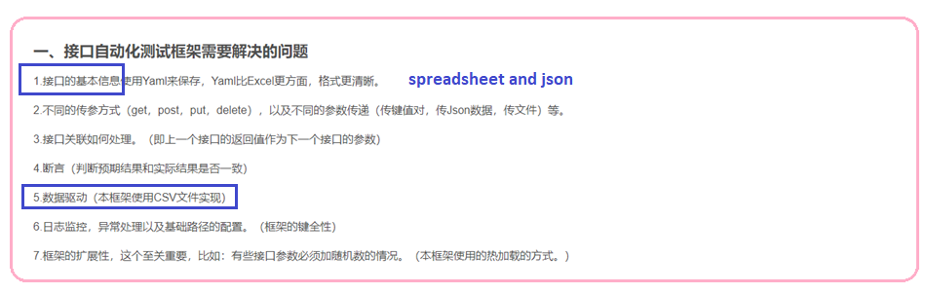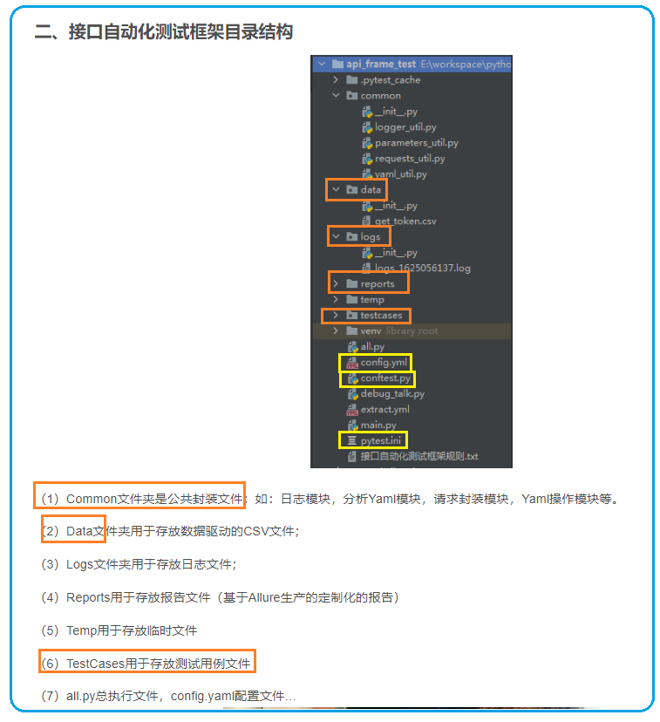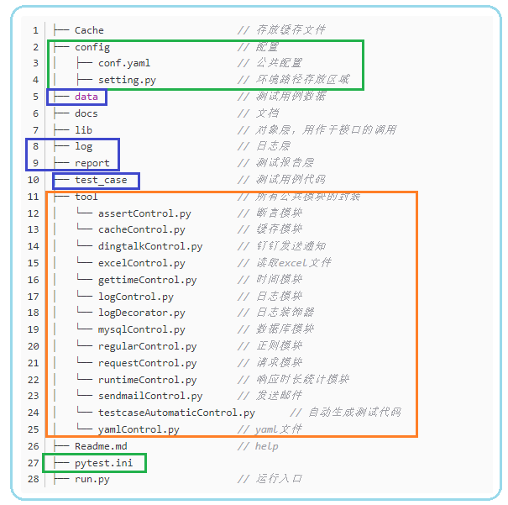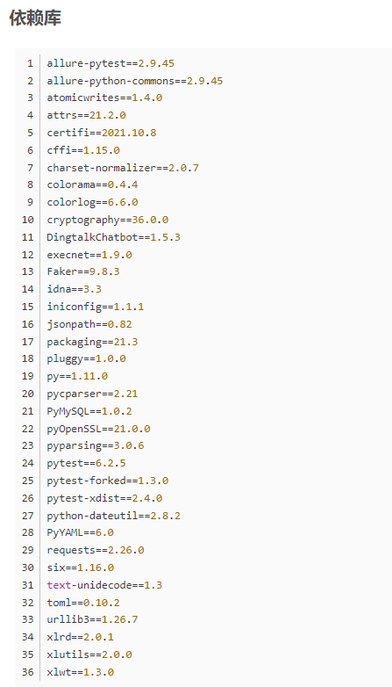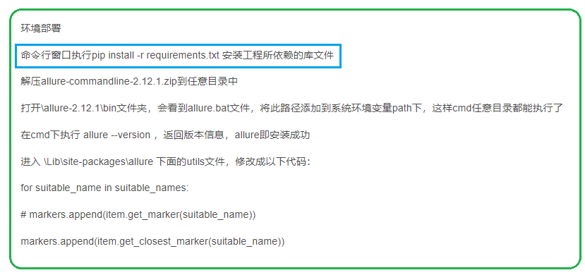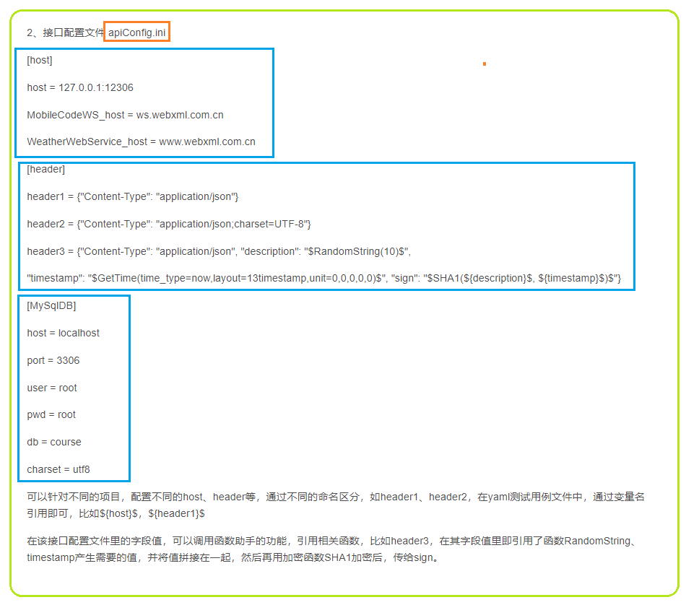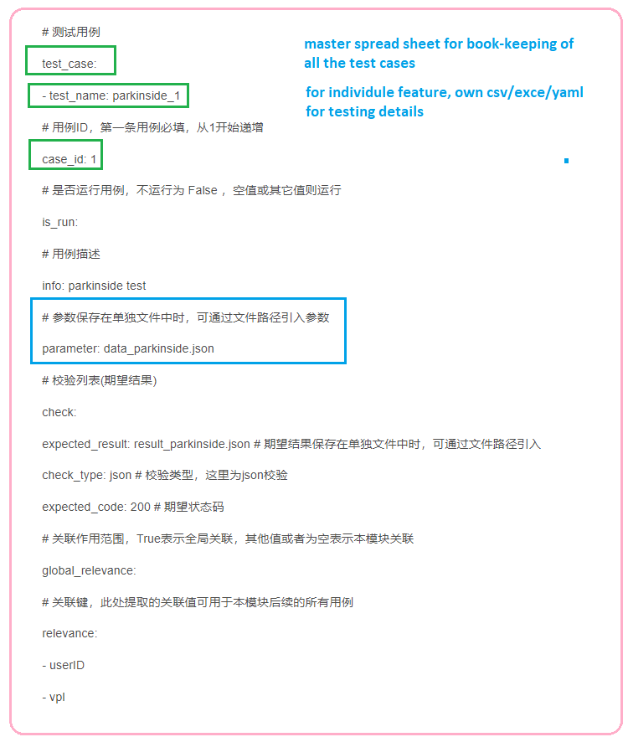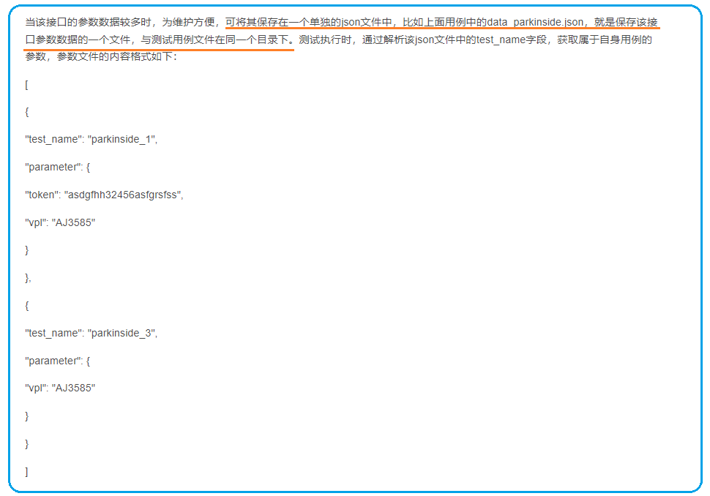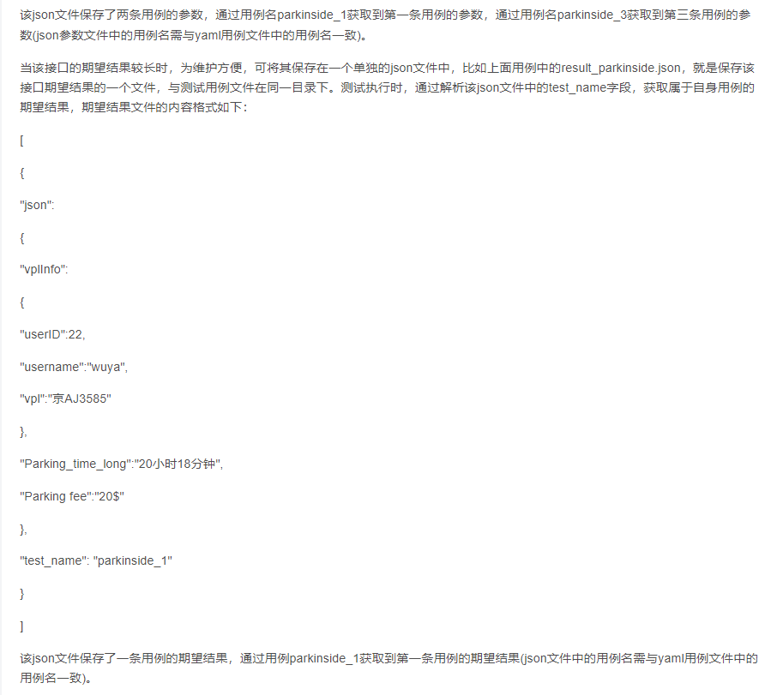

1. **Allure report**
2. **Database schema, pytest – database**
3. **Performance test**

[**https://blog.csdn.net/weixin_46059587/article/details/116893939?ops_request_misc=%257B%2522request%255Fid%2522%253A%2522165153514616781435421525%2522%252C%2522scm%2522%253A%252220140713.130102334.pc%255Fall.%2522%257D&request_id=165153514616781435421525&biz_id=0&utm_medium=distribute.pc_search_result.none-task-blog-2~all~first_rank_ecpm_v1~rank_v31_ecpm-25-116893939.142^v9^pc_search_result_control_group,157^v4^control&utm_term=pytest%2Brequests+%E6%95%B0%E6%8D%AE%E9%A9%B1%E5%8A%A8&spm=1018.2226.3001.4187**](https://blog.csdn.net/weixin_46059587/article/details/116893939?ops_request_misc=%257B%2522request%255Fid%2522%253A%2522165153514616781435421525%2522%252C%2522scm%2522%253A%252220140713.130102334.pc%255Fall.%2522%257D&request_id=165153514616781435421525&biz_id=0&utm_medium=distribute.pc_search_result.none-task-blog-2~all~first_rank_ecpm_v1~rank_v31_ecpm-25-116893939.142%5ev9%5epc_search_result_control_group,157%5ev4%5econtrol&utm_term=pytest%2Brequests+%E6%95%B0%E6%8D%AE%E9%A9%B1%E5%8A%A8&spm=1018.2226.3001.4187)

[**https://blog.csdn.net/weixin_39772652/article/details/111743635?utm_medium=distribute.pc_relevant.none-task-blog-2~default~baidujs_utm_term~default-1.pc_relevant_default&spm=1001.2101.3001.4242.2&utm_relevant_index=4**](https://blog.csdn.net/weixin_39772652/article/details/111743635?utm_medium=distribute.pc_relevant.none-task-blog-2~default~baidujs_utm_term~default-1.pc_relevant_default&spm=1001.2101.3001.4242.2&utm_relevant_index=4)

1. Pytest structure

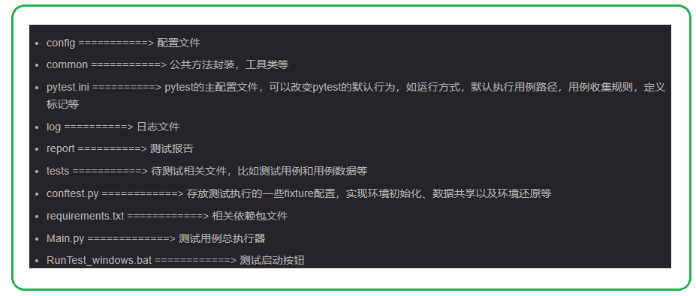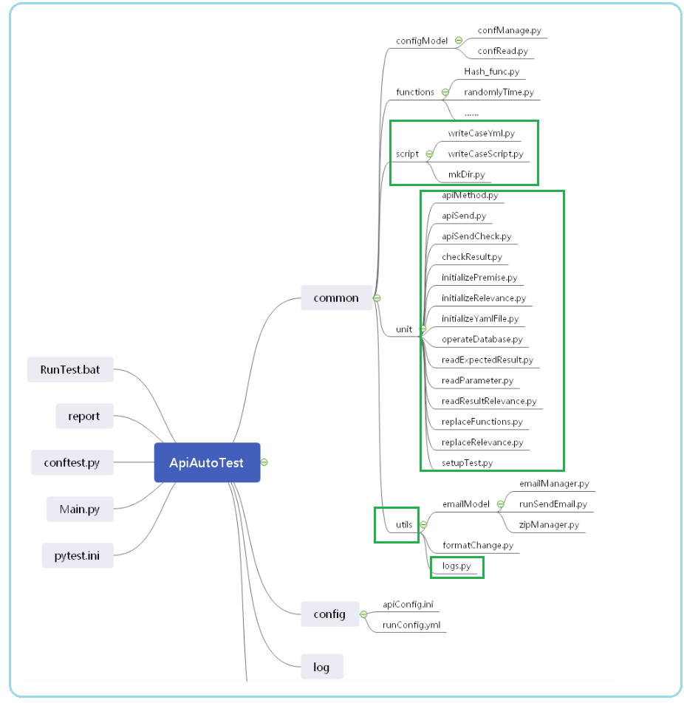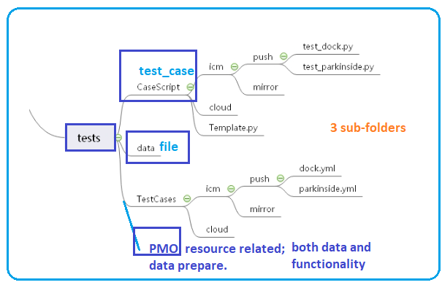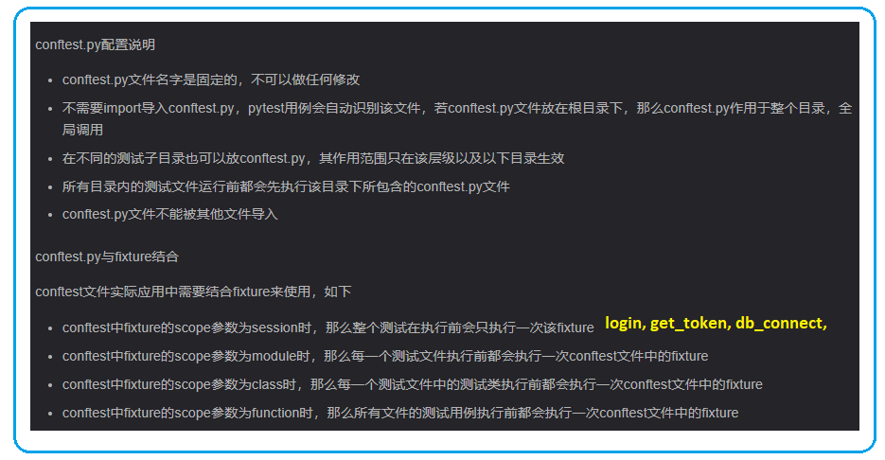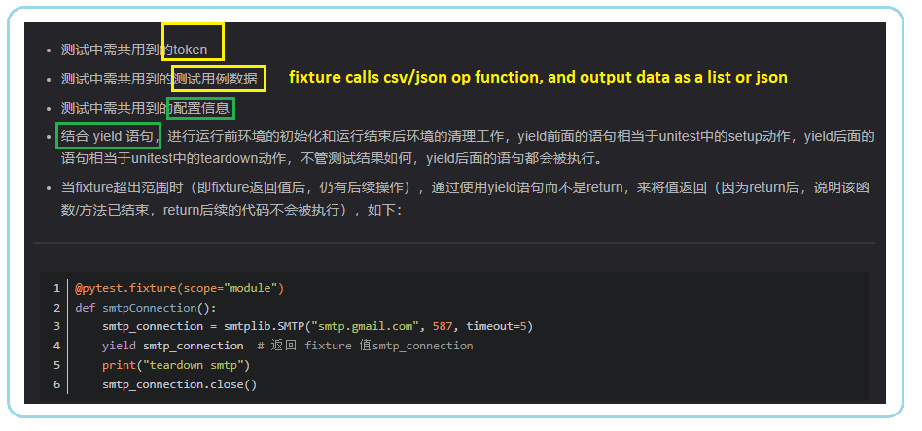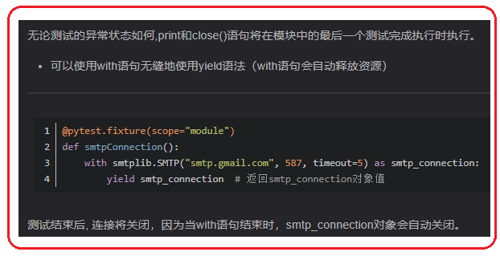 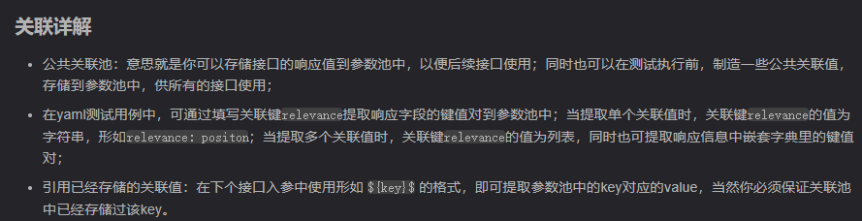 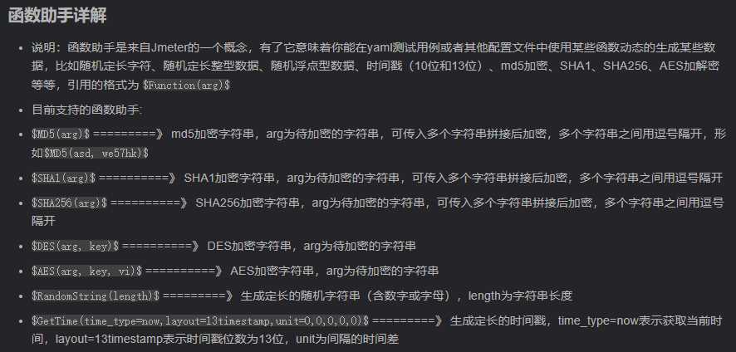

1. **Jkss**