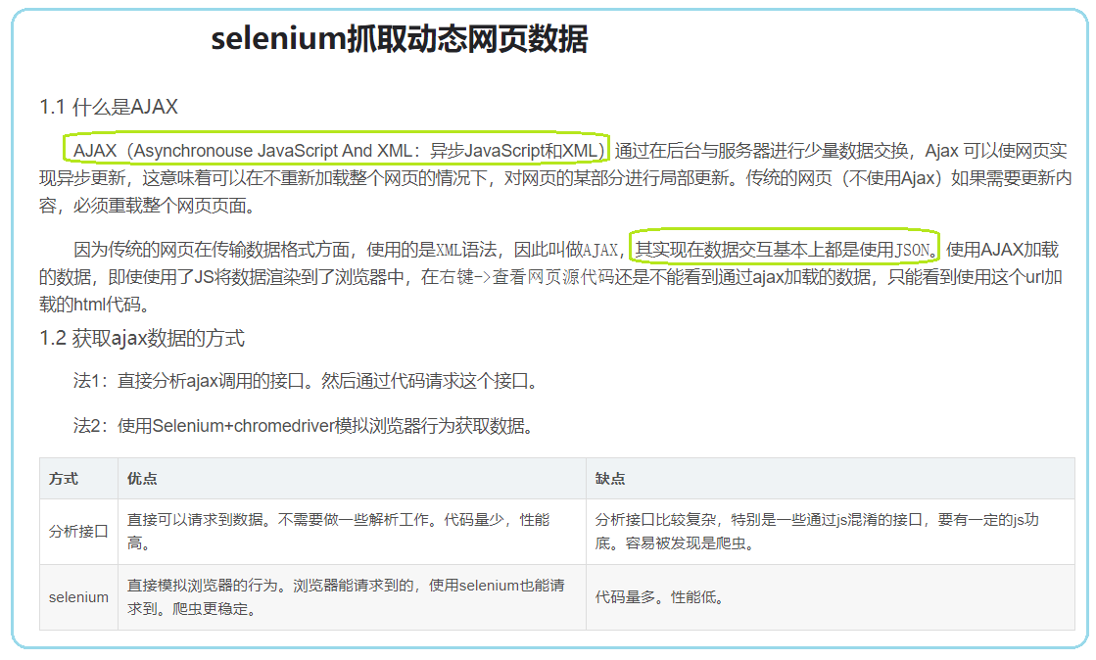

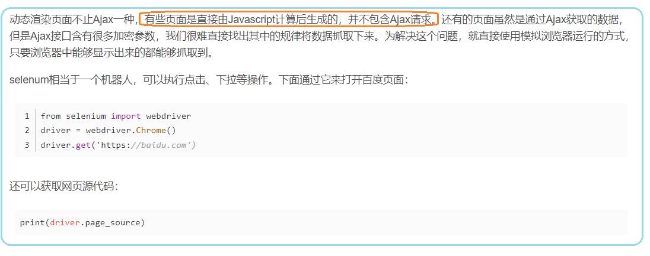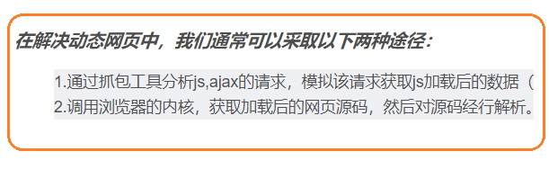

**使用selenium抓取动态页面**

<https://blog.csdn.net/lvcha0219/article/details/108442489?ops_request_misc=%257B%2522request%255Fid%2522%253A%2522163000085116780269812694%2522%252C%2522scm%2522%253A%252220140713.130102334.pc%255Fall.%2522%257D&request_id=163000085116780269812694&biz_id=0&utm_medium=distribute.pc_search_result.none-task-blog-2~all~first_rank_ecpm_v1~rank_v29_ecpm-10-108442489.pc_search_download_positive&utm_term=selenium%E6%8A%93%E5%8F%96%E5%8A%A8%E6%80%81%E7%BD%91%E9%A1%B5&spm=1018.2226.3001.4187>