**python+selenium面试题**

**2022**

**1/17/22, 2/11/22**

[**https://geyao.blog.csdn.net/article/details/112152726?spm=1001.2101.3001.6650.2&utm_medium=distribute.pc_relevant.none-task-blog-2%7Edefault%7ECTRLIST%7ERate-2.pc_relevant_default&depth_1-utm_source=distribute.pc_relevant.none-task-blog-2%7Edefault%7ECTRLIST%7ERate-2.pc_relevant_default&utm_relevant_index=4**](https://geyao.blog.csdn.net/article/details/112152726?spm=1001.2101.3001.6650.2&utm_medium=distribute.pc_relevant.none-task-blog-2%7Edefault%7ECTRLIST%7ERate-2.pc_relevant_default&depth_1-utm_source=distribute.pc_relevant.none-task-blog-2%7Edefault%7ECTRLIST%7ERate-2.pc_relevant_default&utm_relevant_index=4)

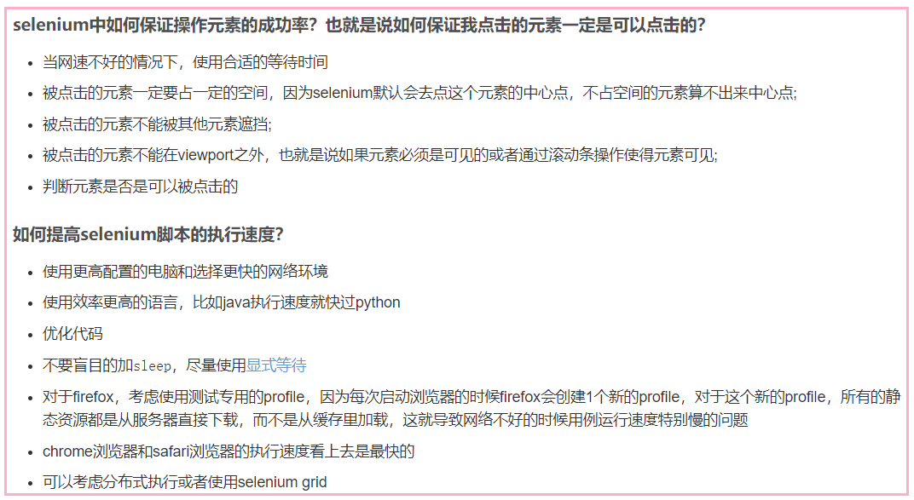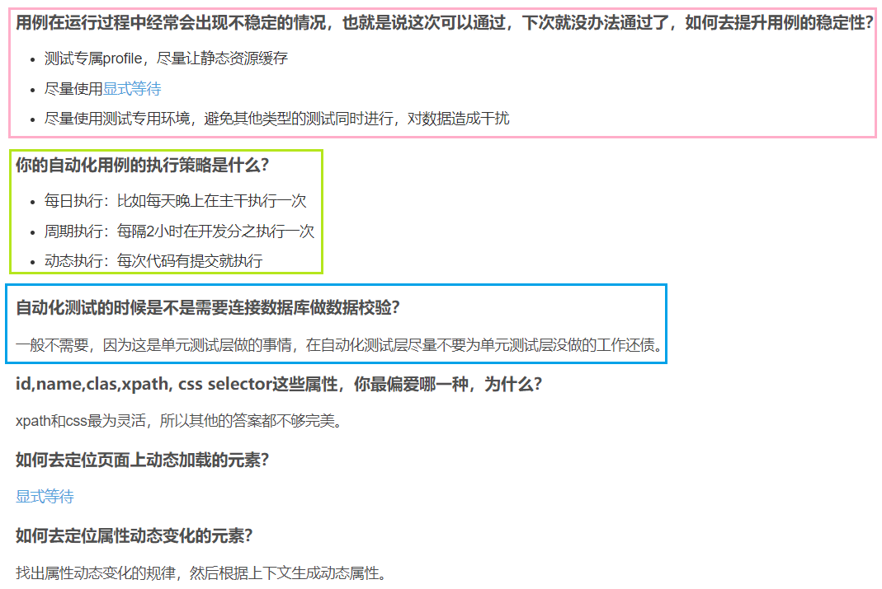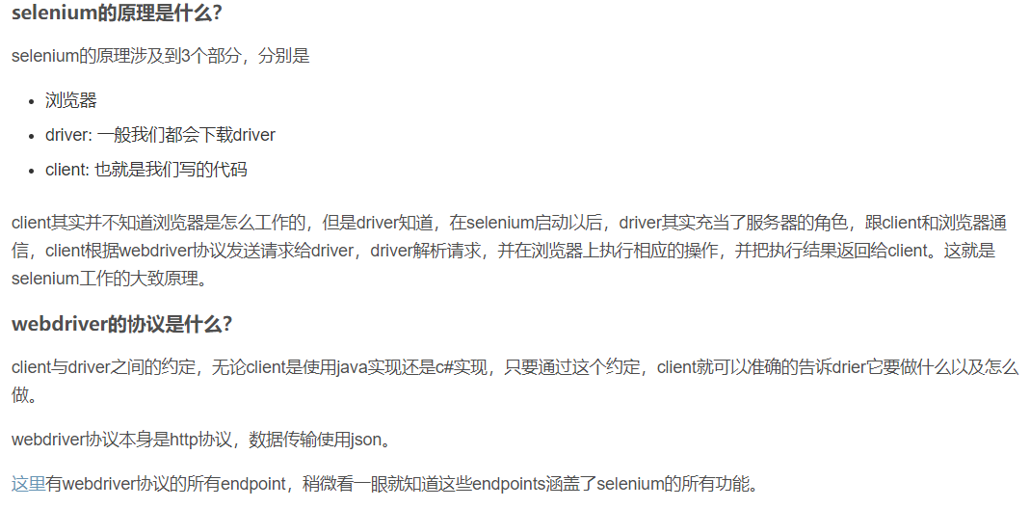

[**https://www.w3.org/TR/webdriver/#list-of-endpoints**](https://www.w3.org/TR/webdriver/#list-of-endpoints)

**page object设计模式？**

[官方介绍](https://github.com/SeleniumHQ/selenium/wiki/PageObjects)，简单来说就是用class去表示被测页面。在class中定义页面上的元素和一些该页面上专属的方法。

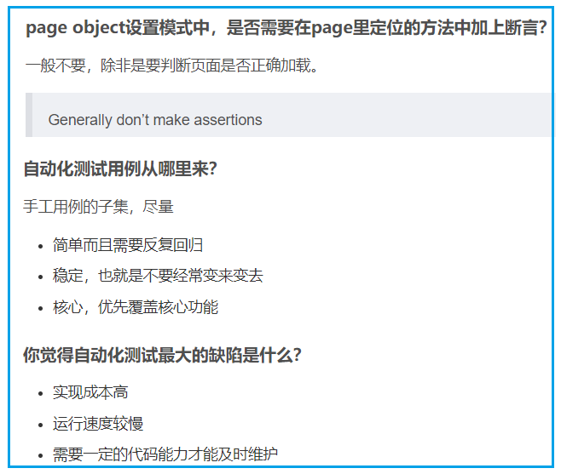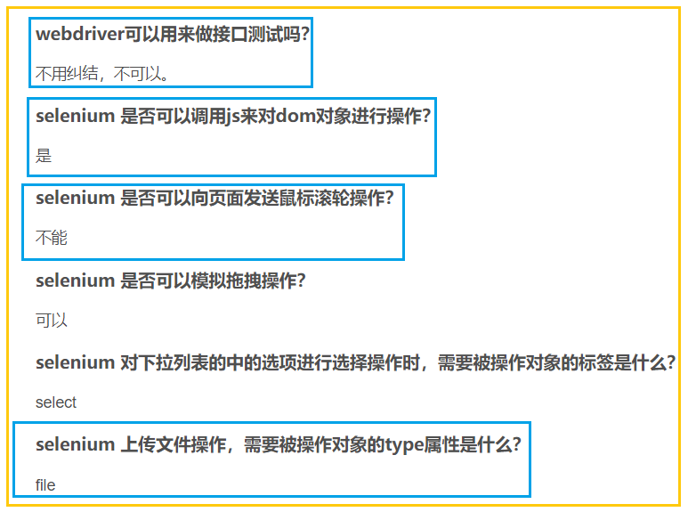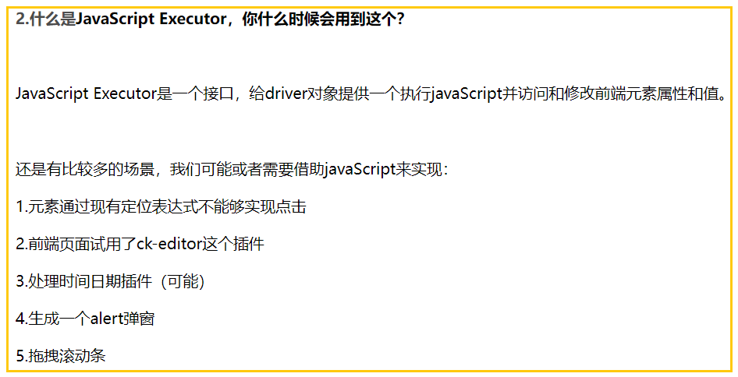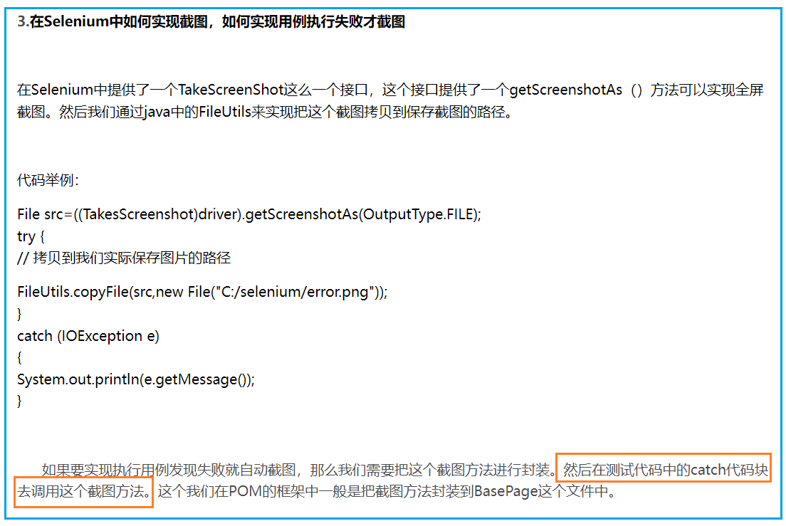

12/13/21

# Java+Selenium3框架设计篇1-跨浏览器支持

<https://blog.csdn.net/u011541946/article/details/76598441>

<https://blog.csdn.net/weixin_30810239/article/details/95048096?spm=1001.2101.3001.6650.2&utm_medium=distribute.pc_relevant.none-task-blog-2%7Edefault%7ECTRLIST%7Edefault-2.no_search_link&depth_1-utm_source=distribute.pc_relevant.none-task-blog-2%7Edefault%7ECTRLIST%7Edefault-2.no_search_link>

<https://blog.csdn.net/weixin_39860064/article/details/111755680?utm_medium=distribute.pc_relevant.none-task-blog-2~default~baidujs_baidulandingword~default-5.no_search_link&spm=1001.2101.3001.4242.4>

<https://blog.csdn.net/weixin_39860064/article/details/111755680?utm_medium=distribute.pc_relevant.none-task-blog-2~default~baidujs_baidulandingword~default-5.essearch_pc_relevant&spm=1001.2101.3001.4242.4>

<https://blog.csdn.net/weixin_30315905/article/details/96836140?utm_medium=distribute.pc_relevant.none-task-blog-2~default~baidujs_utm_term~default-5.essearch_pc_relevant&spm=1001.2101.3001.4242>

# 面试题---Selenium（1）基础问题及自动化测试

<https://blog.csdn.net/XTY00/article/details/101755778/?utm_medium=distribute.pc_relevant.none-task-blog-2~default~baidujs_utm_term~default-4.essearch_pc_relevant&spm=1001.2101.3001.4242>

# 自动化测试+性能面试题整理--个人最新【持续更新】

<https://blog.csdn.net/qq_34671951/article/details/96425740?ops_request_misc=%257B%2522request%255Fid%2522%253A%2522163009890316780265420006%2522%252C%2522scm%2522%253A%252220140713.130102334.pc%255Fall.%2522%257D&request_id=163009890316780265420006&biz_id=0&utm_medium=distribute.pc_search_result.none-task-blog-2~all~first_rank_ecpm_v1~rank_v29_ecpm-15-96425740.pc_search_result_control_group&utm_term=selenium+%E6%B5%8B%E8%AF%95%E7%8E%AF%E5%A2%83%E7%94%9F%E4%BA%A7%E7%8E%AF%E5%A2%83%E5%88%87%E6%8D%A2&spm=1018.2226.3001.4187>

<https://blog.csdn.net/qq_42986622/article/details/119933869?utm_medium=distribute.pc_relevant_t0.579242&depth_1-utm_source=distribute.pc_relevant_t0.579242>

<https://blog.csdn.net/huilan_same/article/details/52559711?utm_medium=distribute.pc_relevant.none-task-blog-2%7Edefault%7EBlogCommendFromMachineLearnPai2%7Edefault-3.essearch_pc_relevant&depth_1-utm_source=distribute.pc_relevant.none-task-blog-2%7Edefault%7EBlogCommendFromMachineLearnPai2%7Edefault-3.essearch_pc_relevant>