

# Proposal / Application For

**Final Year Project**

**Computer & Information Systems Engineering Department**

**Private Cloud Solution Using OpenStack**

**<submitted by>**

**NED University of Engineering & Technology**

## Project Identification

* 1. **Reference Number** (for office use only)

|  |  |  |  |  |  |  |
| --- | --- | --- | --- | --- | --- | --- |
| **C** | **S** | **-** | **1** | **6** |  |  |

### Project Title

**Private Cloud Solution Using OpenStack**

* 1. **Project Internal Advisor**

|  |  |
| --- | --- |
| Name | **Dr. Muhammad Ali Ismail** |
| Designation | **Co-chairman** |

* 1. **Project Internal Co-Advisor**

|  |  |
| --- | --- |
| Name |  |
| Designation |  |

* 1. **Project External Advisor**

|  |  |  |
| --- | --- | --- |
| Name |  | |
| Designation |  | |
| Organization |  | |
| Mobile # |  | Email |

* 1. **Student Team**

|  |  |  |  |  |
| --- | --- | --- | --- | --- |
| **S.No.** | **Roll No.** | **Name** | **CGPA** | **Email** |
| 1. | CS-133 | Danyal Javed Mir | 3.2 | [daniyal.mir.dj@gmail.com](mailto:daniyal.mir.dj@gmail.com) |
| 2. | CS-129 | Muhammad Usman Ghani | 2.75 | [mghani828@gmail.com](mailto:mghani828@gmail.com) |
| 3. | CS-126 | Muhammad Ammar | 3.2 | [iammar7@yahoo.com](mailto:iammar7@yahoo.com) |

* 1. **Sponsoring Organization** (if any)

### Keywords

Cloud Services, OpenStack, Automation, Effortless Installation, On-Premises

### Project Idea

• 



## ABSTRACT

OpenStack based cloud solution that allows users to create a private or public cloud based of requirements without the hassle of installing and configuring the individual services and technologies needed to build a completely running cloud environment. It also eliminates time of deployment and hefty cost of hiring professionals to build the cloud environment for you.

Our product is designed upon OpenStack which serves as the core component. OpenStack installation itself is very confusing and time consuming because of its architecture that uses individual components each individual component requires separate configuration and are usually installed or separate nodes (server) to build a complete cloud environment. We want to automate the process of configuring individual component and provide users with effortless installation through our product. Our automated scripts will fetch required components and configure them according to user specification. It will bypass all obstacles and provide users with their very own cloud platform.

Our solution will benefit small organizations and educational sectors to have their cloud platform without spending on public hosting solutions. It can help organizations spend time and money on business aspects of their company not technical. It can also come very handy for DevOps engineer and others as their training and learning environment. All in all it provides cloud platform to everyone with hassle of configuration and installation.

## Project Background and Literature Review

Cloud Computing

The cloud enables anyone with an internet connection to access IT resources on-demand, such as those consumed by cloud-based applications. The basic resources available are compute, storage, and networking, all of which are needed for a business critical application to deliver a full experience.

A cloud can be private or public. A public cloud sells services to anyone on the Internet. (Currently, Amazon Web Services is the largest public cloud provider.) A private cloud is a proprietary network or a data center that supplies hosted services to a limited number of people. Private or public, the goal of cloud computing is to provide easy, scalable access to computing resources and IT services.

OpenStack

OpenStack is a collection of open source software modules that provides a framework to create and manage both public cloud and private cloud infrastructure. An organization can use OpenStack to deploy and manage cloud-based infrastructure that supports an array of uses cases, including web hosting, big data projects, software as a service (SaaS) delivery, or deploying high volumes of containers.

OpenStack competes most directly with other open source cloud platforms, including Eucalyptus and Apache CloudStack. Some also see it as an alternative to public cloud platforms like Amazon Web Services or Microsoft Azure.

Solutions similar to our product are present such as **DevStack** and **PackStack** they both offer all-in-one installation. DevStack and PackStack is a series of extensible scripts used to quickly bring up a complete OpenStack environment. But it is mainly built for development and testing purpose of new OpenStack features. So its end product can’t really be utilized as your personal cloud platform. After running stack.sh (main script to start DevStack) the resulting (probably) functioning OpenStack is setup. But upon reboot it will not come back up. there are no upstart or systemd or init.d scripts for restarting services. There is no high availability, no backups, no configuration management.

## Motivation and Need

A lot of cloud service providers are present as of today. Using public cloud comes with a lot of difficulties in keeping the service up running if your company doesn’t have employee with required skill. Then there always risks of data privacy and transparency. And cost of running these services are very high. Small organization cannot afford these expenses.

If you plan on having a private cloud it still is very difficult because it cuts expense of hosting services but you need someone to setup a cloud environment for you which still in very inconvenient in terms or cost and time for small organizations. And one cannot simply put a complete cloud environment up and running quickly it can take weeks of configuration and modifying components especially if you plan on using OpenStack which requires immense time and work to build a cloud

Small businesses tend to find their cloud needs evolving as they scale up. Monthly fees that were manageable in a company's early days can become prohibitive when the organization reaches a certain size. After only a few years, running a business entirely on public clouds can actually become more expensive than implementing your own solution. This is especially true when you're working with applications that boast predictable usage and low storage costs

## Objectives

To develop a cloud platform that provides users to run their own private or public clouds on-premises effortlessly. Just by installing a single program that will manage all complex configurations, it will cut the cost of hosting your applications on public cloud solutions which can be very beneficial for small firms and educational sectors.

## Methodology and Equipment/Tools

* OpenStack
* Puppet and Chef
* Git
* Python, React

## Key Milestones and Deliverables

|  |  |  |  |
| --- | --- | --- | --- |
| **No.** | **Elapsed time (in months) from start of the project** | **Milestone** | **Deliverables** |
| 1. | 1 months | Literature review | Documentation & skillset development |
| 2. | 3 months | Customization of OpenStack | Customizable User Interface |
| 3. | 4 months | Script Development with Automation Tool | Customized user packages |
| 4. | 1 month | Final result generation | Research article |

1. **Expected Outcome**

* We will develop cloud platform.
* We will provide an automated installation of cloud environment on user’s system according to their requirement.
* Our product will have different flavors of cloud for users to choose the best option.

## Direct Customers / Beneficiaries of the Project

Small organization and educational sectors are the primary beneficiaries.

## Consent of Advisors

**Consent of the Internal Advisor** Signature:

**Consent of the Co-Internal Advisor** Signature:

**Consent of the External Advisor (if any)** Signature:

## Reviewers Committee’s Comments

1. **Project Schedule / Milestone Chart**

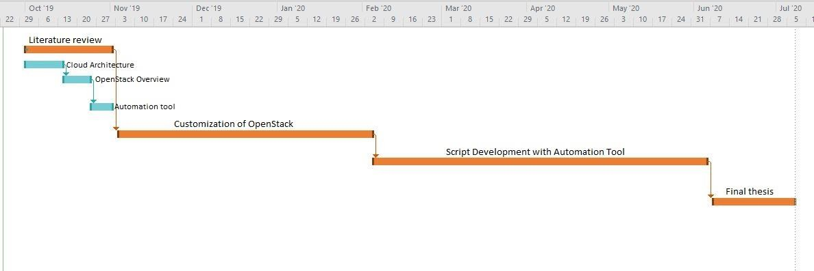

|  |  |  |
| --- | --- | --- |
| **13.** | **Project Approval Certificate** |  |
|  | **Recommendation of FYP Coordinator**  **Approval by the Chairman** | Signature:  Signature: |