William Archer & Dane Walton

3/17/2016

ESE350

Lab 6: Networking Embedded Systems

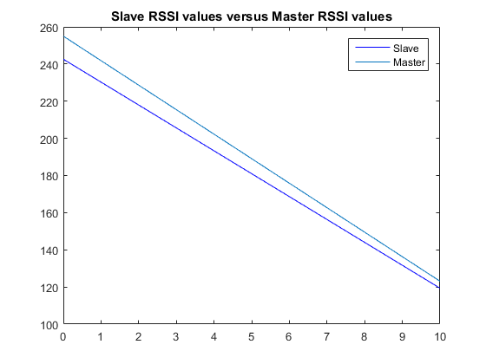

Our master board received packets better than the slave board at both 0m and 10m. This proved to be true throughout the rest of the experimentation as well, with the master receiving a transmission ratio of 100%. It’s lowest RSSI value was 1, however it managed to collect all packets.

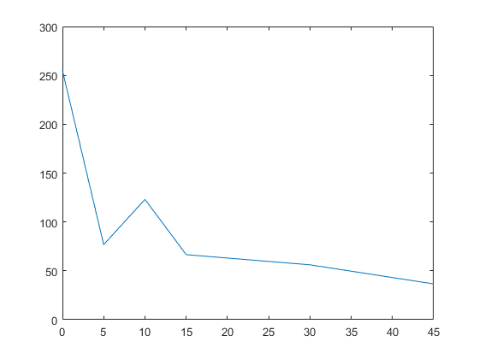

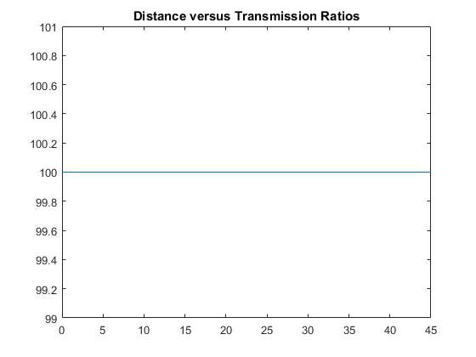This is a plot of the master device and its RSSI values at various distances. From the graph, it is evident that the radio was able to pick up packets much better at 10m, which proved to be an anomaly from the rest of the data. This could be due to less traffic affecting results or some other condition we weren’t aware of.

We had a transmission ratio of 100% at every distance, with our lowest RSSI value being 1 at 45m.