**Test Scenarios**

Test Scenario: Login page(test_login.py)

|  |  |  |  |  |  |
| --- | --- | --- | --- | --- | --- |
| Test Scenario | Test Description | Test Values | Expected Outcome | Actual Outcome | Justification |
| 1 | To test the link to the login page. | Type “<http://localhost:8000/accounts/login/>” in url. | Display title “Login”  Display:  Input textbox for Username  Input textbox for Password | Display title “Login”  Display:  Input textbox for Username  Input textbox for Password | - |
| 1 | User log in with empty username and password | Username: “” Password: “” | Remain on the same page “<http://127.0.0.1:8000/accounts/login/>” and display tab remains “Login”  Username input displays required error: “Please fill up this field”.  Password field did not display anything | Remain on the same page “<http://127.0.0.1:8000/accounts/login/>” | Because no inputs for both username name and password  Validation of username checks that there is no username input. |
| 2 | User log in with wrong username and empty password | Username “peter”    Password: “” | Password input displays required error: “Please fill up this field”. | Remain on the same page “<http://127.0.0.1:8000/accounts/login/>” | Validation of password checks that there is no password input. |
| 3 | User log in with right password and empty username | Username: “”  Password: password | Username input displays required error: “Please fill up this field”.    Password field did not display anything | Remain on the same page “<http://127.0.0.1:8000/accounts/login/>” | Validation of username checks that there is no username input. |
| 4 | User logs in with right username and wrong password | Username: finer    Password: %&$*# | Remain on the same page. “<http://127.0.0.1:8000/accounts/login/>”  Error displays: “Please enter a correct username and password. Note that both fields may be case-sensitive.” | Remain on the same page “<http://127.0.0.1:8000/accounts/login/>”  Error displays:  “Please enter a correct username and password. Note that both fields may be case-sensitive.” | The validation check that the password is incorrect and consider the current username entered by the user is incorrect and did not match username and password of Super user. |
| 5 | To test when the user logs in with wrong username and password | Username: %^&*()%$#@#& *&*&$_+++++&&&&?????/ #*    Password: %%%%% | Remain on the same page “<http://127.0.0.1:8000/accounts/login/>”    Error displays: “Please enter a correct username and password. Note that both fields may be case-sensitive.” | Remain on the same page “<http://127.0.0.1:8000/accounts/login/>”  Error displays: “Please enter a correct username and password. Note that both fields may be case-sensitive.” | The validation checks current username and its password entered by the current user did not matches with the username and password of a Super user. |
| 6 | User logs in with the right username and right password | Super User:    Username: finer  Password: password | Redirects to  <http://localhost:8000/> | Redirects to  <http://localhost:8000/>  Display:  “Welcome back finer! Want to play a game?”  Display:  “logout” link button  “reset password” link button  “Todo List” link button | Note*  Super user account must set ourselves in cmd.  1.Go cmd  2. cd this file  3. Type python manage.py createsuperuser |

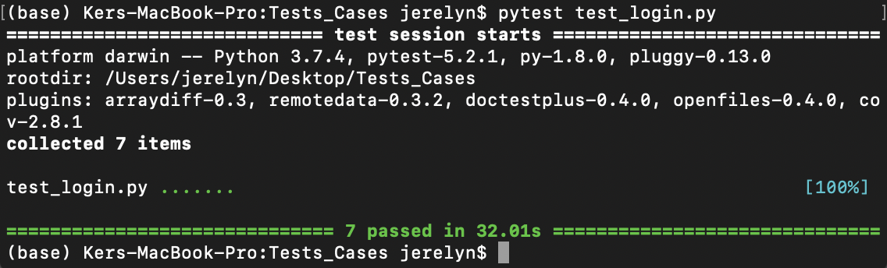

Test Scenario: Adding and Deleting in todo page(test_todo.py)

|  |  |  |  |  |  |
| --- | --- | --- | --- | --- | --- |
| Test Scenario | Test Description | Test  Values | Expected Outcome | Actual Outcome | Justification |
| 1 | To test the feature of Todo navigation button at the navigation bar for able to navigate to display the todo page, input textbox and add button | Click on “To Do” navigation button | Navigate directly to  <http://localhost:8000/todo/> | The font for Todo’s navigation button at the navigation bar becomes white colour  Navigate directly to  <http://localhost:8000/todo/> Display page title: “Todo” and “View all your current and active todo items.” Display input textbox and add button | - |
| 2 | To test clicking on the “Add” button without entering any texts in the input textbox | Click “Add” button | Displays a pop up “Unable to add!” | Remain on the same page  <http://localhost:8000/todo/> Display page title: “Todo” and “View all your current and active todo items.” On top of the todo textbox with its “Add” button, it displays a bullet point and a “Delete” button | [Fail]:  Validation not set! |
| 3 | To test clicking on the “Add” button with input text entered in the input textbox | Textbox: Play Final Fantasy XIII  Click “Add” button | “Play Final Fantasy XIII” is added. | Remain on the same page  <http://localhost:8000/todo/> Display page title: “Todo” and “View all your current and active todo items.” On top of the todo textbox with its “Add” button, it displays a bullet point with “Play Final Fantasy XIII” and a “Delete” button | - |
| 4 | To test clicking on the “Add” button with symbols entered in the input textbox | Textbox: ~`!@#$%^&*()_+}{“:<>?|\  Click “Add” button | “~`!@#$%^&*()_+}{“:<>?|\” is added. | Remain on the same page  <http://localhost:8000/todo/> Display page title: “Todo” and “View all your current and active todo items.” On top of the todo textbox with its “Add” button, it displays a bullet point with “~`!@#$%^&*()_+}{“:<>?|\” and a “Delete” button | - |
| 5 | To test clicking on the “Add” button with input texts, spacing, numbers and symbols entered into the input textbox | Textbox: Hang out with friends! 8^.^8  Click “Add” button | “Hang out with friends! 8^.^8” is added. | Remain on the same page  <http://localhost:8000/todo/> Display page title: “Todo” and “View all your current and active todo items.” On top of the todo textbox with its “Add” button, it displays a bullet point with “Hang out with friends! 8^.^8” and a “Delete” button | - |
| 6 | To test clicking the delete button for to remove those already added into the todo page | Click “Delete” button. | Texts with bullet points added previously into the todo page are successfully removed and all delete buttons are disappeared  Remain on the same page <http://localhost:8000/todo/>  Display an empty input textbox and “Add” button | All texts with bullet points added previously into the todo page are successfully removed and all delete buttons are disappeared.  Remain on the same page <http://localhost:8000/todo/> | - |

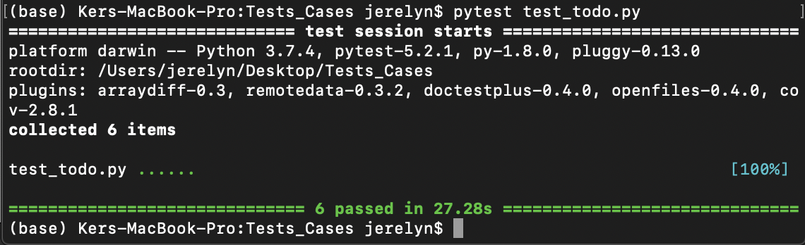

Test Scenario: Todo History page (test_todo_history.py)

|  |  |  |  |  |
| --- | --- | --- | --- | --- |
| Test Scenario | Test Description | Test Values | Expected Outcome | Actual Outcome |
| 1 | To test the feature of Todo History’s navigation button for able to display the Todo History such as viewing what the user have added / deleted previously | Click on “Todo History” navigation button to display the todo list added(existing)  /deleted by user “finer” | Display title “Todo History” and display “View all todo items from anyone”  Display information of user:  Content  DateTime  Author  Status | The font for Todo History’s navigation button at the navigation bar becomes white colour  Display direct to “<http://localhost:8000/todo/history/>” page  Todo History navigation button is highlighted in white colour.  Display title “Todo History” and display “View all todo items from anyone.”  Display:  A screenshot of a cell phone  Description automatically generated |

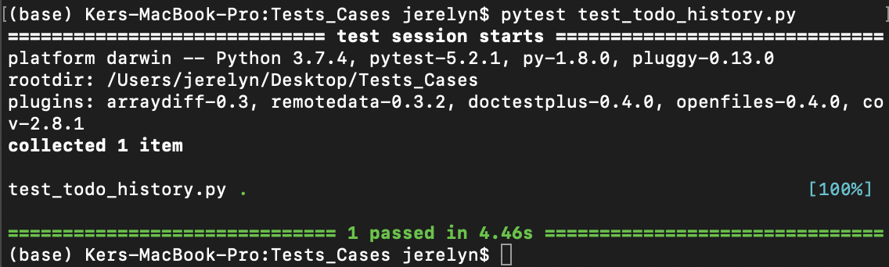

Test Scenario: Team Contribution page(test_todo_history.py)

|  |  |  |  |  |
| --- | --- | --- | --- | --- |
| Test Scenario | Test Description | Test Values | Expected Outcome | Actual Outcome |
| 1 | To test the feature of Team Contribution’s navigation button able display each member’s name and the description of their job roles | Click on “Team Contribution” navigation button | Display  “Project Manager + (Developer & QA Member)”  Display  “Ker Ning Hui”  Display “Ning Hui was assigned the role of a Project Manager, along with being a developer and a QA member. Although she is the overall manager of this project, she was still required to carry out her duties as a developer and a QA member. As a developer, she was assigned the role of working on and coding out the Team Contributions page as instructed by the technical lead. As a QA member, she was assigned to work on the selenium and pytest codes and testing alongside the QA lead. Finally, as a project manager, she was required to monitor the issues and step in whatever necessary. She oversees the overall project movement and actions of her team members while giving certain instructions to the QA lead and technical lead when the need arises and to keep the project moving.  Display “QA Lead”  Display “  Koh Fang Ting”  Display “Fang Ting was assigned the role of a QA lead where she leads her QA members. In this team however, there is only one other QA member. Therefore, not only is she required to work on the testing just like a QA member, she also had to lead the other QA member in the team and provide clear instructions and tasks for that member to work on. She came up with the test cases and monitors the commits by the developers so that she can make changes to her test cases.  Display “Technical Lead”  Display “  Lee Ze Rong”  Display “Ze Rong was assigned the role of a technical lead whereby he was in charge of the developers in this team. In addition to managing the developers under him, he was also required to carry out his duties as a developer. He was required to work on the To Do page while monitoring the activities of his developer teams”.  Display “Developer”  Display “  Jansen Ros”  Display “Jansen Ros was assigned the role of a developer whereby he was required to code out certain parts of the project. He was given the task of developing the To Do page where there is a compilation of all the To Do items added.  Display “Developer”  Display “  Ray Tan”  Display “Ray Tan was assigned the role of a developer and was required to code out certain parts of the project. At the start of the project, he was required to work on coding out a simple code base (referencing from the video) which will later serve as the core to be further developed on. He was later on assigned to also work on the User Login page. | The font for Team Contribution’s navigation button at the navigation bar becomes white colour.  Display direct to <http://localhost:8000/teamContributions/>  Display “Team Contribution” (display in bigger header size, bold)  Display  “Project Manager + (Developer & QA Member)” (display in header size, bold)  Display  “Ker Ning Hui” (display in smaller header size, bold)  Display “Ning Hui was assigned the role of a Project Manager, along with being a developer and a QA member. Although she is the overall manager of this project, she was still required to carry out her duties as a developer and a QA member. As a developer, she was assigned the role of working on and coding out the Team Contributions page as instructed by the technical lead. As a QA member, she was assigned to work on the selenium and pytest codes and testing alongside the QA lead. Finally, as a project manager, she was required to monitor the issues and step in whatever necessary. She oversees the overall project movement and actions of her team members while giving certain instructions to the QA lead and technical lead when the need arises and to keep the project moving.  (Display in paragraph format, without bold)  Display “QA Lead” (display in header size, bold)    Display  “Koh Fang Ting” (display in smaller header size, bold)  Display “Fang Ting was assigned the role of a QA lead where she leads her QA members. In this team however, there is only one other QA member. Therefore, not only is she required to work on the testing just like a QA member, she also had to lead the other QA member in the team and provide clear instructions and tasks for that member to work on. She came up with the test cases and monitors the commits by the developers so that she can make changes to her test cases.  (Display in paragraph format, without bold)  Display “Technical Lead” (display in header size, bold)  Display “  Lee Ze Rong” (display in smaller header size, bold)  Display “Ze Rong was assigned the role of a technical lead whereby he was in charge of the developers in this team. In addition to managing the developers under him, he was also required to carry out his duties as a developer. He was required to work on the To Do page while monitoring the activities of his developer teams”. (Display in paragraph format, without bold)  Display “Developer” (display in header size, bold)  Display “  Jansen Ros” (display in smaller header size, bold)  Display “Jansen Ros was assigned the role of a developer whereby he was required to code out certain parts of the project. He was given the task of developing the To Do page where there is a compilation of all the To Do items added. (Display in paragraph format, without bold)  Display “Developer” (display in header size, bold)  Display “  Ray Tan” (display in smaller header size, bold)  Display “Ray Tan” was assigned the role of a developer and was required to code out certain parts of the project. At the start of the project, he was required to work on coding out a simple code base (referencing from the video) which will later serve as the core to be further developed on. He was later on assigned to also work on the User Login page.  (Display in paragraph format, without bold) |

