Rebecca TeKolste and Arsalan Ahmed

Yale University

HPM 573 Spring 2018

Cost-Effectiveness Study on Innovative Pre-Eclampsia Treatment and Education Programming in Uganda

Dr. Reza Yaesoubi and Alyssa Sbarra (TA)

May 2, 2018

Yale University

**Introduction**

As part of this research report, the student group partnered with SEED Global Health to examine the impact of their training programs. The organization’s primary initiative partners with the US Peace Corps to send trained health professionals to countries abroad. In their capacity as Peace Corps Volunteers, these highly trained professionals work to improve local health capacity through training. This project does not focus on the effectiveness of the training itself but instead examines the potential impact of having a sufficient number of trained doctors in the public health system.

The project focuses on maternal and child health outcomes in Uganda. Maternal and child health was selected due to the international prioritization on the topic through the Millennium Development Goals and Sustainable Development Goals. Within maternal and child health, the student group selected to work specifically on eclampsia because the causes of the disease are unknown but its impacts are severe, causing 8-14 percent of maternal mortality, depending on the location (Khan, 2006).

Among the partner countries that SEED works with, Uganda was selected due to its robust partnership with the organization and public health record. The country has an organized national health system and health delivery in place; health services delivery is decentralized within national, districts and health sub-districts (Bossert et al., 2002).

**Background on Eclampsia**

Preeclampsia (PE) is a complication during pregnancy with unknown causes. It causes high blood pressure, kidney damage, and other problems for both the mother and the fetus. On average, PE is a potentially life-threatening condition that affects 2-8% of pregnancies worldwide and more in lower income countries (Duley, 2009). Preeclampsia is also more common in some ethnic groups (e.g. African-Americans, Sub-Saharan Africans, Latin Americans, African Caribbeans, and Filipinos) (Steegers, 2010). Typically characterized by the onset of high blood pressure and a significant amount of protein in the urine, PE can lead to seizure-like conditions and result in eclampsia (a seizure condition that can put the lives of both mother and baby at risk). Eclampsia affects 1.6% of pregnant women in developed countries and almost 10 to 30 times as many women in low-income countries (Steegers, 2010). PE risk becomes apparent after 20 weeks of pregnancy and is most likely during the third semester (Sibai, 2005).

Global diagnostic criteria for PE involves monitoring blood pressure and urine output. For women with hypertension early in pregnancy, an increase in 30 mm Hg of systolic blood pressure is a common clinical sign for a drug intervention. In more severe cases of PE, the presence of more than 300 mg of protein in the urea is also a recommendation for clinical action (LaMarca et al, 2008).

Preeclampsia becomes more dangerous when the blood pressure rises to and above 140/90 mmHg alongside protein in the urine, causing a diagnosis of severe preeclampsia. At this point, the risk of eclampsia and death is heightened, and anticonvulsants are recommended (Williams, 2004). There is no cure for preeclampsia except delivery. In many developed countries, it is recommended that women with preeclampsia induce labor around the 37th week and those with severe preeclampsia reduce blood pressure as soon as practical (Ramos, 2017). These recommendations do not necessarily apply in the developing world.

**Preeclampsia in Uganda, A Case Study**

Preeclampsia affects developing countries much more than developed countries. Sub-Saharan Africa has an especially high maternal mortality rate, and Uganda’s specific rate is 438 maternal deaths per 100,000 live births (Kabayambi 2014). In Uganda specifically, approximately 10% of maternal deaths are caused by eclampsia (Okong et al, 2006). International protocols detail blood pressure evaluation and urinalysis testing for pregnant women; this is not always the case in resource-deprived settings. Current standards provide for the use of methyldopa upon identification of hypertension (HTN), which has a relative risk (RR) rate of 0.5 and for the use of magnesium sulphate (MgSO4) to prevent eclampsia once preeclampsia is detected (Arulkumaran and Lightstone, 2013).

Despite these robust protocols, the regional health system has been shown to inadequately follow-up, diagnose and treat preeclampsia. Although 94.9% of women reported having attended at least one antenatal care visit, only 59% of them reported having blood pressure taken, and only 21% of them reported having urinalysis done (USAID Country Specific Information PDF, 2017). Without these tests, it is impossible to diagnose and treat hypertension (HTN) before it becomes eclampsia (Chow et al, 2013). Supply concerns bring up another issue in the resource-limited system. One study by population found that only 31% of facilities in Uganda have appropriate supplies (Waiswa et al, 2010). Another study found that only 20% of the required amount of magnesium sulphate was available in facilities in Uganda (Nabatanzi, 2018).

**Methods**

**Decision Tree**

Overall

A decision tree (Figure 1, Table 1) was created to map out health outcomes. Significant determinants of receiving care included being detected for hypertension (HTN), having adequate levels of drug supply, and level of physician training. An individual moving through the model could be categorized into four disease states were identified: well, hypertensive, having severe pre-eclampsia, and eclampsia. As shown in Figures 1 through 5, the decision tree allows a patient to end up in one of five branches, depending on the availability of supplies and proficiency of the health system. The top branch represents a health facility that does not take blood pressure. The second branch down represents the health facility that has all supplies. The third branch represents a health facility that has methyldopa and conducts a urinalysis test but does not have magnesium sulphate. The fourth branch represents a health facility that takes blood pressure and has methyldopa but does not conduct a urinalysis (effectively the same as the previous branch). The final branch represents a health facility that takes blood pressure but has no methyldopa available.

Baseline Scenario

The baseline scenario was used to model the existing outcomes in the country. Probabilities were sourced from existing literature in low-income countries where possible (Table 1, Figure 2). Based on the current challenges in the health system in Uganda, we developed a model based on a system-level rather than on an individual-level change as our treatment effect. Our baseline scenario is the current rates of testing (59% for blood pressure and 21% for urinalysis) and current rates of drug availability (31% for methyldopa and 20% for magnesium sulphate).

Training Scenario

In the training scenario, probabilities were sourced from existing literature in low-income countries where possible (Table 1, Figure 3). Notable changes from baseline include increased likelihood of getting one’s blood pressure taken (1.83x the original rate). This increase is detailed by a study which suggests that adherence to medical protocols can be increased by 83% with improved training (Firth-Cozens, 2001).

Adequate Supply Scenario

In the adequate supply scenario, probabilities were sourced from existing literature in low-income countries where possible (Table 1, Figure 4). Notable changes from baseline include increased likelihood of getting methyldopa (MD) (to 95%) or MgSO4 when needed (to 95%). We chose the amount 95% because we thought that it was unlikely that the health system could meet a 100% threshold with such a low existing rate of availability. Still, wanted to maximize the potential for improved outcomes based on supplies only, and since the health control can control the supply we felt this was a reasonable maximum.

Both Training and Supply Scenario

In the both better training and adequate supplies scenario, probabilities were sourced from existing literature in low-income countries where possible (Table 1, Figure 5). Notable changes from baseline include increased likelihood of getting one’s blood pressure taken (83% increase) and probability of receiving a urinalysis (83% increase). Notable treatment changes associated with better supplies from baseline include increased likelihood of getting methyldopa (95%) or MgSO4 when needed (95%). A combined approach was examined because our hypothesis was that only improving training without improving supplies would not be as cost-effective.

Key Assumptions

A number of simplifying assumptions were made in this model. If blood pressure is not diagnosed, then urinalysis will not be taken, regardless of whether it is available. Similarly if no methyldopa is available, then the diagnostic process also terminates at that juncture. Another simplifying assumption is that while blood pressure detection is a result of only *training*, the use of urinalysis is a combination of training and availability of supplies (because the urine dipsticks are single use, and there is a cost associated with them). Therefore, the probability of receiving a urinalysis test only increases if both training and supplies are increased. Another simplifying assumption is that since blood pressure cuffs are reusable almost indefinitely, that the cost of taking blood pressure is $0. Finally, we assume that uptake for medication is 100%. When medicine is available and appropriate, it is administered and taken.

**Costing Data**

Drug prices (treatment costs) were sourced from the WHO’s International Drug Price Indicator Guide (McFayden et al, 2002). Each participant incurred the noted costs by entering the state associated with that treatment (Table 2). Costs were added at chance nodes involving a Methyldopa prescription, MgSO4 prescription, or urinalysis (Figure 6). In the training and both training and supply models, cost of putting a physician through more clinical training in a low-income country was averaged at about $8 per patient for low income countries. This is based on data from Gaziano et al, where costs in Africa range from $6 per capita in Ethiopia to as much as $390 per capita in South Africa (2008)..

**Health Utility**

State health utilities (Table 3) were determined based on past qualitative research findings from a rural South African study that conducted intensive interviews speaking with pregnant women in each of the health states (Kahn et al, 2007). Qualitative responses from pregnant women were then scored on the HUI-3 scale which generates a score based on a weighted average of vision, hearing, speech, ambulation, dexterity, emotion, cognition, and pain (Lubetkin and Gold, 2003). Scores were scaled and being “pregnant and well,” was classified as a 1.0. Approximated HUI scores (to the nearest tenth) were generated based on the women’s responses. All utility scores were derived from the HUI3 formula: u* = 1.371 (0.98 * 1.00 * 1.00 * 0.93 * 1.00 * 0.95 * 1.00 * 0.90) - 0.371; where u* is utility score for an individual patient.

**Cost Burden to Health System**

Though the average cost burdens of basic pregnancy (Well), pregnancy with hypertension (HTN), pregnancy with severe preeclampsia (Severe PE), and pregnancy with eclampsia (EC) in the United States are nearly $5000 USD, $5500 USD, $8000 USD, and $9500 USD, respectively (Pennington, 2012), it is expected that these US-based costs are much higher than those found within Uganda and would have certainly skewed the model. Data from other low-income countries has found that the cost burden of hypertension is about $38 per year in addition to the cost of pregnancy (Lawes et al, 2008). Cost burden of pregnancy with severe PE in low income countries was $456 USD per year (Simon et al, 2006). Increased cost burden of eclampsia was $1604 USD in low-income countries (Blackwell et al, 2001). The cost of pregnancy was $130 USD per patient (Vlasoff et al, 2009). Cost burdens are detailed in Table 4.

**Sensitivity Analysis**

For our sensitivity analysis, we used different estimates of the rate of hypertension in the population. Since estimates range from 4-18% (Rath and Fischer, 2009; Ross 2004), this area was the most appropriate for our sensitivity analysis. A cost-utility curve and a cost-effectiveness analysis was done for both the upper and lower bound, as well as the 10% estimate used in the original model.

**Software and Code**

All coding was done using PyCharm Edu software, a coding software for Python 2.7 and 3.0. Supplemental libraries were sourced from the HPM 573 Support Library publicly available on Github.

**Results**

**Cost-Utility Graph**

A cost-utility graph (Figure 7) was generated to examine the different costs and utilities of the different treatments. All treatments improved health utilities. The training only model improved health utility by 0.002 from baseline for an extra cost of $4.92. The supplies only model improved health utility by 0.0025 from baseline and decreased cost by $3.14. The combined or *both training and supply* treatment improved health utility from baseline by 0.00556 for $4.41. Raw data are also provided (Table 5).

**Cost-Effective Analysis**

A cost-effective analysis (Figure 8) was generated. A cost effectiveness analysis shows that the frontier for the model under the original 10% hypertension rate has the highest cost-effectiveness ratio with the following two scenarios Supplies Only and Both Training and Supplies. These two options dominate the Baseline and Training Only options.

**Sensitivity Analyses**

Introduction

In addition to finding the cost-utility graph and CEA at our baseline rate of hypertension (10%), a sensitivity analysis examined the four treatments in populations with either lower or higher rates of hypertension. Current literature suggests that rates range from about 4% to 18% so these were established as higher and lower ends for our sensitivity analyses (Rath and Fischer, 2009; Ross 2004).

Higher end:

The cost-utility graph and cost-effectiveness analysis was done again at an 18% incidence rate of hypertension (Figures 9 and 10). The lowest cost option remains the supplies only treatment but the highest utility is the combined both training and supplies treatment. In addition, the utility gap is higher between branches in this scenario. The CEA frontier shows the same dominant options for this sensitivity analysis scenario, indicating that supplies only is the best option for price-sensitive health systems and both training and supplies provides the optimal utility.

Lower end:

The cost-utility graph and cost-effectiveness analysis was done again at a 4% incidence rate of hypertension (Figures 11 and 12). The cost-utility graph saw less variance in resulting utilities, this is intuitive because it may be due to the fact that hypertension, a predecessor to more serious complications in pregnancy, is not as common in this population thus rendering treatments not as cost-effective. CEA frontier shows the same options for this sensitivity analysis scenario, indicating that supplies only is the best option for price-sensitive health systems and both training and supplies provides the optimal utility but the difference in utility was much smaller.

Sensitivity Analysis Takeaways:

The conclusion of our sensitivity analysis indicates that the best options are either to improve the supplies or improve both training and supplies, depending on the price sensitivity of the health system.

**ICER**

Table 5 in the appendix displays the results of the ICER calculations provided by our analysis. In sum, we found that in all sensitivity analysis scenarios, the frontier included only two options: increasing supplies and increasing both training and supplies, but the incremental cost effectiveness ratio of moving from the scenario with just supplies to the scenario with both supplies and increased training depended on the amount of hypertension in the model. For the 4% scenario, the ICER value was 6357.723577. For the 10% scenario, the ICER value was 2457.682292, and for the 18% scenario the ICER value was 1297.833935. In other words, starting in the additional supplies scenario, adding additional resources to training has a different cost-utility ratio, depending on the incidence of hypertension in pregnancy. At that point, the training is most cost-effective when hypertension is highest. This suggests that before any final conclusions about the relative cost-effectiveness of the training strategy vs. the combination strategy can be drawn, a more thorough understanding of the incidence of hypertension must be reached.

**Discussion**

This study created a decision-tree to move patients through four different health states (well, hypertension, severe preeclampsia, and eclampsia) to examine differences in outcomes due to four different treatment options: baseline, more clinical training, adequate supplies present, or both training and supplies present. Results from the study suggest that using either a training only, supplies only, or both training and supplies model can be cost-effective solutions at improving maternal health utility.

A supplies-only program is particularly noteworthy as it reduces costs in the system while increasing utility. This phenomenon is supported by the literature as well. The ability to maintain an actively-maintained supply of medication encourages the proper allocation and diagnosis of useful drugs that prevent fatal complications of pregnancy. Methyldopa is a medication that has been used to treat high blood pressure since the early 1960’s. Compared to the use of placebo, a meta-analysis by Mah et al (2009) showed that methyldopa reduces systolic/diastolic blood pressure by approximately 13/8 mm Hg compared to placebo.

Although the increased utility of a training only program is only marginal, when paired with adequate supplies, a combination treatment offers the best health utility outcomes overall. There is literary support for the use of simulation to improve clinical training and detection of hypertension or eclampsia. Literature supports these findings; Ugwu et al (2011) found that patients benefit when correctly diagnosed and treated with well-supplied MgSO4. The use of Magnesium sulfate (MgSO4) was the most effective seizure prophylaxis in the management of severe pre-eclampsia amongst women in South-Eastern parts of Nigeria when used correctly; in other words, when both the diagnosis was correct and the drug was present. Additional benefits were also made known; though there were non-significant findings in changes to maternal mortality, the use of MgSO4 was touted as a cost-effective solution at significantly reducing length of hospital stay by 32% (a crucial variable in resource-strained settings) for a complication that affected 3.3% of the study group (Ugwu et al, 2011).

All treatments, including the combination treatment, cost the system less than $5 additional investment per patient. This suggests, even with an additional cost of providing more simulation or clinical exposure to young doctors in Uganda or the additional cost of maintaining a supply of needed medication, the overall costs to the system remain lower than initial inputs. The results of this study suggest a need for more resources to be allocated towards maternal health primary care interventions, specifically through the provision of increased supplies and potentially through increased training. It would also be beneficial to model these outcomes alongside existing protocols like the WHO’s ASSURED criteria (McFayaden, 2002). The WHO’s protocol offers a framework for better patient care and clinical output. It already advises that physicians use rigorous screening methods (e.g. taking a blood pressure measurement at all pregnancy visits), so this model could be applied to a healthcare system that already makes use of these protocols.

**Limitations**

Some limitations of this analysis are noteworthy. The data suggests that increased cost-effectiveness is expected even when modeled on a single outcome that makes up only a part of maternal and prenatal wellbeing. Although this study examined only rates of eclampsia itself through direct measurement of seizure probability, eclampsia can have other health effects. Eclampsia is a harmful disease that has been associated with a high perinatal mortality ratio of up to 406 per 1,000 births that has been documented in some health facilities in Nigeria (Oguntunde, 2015).

The model can be improved by incorporating the health costs of different complications. Eclampsia-related death or maternal mortality can also be integrated into the model for future use as they are commonly used measures of healthcare quality. Transportation and preservation costs of medication were not accounted for in the pricing. Eclampsia (presence of seizures during pregnancy) was noted as an endpoint but death can be used as an endpoint in a future study.

In addition, it is possible that the training which increased protocol adherence could have impacts in other areas, far beyond eclampsia-related health effect. If that is the case, overall health cost-effectiveness of that training may not be captured by this model on eclampsia outcomes alone. Both *increased supplies* and *training*, for example,could have an additional beneficial effect. Extending this model to other health outcomes may offer a clearer picture of these interventions’ impact on maternal health as a whole.

**Conclusion**

A decision tree was used to model four different setups: baseline, better training, better supplies, and a combination of both better supplies and training. Depending on the availability in the health system, they had a certain probability of receiving a blood pressure reading, Methyldopa (MD), a urinalysis, or MgSO4, as needed. Their access to these critical health actions was determined by the availability in the system, given by one of four scenarios expressing different levels of proficiency and supply availability.

The results found that the interventions of (1) increased supplies and (2) increased supplies and training dominated both the baseline scenario and increased training alone. After conducting a CEA and one-way sensitivity analysis, it was observed that this frontier is robust to changes in the incidence rate of hypertension, but the relative cost effectiveness of the two recommendations changes drastically depending on the hypertension rate. This robustness indicates a greater need for ensuring an adequate ***amount of supplies*** in primary health centers. Providing additional training to doctors was associated with an increase health utility in all hypertension scenarios compared to baseline, but more outcomes would need to be incorporated into the model to have a robust view of the cost-effectiveness of training on outcomes other than eclampsia.

**Appendix:**

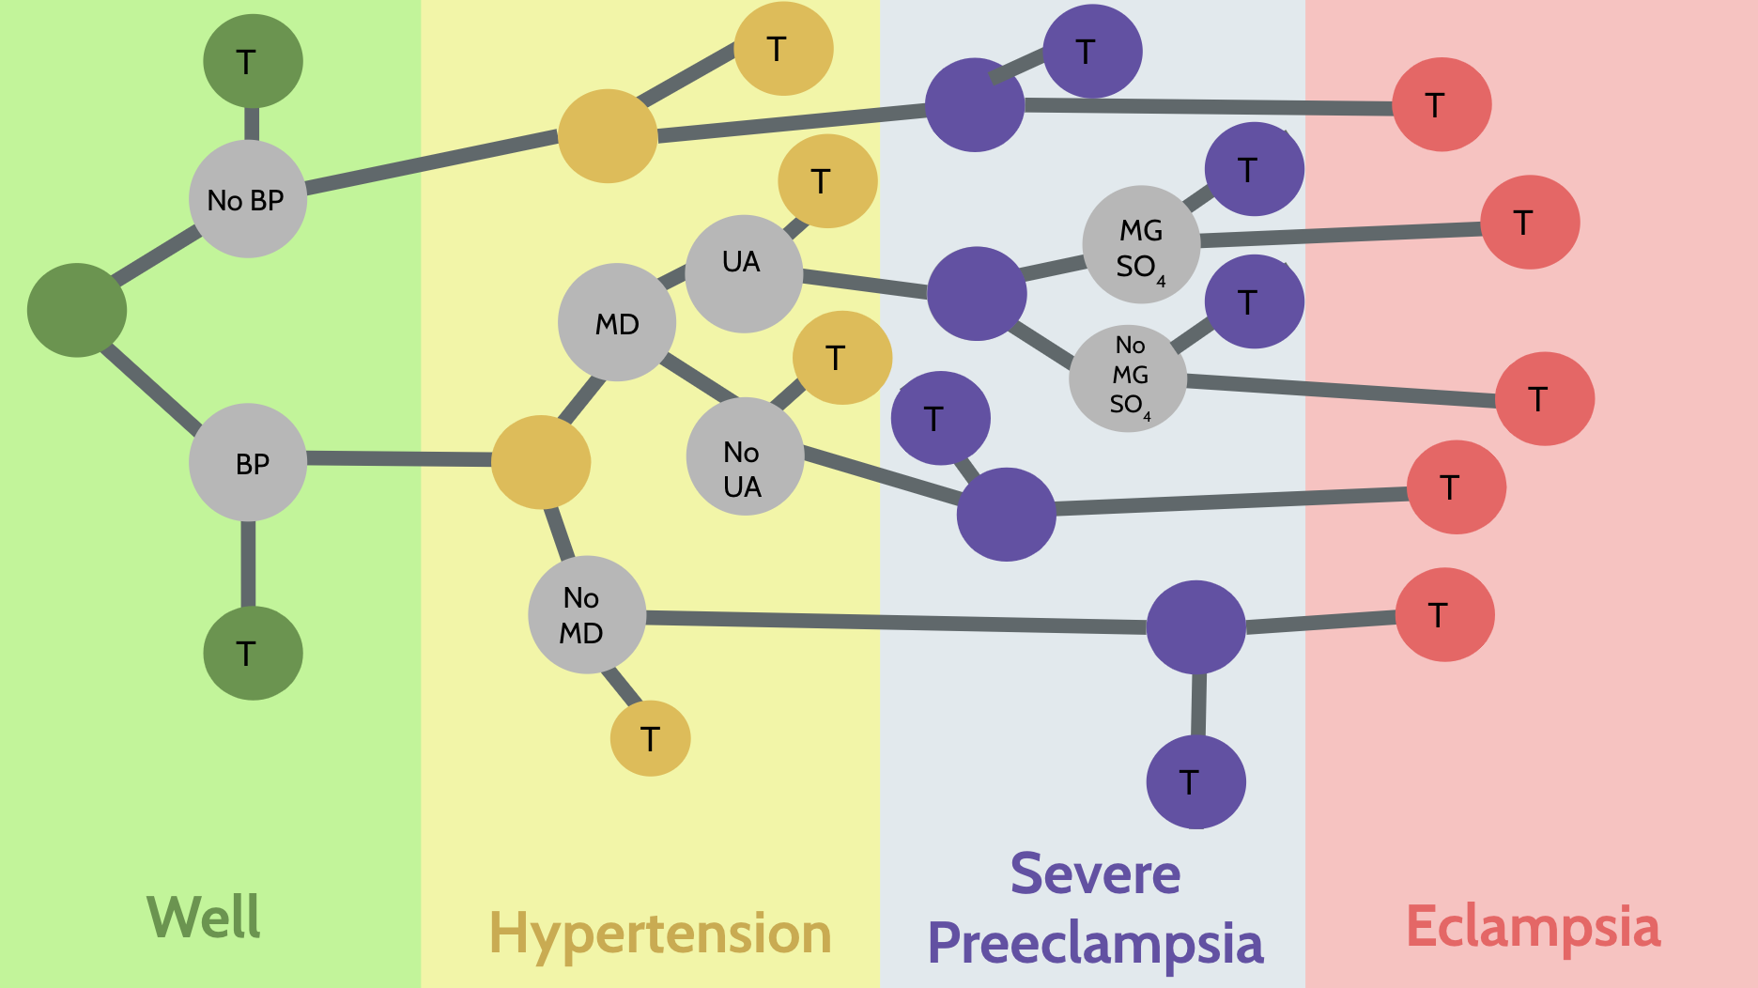

**Figure 1:** A decision tree detailing a patient’s probability of moving from Well (pregnant and well) to Eclampsia. The health states vary for different availabilities of treatment (MGSO4, MD) and different training abilities.

|  |  |  |
| --- | --- | --- |
| **Table 1: Baseline Decision Tree Probabilities** | | |
| **Transition** | **Probability** | **Source** |
| Likelihood of Well to HTN untreated | 0.1 | Sibai, 2004 |
| Likelihood of HTN to Severe PE untreated | 0.34 | (Douglas, 1994) |
| Risk Reduction of Methyldopa | .5 | (Stocks, 2014) |
| Likelihood of Severe PE to Eclampsia untreated | 0.02 | (Cifford, 2000) |
| Likelihood of Severe PE to Eclampsia treated with MgSO4 | 0.006 | (Long et al, 2017) |
| Likelihood of having BP detected | 0.591 | (USAID Country Specific Information PDF, 2017) |
| Likelihood of developing HTN | 0.1 | (Ross, 2004) |
| Likelihood of receiving Methyldopa (MD) following HTN diagnosis | 0.31 | (USAID Country Specific Information PDF, 2017) |
| Likelihood of getting a urinalysis following MD treatment | 0.223 | (Gifford, 2000) |
| Likelihood of getting MgSO4 following urinalysis | 0.20 | (Ugwu et al, 2011) |

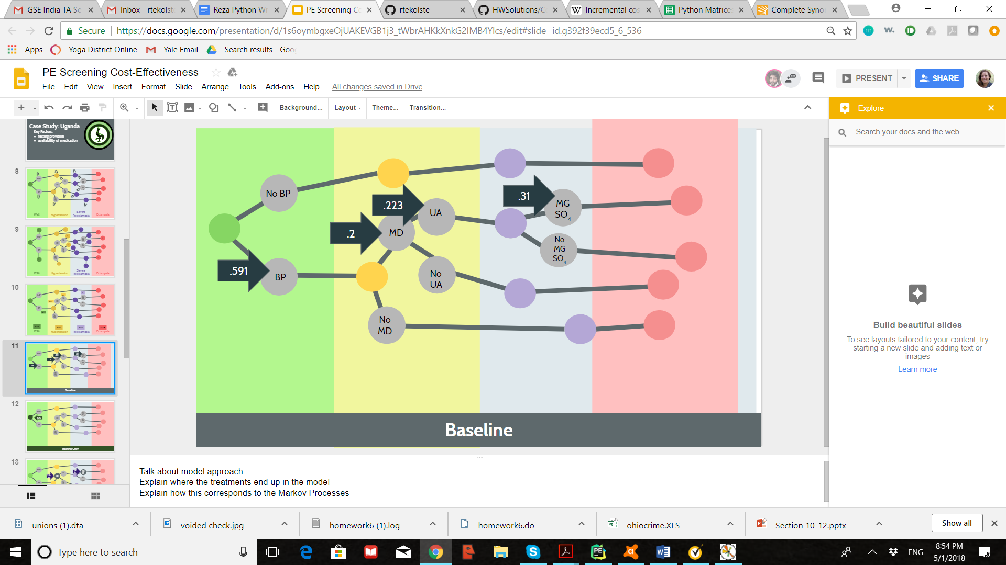

**Figure 2:** Depiction of the decision tree under the baseline scenario. End-points detail a patient’s probability of moving from Well (pregnant and well) to Eclampsia. Patients move through the system which lasts through the second half of a pregnancy (20 weeks). Risk of HTN, PE, and Eclampsia become most noteworthy at the 20 week point. The health states vary for different availabilities of treatment (MGSO4, MD) and different training abilities. The embedded values in this scenario are given by the literature.

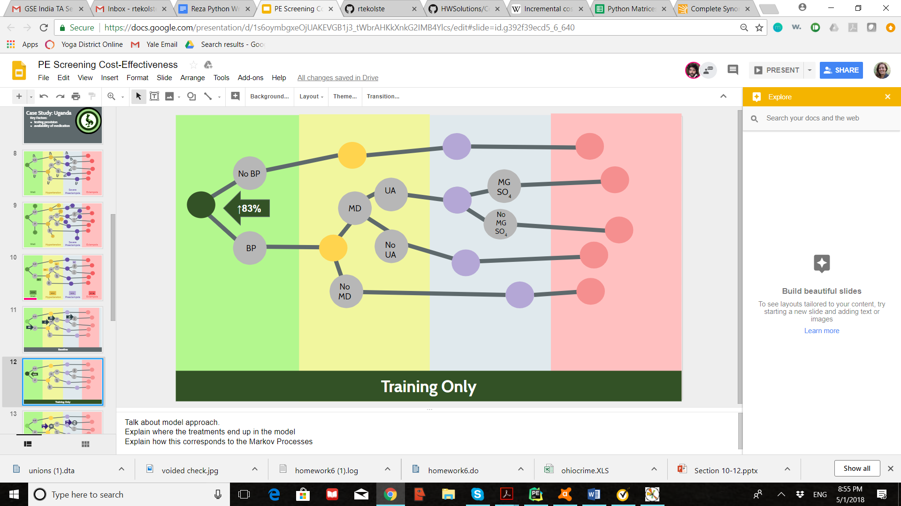

**Figure 3:** Depiction of the decision tree under the training scenario. Notable changes from baseline include increased likelihood of getting one’s blood pressure taken (1.83x the original rate). This increase is detailed by a study which suggest that adherence to medical protocols can be increased by 83% with improved training.

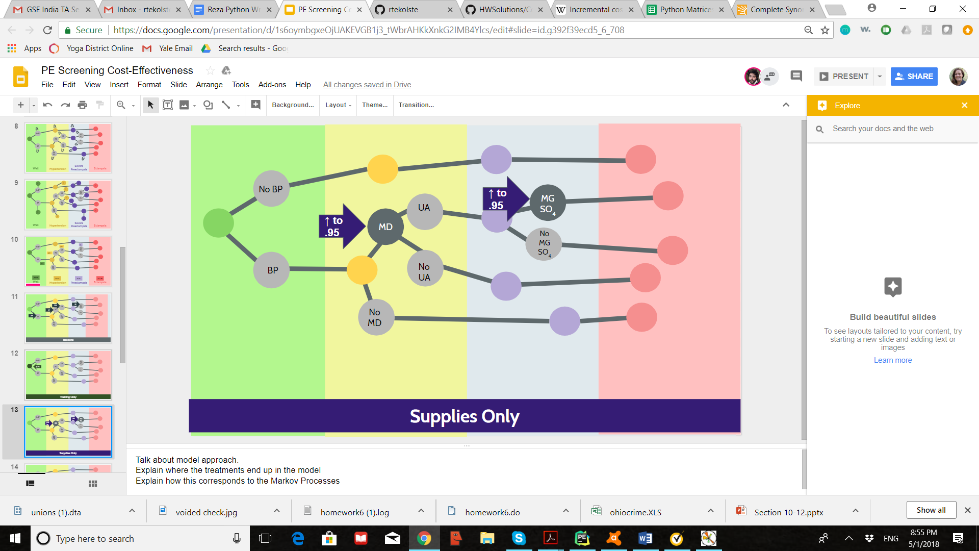

**Figure 4:** Depiction of the decision tree under the adequate supply scenario. Notable changes from baseline include increased likelihood of getting methyldopa (95%) or MgSO4 when needed (95%). We chose the amount 95% because we thought that it was unlikely that the health system could meet a 100% threshold with such a low existing rate of availability.

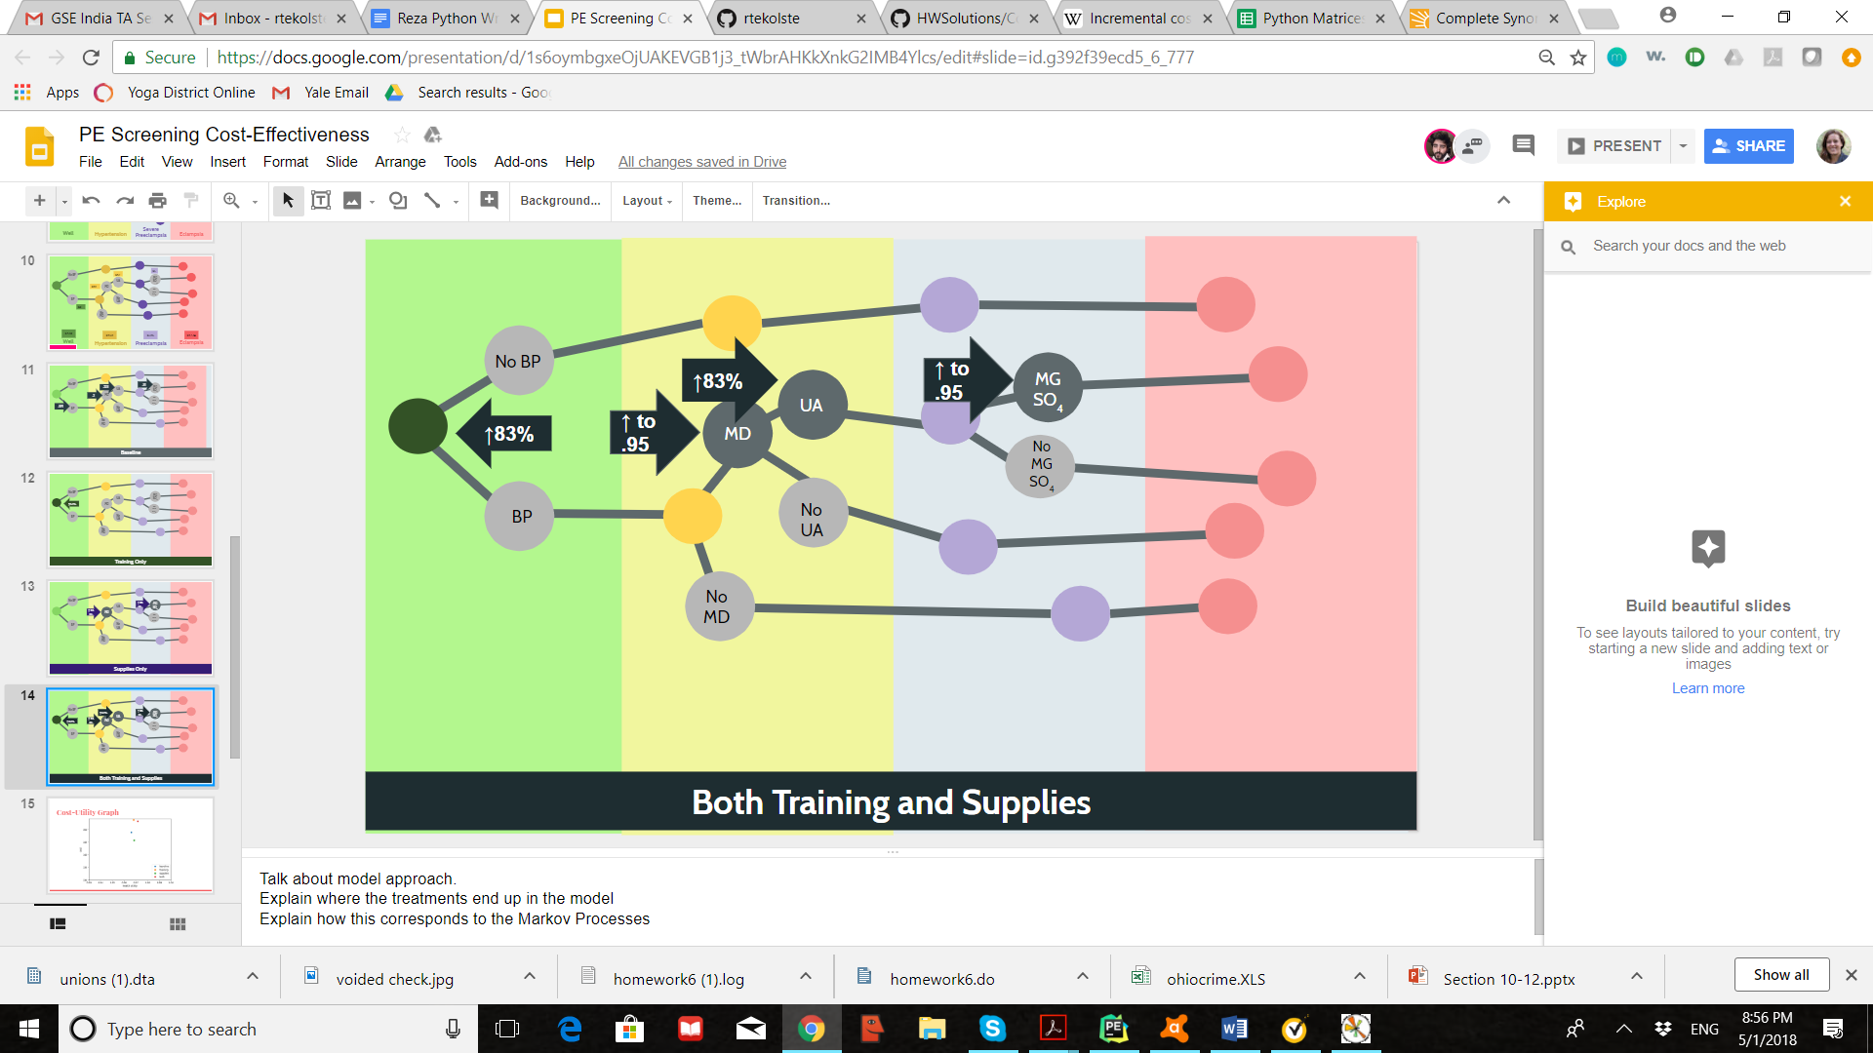

**Figure 5:** Depiction of the decision tree under the both adequate supply and training scenario. Notable changes from baseline include increased likelihood of getting one’s blood pressure taken (83% increase) and probability of receiving a urinalysis (83% increase). Notable treatment changes associated with better supplies from baseline include increased likelihood of getting methyldopa (95%) or MgSO4 when needed (95%).

|  |  |  |
| --- | --- | --- |
| **Table 2: Treatment Prices** | | |
| **Drug** | **Cost** | **Source** |
| Taking Blood Pressure | $0 | N/A |
| Methyldopa | $18.00 ($4.50/per prescription x4 times over pregnancy or as needed) | WHO’s International Drug Price Indicator Guide. |
| MgSO4 | $13.00 (as needed) | WHO’s International Drug Price Indicator Guide. |
| Urinalysis | $12.00 ($3.00/per x4 times over pregnancy or as needed) | WHO’s International Drug Price Indicator Guide. |
| Cost of Training | $8.00 per patient | (Gaziano et al, 2008) |

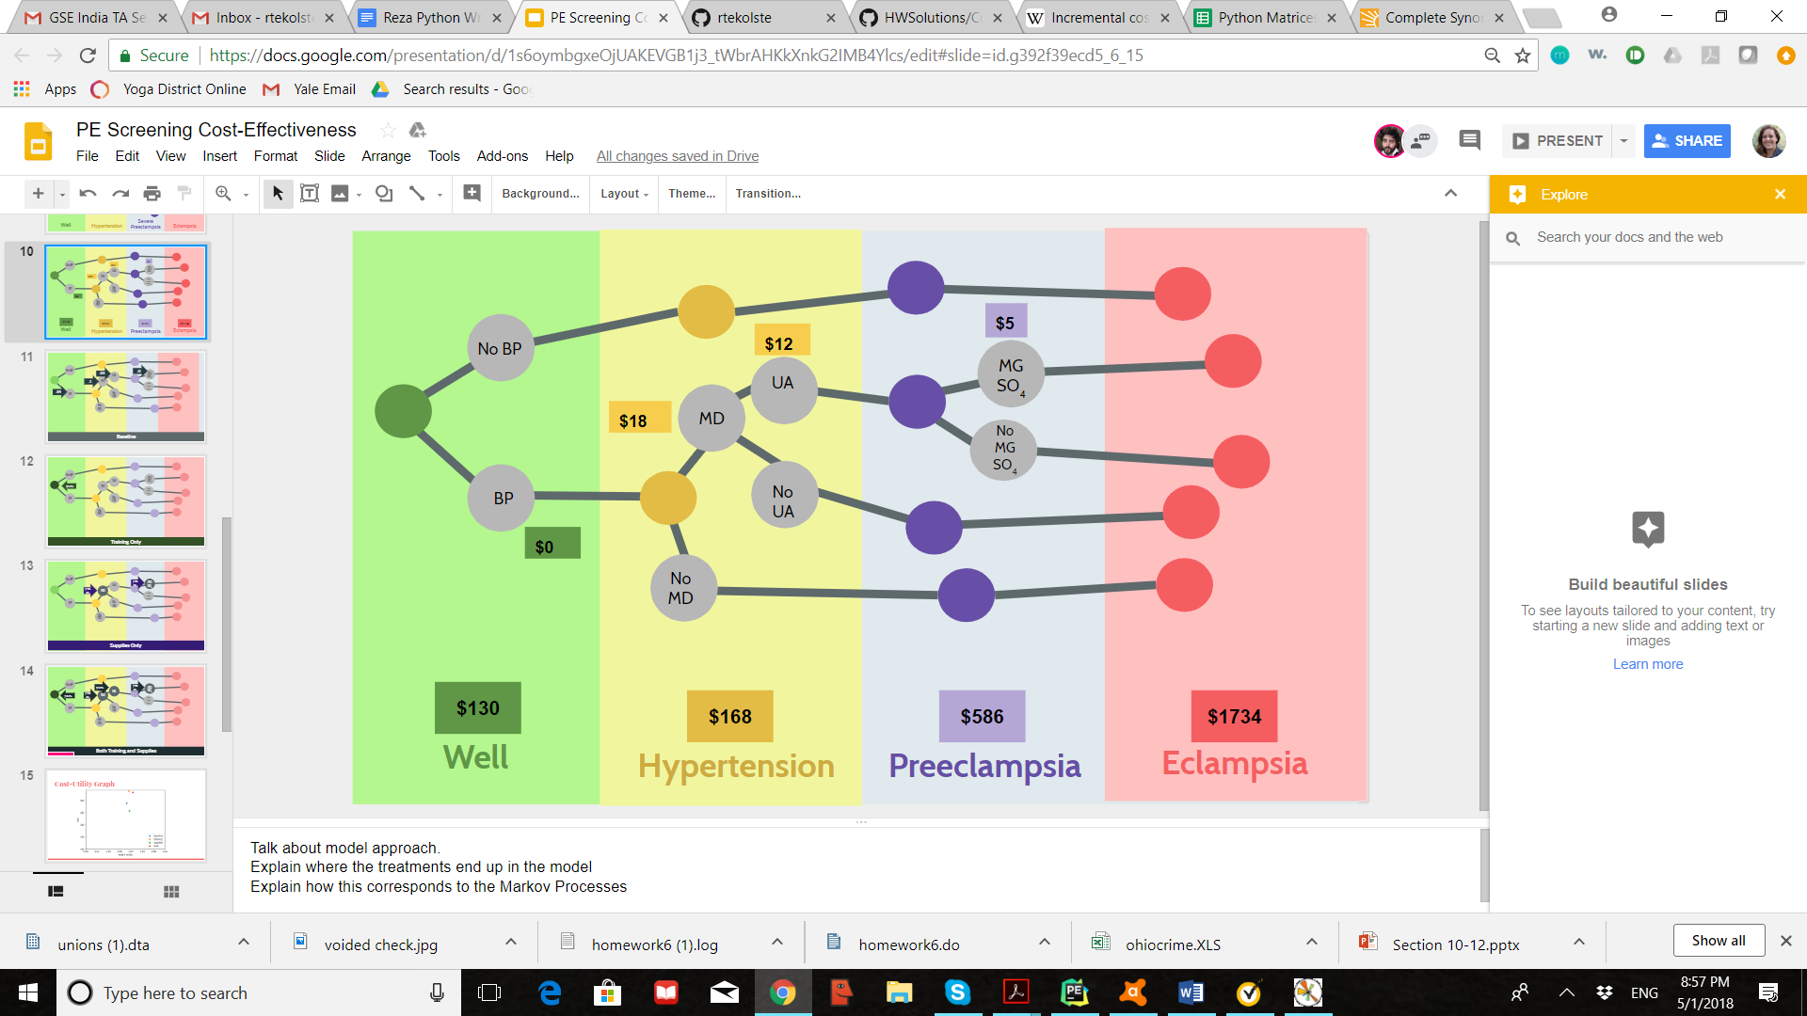

**Figure 6:** Depiction of the treatment costs within the integrated model. Inputs were derived from drug prices in Table 3. The probability of incurring these costs would change if the probabilities of the progression of the disease changed. The treatment cost of additional training was added by entering a decision node which has increased training included.

|  |  |
| --- | --- |
| **Table 3: State Health Utilities** | |
| **Health State** | **Utility**  (Lubetkin and Gold, 2003; (Kahn et al, 2007)) |
| **Well** | 1.0 |
| **Hypertension (HTN)** | 0.78 |
| **Severe Preeclampsia (Severe PE)** | 0.4 |
| **Eclampsia (EC)** | 0.1 |

|  |  |
| --- | --- |
| **Table 4: Cost Burdens** | |
| **Health State** | **Utility** |
| **Pregnancy** | $130 USD |
| **Pregnancy+Hypertension (HTN)** | $130+ $38 = $168 USD  (Lawes et al, 2008) |
| **Pregnancy+Severe Preeclampsia (Severe PE)** | $130 + $456 = $586 USD  (Simon et al, 2006) |
| **Pregnancy+Eclampsia (EC)** | $130 + $1604 = $1734 USD  (Blackwell et al, 2001) |

|  |  |  |  |  |  |
| --- | --- | --- | --- | --- | --- |
| **Table 5: Costs and Utilities of Treatment Models** | | | | | |
| **Sensitivity Scenario** | **Decision Tree Branch** | **Cost** | **Utility** | **ICER - Baseline** | **ICER - Supplies Only** |
| **10% HTN** | **Baseline** | 148.86 | 0.96608 | - | - |
| **10% HTN** | **Training Only** | 153.82 | 0.96808 | 2480 | -16598.36066 |
| **10% HTN** | **Supplies Only** | 145.72 | 0.968568 | -1262.057878 | - |
| **10% HTN** | **Supplies + Training** | 153.27 | 0.97164 | 793.1654676 | 2457.682292 |
|  |  |  |  |  |  |
| 18%HTN | **Baseline** | 163.95 | 0.93894 | - | - |
| 18%HTN | **Training Only** | 166.47 | 0.94255 | 698.0609418 | -9390.804598 |
| 18%HTN | **Supplies Only** | 158.3 | 0.94342 | -1261.160714 | - |
| 18%HTN | **Supplies + Training** | 165.49 | 0.94896 | 153.6926148 | 1297.833935 |
|  |  |  |  |  |  |
| 4% HTN | **Baseline** | 137.54 | 0.98643 | - | - |
| 4% HTN | **Training Only** | 144.33 | 0.98723 | 8487.5 | -40200 |
| 4% HTN | **Supplies Only** | 136.29 | 0.98743 | -1250 | - |
| 4% HTN | **Supplies + Training** | 144.11 | 0.98866 | 2946.188341 | 6357.723577 |

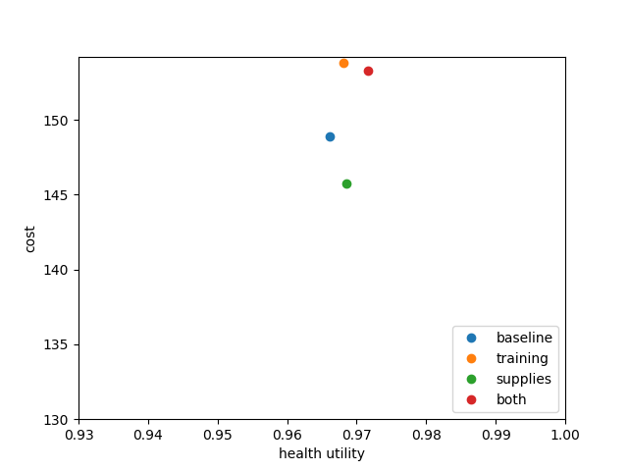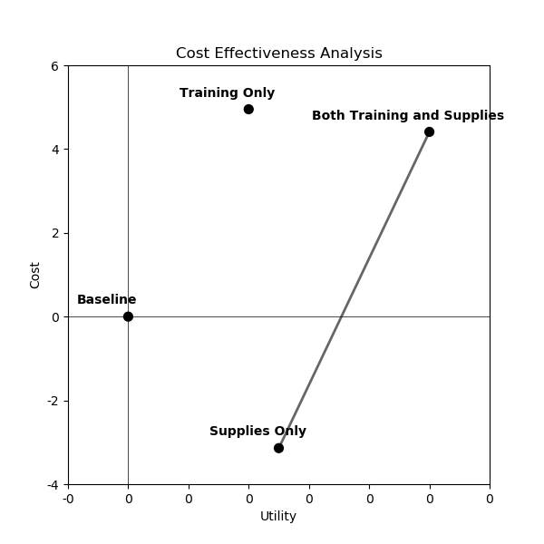

**Figures 7 & 8:** A Cost-Utility graph (left) is provided for the four different treatments with the original 10% incidence rate of hypertension. This indicates that the lowest cost option is the supplies option but the one that leads to the highest utility is the both training and supply treatment. A cost effectiveness analysis (CEA) shows that the frontier for the model under the original 10% hypertension rate has the highest cost-effectiveness ratio with the following two scenarios Supplies Only and Both Training and Supplies. These two options dominate the Baseline and Training Only options.

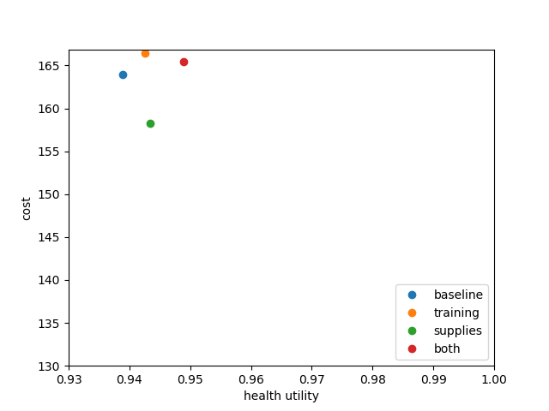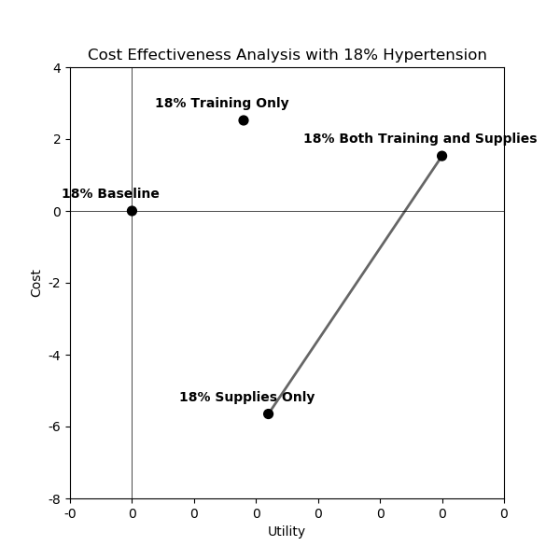

**Figures 9 & 10:** A Cost-Utility graph is provided for the four different treatments with the first one-way sensitivity analysis with 18% incidence rate of hypertension. This indicates that in this scenario as well, the lowest cost option is the supplies option but the one that leads to the highest utility is the both training and supplies. The utility gap between the different branches is much higher in this scenario. On the right, the CEA frontier shows the same options for this sensitivity analysis scenario, indicating that supplies only is the best option for price-sensitive health systems and both training and supplies provides the optimal utility.

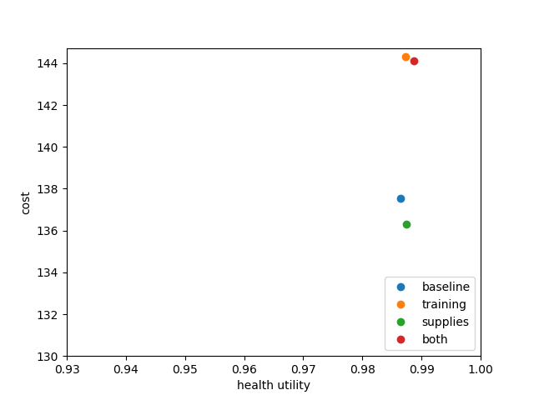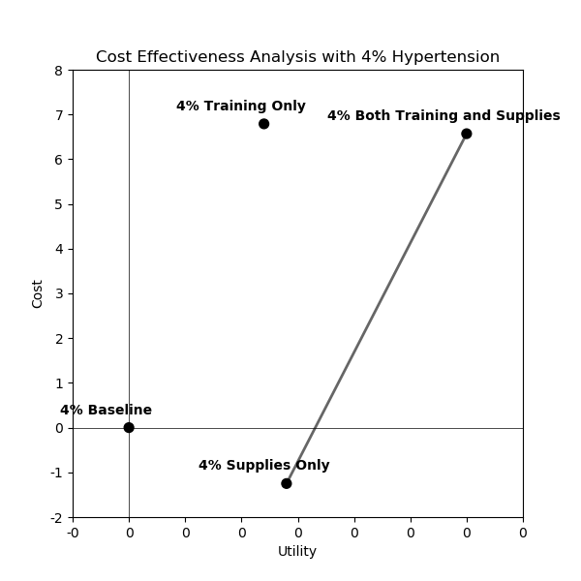

**Figures 11 & 12:** In the final one-way sensitivity analysis, we explored the same health system options but with only a 4% incidence rate of hypertension. In this scenario, the same options dominated the model (better supplies and better training and supplies) but the difference in utility was much smaller.

**Works Cited**

Arulkumaran, N., and L. Lightstone. "Severe pre-eclampsia and hypertensive crises." *Best Practice & Research Clinical Obstetrics & Gynaecology* 27.6 (2013): 877-884.

Blackwell, S. C., et al. "The use of magnesium sulfate to prevent seizures in the pre-eclamptic gravida: a cost-effectiveness analysis." *Prenatal and Neonatal Medicine* 6.5 (2001): 310-317.

Boomsma, C. M., et al. "A meta-analysis of pregnancy outcomes in women with polycystic ovary syndrome." *Human reproduction update* 12.6 (2006): 673-683.

Bossert, Thomas J., and Joel C. Beauvais. "Decentralization of health systems in Ghana, Zambia, Uganda and the Philippines: a comparative analysis of decision space." *Health policy and planning* 17.1 (2002): 14-31.

Briggs, Gerald G., Roger K. Freeman, and Sumner J. Yaffe. *Drugs in pregnancy and lactation: a reference guide to fetal and neonatal risk*. Lippincott Williams & Wilkins, 2012.

Chow, Clara K., et al. "Prevalence, awareness, treatment, and control of hypertension in rural and urban communities in high-, middle-, and low-income countries." *Jama* 310.9 (2013): 959-968.

Douglas KA, Redman CWG. Eclampsia in the United Kingdom. BMJ. 1994;309:1395–1410.

Duley, Lelia. "The global impact of pre-eclampsia and eclampsia." *Seminars in perinatology*. Vol. 33. No. 3. Elsevier, 2009.

Firth-Cozens, Jenny. "Interventions to improve physicians’ well-being and patient care." *Social science & medicine* 52.2 (2001): 215-222.

Gaziano, Thomas A. "Economic burden and the cost-effectiveness of treatment of cardiovascular diseases in Africa." *Heart* 94.2 (2008): 140-144.

Gifford, R. W. A. P. "Report of the national high blood pressure education program working group on high blood pressure in pregnancy." *Am J Obstet Gynecol* 183 (2000): S1-S15.

Kabayambi, Joan, et al. "Living with Obstetric Fistula: Perceived Causes, Challenges and Coping Strategies among Women Attending the Fistula Clinic at Mulago Hospital, Uganda." (2014).

Kahn, Kathleen, et al. "Research into health, population and social transitions in rural South Africa: Data and methods of the Agincourt Health and Demographic Surveillance System." *Scandinavian journal of public health* 35.69_suppl (2007): 8-20.

Khan, Khalid S., et al. "WHO analysis of causes of maternal death: a systematic review." *The Lancet* 367.9516 (2006): 1066-1074.

LaMarca, Babbette D., Jeffery Gilbert, and Joey P. Granger. "Recent progress toward the understanding of the pathophysiology of hypertension during preeclampsia." *Hypertension* 51.4 (2008): 982-988.

Lawes, Carlene MM, Stephen Vander Hoorn, and Anthony Rodgers. "Global burden of blood-pressure-related disease, 2001." *The Lancet*371.9623 (2008): 1513-1518.

Long, Q., et al. "Clinical practice patterns on the use of magnesium sulphate for treatment of pre‐eclampsia and eclampsia: a multi‐country survey." *BJOG: An International Journal of Obstetrics & Gynaecology* 124.12 (2017): 1883-1890.

Lubetkin, Erica I., and Marthe R. Gold. "Areas of decrement in health-related quality of life (HRQL): comparing the SF-12, EQ-5D, and HUI 3." *Quality of Life Research* 12.8 (2003): 1059-1067.

Mah, Greg T., Aaron M. Tejani, and Vijaya M. Musini. "Methyldopa for primary hypertension." The Cochrane Library (2009).

Mashamba-Thompson, Tivani P., Benn Sartorius, and Paul K. Drain. "Point-of-care diagnostics for improving maternal health in South Africa." *Diagnostics* 6.3 (2016): 31.

McFayden, Julie E. *WHO* *International drug price indicator guide*. Management Sciences for Health, Drug Management Program, 2002.

Nabatanzi, Violet. “Health facilities lack drugs to manage preeclampsia“ *New Vision- Uganda’s Leading Daily.* <https://www.newvision.co.ug/new_vision/news/1473848/health-facilities-lack-drugs-manage-preeclampsia-study>*.* Accessed April 18, 2018. (2018).

Ninsiima, Lynn. "Overview of dosimetry methods used in medical exposure." (2016).

Oguntunde, Olugbenga, et al. "Factors influencing the use of magnesium sulphate in pre-eclampsia/eclampsia management in health facilities in Northern Nigeria: a mixed methods study." *BMC pregnancy and childbirth* 15.1 (2015): 130.

Okong, Pius, et al. "Audit of severe maternal morbidity in Uganda–implications for quality of obstetric care." *Acta obstetricia et gynecologica Scandinavica* 85.7 (2006): 797-804.

Pennington, Kathleen A., et al. "Preeclampsia: multiple approaches for a multifactorial disease." *Disease models & mechanisms* 5.1 (2012): 9-18.

Ramos, José Geraldo Lopes, Nelson Sass, and Sérgio Hofmeister Martins Costa. "Preeclampsia." *Revista Brasileira de Ginecologia e Obstetrícia* 39.9 (2017): 496-512.

Rath, Werner, and Thorsten Fischer. "The diagnosis and treatment of hypertensive disorders of pregnancy: new findings for antenatal and inpatient care." Deutsches Ärzteblatt International 106.45 (2009): 733.

Ross, Sarah, A. Walker, and Mary Joan MacLeod. "Patient compliance in hypertension: role of illness perceptions and treatment beliefs." Journal of human hypertension 18.9 (2004): 607.

Sibai, Baha, Gus Dekker, and Michael Kupferminc. "Pre-eclampsia." *The Lancet* 365.9461 (2005): 785-799.

Sibai, Baha M. "Diagnosis, controversies, and management of the syndrome of hemolysis, elevated liver enzymes, and low platelet count." *Obstetrics & Gynecology* 103.5, Part 1 (2004): 981-991.

Simon, Judit, et al. "Cost‐effectiveness of prophylactic magnesium sulphate for 9996 women with pre‐eclampsia from 33 countries: economic evaluation of the Magpie Trial." *BJOG: An International Journal of Obstetrics & Gynaecology*113.2 (2006): 144-151.

Steegers, Eric AP, et al. "Pre-eclampsia." *The Lancet* 376.9741 (2010): 631-644.

Ugwu, E. O. V., et al. "Maternal and perinatal outcome of severe pre-eclampsia in Enugu, Nigeria after introduction of Magnesium sulfate." *Nigerian journal of clinical practice* 14.4 (2011): 418-421).

Vlassoff, Michael, et al. "Estimates of health care system costs of unsafe abortion in Africa and Latin America." *International perspectives on sexual and reproductive health* (2009): 114-121.

Waiswa, Peter, et al. "Poor newborn care practices-a population based survey in eastern Uganda." *BMC pregnancy and childbirth* 10.1 (2010): 9.

Williams, Bryan, et al. "Guidelines for management of hypertension: report of the fourth working party of the British Hypertension Society, 2004—BHS IV." *Journal of human hypertension* 18.3 (2004): 139.

“Country Specific Information (CSI): Karamoja, Uganda U.S. Agency for International Development Office of Food for Peace Fiscal Year of 2017.” <https://www.usaid.gov/sites/default/files/documents/1866/Karamoja_CSI_final_edited_4.10.17.pdf> Accessed April 21, 2018. (2017).