Command to run : **python index.py**.

Used pymysql for database.

IDE used phpmyadmin.

Name of files :

1. Index.py
2. Templates / Home .html
3. Static / Inventory.js

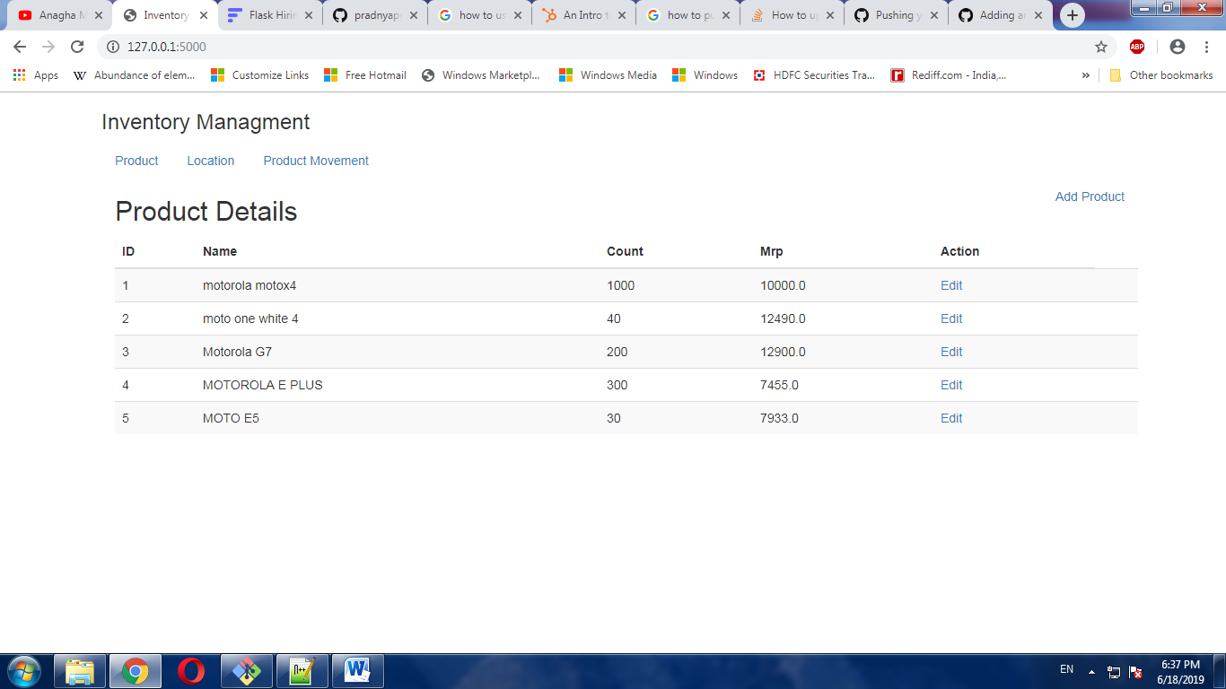

Fig : This Page shows the details of the Product.

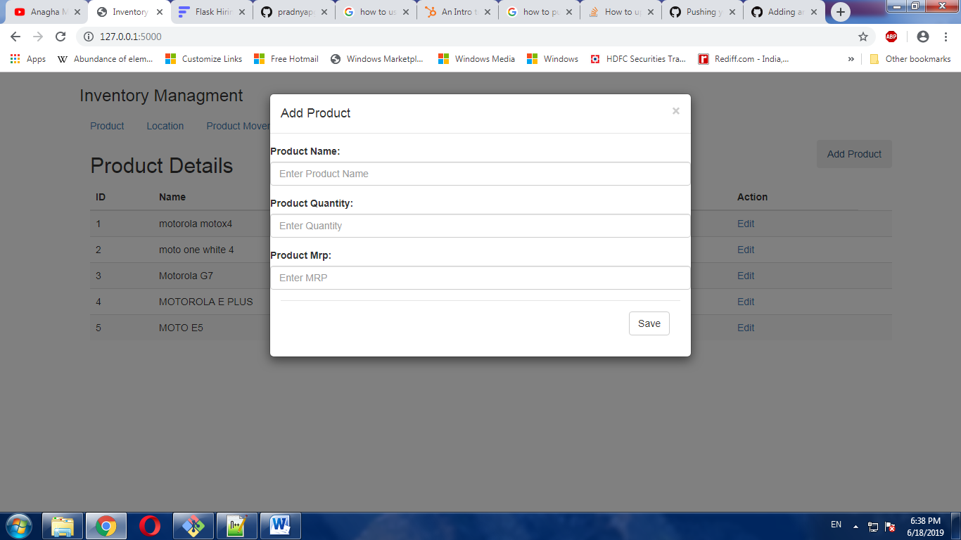

Fig : Here we can add new Product.

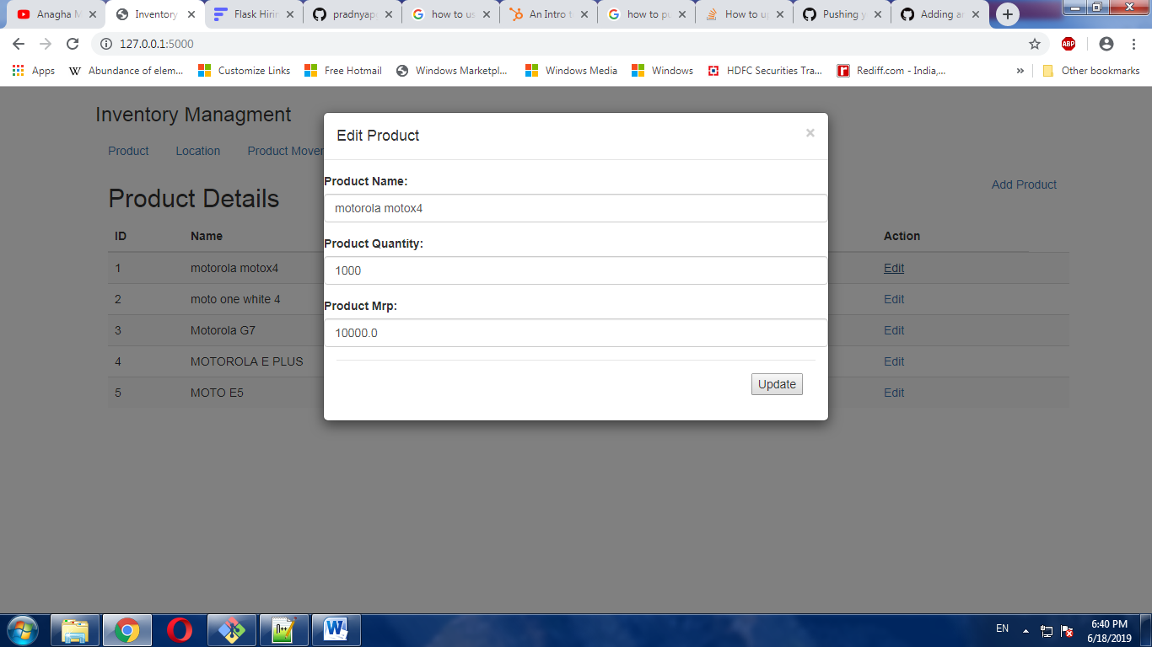

Fig: Edit Page for the Product.

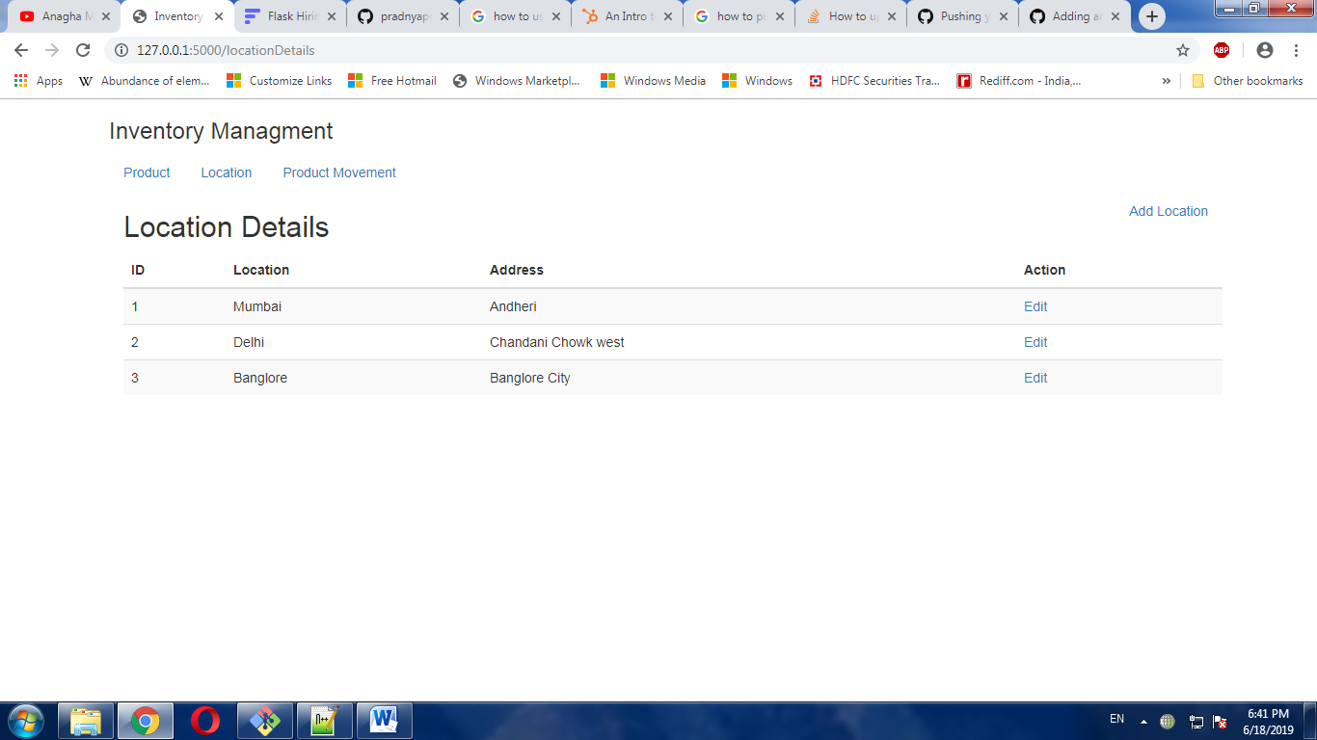

Fig: This Page shows Location Details.

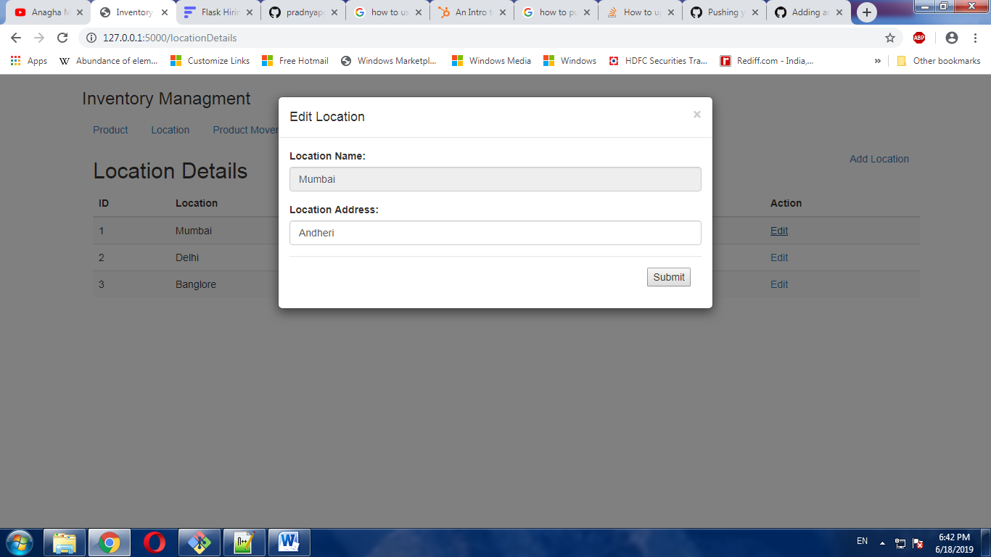

Fig: Shows editing page for location.

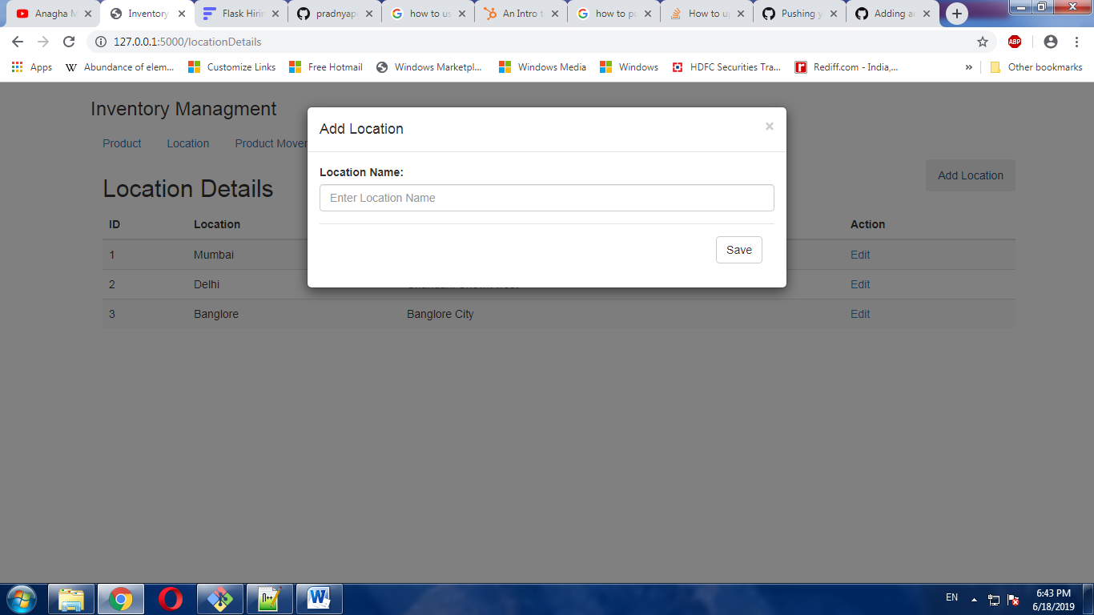

Fig: Add Location Page to add new location.

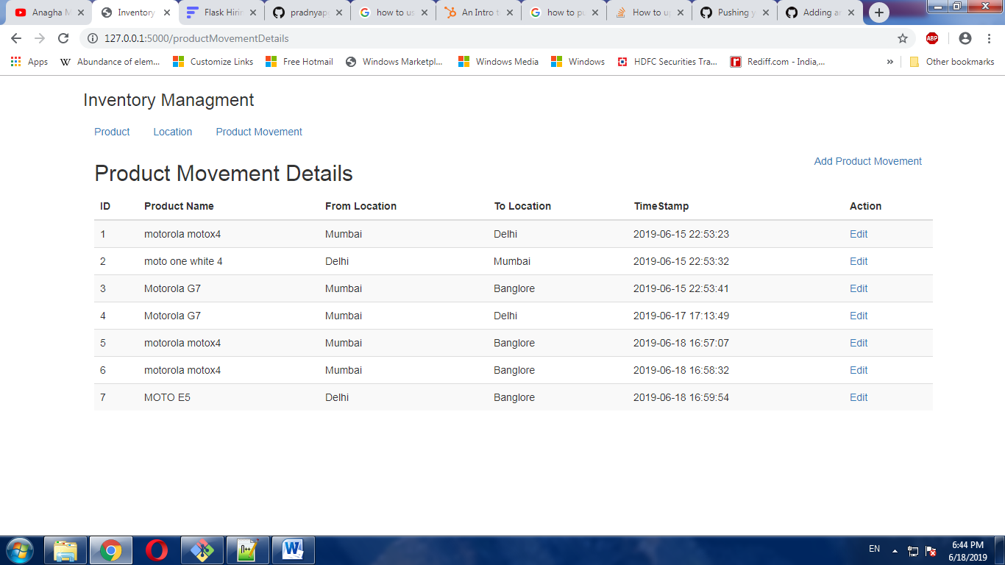

Fig: Showing product movement Details page.

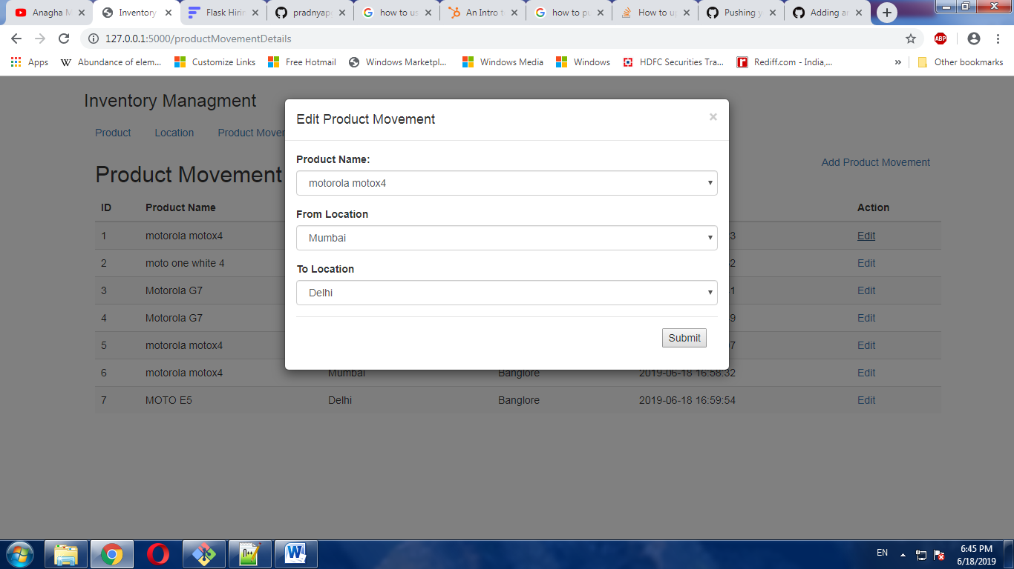

Fig : Showing the edit product movement from location one to another.

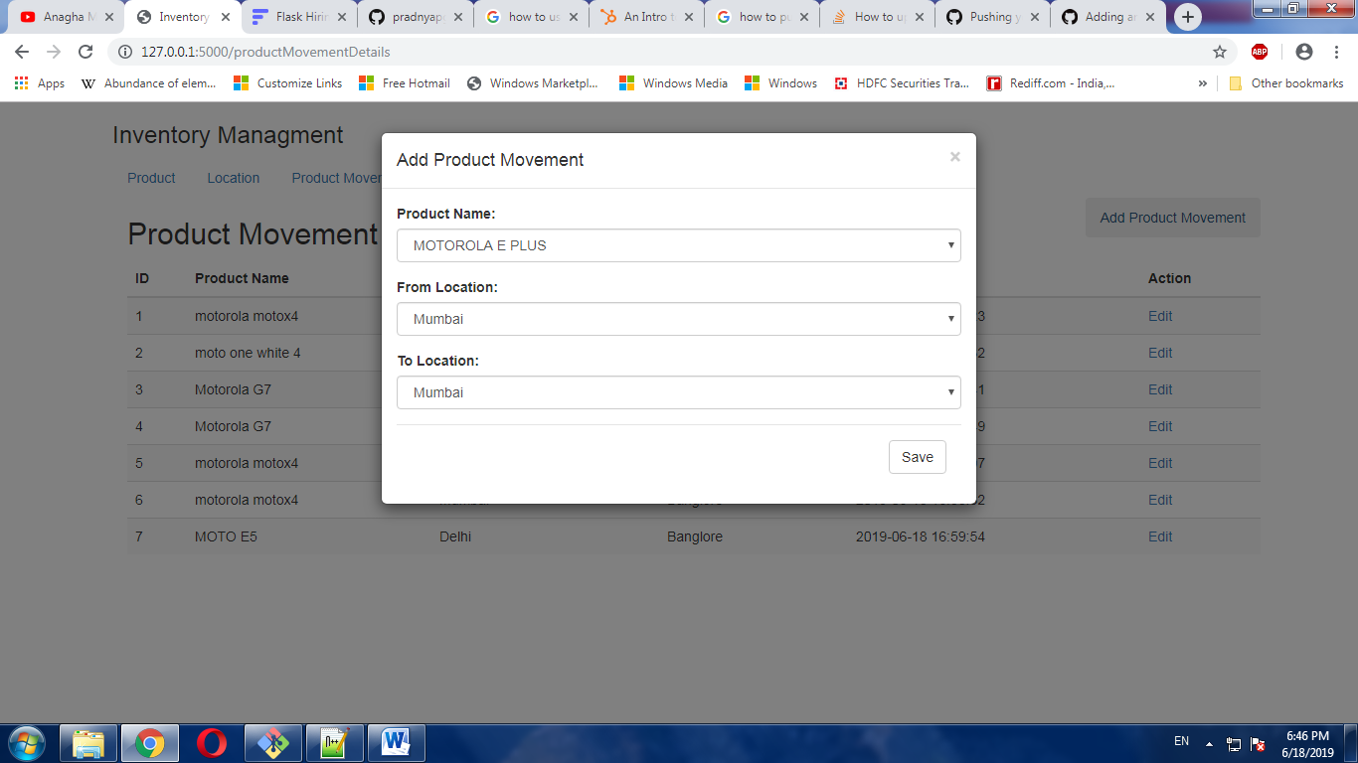

Fig : Adding new product movement page .