Q1. if the parent div has 100px width and height and the child div has 200px. From what position the child div will start and also if it’s come outside the box or will be inside?

Ans: The initial position of start would be (0,0) if we don’t define max-width and max-height. It will go outside from that box.

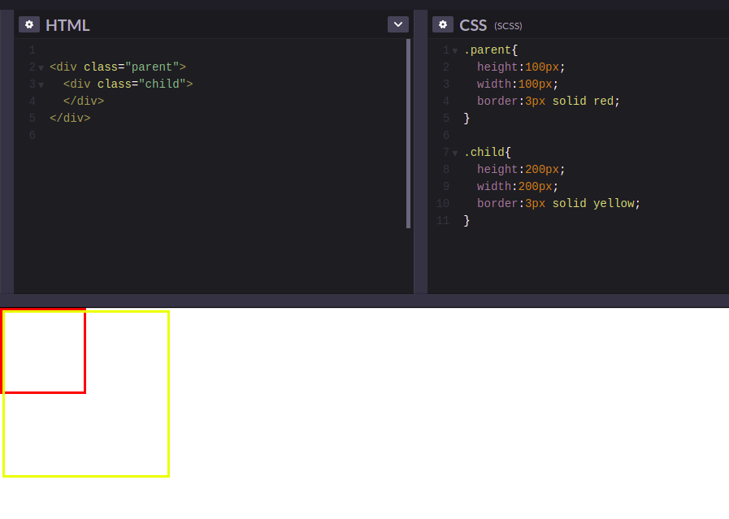

**Q2. In Parent div align Child div Center methods :-**

**First method using Flex:-**

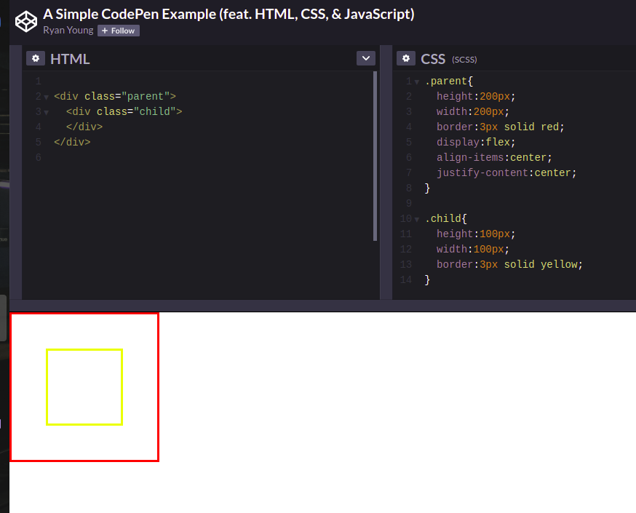

**Sub Part of Flex using margin:-**

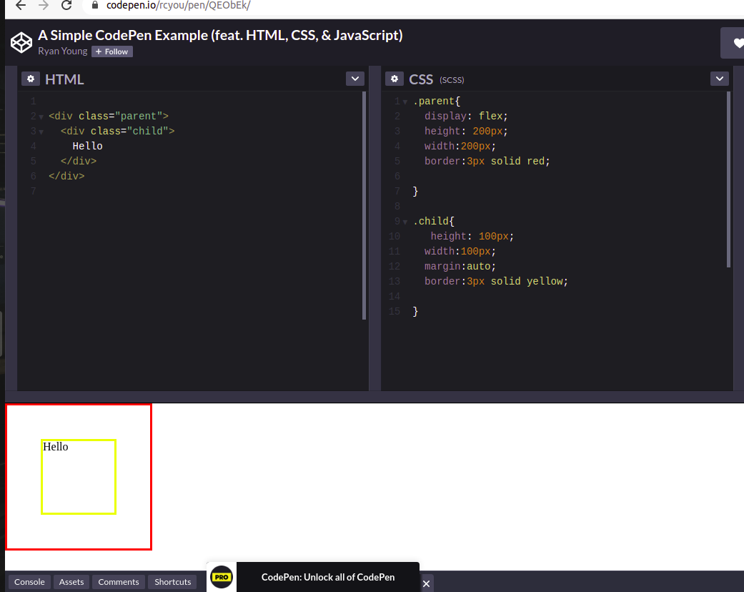

**Second Method using Position:-**

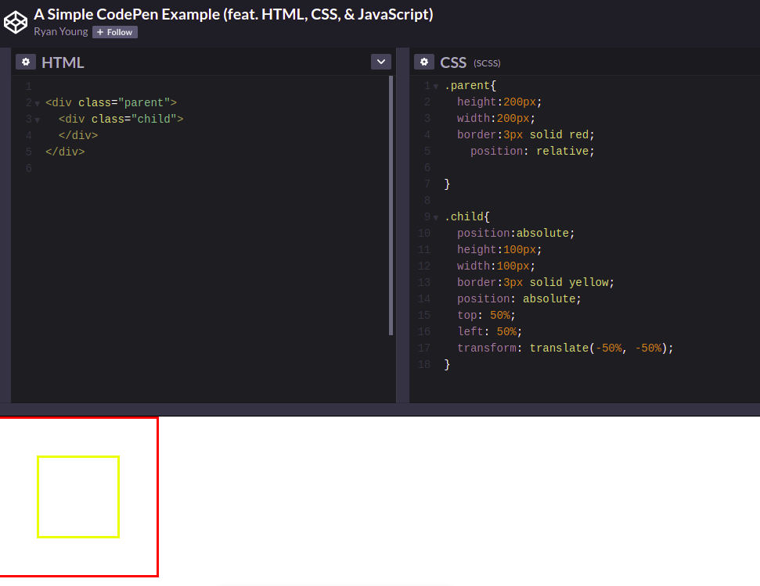

**Third method using Grid:-**

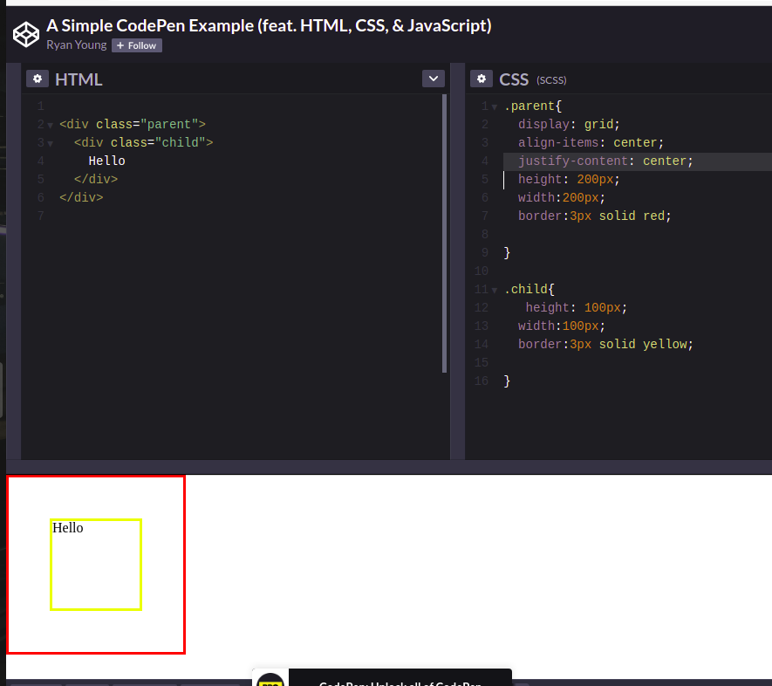

**Sub Part of grid using margin:-**

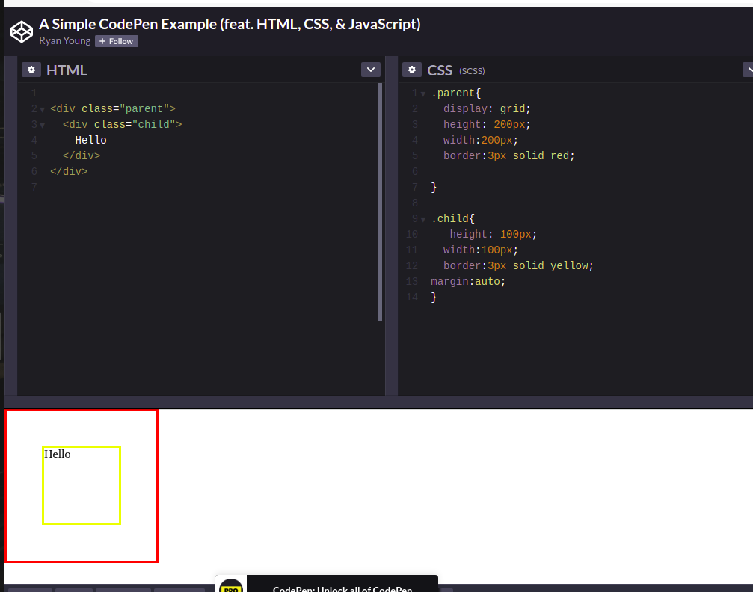

**Text align center using table and table-cell:-**

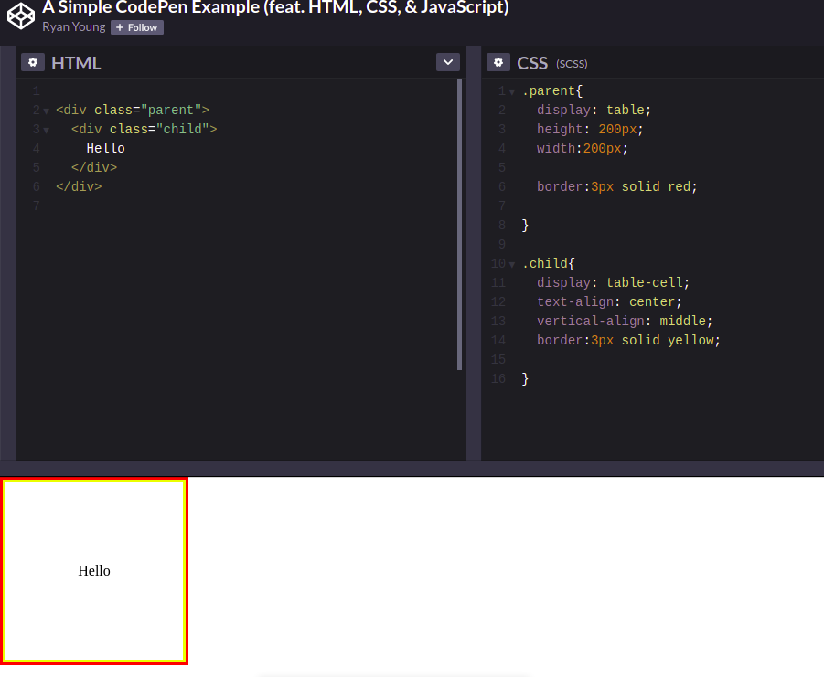

**BOX-SIZING :**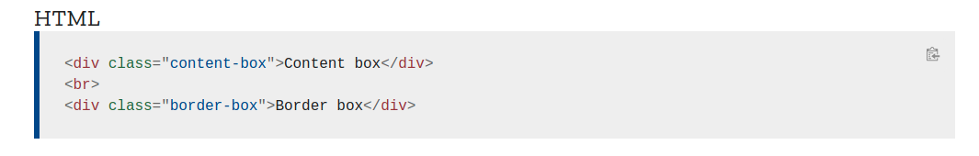

**CSS**

