*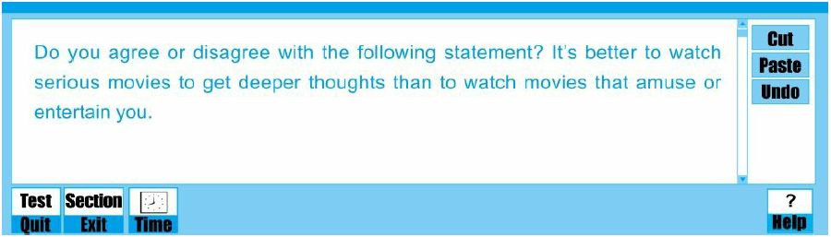*

*Films have witnessed unprecedented boom in recent years, and watching movies has always been one of the hottest topics in individuals’ daily life. Among these popular film productions, serious movies and entertainment movies are most influential. When youngsters consult parents which movie should they watch, parents always get in a dilemma, without a reasonable suggestion. There may be one or two advantages made by entertaining movies; however, I believe serious movies have far more advantages, truly benefiting the childhood.*

*To begin with, some minor advantages of entertaining movies include that funning movies is certainly an excellent way of relief, especially after children complete lots of coursework. Watching entertaining films puts kids in a pleasant environment, and forget the huge burden coming from huge daily work or peer competition. However, addiction to funning movies may lure children away from lessons. To free children’s mental stress in a positive way, doing some physical exercise is also recommendable, such as playing basketball, badminton and so on.*

*Even though there may be one or two advantages of entertaining movies, the advantages of serious movies far outweigh them. Contents in serious films can well educate and positively guide children in their growing path. In serious films, a majority of contents focus on the real life of low social class, which describes their spirit of never giving up and optimistic attitude in fighting with difficulties. On growing path, children are likely to encounter trouble. Some excellent serious movies could be the lifelong instructor and bring kids powerful mental power. For example, the movie The Pursuit of Happiness, nomination of Oscar Award, describes the struggling life of an African American man, Will Smith, who was at a bottom of his life with a little kid to nourish, his wife left, and negligible income. Once I feel powerless to fight with hardship, the movie and Will Smith will provide with the encouragement and boost my motivation.*

*Another advantage is that serious movies provide an excellent opportunity for children to comprehend a vast amount of knowledge and experience. A plenty of movies would record the social reality of various history periods among the whole world. For example, Gone with the wind, a most popular movie starring Clark Gable and Vivien Leigh, presents a story during the Civil War. The social realities during that period in history were vividly shown in the plots. Except for the reality, the movie The Wolf of Wall Street, teaches children lots of financial knowledge and trading techniques, which absolutely broaden the horizons.*

*Although I agree with a couple of advantages provided by entertaining movies, I believe that the merits encompassed within serious movies are more obvious. Serious movies not only convey a positive attitude towards children’s life, but also describe the social realities enriching children’s knowledge. Therefore, according to above-mentioned statements, I express my appreciation for serious movies.*