TASK 2: TOEFL INDEPENDENT WRITING TEST

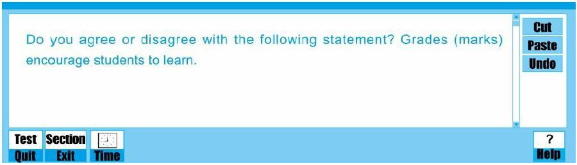

*Write at least 300 words.*

Word Count: 501

Large varieties of [Multifarious] examinations are taken by students ~~at~~ each [every] semester. Giving grades is considered as the most common [prevailing] method to evaluate the learning performance of students. Examinations [Examination] grades have always been one of the topics [broadly] discussed ~~the most~~ in students’ campus lives, because [owing to the fact that] the mark is closely related with many things including emotions and scholarship[s]. Competing for good grades will add a huge amount of pressure on some students, who think examinations should not be marked. However [Be that as it may], ~~as far as I am concerned~~, pursuing high grades is indeed an essential stimulus [catalyst] for students to concentrate [focus] on their textbooks. It is admitted that marks really encourage students to learn, but their performance should not be vastly exaggerated.

To begin with, giving grades urges students to study hard to obtain satisfactory ~~examination~~ marks. Most students want to achieve the top score in tests, and no one wishes to fall behind. Thus [On that account], once ~~the~~ ~~grades~~ [academic] competition starts among these classmates [schoolmates], their study efficiency will increase [be enhanced] and the academic performance will be on the upgrade. Those who have already won will make greater efforts to hold on to their superior position in examinations, whereas those who lost in the previous competitions will pay more attention to study [double their efforts] to erase past mistakes and continue the fight [struggle] for ~~the~~ higher scores next time. For instance [To demonstrate], my best friend Jason is a good student and always gets perfect marks [scores] in different tests. To safeguard his superior position in the grade system, he has to exert himself tirelessly on the study [more effort in studying]. As soon as he starts to stack off, other classmates will surpass him. The pursuit of good grades encourages him to learn.

In addition [What is more], grades can help reveal students’ shortcomings in studies. When a new round of assessments is completed and final grades are announced, students will have the opportunity to discover the weakness of the knowledge hierarchy [hierarchy of his weaknesses] on some [different] subjects, according to the loss of marks. They may go all out to find the reasons for these losses. After reviewing test papers, it is natural for them to notice what has been neglected previously and obtain an objective attitude on their studying [in studying]. From then on, their attention might be focused on these drawbacks, and in the following examinations, they are likely to overcome these shortcomings and achieve better grades.

Nevertheless, the exam grade will certainly increase students’ ~~some~~ mental and body [bodily] pressure, because part of them [in some of the exams][,] [they] may not achieve satisfactory scores. Once getting low scores, students will lose confidence in themselves and even be harshly scolded by their parents and teachers. Apart from additional mental pressure, to achieve perfect marks, some students may sacrifice their physical exercise [workout] time to complete coursework, which may in turn cause young students some ill health. Thus [Accordingly], in view of these side effect[s] [that] resulted from examination grades [scores], the advantages of giving grades should not be excessively exaggerated. [THIS IS A REPETITIVE IDEA, AS YOU HAVE ALREADY MENTIONED IT.]

All in all, although grades have minor disadvantage on students’ study [studying], grades bring [render] students more benefits, including hard [effective] learning and revealing [discovering] shortcomings in [their] studies.

**SCORE INDEX:**

|  |  |  |
| --- | --- | --- |
| TOEFL ACADEMIC TASK 2  SCORE INDEX | | |
| **CRITERIA**  (BAND DESCRIPTORS) | **RATER’S COMMENTS** | **SCORE** |
| TASK RESPONSE  To do well in this area, you will need to be very specific in your body paragraphs as you use examples to explain your ideas. You will need to draw on your personal experience, but, if you come up empty, then you will need to be creative. Indeed, that means you will have to imagine some details that you can use to explain these ideas. | **(STRONG POINT)** Compelling arguments were presented by the candidate. He/she was able to support it with explanations, details and examples.  **(WEAK POINT)** Some parts of the essay are unclear. Some ideas are rather repetitive. | 4.5 |
| ORGANIZATION AND DEVELOPMENT  If you want to hit an ideal score, you should consider all important parts of an essay, as well as the integral parts of each paragraph | **(STRONG POINT)** There isa good organization of ideas. The arguments were developed further.  **(WEAK POINT)** Sometimes, for one argument, the explanation tends to be very long that’s why other arguments have not been covered. | 4.5 |
| UNITY, COHERENCE, AND COHESION  To further help you develop native-like writer proficiency, you must show coherence or the overall connectedness of your writing, which can be achieved by doing three things: Tell the reader what you want to say. Say it to the reader and tell the reader what you just said. | **(STRONG POINT)** There is an overall unity in the ideas. Every idea connects to another. Cohesive devices were applied.  **(WEAK POINT)** Less common transitional devices are not evident. | 4.0 |
| LANGUAGE USE  If you have consistent facility in the use of language, it will be easy for you to construct your sentences. | **(STRONG POINT)** His/her grammar displays a good range of both simple and complex sentence structures*.*  **(WEAK POINT)** There are some error with  Word choice: revealing [discovering] ; concentrate [focus]; word formation: body [bodily]; collocation: himself tirelessly on the study [more effort in studying]. ; forming the plural form: effect[s] ; weakness [weaknesses] | 4.0 |
| **SCALE SCORE: 4.25 = 4.0**  **CONVERTED SCORE: 24**  **RATING: GOOD** | | |