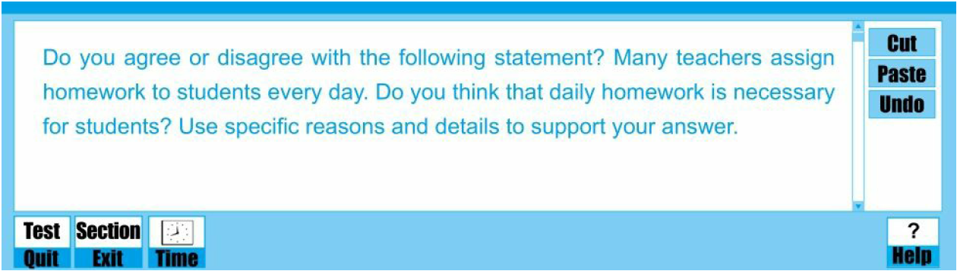

**注：采用交通信号灯颜色批注。**批注中：

黄色高亮标注的是文章的观点或者主旨句。

绿色高亮标注词汇方面做的比较好的，如逻辑词，转折词等信号词。

灰色高亮标注错误的，需要修改的内容。

蓝色为老师批改意见。

Homework is one of the most effective methods to evaluate students’ learning performance, after students complete the day’s classes. Thus, to reveal the weak points in subjects learning, varieties of related homework are assigned to students by many teachers every day. 【介绍背景引出话题】 Consequently, many students have to spend a huge amount of time on their homework after school. Some people are not in favor of the daily homework 【作业是不需要赞同的，布置作业这种行为或者做法才可以被赞同，assigning the daily homework to students】 because they deem these tasks will 【表示将来的事情，但后面的是表示事实， are likely to】demand 【用词不够准确，take】 a lot of students’ after-school time. However, from a personal viewpoint, daily homework is requisite for a majority of students. The reasons are elaborated in the following paragraphs.

【首段，引出话题；清晰表明个人观点，结构安排合理，但是一些词汇的准确用法需要进一步检查完善】

To begin with, homework helps【+can help，表示可能性，而不是所有的作业都能帮助学生进步】 the students to review what has been learned on the day’s class and prepare for the new knowledge that will be present in the following classes. In the class, lots of knowledge will be conveyed by teachers every day, and needless to say, plenty of time must be spent to digest the accumulated knowledge 【用法不当，accumulated意为累积的，有隐含的已经掌握的意思，但需要消化就意味着还没有掌握，master the new knowledge】. Students do their homework to check the mastery degree of the knowledge points 【表达中式，whether they have a good command of the new knowledge or not, 且此句与后文中的知道哪里薄弱语意重复，建议整句删去】. When a round of homework is submitted and then marked by teachers, students have the opportunity to find the weak points in their studying, based on the loss of marks. From then on, students may 【+be able to】 focus on 【+overcoming】 these weaknesses and assimilate what teachers taught better. Apart from that, preparing lessons before class is a common form of homework. With the preparation for 【+the】 following classes, students could master the new coming 【表达不当，coming new】 knowledge as soon as possible.

【本段的角度基本合理，过渡词使用恰当，段内逻辑合理；但要表达观点时注意不要绝对，客观表达观点；存在一些中式表达，注意培养语感;部分句子之间语意重复，注意之后简练表达】

In addition, a huge amount of daily homework can force 【固定搭配，+on】 students to increase their studying efficiency and their academic performance will be on the upgrade. To overcome these burden academic tasks, one way is to add engaged time, and another way is to enhance personal efficiency. Beyond doubt, the former one is infeasible due to limited after-school time. Students have no way but to become more efficient and productive. For instance, 【注意整句的逻辑关系，用长短句结合的方法能让意思表达更清楚】【+ when】 my cousin Jackson was an elementary school student and 【， he】 always did his homework while listening to music or watching television, because the primary school has little daily homework【后文已经提到后面的效率问题，此处可以不提】. Distracted by these entertainments 【本身这些娱乐方式是不会拉低效率的，为什么效率低呢，是因为被影响了，Being distracted】, his working efficiency is terrible, and he often did not complete the homework until 10.p.m. However, after he enters 【注意语言的简洁性，entering】 high school with a large amount of daily homework to do, he has to give up the previous studying style and put his heart and soul into homework. In the end, he succeeds to complete these tasks before 9.p.m.

【本段说理角度是合理的，通过反面例子来论述大量作业会促使学生提高效率； 建议同学在段落最后进行一个总结，整体结构上为总分总，这样能显得段落更加有条理性一些】

Nevertheless, daily homework will【可删，用词不当，will代表将来的事情，但花课外时间做作业是事实，应当用现在时】 certainly occupy students’ lots of after-school time. Current students may have a dozen of courses, with the diversification of subjects and the explosive growth of knowledge in recent years. Once every course has its required daily homework, students absolutely 【过于绝对，不会是所有学生，有些学生完成作业确实很快，而有些不写作业的学生也不会关心作业多不多哦，some students】 need to devote great efforts to these assignments. Even some students will 【may】 sacrifice the valuable leisure time, which should be invested in physical exercise. Lacking sufficient body exercise will 【might】 cause students some illness 【表达不当，如用法cause sb. great anxiety 引起某人非常不安，即引起。。。，但在illness这里，显然不适合‘引起疾病’，建议用cause sb. to do sth. 使某人做某事，cause students to get sick】. Thus, in view of the possible side effects resulted from daily homework, the advantages of daily homework should not be excessively exaggerated.

【简要的让步，一定程度上强化了自己的观点；需要注意客观表达，所有事情都不是绝对的】

All in all, although daily homework has some disadvantages, it brings more benefits including reviewing knowledge, 【+covering】preparing lessons for next classes and enhancing efficiency.

【尾段，简要重申观点。但不建议在尾段再进行一定让步，因为前面已经说明。建议直接重申观点，回应题目即可。本文字数538. 达到托福独立写作要求,但总体篇幅较长，请同学确认是否能在30-40分钟内完成，因为一方面同学可能会写不完，一方面由于篇幅过长导致语法及标点符号的总错误数量增加，导致更多的扣分】

|  |  |
| --- | --- |
| Words | 538 |
| Score | 3.75/24 |
| Level | Fair |

老师点评

Task Response: 整体写作内容与主题相关；但是部分表述比较绝对主观

Organization and Development: 文章整体结构清晰、完整； 总分总；段落结构清晰；段落内衔接恰当;行文推进比较合理

Progression and Coherence: 整体和表达基本连贯；段落之间衔接到位

Use of Language: 主观点表述清晰，词汇量尚可;但是有一些语法错误;有些语言表达不够到位；此外，语气上，要注意合理使用情态动词和程度副词，增强客观性；在简洁表达上还需要提高

Strength:整体结构；主观点明确；分论点角度

To Be Improved:

分论点的论证力度；语法和表达 ；点题

Suggestions for Improvement:

整体而言，同学的逻辑清晰，安排合理，用词方面问题不大。不过一些细微的语法错误建议要多留心，平时养成良好的写作习惯，预留两三分钟时间来快速过一遍语法，排查出比较明显的语法错误；语言上，要注意客观性；多用一些表示“可能”的词汇，例如may/might等词；论证内容上，具体展开和论证不足以及改进方案见批注