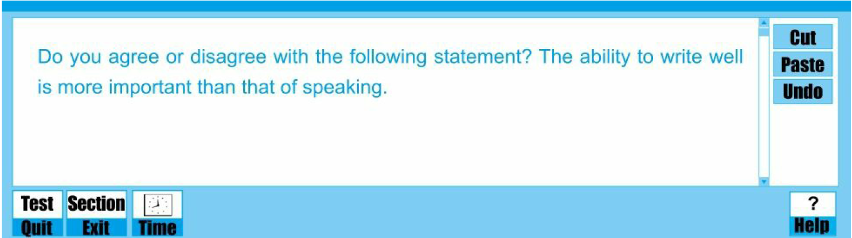

*The communication among individuals has become more frequent than ever before with the development of social media in recent years. The common communication method includes writing and speaking, and both abilities of writing and speaking are considered as the essential skill to ensure the bright future of a person in such a dense communication era. A general controversy rises up when the two are presented together. Some people attach greater importance to speaking than writing, while others hold the opposite attitude. In my view, the importance of both abilities is equally important.*

*With reference to the skill of speaking, eloquence is a most direct indication of one's outstanding talent, thus paving the way toward career success. We could trace evidence to Martin Luther King, the famous leader of human rights. His famous lecture ‘I have a dream’ was delivered to the public without a draft and deeply touched the hearts of all around the whole world, which in some extent promotes the civil rights movements in American. Apart from his outstanding speech, he is remembered as a best-known elocutionist last forever. Oprah Winfrey, the world-renowned talk show queen is another model. Her unparalleled talking skills appeal to all ages and races. Her speech possesses the ability to connect with the hearts and souls of her guests and audiences closely.*

*In addition, a competent speaker is able to communicate to others with ease. Deep understanding can be achieved and the friend relationship could be enhanced. For instance, when your friends are suffering, your warm words could comfort them and bridge the mutual distance. Moreover, profiting from excellent communication skills, you will harvest a good reputation, like a thoughtfulness and gentle man. With such public praise, many unacquainted individuals are willing to get to know and make friends with you, and consequently your social circle will be enlarged.*

*The significance of a person's writing ability should also be mentioned.* *Excellent writing skills do ensure one's academic and professional success. To illustrate, for a student, good writing ability helps them obtain high marks on the writing examination papers, which could make students get academic scholarship.* *For a graduate student, completing a satisfactory thesis means they will be granted a dream academic degree or reward. For an academic researcher, excellent writing skills ensure excellent paper published in top-level journals. For a white-collar worker, having the competence to draft articles may be an important stepping stone leading toward promotion and career success. As for professional writers, their popular works record the essences of history and might be regarded as milestones of an age.*

*All in all, there should be no prejudice against either of these two basic skills. Both speaking and writing abilities are critical to a person's overall development* *and each one deserves our ever-lasting attention.*