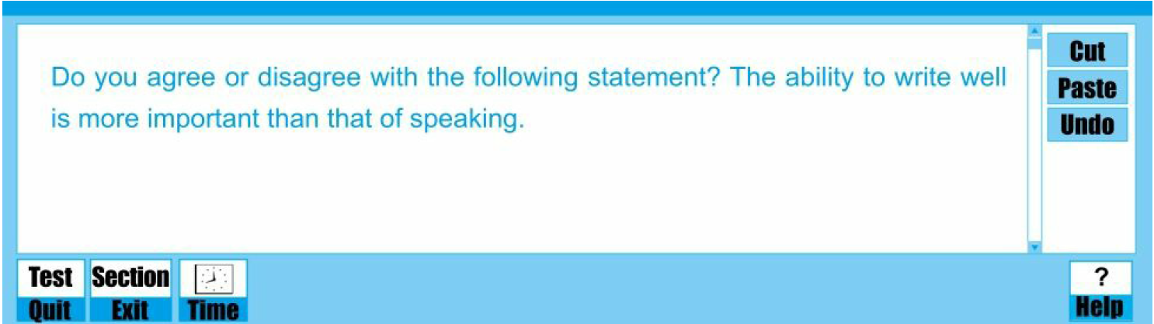

**注：采用交通信号灯颜色批注。**批注中：

黄色高亮标注的是文章的观点或者主旨句。

绿色高亮标注词汇方面做的比较好的，如逻辑词，转折词等信号词。

灰色高亮标注错误的，需要修改的内容。

蓝色为老师批改意见。

The communication among individuals has become more frequent than ever before with the development of social media in recent years. The common communication method【methods，注意单复数】 includes writing and speaking, and both abilities of writing and speaking【which，注意语言精炼性】 are considered as the essential skill【skills】 to ensure the bright future of a person in such a dense communication era. A general controversy rises up when the two are presented together. Some people attach 【+a】greater importance to speaking than writing, while others hold the opposite attitude. In my view, ~~the importance of~~【注意后文已有important，意思重复】 both abilities is 【are】equally important.

【首段引出话题，并明确表达作者立场，注意语言精炼，注意语法细节】

【+To begin with/ First/ Firstly，注意段首适当使用过渡词，体现文章逻辑】With reference to the skill of speaking, 【+the】eloquence is a most direct indication of one's outstanding talent, thus paving the way toward 【towards】career success. We【People，注意文中客观论述部分统一使用第三人称，体现客观性】 could trace evidence to Martin Luther King, the famous leader of human rights.【结合实际举例论证，很好】 His famous lecture ‘I have a dream’【“ I have a dream”，注意使用双引号】 was delivered to the public without a draft and deeply touched the hearts of 【+almost，注意适当使用程度词，体现语言客观性，避免此类过于主观绝对的表述】all around the ~~whole~~【和all around词义重复，注意语言精炼有效】 world, which in some extent promotes【promoted，注意统一时态】 the civil rights movements in American. Apart from his outstanding speech, he is remembered as a best-known elocutionist last forever. Oprah Winfrey, the world-renowned talk show queen is another model. Her unparalleled talking skills appeal to【+nearly，注意体现客观性】 all ages and races. ~~Her speech possesses the ability to connect with the hearts and souls of her guests and audiences closely.~~【和上一句句子意义重复，注意表达精炼性】【缺乏进一步展开，同学需要说明“这样出色的能力使她受观众的欢迎，因此事业非常成功”这一点来回应本段分论点“career success”】

【本段说理角度合理，结构清晰，但注意段首适当使用过渡词，说理过程要充分展开；关注语言客观性、精炼性，避免主观绝对化表述，注意标点符号的规范使用】

In addition, a competent speaker is able to communicate to others with ease【enhance the relationships with others and enlarge his or her own social circle，注意段落主题句应对本段分论点进行总体概括，注意语言简练，突出重点】. Deep understanding can be achieved and the friend relationship could be enhanced. For instance, when your【one’s，注意统一使用第三人称，同类问题已标出】 friends are suffering, your warm words could comfort them and bridge the mutual distance. Moreover, profiting from excellent communication skills, you will harvest a good reputation,【删去逗号】 like【as，应该是作为一个这样的人】 a thoughtfulness【thoughtful，注意词性】 and gentle man. With such public praise, many unacquainted individuals are willing to get to know and make friends with you, and consequently your social circle will be enlarged.

【本段说理角度很好，结构合理，且有意识地去写主题句，很好，但该段的主题句没能对本段分论点进行概括，注意高度概括的主题句能突出出行文逻辑，体现逻辑的严密性；注意统一使用第三人称，体现客观性】

【+Besides，注意句首适当使用过渡词】The significance of a person's writing ability should also be mentioned. Excellent writing skills do【could，注意体现语言客观性】 ensure one's academic and professional success. To illustrate, for a student【students，注意前后单复数一致】, good writing ability helps them obtain high marks on the writing examination papers, which could make students get academic scholarship【本句逻辑不恰当，注意奖学金并不是因为写作考试成绩好就能得到的，建议同学改为从“学生会有很多需要写作的作业，有好的写作能力能帮助他们在这一类作业中获得好成绩”这个角度进行论述，更为恰当】. ~~For a graduate student~~【graduate students】, ~~completing a satisfactory thesis means they will be granted a dream academic degree or reward.~~【有意识地对学生进行分类讨论，很好，但注意同学分的一类是“students”，一类是“graduate students”，这两者的范围是包含关系，没有必要分开进行论述，且研究生的论文也是学生的写作作业的一种，因此建议删去研究生的这一部分论述】 For an academic researcher, excellent writing skills【+would，注意体现语言客观性】 ensure【guarantee，注意上文多次使用ensure，建议替换，增强语言多样性】 excellent paper【papers】 published in top-level journals. For a white-collar worker, having the competence to draft articles may be an important stepping stone leading toward promotion【promotions】 and career success. 【逻辑跳跃，注意对白领来说，好的写作能力与升职和成功没有直接联系，而且并不是所有白领都需要做写作相关的工作，同学应该具体将人群限定为在工作中需要写作或起草文件的工作种类，如记者、文员等等】 As for professional writers, their popular works record the essences of history and might be regarded as milestones of an age.

【本段分论点切题，但需要注意的是进行分类讨论的时候要所讨论的范围不能有重叠的部分，否则就失去了分类讨论的必要性，且注意论证逻辑】

All in all, ~~there should be no prejudice against either of these two basic skills.~~【结尾段只需要正面回应题目要求，说明哪一种更重要或两种同样重要即可，注意语言精炼性】 Both speaking and writing abilities are critical to a person's overall development ~~and each one deserves our~~【people’s，注意人称】 ~~ever-lasting attention~~【注意题目只要求同学讨论重要性，正面回应题干要求即可】.

【结尾段重申作者观点，注意正面回应题干要求，语言应简练通顺，统一使用第三人称】

【462词，篇幅较长，请同学确认是否在规定时间内完成，否则请适当控制篇幅，同时虽然超出字数要求并不扣分，但超出部分的内容以及语法方面的错误仍然会被纳入评分的考察范围内，请同学注意】

|  |  |
| --- | --- |
| 字数 | 462 |
| Score | 22（3.50） |
| Level | Fair |

老师点评：

Task Response: 本文基本能够回应题目要求，但部分论述逻辑不恰当，且部分分类说理不合理，存在少量不相关的论述，具体修改建议见文中批注

Organization and Development: 文章整体结构合理，每个主体段都有主题句，但第二自然段的主题句未能完整概括该段分论点，注意优化

Unity, Progression and Coherence: 能够运用一定过渡词衔接；但段首过渡词使用较欠缺

Use of Language: 词汇量丰富，但语法、句式小错误较多，请进一步检查；存在大量主观绝对化表述；人称应统一为第三人称；部分表述不够精炼

Strength: 过渡词； 词汇量；说理角度；举例论证；文章结构和段落内部结构

To Be Improved:

加强论述逻辑；分类讨论的范围恰当；人称问题；语法检查；客观表达；表述精炼性；结尾段正面回应题目

Suggestions for Improvement:

结构和内容上，同学需要注意加强论证逻辑；注意合理分类进行讨论；结尾段直接回应题目要求即可，注意表述切题；具体改进方案见文中批注

语法和表达方面，建议养成良好的写作习惯，考试时预留2分钟进行检查，排除一些低级的错误，如单词拼写、单复数等；写作时建议关注句式的正确用法；注意表述的客观性；注意统一使用第三人称；注意语言表述精炼有效、突出重点