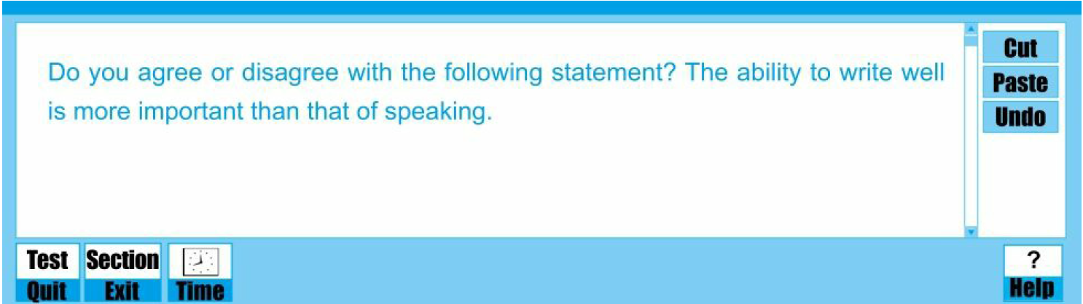

*The communication among individuals has become more frequent than ever before with the development of social media in recent years. The common communication methods includes writing and speaking, which are considered as the essential skills to ensure the bright future of a person in such a dense communication era. A general controversy rises up when the two are presented together. Some people attach a greater importance to speaking than writing, while others hold the opposite attitude. In my view, both abilities are equally important.*

*With reference to the skill of speaking, the eloquence is a most direct indication of one's outstanding talent, thus paving the way towards career success. People could trace evidence to Martin Luther King, the famous leader of human rights. His famous lecture “I have a dream” was delivered to the public without a draft and deeply touched the hearts of almost all around the world, which in some extent promoted the civil rights movements in American. Apart from his outstanding speech, he is remembered as a best-known elocutionist last forever. Oprah Winfrey, the world-renowned talk show queen is another model. Her unparalleled talking skills appeal to nearly all ages and races. By the virtue of such an excellent ability, she is popular and thus obtain a successful career.*

*In addition, a competent speaker is able to enhance the relationships with others and enlarge his or her own circle. Deep understanding can be achieved and the friend relationship could be enhanced. For instance, when one’s friends are suffering, one’s warm words could comfort them and bridge the mutual distance. Moreover, profiting from excellent communication skills, one will harvest a good reputation as a thoughtful and gentle man. With such public praise, many unacquainted individuals are willing to get to know and make friends with one, and consequently one’s social circle will be enlarged.*

*Besides, the significance of a person's writing ability should also be mentioned.* *Excellent writing skills could ensure one's academic and professional success. To illustrate, for students who may have lots of essay to complete, good writing ability helps them obtain high marks on the writing papers. With good grades, students are likely to get academic scholarships. In addition, with good writing skills, some graduate students could complete satisfactory thesis, which means they are likely to be granted a dream academic degree or reward. For academic researchers, excellent writing skills would guarantee excellent papers published in top-level journals. For journalist, having the competence to draft articles may be an important stepping stone leading toward promotions and career success. As for professional writers, their popular works record the essences of history and might be regarded as milestones of an age.*

*All in all, both speaking and writing abilities are critical to a person's overall development*.