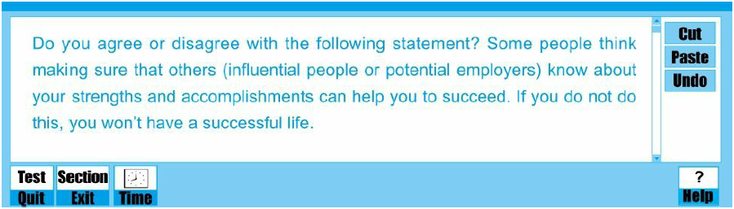

*How to have successful lives has always been one of the most concerned things in individuals’ lives. It is well-known that success depends not only on our efforts but also others. Influential persons and employers master a significant amount of tangible and intangible resources in the society. Once cooperating with these people, a person could accelerate their success on the occupational path. Thus, some individuals, who desire for satisfying lives, believe that these influential persons have considerable influence on their bright future, and want these influential people to know about their strengths and accomplishments. From a personal viewpoint, I am in favor of this behavior. The reasons are elaborated in the following paragraphs.*

*To begin with, you can get opportunities for cooperation with influential persons, if ensuring they know your achievements and advantages. As we know, successful collaboration can create enormous benefits for individuals. Prominent persons, who want cooperation, will select their partners carefully and may regard partners’ competence as significantly important because partners’ ability could guarantee the successful cooperation to a great extent. To be an influential persons’ partner, your accomplishments and strengths are indeed the best proof of your competence. For instance, Zhang Xi is a great entrepreneur who manages a high-tech company. Last year, he sought for a technical expert as his partner for an important project in his company. My father became his partner successfully, after introducing the latest patents related to the project to Zhang Xi. From then on, my father could not only transform his patents into products but also obtained a high peak on his occupational path.*

*What’s more, you can surpass other competitors and get a well-paid job, if convince potential employers of his merits and achievements. It is difficult to obtain a satisfactory job due to limited decent jobs and many competitors. When a company recruits people, to have a good offer, you must display your talent and competence in the interview. Similarly, your achievements and advantages could testify your capability and make your boss give your offer. On the contrary, if you are in your shell and hide your achievements and strength, it is difficult to gain your boss’s acceptance and trump other job seekers. To demonstrate, in the movie The Pursuit of Happiness, Will Smith could not get an opportunity of the internship, if he lacks confidence and does not introduce his strength, such as perseverance and proficiency in mathematics.*

*Nevertheless, the advantages of showing our accomplishment and benefits to others should not be excessively exaggerated. If a person manages to convince an influential figure of his merits and achievements, he is more likely to be promoted to a higher position or work on an important project. That indeed paves the way to his success. Nonetheless, suppose this person becomes overly self-contented and stops making great efforts? Then the blessed opportunity will be wasted. No matter how brilliant his past used to be and what great achievements he made, his future will not be promising.*

*All in all, ensuring others know your strength and accomplishment could bring lots of benefits, including opportunities for cooperation and a well-paid job, which accelerates your occupational success.*