

In many countries of the world, young people are usually encouraged to work or travel for a gap year between ending of high school and starting university studies.

Some young people of wealthy tend to take trips during this period, either traveling abroad or taking trips within national boundaries, both of which can broaden their horizons. Traveling abroad means satisfying their taste buds and quenching their thirsts for excitement and fun. While young people travel to domestic tourist attractions, they are given the chance to appreciate natural beauty, as well as learn about their country’s history and culture.

Aside from travelling, young people also can be benefit from working for a gap year. Temporary jobs can provide valuable chances for young adults to develop some useful skills like time management, and at the same time make ends meet. Young people who merely play in the home environment or study at school may get into troubles when they enter society because they do not understand how society works. If young people know nothing about account management, chances are high that they are going to encounter great difficulties at some point of their lives.

However, there are certainly dangers in spending time at that important age. Young adults may end up never continuing with their studies or finding it difficult to re-adapt to an academic environment. They may think that it is better to continue in a particular job, or to do something completely different from a university course. But in general, I believe this is less possible today, when academic qualifications are essential for getting a reasonable career.

My view is that young people should be encouraged to expand their outlook. That is the best way for them to get a clear perspective of what they are hoping to do with their lives and why. Students with such perspective are usually the most effective and motivated ones and taking a year off may be the best way to gain this.

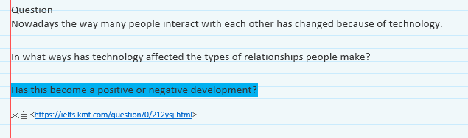

I strongly agree with the assertion that our contemporary world has changed dramatically because of the burgeoning development of science and technology in comparison to the past. And vast electronic products, public infrastructure and intelligent manufacture are all exerting profound impact on modern life. In the meantime, advanced technology has also affected the types of relationships people make, with both positive and negative outcomes.

In the past when technology was less available, people used to keep in touch with each other with letters by hand, meaning that they cannot aptly deliver feelings in time. In contemporary era, however, various kinds of applications in smart phones and watches already provide us with timely information as well as enable the way people interact with each other to be greatly convenient. Wechat is just one example of today’s popular communication tools, through which people can add new friends, send timely message or voice, as well as dial voice call or video call. Overall, the technology enables us to do almost everything that we previously thought of，not only changes the way of people’s life with more convenient but also broaden our horizons and open our minds.

In the meantime, however, there is also an increasing number of the problems with technology. Cyber criminals use social networking websites and spread the harmful Internet content. Such types of network illegal crimes cases in many countries are various, including network swindle, gambling, stealing, pornographic act, transferring and so forth. Nevertheless, the fact is that governments are taking effective measurements to address these problems and try to build the atmosphere of being secure and healthy. Besides, in many countries around world they are taking advantage of advanced technology to help solve the crime, like the surveillance video.

To conclude, the benefits with the development of technology far outweigh the problems it brings along.