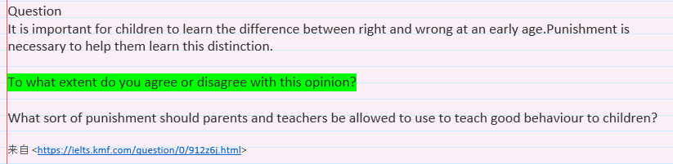

I entirely agree with the assertion that punishment is necessary for children to learn the difference between right and wrong at an early age. However, as far as I know, although punishment plays a great important role for that, taking measures under an appropriate reward-punishment mechanism makes sense to achieve that goal, helping children grow into good individuals in society.

Universally acknowledged is that punishment is the act of punishing someone who behaves very badly. Meanwhile, the punishment can be able to alarm one’s bad behavior so as to avoid going astray. It can be best exemplified by the case of a series of laws in terms of juvenile delinquency, which are severe punishment for today’s youth once somebody of them crime. Thus none of them would like to try to take high risks of imprisoning to behave very badly in real world; as a matter of fact, most of young people tend to obey such certain rules to act as a good member.

Nevertheless, parents, teachers, or even educationists should pay more attention to what sort of punishment should be allowed to use when teaching positive behaviors to children at an early age. As far as I am concerned, most of young kids are vulnerable as well as sensible, both physically and psychologically. Therefore, controversial as it may sound, I do believe such measures like making an apology, doing housework would be better choices, rather than some severe punishments like physical punishment, a torrent of abuse and so forth.

Besides, I believe that proper rewards as just important as punishment, which can also be beneficial to help them learn this distinction, especially when they have done something good. For instance, when young children perform well in primary school, it is suggested that teachers should reward for children’s good behaviors with a positive inspiration. Yet teachers should also pay attention to the way of rewards, avoiding spoiling these little kids. In my personal view, praise, applause and little gifts may be good choices.

In conclusion, although punishment is necessary for children to distinguish the difference between right and wrong, people should also pay much attention to what sort of punishment they use. My personal view is that it would be a better choice to teach children to learn this distinguish by taking appropriate punishment-reward mechanism.