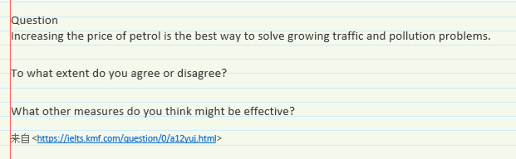

In recent years, there has been a considerable rise in the number of vehicles running on the streets, which contribute to a series of severe traffic jam and pollution problems in society. To address such problems, some hold that increasing the price of petrol is the best way to prevent from growing traffic and pollution problems. Yet I would say, just

Admittedly, it is arguable that increasing the price of petrol is an approach to solve growing traffic and pollution issues. On of compulsory explanations is that a high price of oil curb one’s consumption behaviors, once seldom pays for those related productions, some severe environmental problems would be solved. For instance, automation emission is one of the most significant factors that contribute to air pollution, however, if automobile ownership were reduced involved high price of oil, then the traffic jam and pollution problems would be reduced.

Confronted with the growing traffic and pollution problems, nevertheless, it would be reckless and somewhat naïve if they increase merely the price of petrol and hope that such problems would be totally solved. As a matter of fact, the number of private cars is unlikely to decrease by growing up the price of petrol. The authority should take other much more effective measures to tackle these issues. From my prospect of view, there are two main ways to cope with growing traffic and environmental problems, respectively. First,

To conclude,