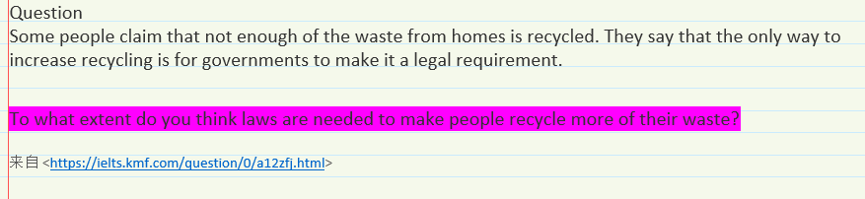

It is arguable that nowadays there has been not enough of the waste from homes is recycled. To address this problem, some stand the point that the only way to increase reusing for governments is to make it a legal requirement.

Admittedly, confronted with severe environmental crisis, it is universally acknowledged that governments should take actions to protect our eco-system from corrupt and dishonest businessmen by making it a legal requirement, as well as deliver the idea of sustainable development. A few decades ago, environment were severely threatened by human excessive deforestation, unscrupulous discharge sewage, and a variety of industrial pollution. It is this contemporary transformation in the significance of legislation governments that pushes an increasing number of industries to reduce related contaminants’ discharge. Similarly, I believe that legislating is a good choice for government to increase recycling on the waste of home.

Nevertheless, it would be reckless and somewhat naïve if governments make only a legal requirement and hope everything would be better. Such technical problems might not seem to be simply solved by governments’ laws, but according to collaborate with education and research institutes, it would be able to be conducive to a higher efficiency. Researchers and students can directly take participated in the topics about how to improve the rate of waste recycling by some courses and scientific and technological competitions. It is awesome that almost those intelligent people join the game with their creativity.

To sum up, my view is that making laws can be a good choice for governments but it is not the only way to cope with recycling problems in terms of the waste from home. What’s more, we should also take advantage of the of organized education and research institutes, which play a pivotal role on environmental protection such as how to increase recycling of the waste from home.