**Lab2 Frequency response**

For this lab we are going to measure the frequency response for two circuits, which contain the same components, slightly rearranged.

Both circuits function as *filters*, that is, the output is lower for some frequencies than others. This is because the circuits function as voltage dividers, and the reactance of the capacitor changes with frequency, so the fraction of the input voltage which appears at the test point also varies with frequency. A typical response graph for a filter might look like this:

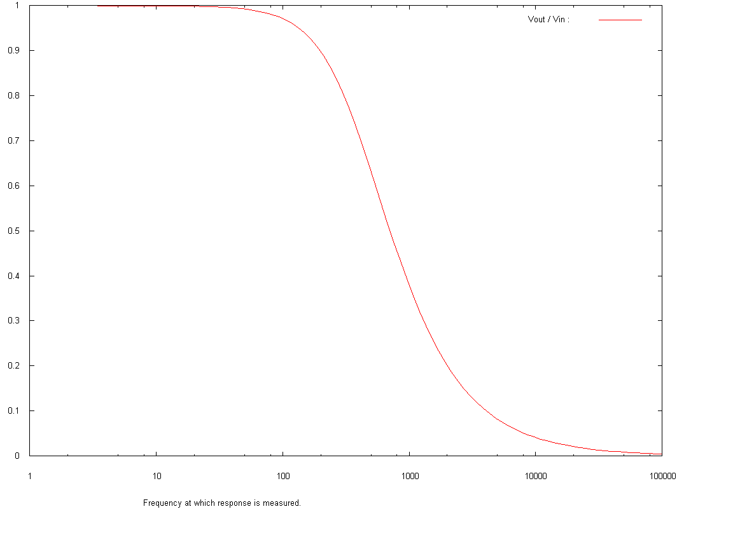

**Circuit 1**

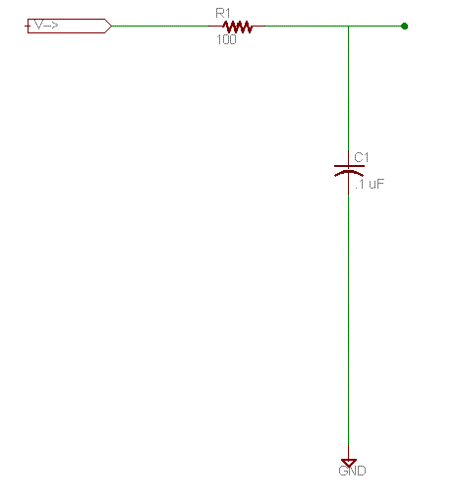

Set up the circuit above on a prototype board, and feed the V_in junction with the function generator output on the power supply.

Today we will use the oscilloscope to measure the voltage and phase at the test point. It is more difficult to get precise numbers from the oscilloscope, but it is easy to see the oscillating nature of the output, and the relationship between input and output voltages.

Set channel one to measure the input voltage, and channel two to measure at the TEST junction. Our digital oscilloscopes can be set up to compute some measurements, and so far as possible, you want to copy numbers down instead of estimating them, so play with that feature.

The frequency produced by our frequency generators may not be exactly as indicated on the input dials, and the voltage tends to change when you change the frequency. So you need to measure the input voltage and input frequency, as well as the output voltage. The output frequency should be the same as the input frequency, but the phase of the output will be different, and since I ask you to graph it, you'll need to measure that also.

Note the value of the input voltage, then record measurements for the output voltage and relative phase for a variety of frequencies: 1,2,4,8,10,20,40,80,100,200,400,800,1000,2000,4000,8000,10000,20000,40000,80000

Usually filter response graphs are presented as a graph of output power versus frequency. Since output power varies as the square of the voltage, you can obtain relative output power in decibels by dB down = 20 log10 (VOUT/VIN). However, to simplify our lives, you can instead graph the ratio VOUT/VIN, as I did above. (The "3 dB down" point is the frequency value for which the value of the ratio is -3, so in a ratio graph the log of the ratio is -0.15, which is a ratio of .707.)

I suggested measuring rapidly increasing frequencies because of the way the output changes. But you won't be able to make much sense of the graph unless you either

1. Use a log scale for the X axis, or
2. Fake the use of a log scale by creating a derived variable defined to be the log of your real X-values, and doing a scatter-plot

You'll be able to use a log-scale if you draw the graph by hand. Just search the internet for log-log graph paper and graph the points. [Here's a sheet of semi-log graph paper I thought would be useful.](http://computersystemsartists.net/spring16/csc7011/assign/lab2/logarithmic-4.pdf)

Some graphing programs, like gnuplot, do support log-scale axes. But if you are using Excel, you'll have to play around to get a readable log-scaled graph.

Graph the output phase versus frequency.   
Do a few hand-calculations to see whether the measured values match your understanding of the theory.   
According to your graph, at what frequency does the circuit seem to be 3 dB down?

**Circuit 2**

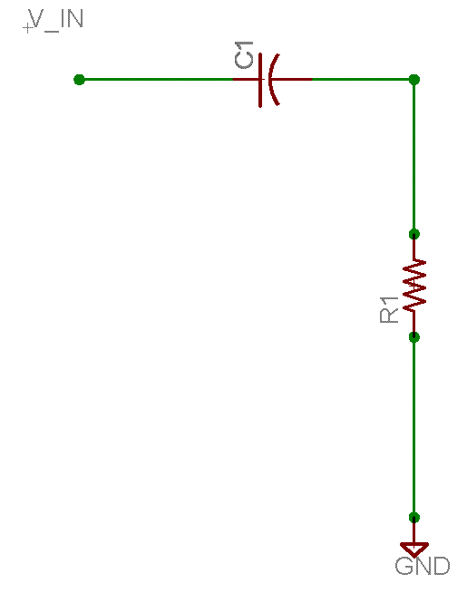

Graph the VOUT/VIN ratio versus frequency.

Graph the output phase versus frequency.

Do a few hand-calculations to see whether the measured values match your understanding of the theory.   
According to your graph, at what frequency does the circuit seem to be 3 dB down?

**You will turn in**

you will submit a written report including the following sections:

1. The purpose of the lab. The title is a good suggestion, but you should provide a long enough explanation so that if you pick it up next year, you will be able to tell generally what the lab is about without reading the rest of it.
2. Schematics for all the circuits you built in the lab. If two circuits are identical except for resistor values, you may provide one diagram, with a note explaining the different values you used.
3. tables of recorded results. If calculations were necessary, show your calculations.
4. The four graphs mentioned above.
5. A narrative telling exactly what you did, what you took from the assignment, the book, or the web, and what your lab partner did.
6. A generalization of the final results, that is, your thoughts about the various questions I asked you to consider.

The lab report should be detailed enough so that rereading it in forty years, you should be able to figure out enough details to explain it to your grandchildren.

Lab reports should be typed. Circuit diagrams or calculation pages may be drawn or written by hand. Graphs may be drawn by hand if you wish, but you must do so on printed graph paper.