**Project Report**

**OF**

**“Online Book Rental System”**

**Prof. Nguyen Thai**

**The Practice of Computer programming**

**CSC7014**

**Submission Date- 12/06/2016**

**Prepared By-**

**Arnika Vishwakarma (@01367603)**

**Keerthika Uvarajan (@01376036)**

Contents

**EXECUTIVE SUMMARY** 4

**INTRODUCTION** 4

**PROJECT OVERVIEW** 4

**PROJECT REQUIREMENTS** 5

**Functionality Requirements** 5

Add / Maintain User Account 5

Delete User Profile 5

Add a Book to rent 5

Delete a Book 6

Search Book 6

List Books I own 6

List Borrowed Books 6

Update Book Status 6

Provide Feedback / Reviews 7

Provide Payment system 7

**External Interface Requirements** 7

Web Server 7

User Interfaces 7

**Security** 7

Data Transfer 7

Data Storage 8

**PROJECT DESIGN** 8

Use Case Definition 8

Adding User Account Use Case Definition 8

Logging into Account Use Case Definition 9

Dashboard Use Case Definition 10

View Profile Use Case Definition 10

Edit Profile Use Case Definition 11

Add a Book Use Case Definition 12

Books I Own Use Case Definition 12

Search Book Use Case Definition 13

Searched Results Use Case Definition 14

Renting a Book Use Case Definition 14

Borrowed Books Use Case Definition 15

Use Case Diagram 16

UML Class Diagram 17

SOFTWARE DEVELOPMENT 17

KEY ISSUES AND CHALLENGES 18

PROJECT OPERATION 18

CONCLUSION 20

REFERENCES 20

# **EXECUTIVE SUMMARY**

Book lease is a web application which allows user to rent used books from the owner. This application has the books for every category. This system work as a mediator between the users and the book renters. This software aims to rent used books to the customer at a very cheap price.

**Key Capabilities of the software:**

* This software provides with the admin account. Admin is capable of viewing user’s account, admin can delete the user’s account.
* This software provides with the user log in account system, and those who don’t have account can sign up in the system.
* Book lease provide the search engine through which user can search for the books available.
* Software is capable of providing a platform where book owner rent the book. Book borrower can view the history of borrowed books and current borrowed books.

# **INTRODUCTION**

Book Lease is online application where customer can rent books from the book owner. This software is being created using the web framework Django. The detailed information of the **online book rental system** are provided in this document.

# **PROJECT OVERVIEW**

Booklease software is designed to provide customer an ease of renting and borrowing the book. This software provides different functionalities like- customer can search for the book by book name. Book borrower can rent the desired book by sending a request to the book owner. Book owner has the authority to accept or decline the request. If book owner accepts the request, then the book is rented to the borrower. After the return of the book again the book will be available for rent.

# **PROJECT REQUIREMENTS**

## **Functionality Requirements**

Introduction --

This subsection contains the requirements for the book rental system. These requirements are organized by the features of the system.

### Add / Maintain User Account

* The system allows new users to create new account.
* A new user asked for the following **mandatory** details while creating new account / profile:
  + First Name and Last Name
  + User id
  + Password
  + Email address
  + Phone Number (Optional)
  + Address
  + Gender
  + Describe Yourself
* A new user been asked for the following **Optional** details while create new account / profile
  + School
  + Work
* A user can change password and any other information in the profil

### Delete User Profile

* The system allows to delete its account from the system.

### Add a Book to rent

* The system will allow the user to add the book with the following details
  + Name of the book
  + Edition
  + Author
  + Renting Price per day
  + ISBN Number
* The system display a message to the book owner that the addition of the book completed.
* The system update the availability of the book as soon as the user adds the book to the system.

### Delete a Book

* The system allows the user to delete a book from the system.

### Search Book

* The system allows the user to search book with following parameters:
  + Search by Name
* The system display the search results in the form of list matching the criteria. If no matches are found, the list will be empty.

### List Books I own

* The system allows the user to see the books he/she added to rent to other users.
* The system also display information on the status of each book i.e. whether the book is available to rent, or Rented.

### List Borrowed Books

* The system shall allow the user to view all the current book borrowed history and past history of books borrowed.

### Update Book Status

* The system automatically update the status “Available” as soon as the book owner adds the book for rent.
* The system allows the book owner to update the status of the book to “Rented” if the other user has borrowed the book.
* The system allows the book owner to update the status of the book to “Available” after the book is returned.

### Provide Feedback / Reviews

* The system allows the book borrower to provide the feedback to the book owner on return of the book.
* The system allows the book owner to provide the feedback to the borrower as soon he/she returns the book.
* The system verifies the reviews from both users and book owners and display the reviews in their account.

### Provide Payment system

* The system allows the users to deal with the payment method like- cash, credit, check.

# **External Interface Requirements**

## Web Server

* Since this is a web application, we have a system with a dedicated web server of Django local server.

## User Interfaces

* The system allows the user to make use of the existing web browsers such as Microsoft Internet Explorer, Mozilla Firefox, Google chrome etc. by which user can access the system.

# **Security**

### Data Transfer

* The system not leave any cookies on the user’s computer containing the user’s password.

### Data Storage

* The system never displays the user’s password on user’s browser. It shall always be echoed with special characters representing typed characters.
* The system back-end servers never display a user’s password.

# **PROJECT DESIGN**

## 

## Use Case Definition

## Adding User Account Use Case Definition

* User clicks the sign up button to add his/her account in the system.
* Program displays a form page to sign up with following field information to be filled up by the user:
* First name and last name
* User id
* Password (only characters and numbers)
* Email address
* Phone number
* Address
* Gender
* Describe yourself
* School
* Work
* User click on the submit button to sign up for the account.

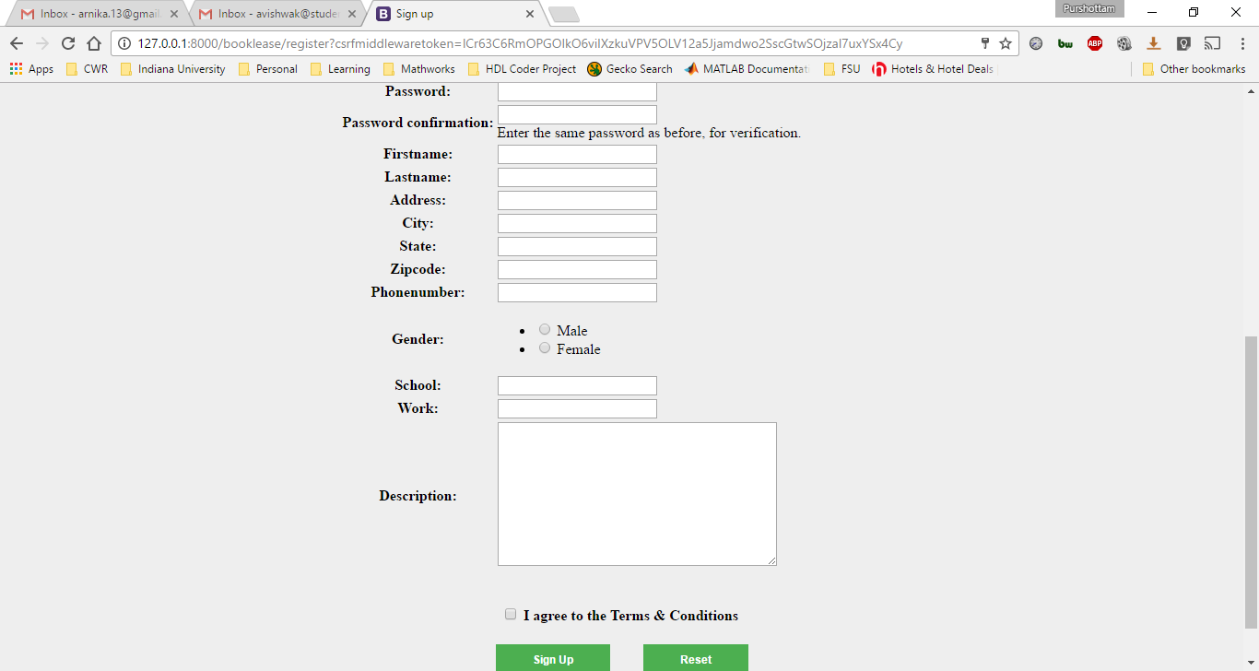

Fig.1 User interface for sign up

## Logging into Account Use Case Definition

* User will log in by filling the user Id and password.
* User clicks the Log in button to sign in into his/ her account.

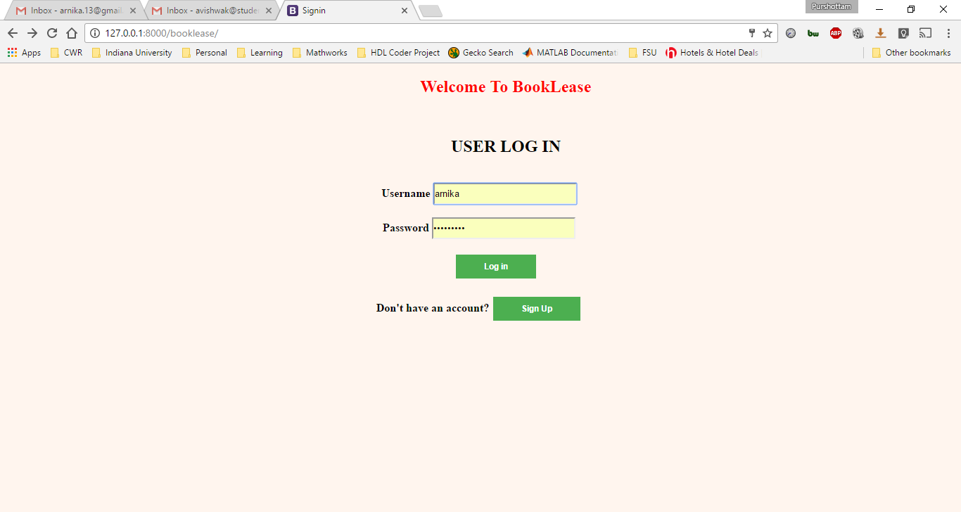

Fig.2 User interface for Log in

## Dashboard Use Case Definition

* Once the user logged into his / her account, program will display a page with different tabs named- dashboard, profile, Your Book listing, Borrowed Books, Add a Book.
* By default, program will redirect to the dashboard page, where user can view the renting request

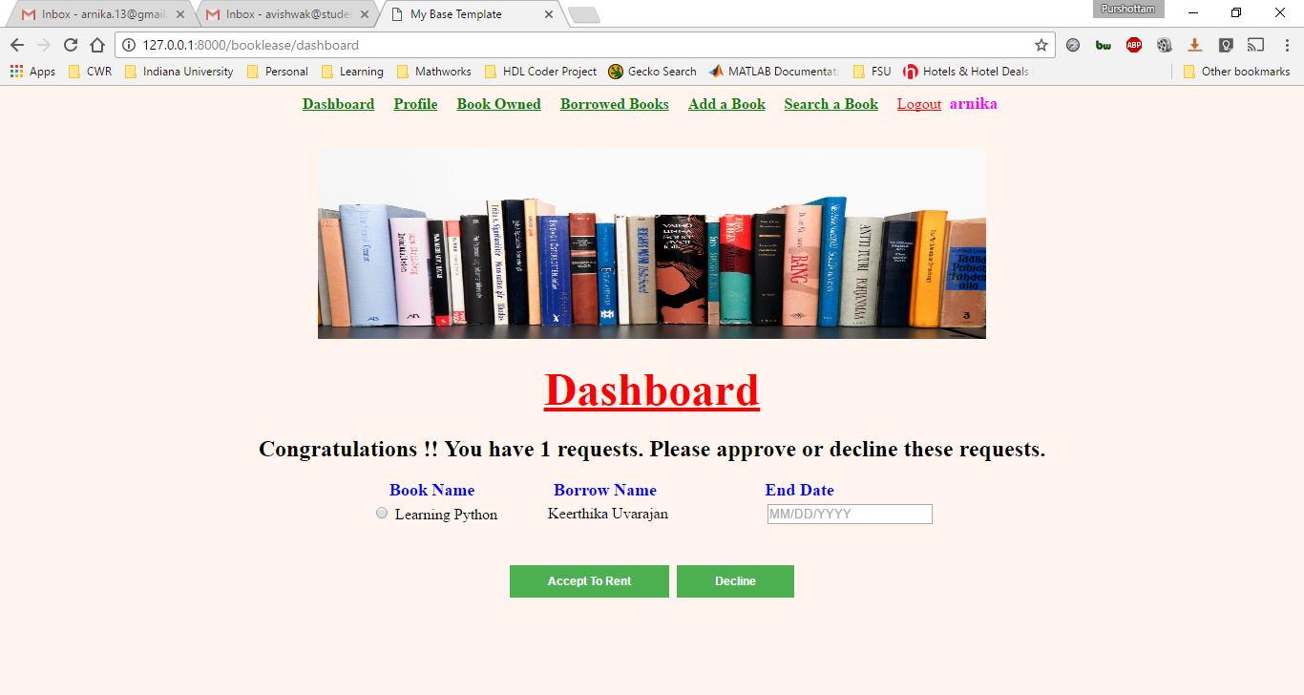

Fig.3 User Interface for Dashboard

## View Profile Use Case Definition

* User clicks on the view profile link which redirect to the view profile page, which includes the information about the user.
* Program page includes:
* Description about user
* Reviews from other users

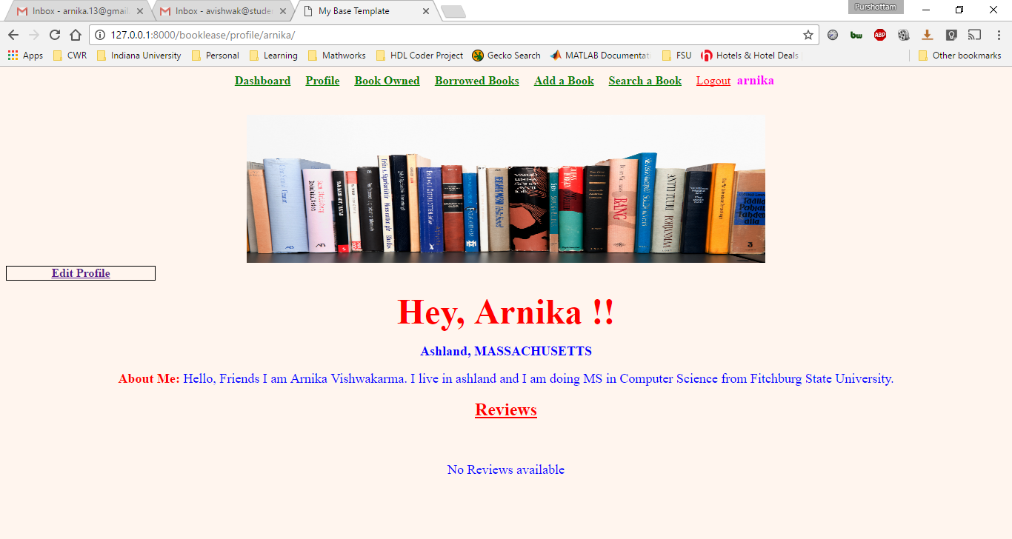

Fig. 4 User Interface for View profile

## Edit Profile Use Case Definition

* User can edit his / her profile by clicking edit profile inside the profile tab.
* Edit profile has all the information need to be updated.
* After filling out the required field to edit user will click on the save button to save the changes made.

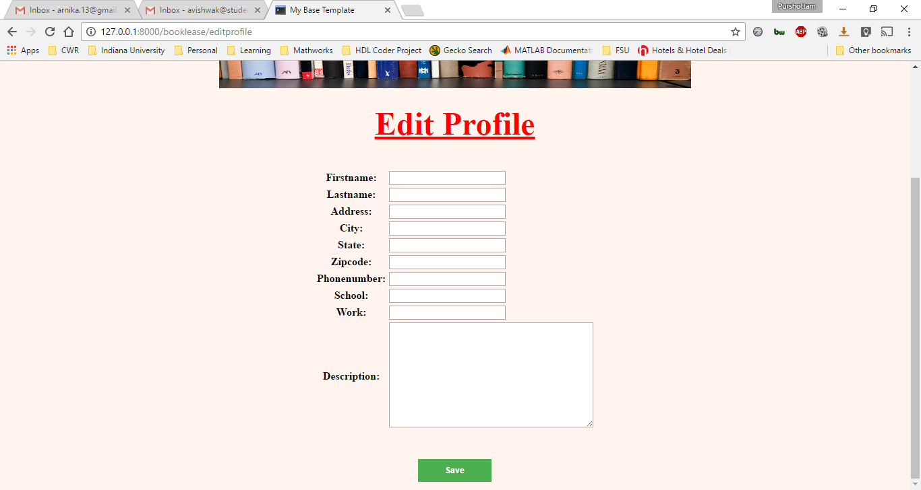

Fig. 5 User Interface for Edit profile

## Add a Book Use Case Definition

* User add books by clicking on the “Add a Book” button on the top of the page.
* Program displays the fields mandatory/optional to be filled i.e. Book Name, Book Author, Book Edition, Book Rent Price, ISBN Number.
* After filling all the details about the book, User will click on “Add” Button to proceed.
* Once the user clicks on the Add button those books will be available in the system for rent.

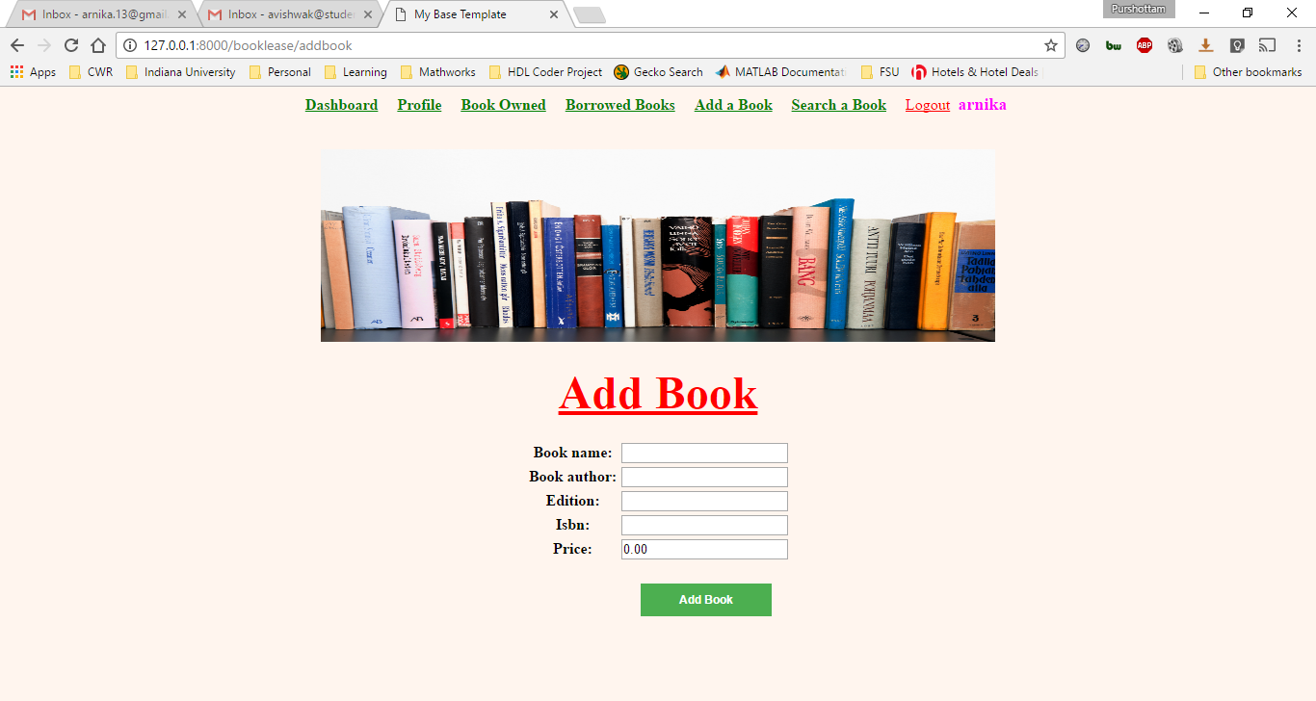

Fig. 6 User Interface for Add Book

## Books I Own Use Case Definition

* Once the books will be added in the system, User see the books which he/she added to rent by clicking on “Book Owned”.
* Program displays the books with all the details the book owner has added for rent.
* Program will also display the status of the book whether it is rented, or available.
* Book Owner can write a review once the book is returned by the borrower.
* User can delete a book either one by one or selecting from select all checkbox.

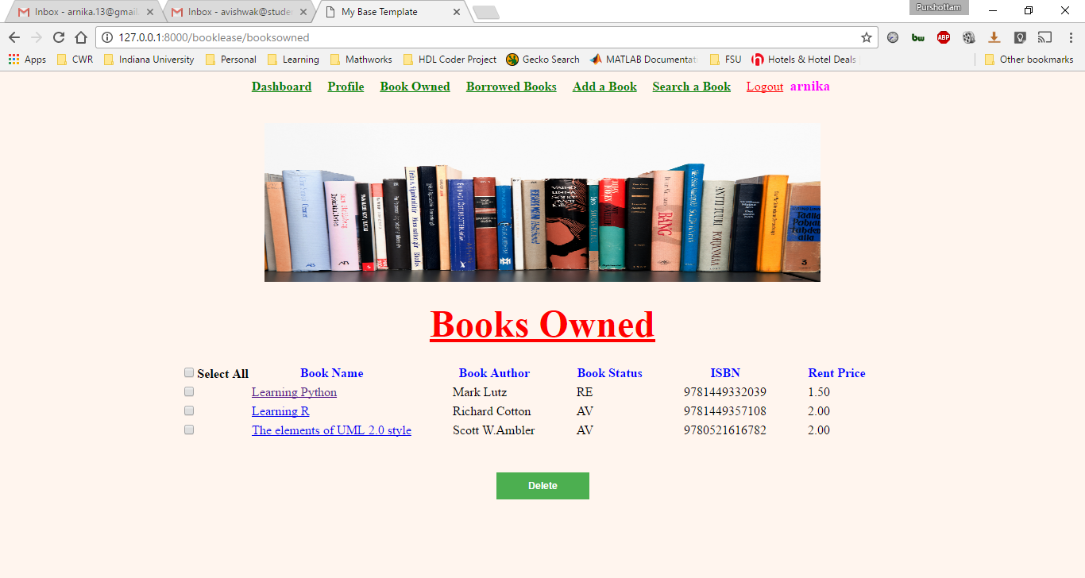

Fig. 7 User Interface for Books Owned

## Search Book Use Case Definition

* User will search for the books by Book name.
* User will click on the search button to find the searched results.

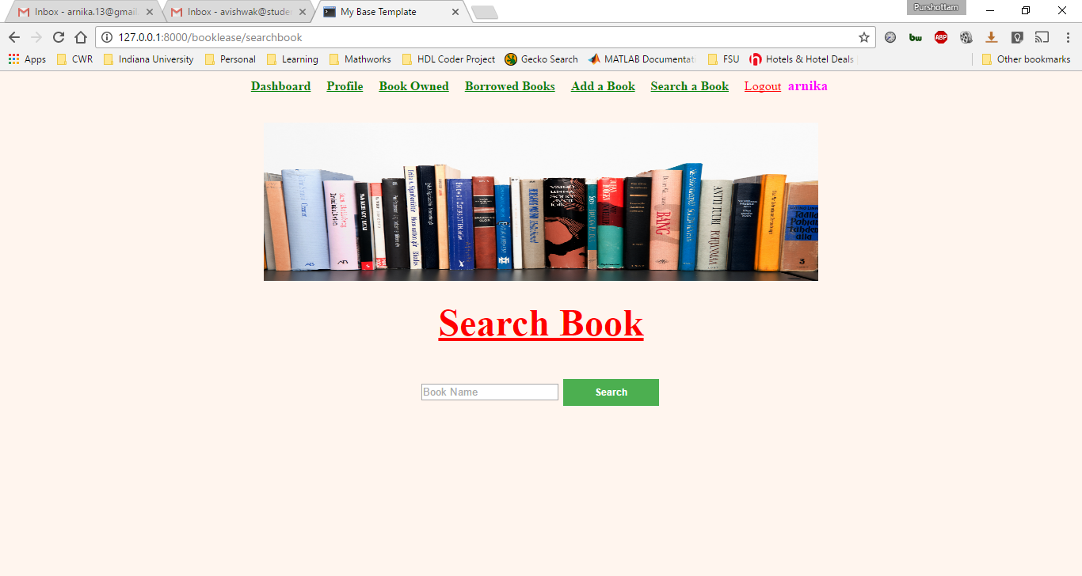

Fig. 8 User Interface for Search Book

## 

## Searched Results Use Case Definition

* User clicks on search button program will display the searched result page with the book name.
* User can choose from the displayed list of the books he wants to rent from the book owner.

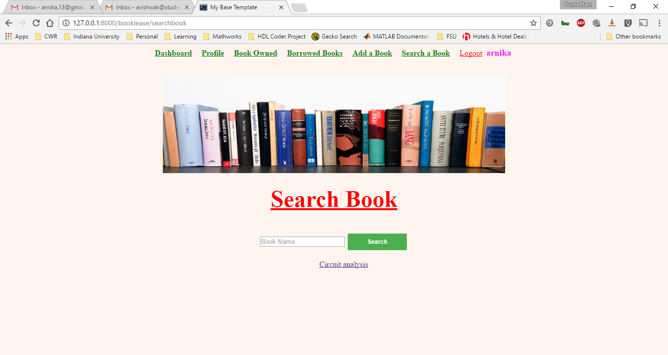

Fig. 9 User Interface for Searched result

## Renting a Book Use Case Definition

* User clicks on the book name that he / she wants to rent.
* Program displays the Book owners detail with the book details
* User clicks on the button “Request to rent”.
* Payment will be made in cash or cheque directly to the book owner when the borrower rent the book.
* Program displays the message “email sent to the book owner”.

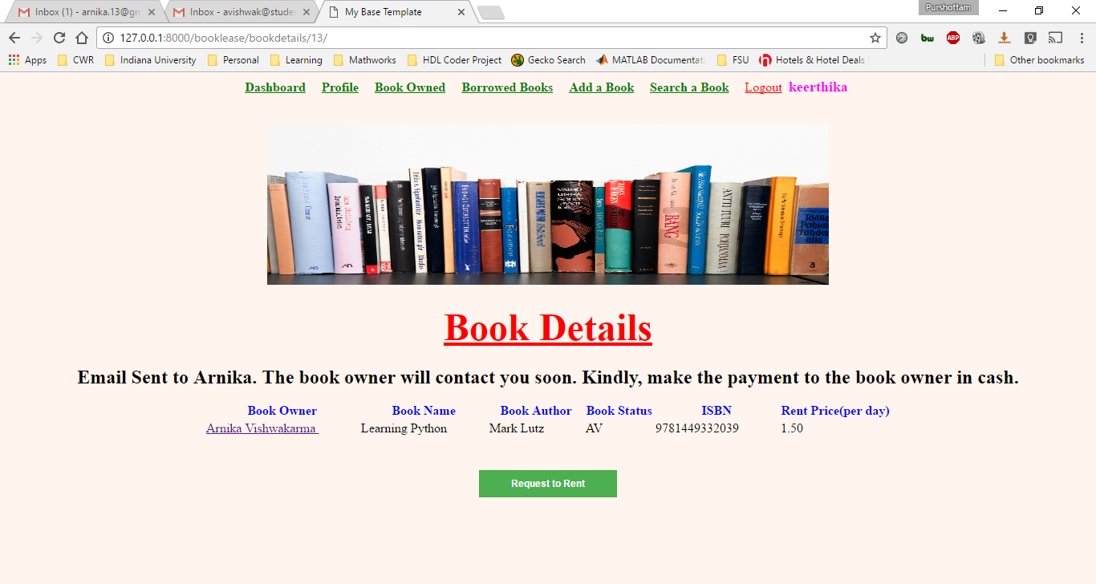

Fig. 10 User Interface for Renting a Book

## Borrowed Books Use Case Definition

* User clicks on the Borrowed Books to view the list of the books he/ she borrowed from the book owner.
* Program displays the list of the books with detail he / she borrowed from the book owner.
* User will write a review by clicking on the link “Write a Review” once he returns the book.

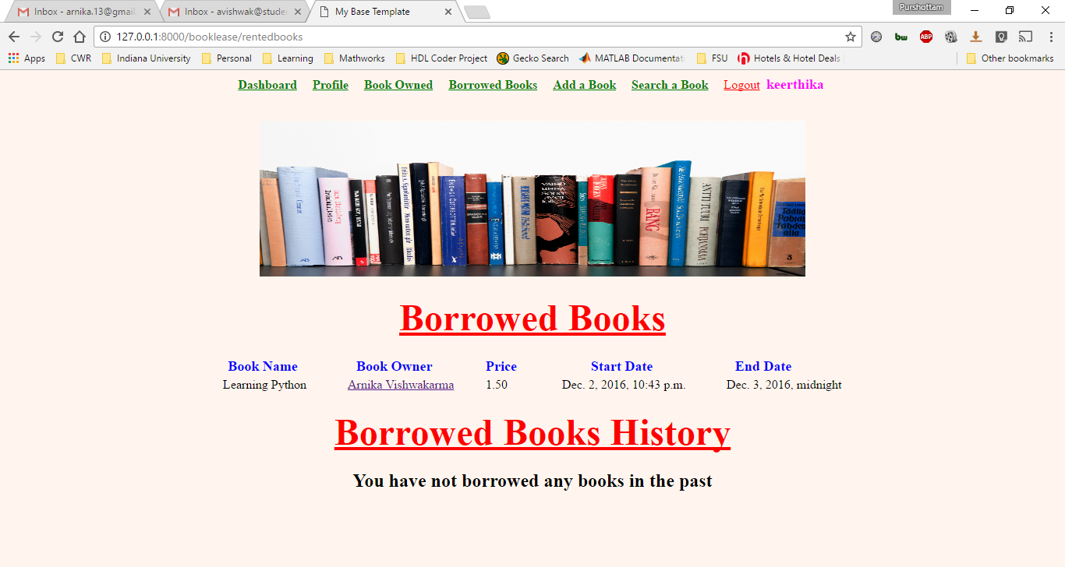

Fig.11 User Interface for Borrowed books

## Use Case Diagram

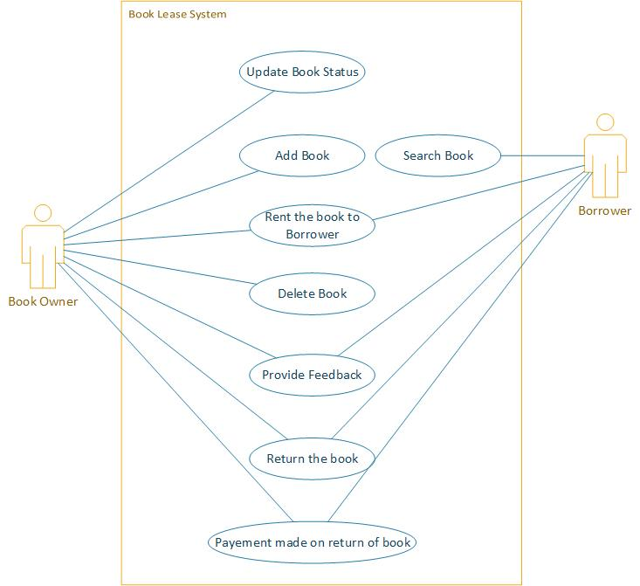

Fig. 12 Use Case Diagram

## UML Class Diagram

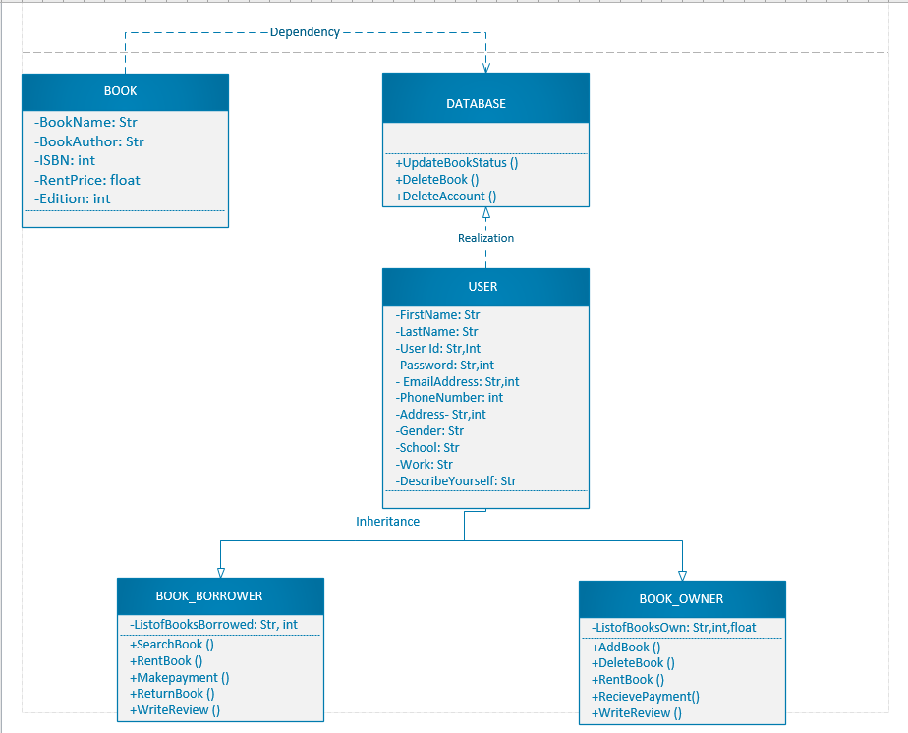

# **SOFTWARE DEVELOPMENT**

This software is build using the language Python and web framework named Django. Django is a free and open source web application framework, written in python. Web framework is require to develop the website faster and easier. Django follows the MVC architecture. Django also provides with an inbuilt database called SQLite3. To build a website using this framework we must have three software installed in our system: Python (2.7, 3.3, 3.4, 3.5), Python Virtual environment and Django.

# **KEY ISSUES AND CHALLENGES**

* During the Initial period of development we faced lot of difficulties in fetching the data from the database and implementing the functionalities.
* There are few known bugs which we couldn’t fix it for now. For instance- when the book owner delete the book from his/her account, then, the past borrowed history and reviews associated with that book also gets deleted.
* In future we are going to deploy our website at [www.arnikav.com](http://www.arnikav.com/)

# **PROJECT OPERATION**

* Book lease software works on Windows 7, 8, 10, Linux.
* After the improvement in first version the current version of this software requires Django Web Framework to run the website. Install the python version 3.5.2, python package manager, python virtual environment and Django. Follow the following instructions :
* Install python 3.5.2. Make sure python is in the path.
* Install python package manager using the below command in command prompt.

**C:\Users\arnika> python -m pip install -U pip**

* Install Python Virtual Environment

**C:\Users\arnika>pip install virtualenv**

* After extracting the files from the zip file, ‘booklease_i3’ folder will be created as shown below

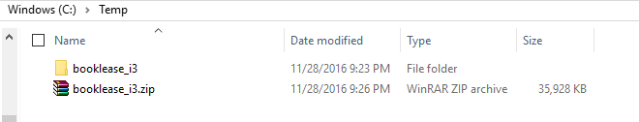

* Go to the directory ‘booklease_i3’ in the command prompt as shown below.



* Now run the below command:

**C:\Temp\booklease_i3>virtualenv env_mysite**

You should see output something like below:

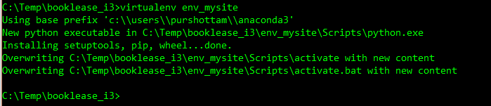

* In the command prompt go to “**booklease_i3\env_mysite\Scripts”** directory by using the below command

>> **cd booklease_i3\env_mysite\Scripts**

* Now run the below command in the command prompt.

>> **activate**

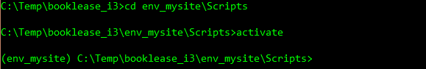

* Now change the directory to “**booklease_i3\env_mysite\mysite”** in command prompt.
* Run the below command :

>> **python manage.py runserver**

This will be run the local server on port 8000

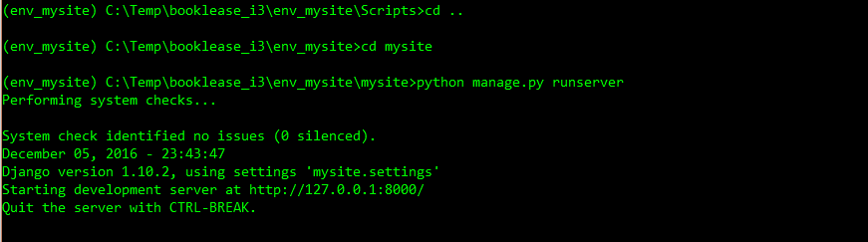

* Now open the browser on the local machine and type the below URL :

**http://127.0.0.1:8000/booklease**

# **CONCLUSION**

Book Lease software is functioning properly. Each and every functionalities have been implemented. During the development of this software we have learned a new web framework “Django”. Initially it took little time to grasp the knowledge but in the later run we were acquainted with the server side coding and applying the functionalities. Overall it was a great experience to build our software using Django.

# **REFERENCES**

* *Software Project guidelines,* Thai, Nguyen, COMP 1050 Computer Science II,Spring 2016 Wentworth Institute of Technology.
* UML Reference Manual - Second Edition
* The Elements of UML 2 Style
* IEEE-SA Standards Board, “IEEE Recommended Practice for Software Requirements Specifications”, Software Engineering Standards Committee of the IEEE Computer Society, June 25th 1998.
* The Django book- https://djangobook.com/
* Mike’s Django tutorials - <https://mikesdjangotutorials.co.uk/>
* Stack Overflow- <http://stackoverflow.com/>