**Documentation / Screenshots / Problems**

**BACKEND**

* **Django Admin Panel:**

**Localhost:8000/admin/**

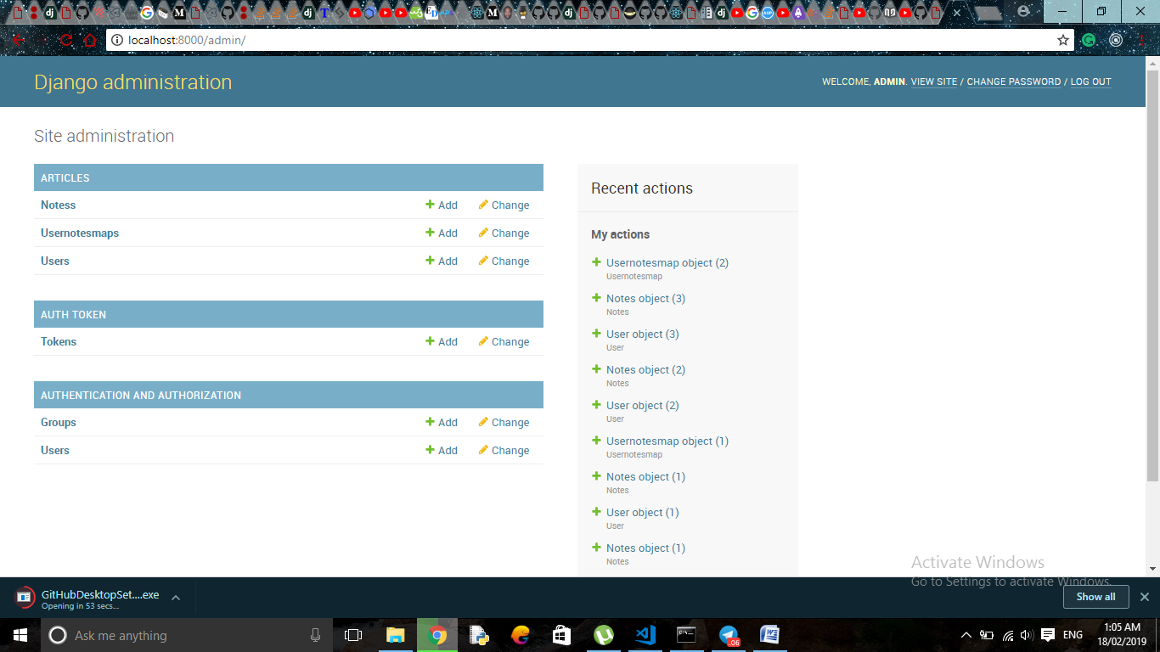

**1)USER**

**localhost:8000/admin/articles/user/**

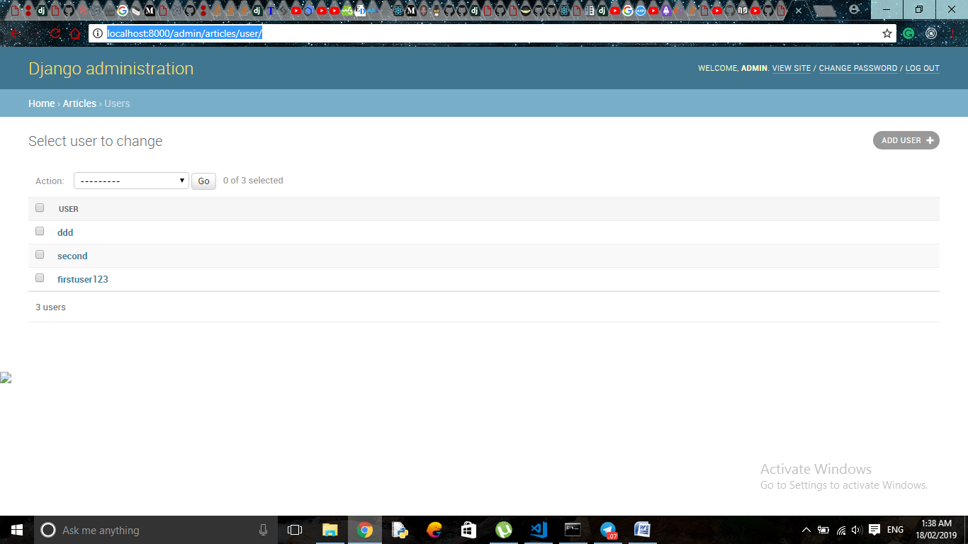

**Adding New User through Admin Panel:-**

**localhost:8000/admin/articles/user/add/**

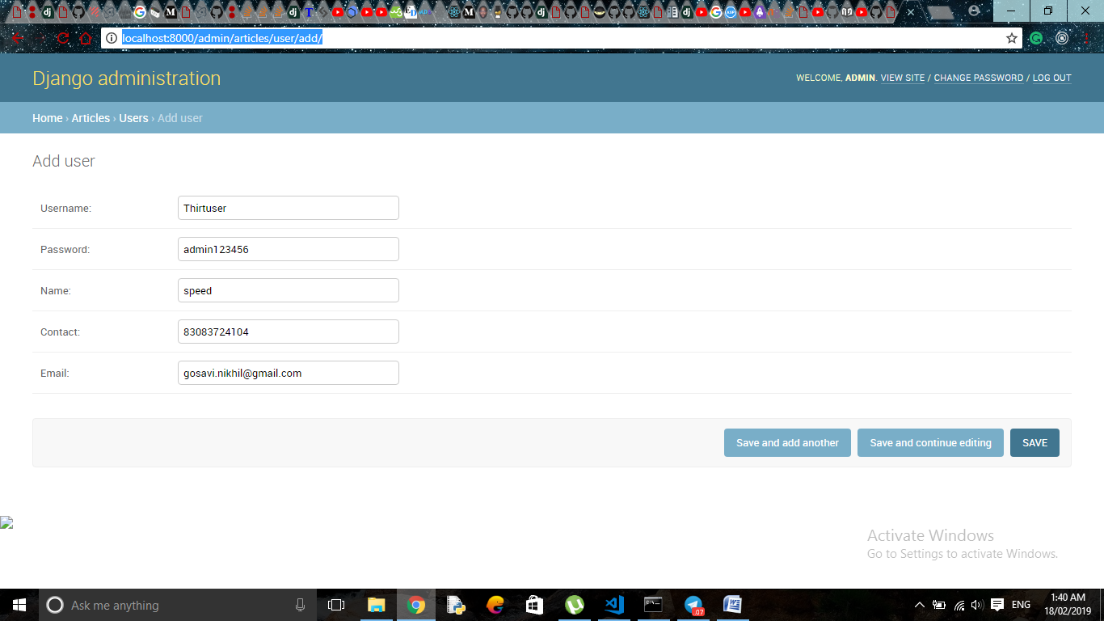

**2)NOTES**

**localhost:8000/admin/articles/notes/**

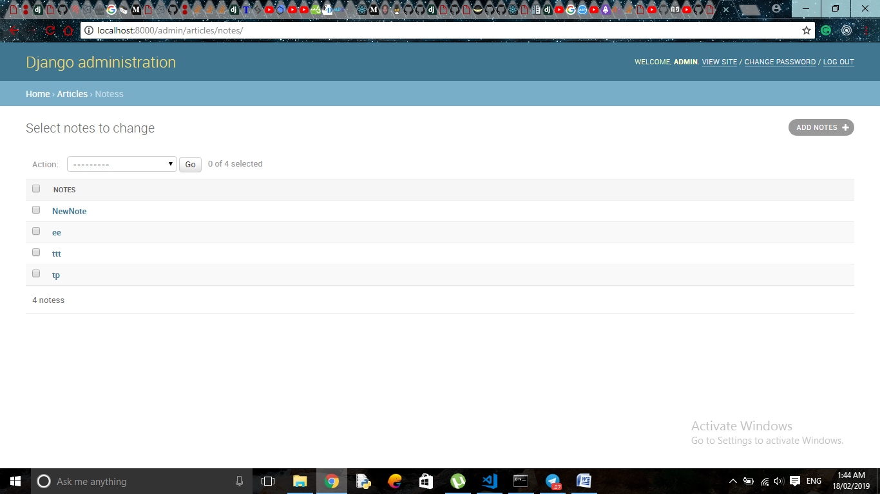

**Adding new notes with Userid**

**localhost:8000/admin/articles/notes/add/**

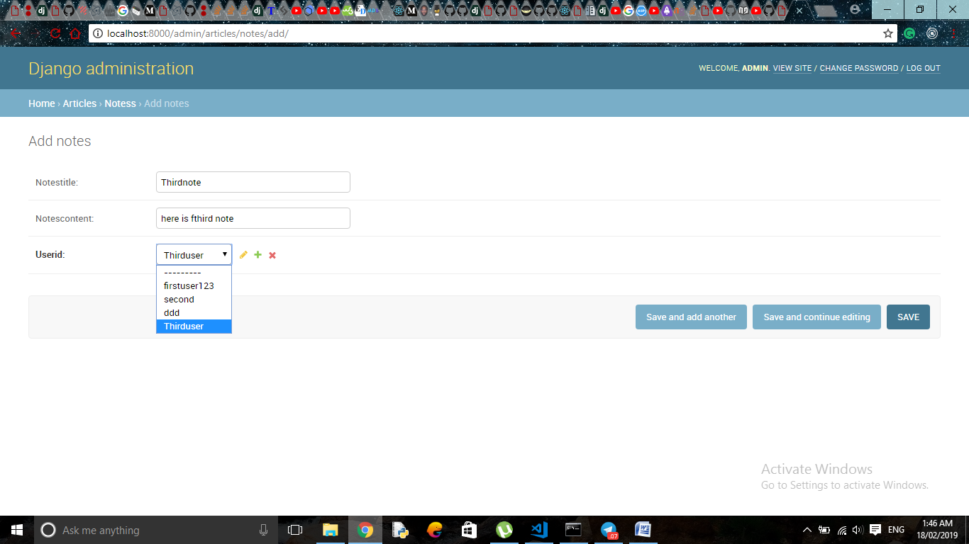

**3)USERNOTESMAP**

**localhost:8000/admin/articles/usernotesmap/**

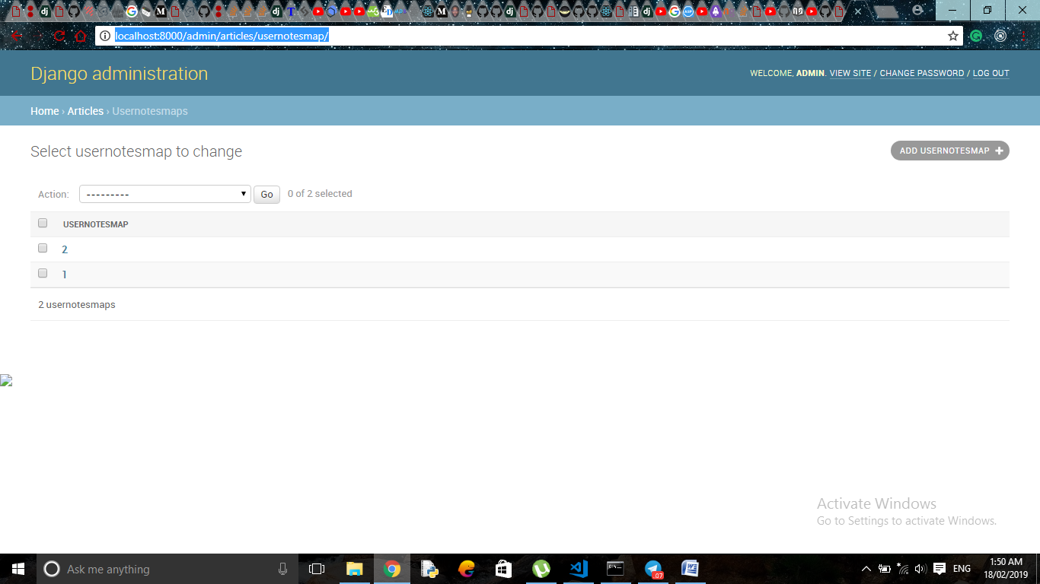

**Mapping users and notes using Userid and Notesid**

**localhost:8000/admin/articles/usernotesmap/add/**

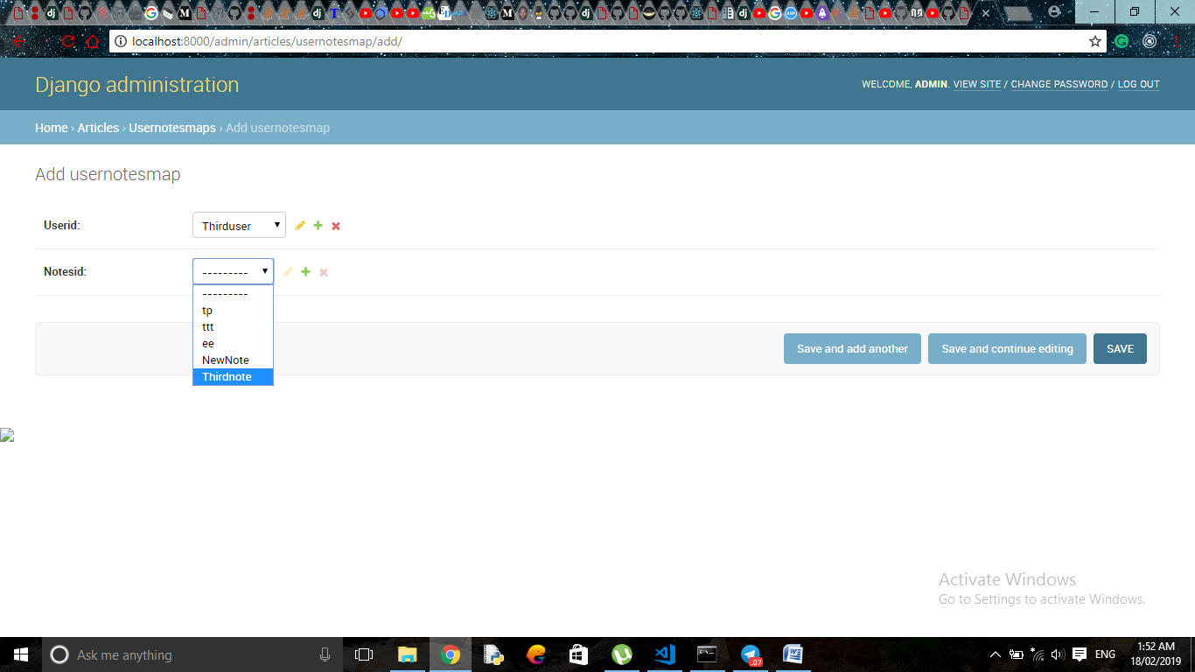

**Auth token**

**localhost:8000/admin/authtoken/token/**

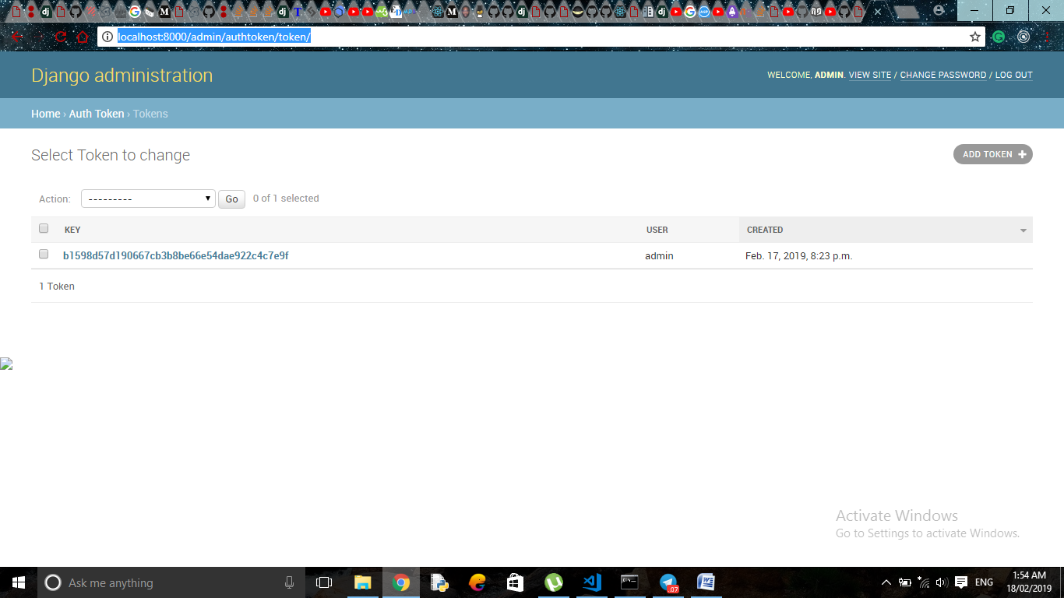

* **Django Rest Framework**

**LIST Notes**

**localhost:8000/api/**

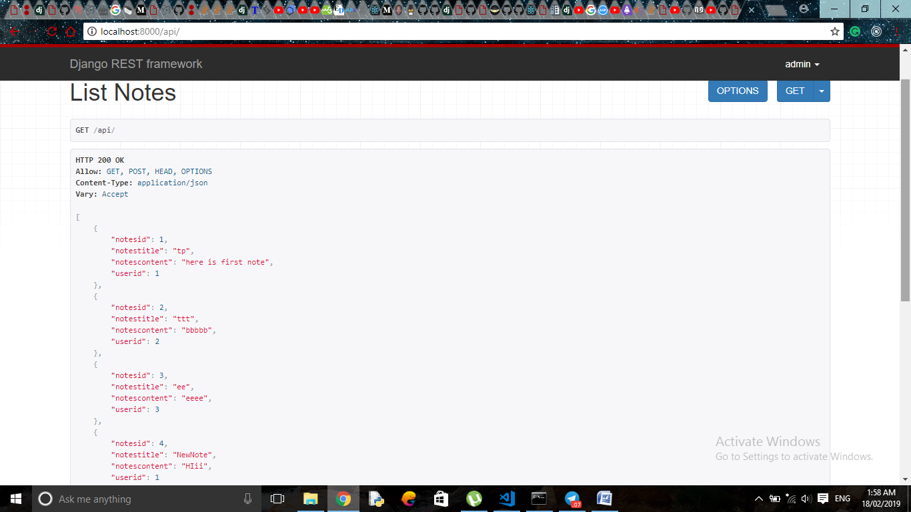

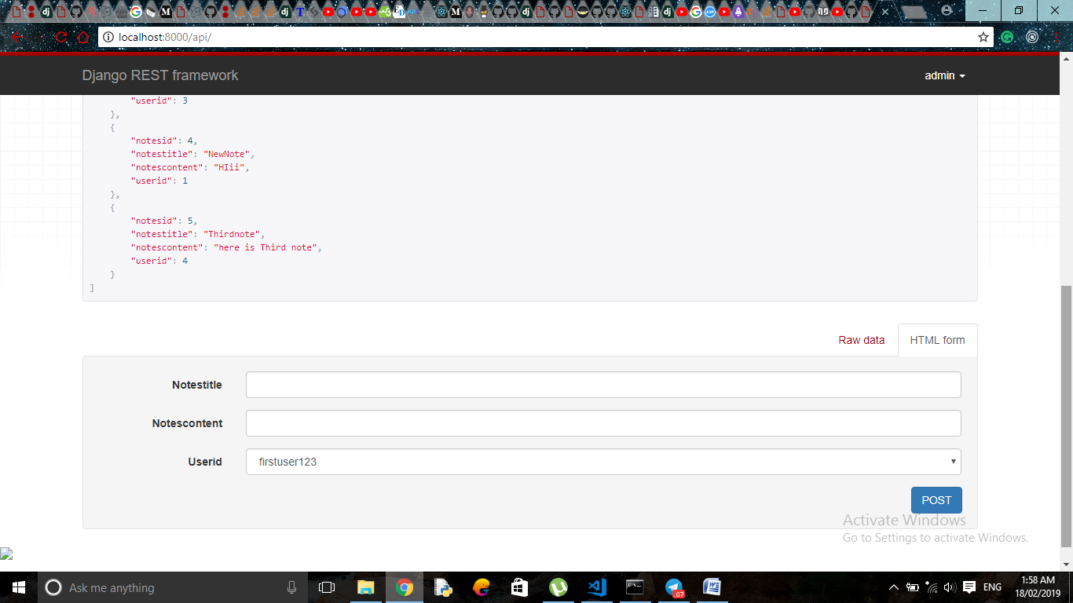

**Adding new note using django rest framework(with userid)**

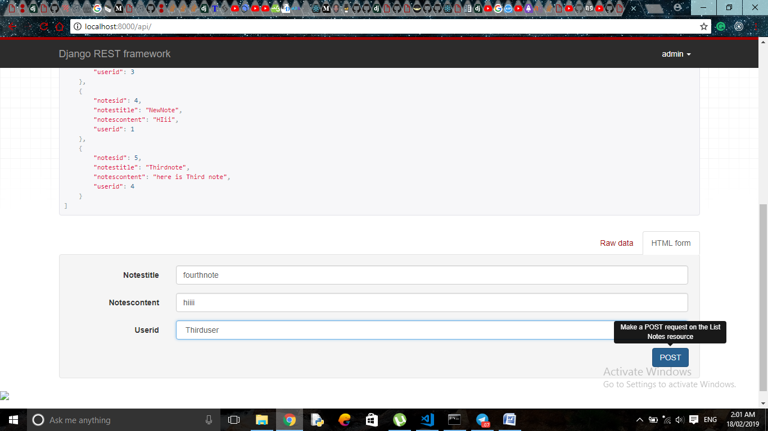

**DETAIL notes**

**localhost:8000/api/1/**

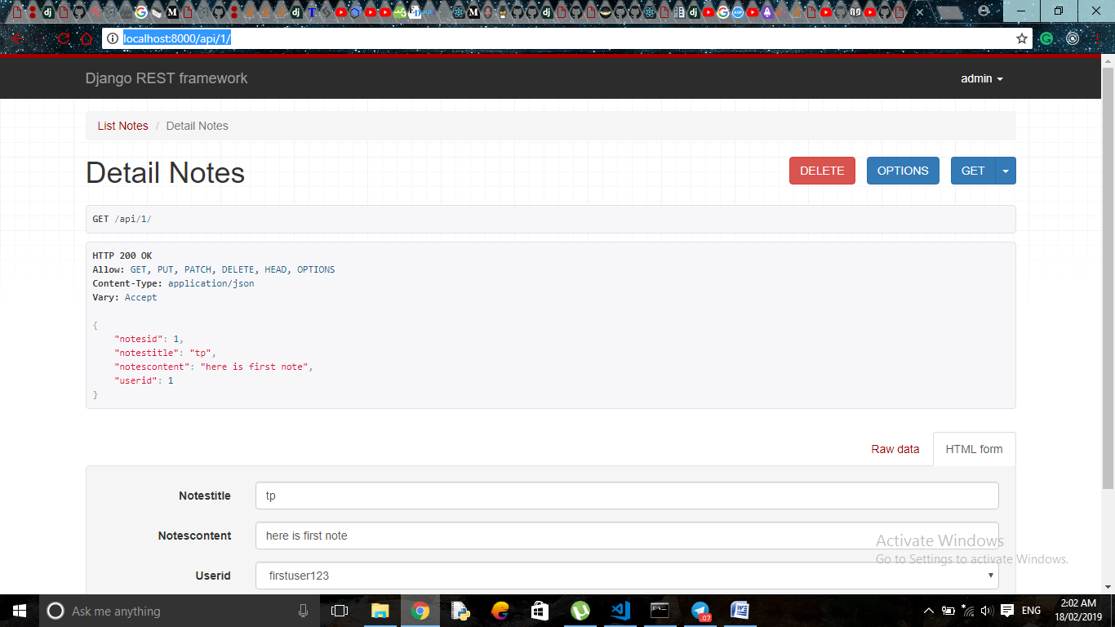

**FRONTEND**

**Home.js**

**localhost:3000/Home**

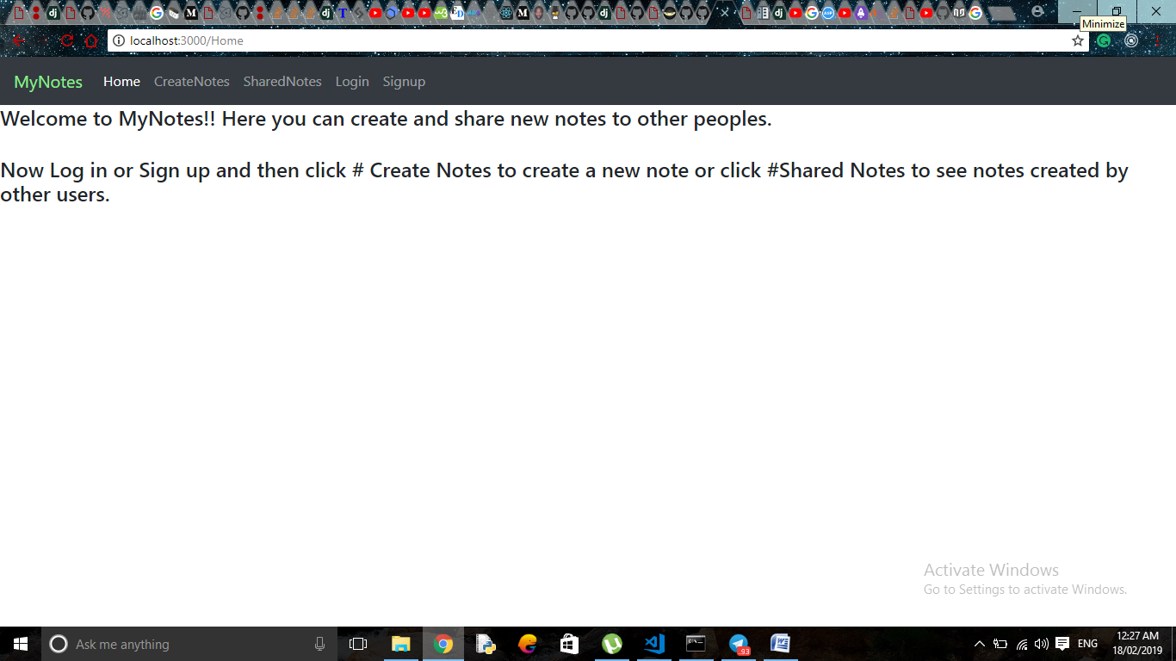

**Createnotes.js**

**localhost:3000/CreateNotes**

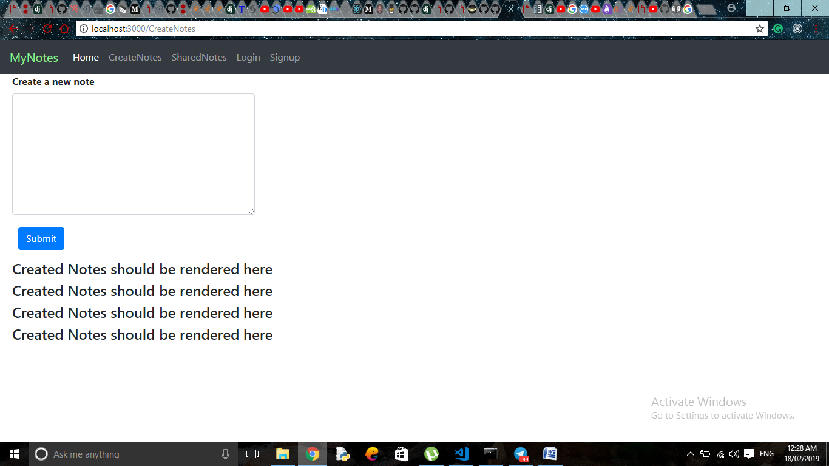

**Sharednotes.js**

**localhost:3000/SharedNotes**

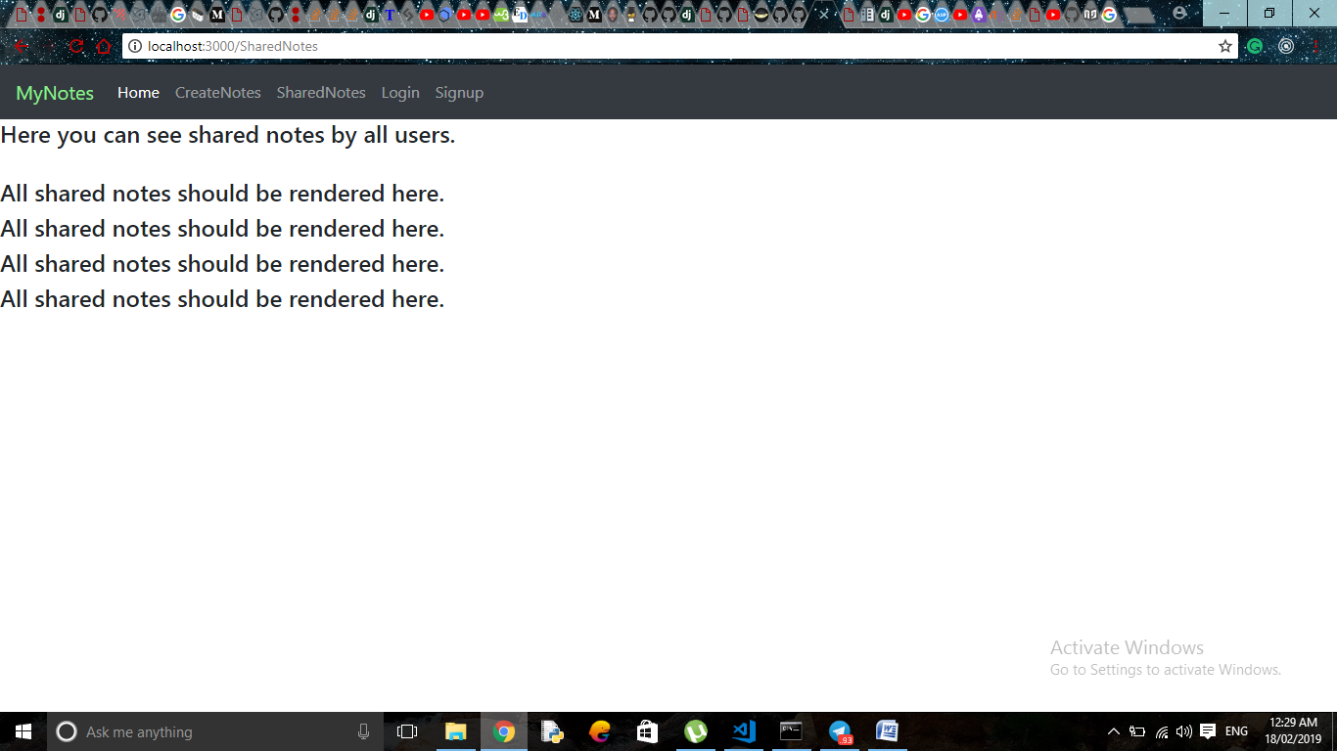

**Login.js**

**localhost:3000/Login**

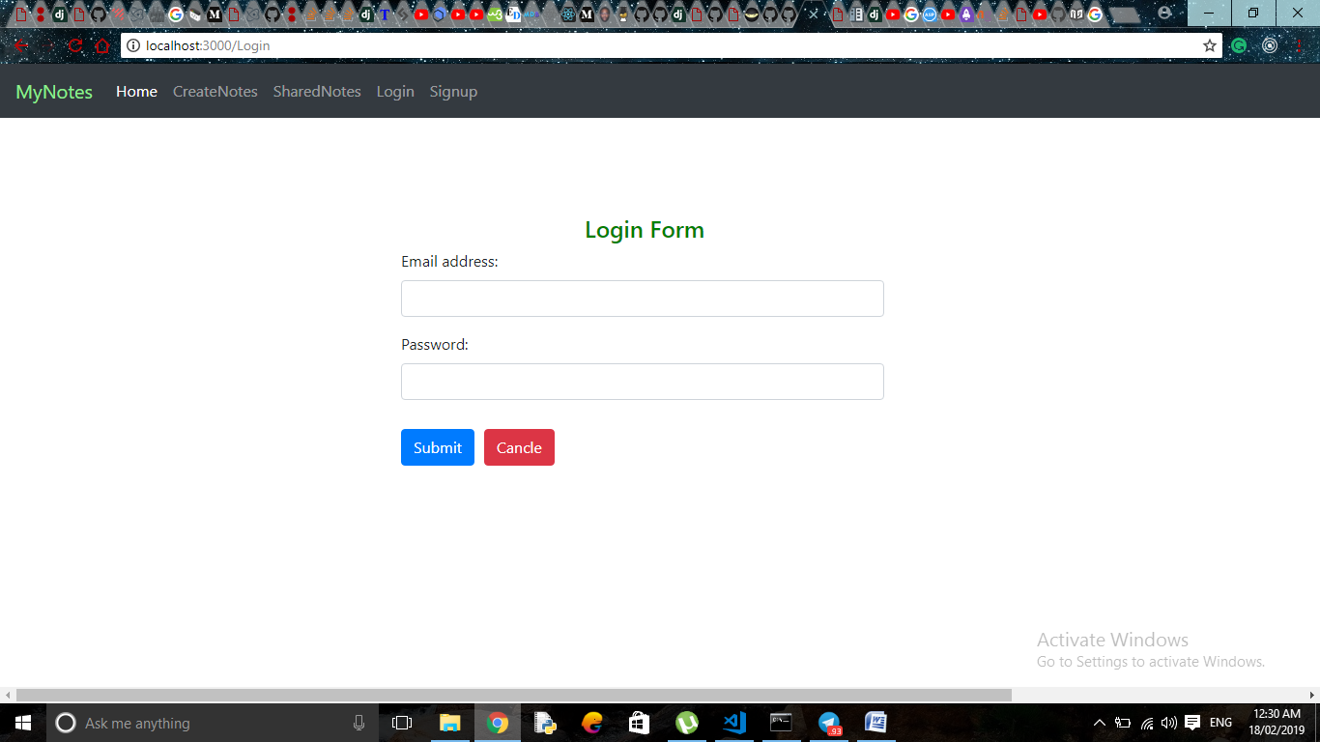

**Signup.js**

**localhost:3000/Signup**

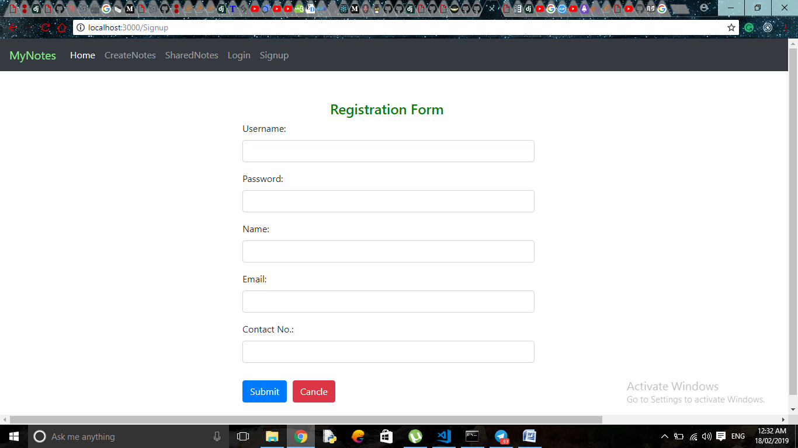

**Problems:-**

**1)My API only renders Notes API, although I have created all models, views, and serializers for all APIs.**

**2)I have created the MySql database and imported it using ‘inspectdb’. But I can’t store my registration details to the database and here I  was stuck and confused.**

**3)I also read ORM and tried it but it didn’t work for me.**

**4)Without user, I couldn’t go for further processing of project and that is the reason the project is incomplete. I am sorry for that.**

**5) I haven’t work on Django, Django rest framework or ReactJS before this project. So I worked very hard for this. But unfortunately, I am not able to do this.**