Description

Project for creating an interface for a tv. The controls need to be easy and operated by arrow keys. Three sections of the UI include movies, channels and tv series. The project also contains authentication of the user and also maintain the record of viewed videos and the time where each video was paused and resumes based the previous view result.

Requirements

Software: NodeJS, Web Browser, Sql Database.

Workflow Diagrams:

Server operation: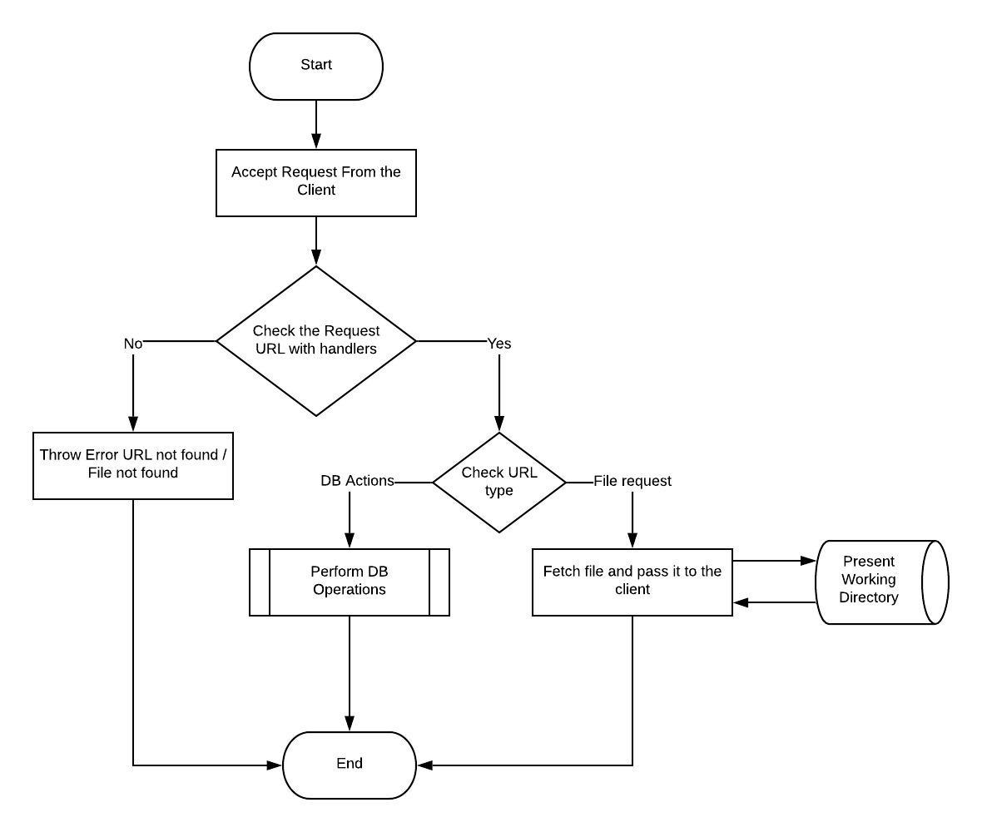

Login Authentication:

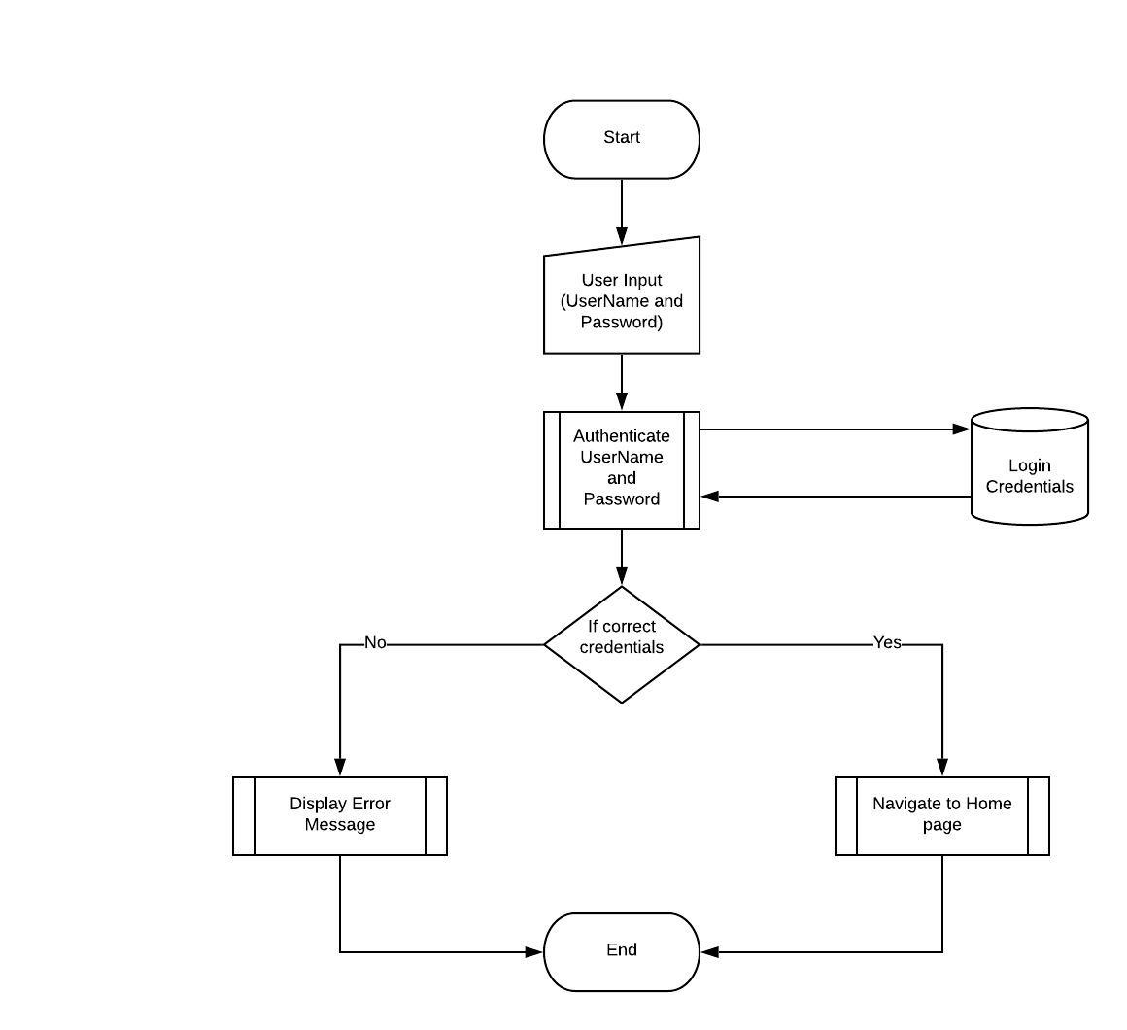

Database Tables

Session

|  |  |  |
| --- | --- | --- |
| **Attribute** | **Data Type** | **Constraint** |
| Email Id | Varchar(20) | Primary Key |
| Time | Float(4,3) | Not Null |
| Filename | Varchar(20) | Not Null |

User

|  |  |  |
| --- | --- | --- |
| **Attribute** | **Data Type** | **Constraint** |
| Email Id | Varchar(20) | Primary Key |
| Name | Varchar(20) | Not Null |
| Password | Varchar(20) | Not Null |

Advantages

* Easier and simple UI
* Easy installation
* Smart video player