End-user Portfolio

Each Panel is its own class with methods where they manage the contact object to do what is required. The contact class declares its variables as strings, which allow the use of textboxes to read, write and update.

The first screen demonstrates database connectivity and GUI by displaying the contents of the addressBook.db into the listbox. Looping structures are also used to cycle through each entry and display the information.

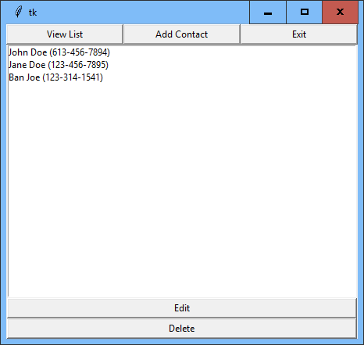

The add and update screens demonstrate Abstract classes to where a generic ContactFieldPanel class defines the fields but changes the text according to the intent to either update or add a new entry

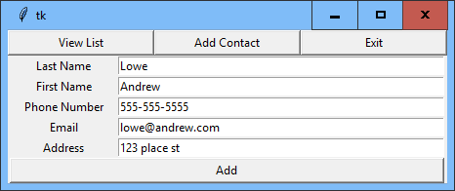

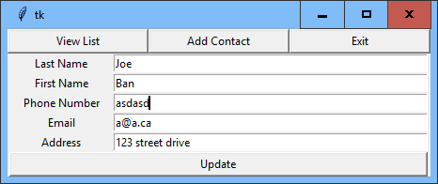

The error panel demonstrates exception handling and decision structures where if the entered values do not match the regex as shown in the Phone Number Field then this message will display

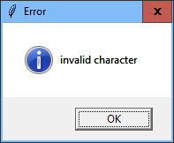

If the entered values do match with the regex then the list will update with the new entry as displayed below.

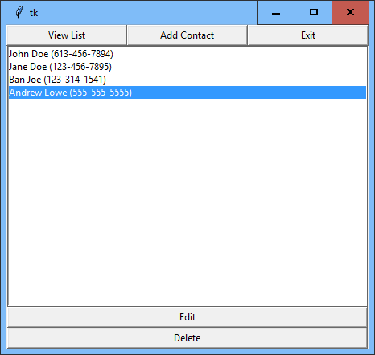

The project does run as it is intended to. It is able to create update and delete records from the database by using the GUI to communicate these actions.