Assignment 4

CST8333 Programming Language Research

Andrew Lowe

Michel Cyr Bakinde

2016 Fall Semester

Dec 4, 2016

Variables

Variables are declared by simply stating a name and assigning a value to it. Python has five data types – number, string, list, tuple, and dictionary. The difference between Python and Java is that these data types would have to be defined as an int, String, Array or an ArrayList. With Python, this is not necessary.

This source code from the contact file demonstrates how variables are declared without the need to identify them as strings or integers.

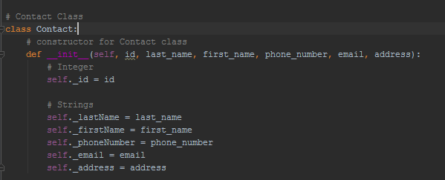

Memory Management

Python uses garbage collection to delete objects that are no longer in use. This is done automatically while the program is running. When an object no longer has a reference the garbage collection is triggered. It is very similar in the way that Java uses garbage collection to remove objects once a heap is full.

<http://www.careerride.com/python-memory-management.aspx>

<http://www.digi.com/wiki/developer/index.php/Python_Garbage_Collection>

Decision Structures

Python uses if statements to evaluate whether an expression is true or false and carries out the appropriate action according to the Boolean value. Python follows the same convention as java by using if/else statements as syntax.

This source code from contact demonstrates how if statements work. The regex describes how data is to be entered where if the entered data does not match then an error message is displayed. If it does match then it will accept the entered value.

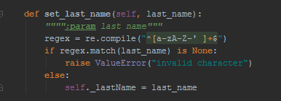

Looping Structures

Self.contactList points to the get_all_contact() method and assigns each iteration to the contact variable in the for loop. The insert statement is executed for each contact in the sequence which populates the listbox. Python works the same way as Java where contactList is an array and contact is the variable in that array. The only difference is in the syntax where in Java it would look more like for (int contact : contactlist) and then execution of the statement that follows.

This code is pulled from mainfraime.py to demonstrate the looping structure of Python.

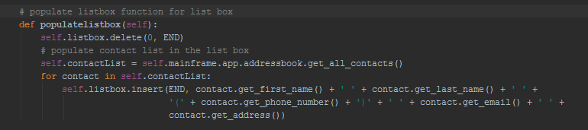

Methods / Functions as well as Classes / Objects / Structs / Modules

Classes are created by using the class statement to create a new class definition. __init__ is a constructor method used to initialize each instance of that class. It will give the object all of the starting values stored in the constructor method. Functions are created using the def statement and storing arguments in parenthesis. Unlike Java Python does not need to define methods as being private, public, int, string, or void and classes do not need to be told whether they are abstract, public or private. This is demonstrated in the contact.py file.

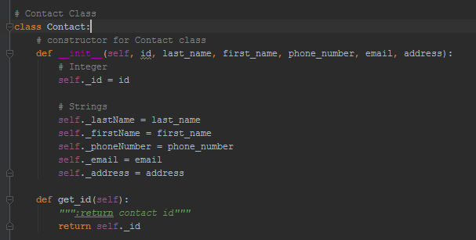

Exception Handling

Python uses try to carry out an operation, except to catch an error that may occur and what to execute if an error is found, finally is then used to execute an operation after both try and except have been evaluated. Java uses exception handling the same way as Python, however the syntax uses try, catch, finally instead of try, except, finally.

Addressbook.py demonstrates how exception handling functions using try/except/finally

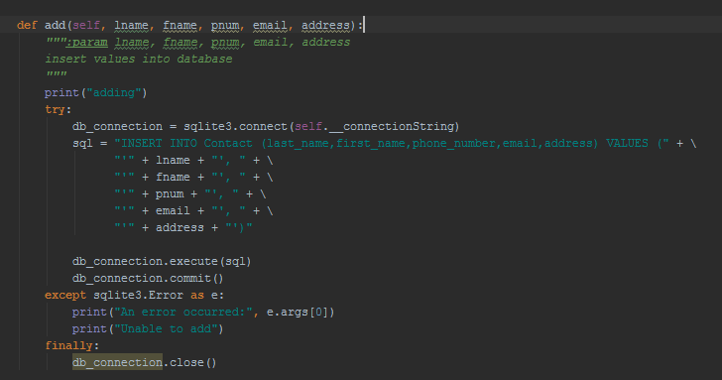

File IO

A file object is created when using the built-in open() function. The first argument is the name of the file and the second argument is the access mode where w+ opens a file for writing which either creates a new file or overwrites the old one. Java functions differently by using input and output streams to read and write data whereas python uses methods to do the same.

Mainframe.py demonstrates how file IO function in python.

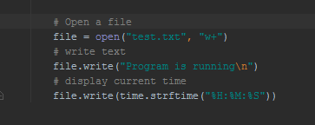

API

<https://docs.python.org/3/index.html>

<https://docs.oracle.com/javase/7/docs/api/>

Python provides documentation on its built-in functions, its libraries, and installation of python as well as modules. Built-in functions include ones used in this project such as print() and str(). Its standard library contains data types, exceptions as well as modules such as tkinter, unittests, and more. Built-in functions, exceptions, and data types do not need to be imported however modules such as tkinter do.

For Java, packages need to be imported before they are used including ones for print and exception handling. The Java API provides information on how to use the packages

Mainfraime.py imports the tkinter module so that the components can be used to create the GUI.

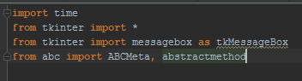

Database Structures

Stored in the AddressBook Class, this database currently uses four functions add, edit, delete, and get_all_contacts. The AddressBook Class uses sqlite3 to select, update, insert and delete to manipulate the contact info stored in addressBook.db. Python functions the same way as Java when creating database connectivity where you need to open the connection using sqlite3.connect() and then use a string to point to the location of a database. A cursor is then also created to execute the created sql statement and then close the connection once the execution is complete.

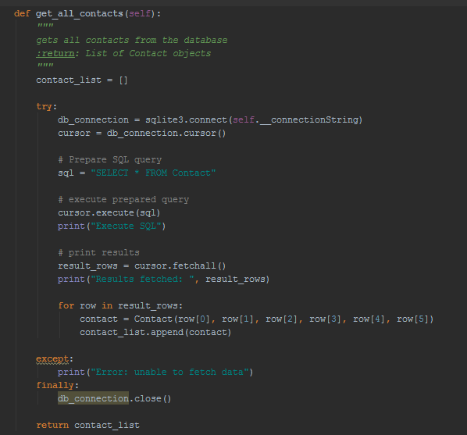

GUI

The MainFrame class is responsible for handling all the GUI functionality. It will use the Frame imported by tkinter to create the frames and bring the desired frame to the front when a button is selected. Tkinter functions by using frames the same way as Java swing functions by using panels. Tk() is the class used to create the window that will use these frames.

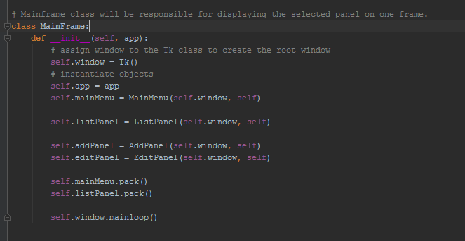

Inheritance

The ContactFieldPanel is a generic class that is used by both the AddPanel and the EditPanel. When the Add button is selected, the frame will change the button text in the ContactFieldPanel to “Add” whereas is Edit is selected the button will change the text to “Update”. Rather that declaring the class as being abstract like in Java, Python uses an ABC module to implement the methods. These methods are declared using the @abstractmethod annotation on that method. Submtiable submit is responsible for for overriding the submit functions found in AddPanel and EditPanel.

