Unit Test Portfolio

The screen shots demonstrates how the contact class works where an object class is instantiated with valid values found in the database. The assert True function demonstrates that values are accepted and that the program works.

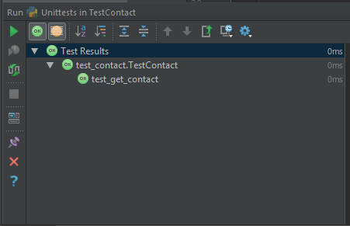

TestContact displays True in the IDE

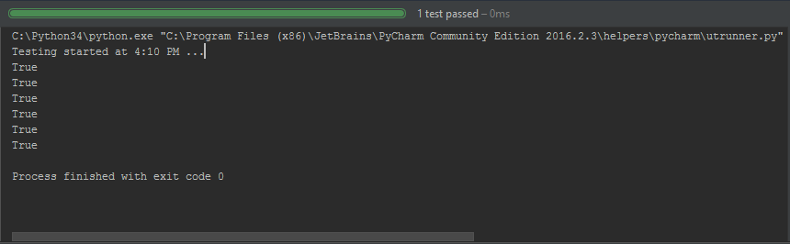

Results from TestAddressBook show that the database runs successfully.

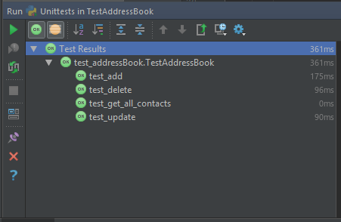

The IDE displays the results of select for TestAddressBook

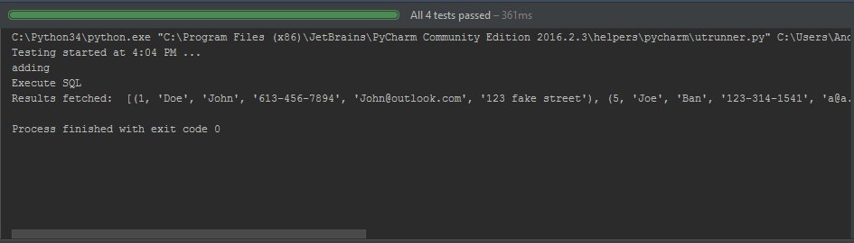

While TestAddressBookApp does run successfully, it appears to stay in initialization even though it is showing results. This is seems to be a problem inherit with gui testing which is why it is recommended to test what the GUI actually does which is located in the contact class and the addressbook class.

