Lappeenrannan teknillinen yliopisto

School of Engineering Science

Sofware Development Skills

Milla Kotilainen, 438818

LEARNING DIARY, FRONT-END MODULE

**LEARNING DIARY**

9.5.2022

I checked the general information and course goal. The goal of the course is to offer tools for creating unique projects and finding my passion for software developer. I chose front-end module, because I feel like front-end isn’t my strongest suit and I want to develop this skill. I also set up my environment by updating GIT and searching VS Code addons.

Today I also coded the home page. I created a folder called ‘dist’, where html, compiled CSS, JavaScript and images go. There was a problem with node-sass, but downgrading Node.js helped. Sass is compiled to CSS, so it works as preprocessor allowing developer to code in one language and then compile it to CSS. Compiled CSS isn’t to be touched. Scss contains sass files. I also learned that 1rem = 16pixels (by default)**.**

I did my first git commits and everything when smoothly after some googling on how to do it in practice.

11.5.

Today I programmed the rotating menu button and menu overlay. I also learned about responsiveness. I made media query, which every CSS will only apply then screen is some size. I didn’t have any problems today.

13.5.

Watched videos 5 to 7 and finished the website. I had problems with GitHub pages as the pictures didn’t show up when typing the URL in web browser. I didn’t manage to solve this problem today but might give it another try tomorrow.

17.5.

I found out that there is some delay in updating the project on GitHub Pages. I still haven’t solved the image issue due to this delay. I decided to start doing the project today and solving this problem later.

I also noticed that I forgot to make different directories for coursework and project, so before starting the project I had to fight with this for couple of hours. The problem was how to move directories and files under a folder on remote. I decided to make completely new repository because trying to make took too much time.

Now the image doesn’t even show on the live server….

29.5.

Today I did a quick recap on videos and code I’ve made before, as it has been a long time since I last coded this project. I made my projects home page today.

1.6.

Today I made the menu button and the menu for my project.

11.6.

I have forgotten to write my diary, but my course project is almost finished. Haven’t had any major issues this week. I decided to try make a parallax website, but now I am having issues with it. This is what it looks like:

I’ll try to fix it later.

13.6.

Today I finally tried to fix the website. Images two and three where on top of each other.

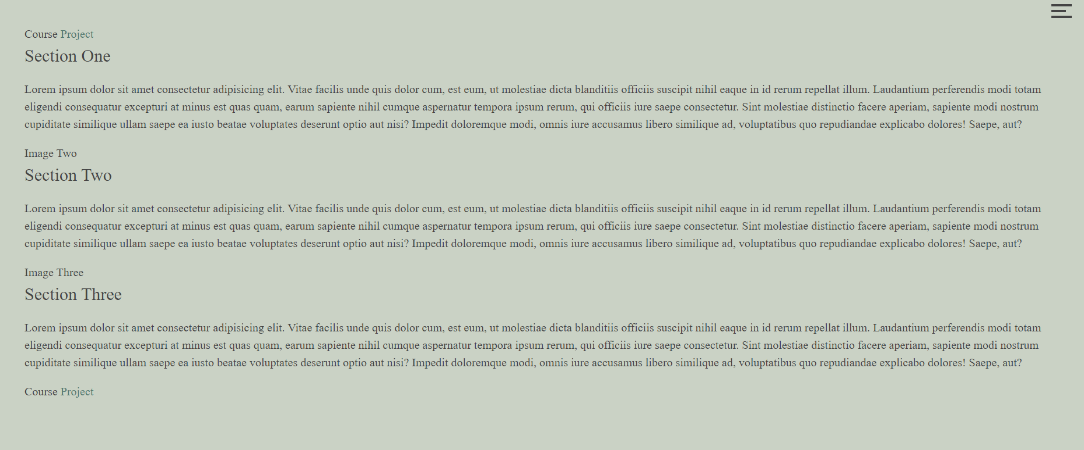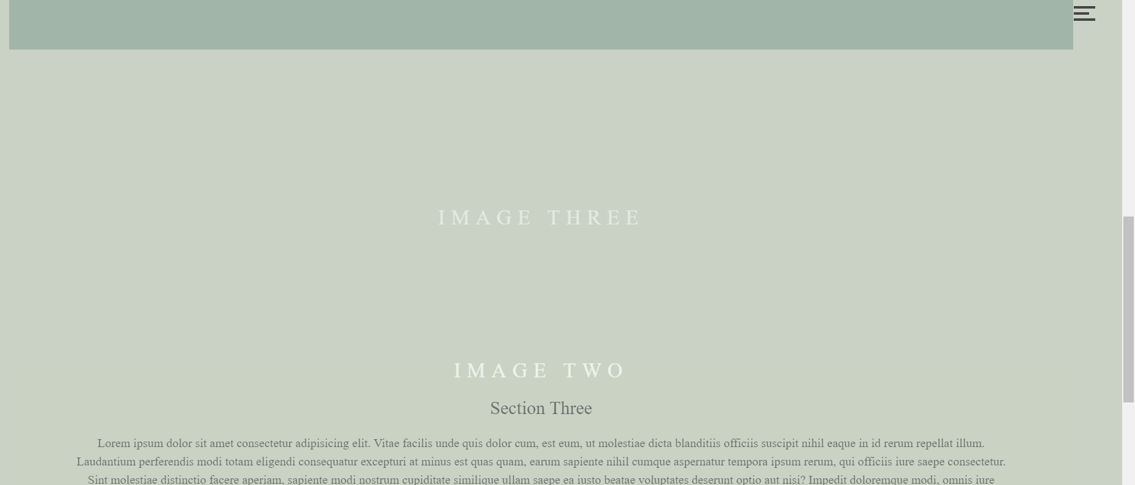

For some reason when I add CSS the order changes. I must look at existing code and if I can’t make this work, I might have to change the design.

14.6.

I continued with parallax website problem. I found the problem from html file.

There was one div missing. There also were problems with first image not showing, which I fixed by setting minimum height to 400 pixels rather than 100%. I am still a bit confused with path to images cause sometimes it works just with “../img/picture.jpg” but sometimes I need to write the whole path like “/Project/dist/img/ picture.jpg”. I have to also see what works on the deployed website, cause earlier I had problem with images not showing.

Today I also made the website more appealing as I wasn’t happy on how the site looks. The project is done. Just incase something goes wrong, I created a new repository where I first tested that everything is okay. I usually have some problems when combining code, so I thought this is the smartest thing to do at this point.

In the deployed website everything seemed fine except one page didn’t have images which I already expected to be a problem. In Live Server I could see all the pics, but in the deployed website there were none. I had to play with the path to the images again to make them visible. Apparently it takes some time before the changes update, so meanwhile I tried to fix the same problem in my Coursework directory. I got both sites working and took a video of each one.

Then I had to do the hardest part: combining everything. For this part I had to rely on Google as this is always the part that causes me problems. This part took me 2 hours because I couldn’t find any beginner friendly tutorial on how to do this and had to google almost every step. I didn’t manage to do this in cmd, so I did it by hand in the File Explorer. Everything seemed to work there.

I learned a lot during this course. It was so fun to learn more about front-end programming and using GitHub. Now I have some new tools to continue my software engineering journey.

.