**CSC236: Assignment 3**

Ruijie Sun, Wenjie Hao

7th, August, 2017

**1.**

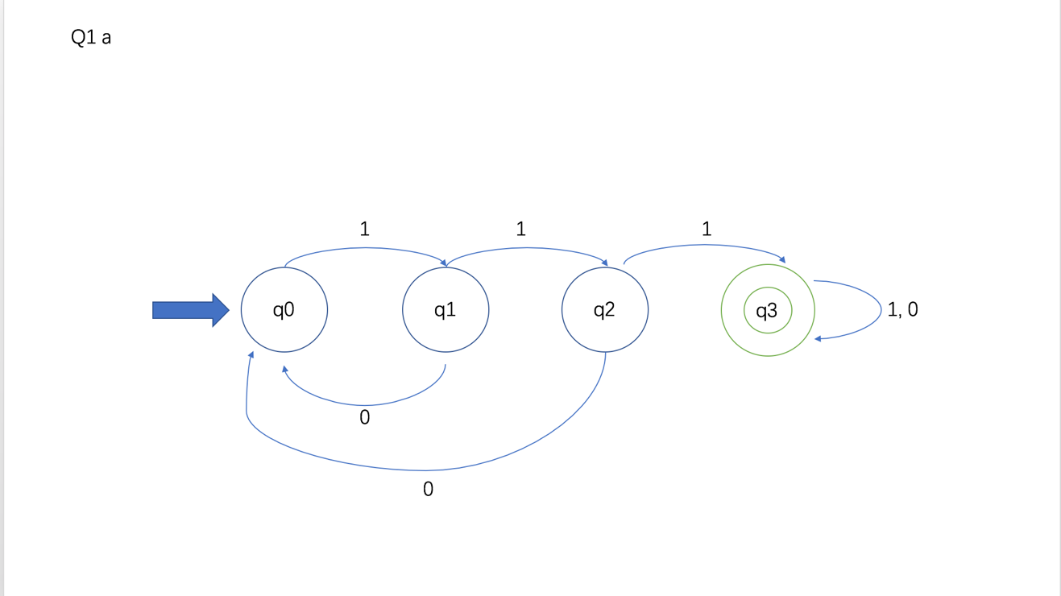

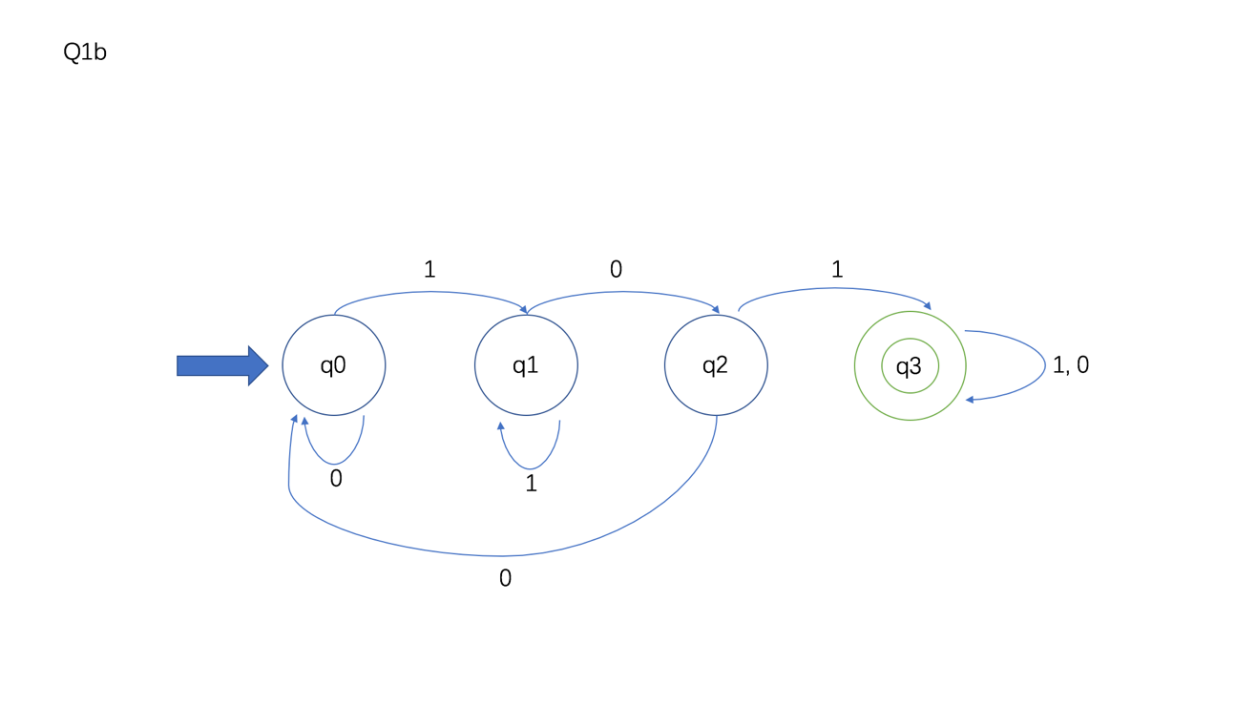

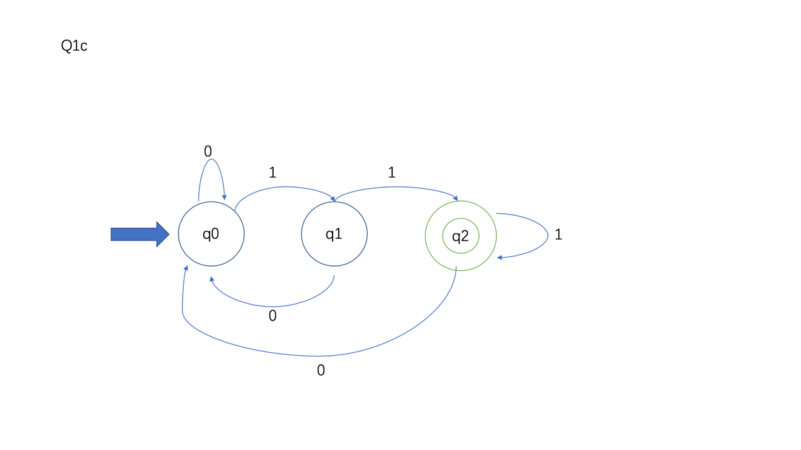

**2.**

Define P（n）: “(q, w) $⊢$* (q, $ε$)”, where |w| = n

Base Case： n = 0

w = $ε$

(q, w) $⊢^{0}$ (q, $ε$) $⊢$* (q, $ε$)

Inductive Step：

Let n = k, Assume P(k), i.e., (q, w) $⊢$* (q, $ε$), where |w| = k

Let w’ = wa. We want to show P(k+1), i.e., (q, w’) $⊢$* (q, $ε$)

(q, w’) $⊢^{0}$ (q, $wa$) $⊢^{k}$ (q, a) (By inductive hypothesis)

Then, (q, a) $⊢$ (q, $ε$)

So P(k+1) holds.

**3.**

The automation accepts the language that ends with “01” or “00”.

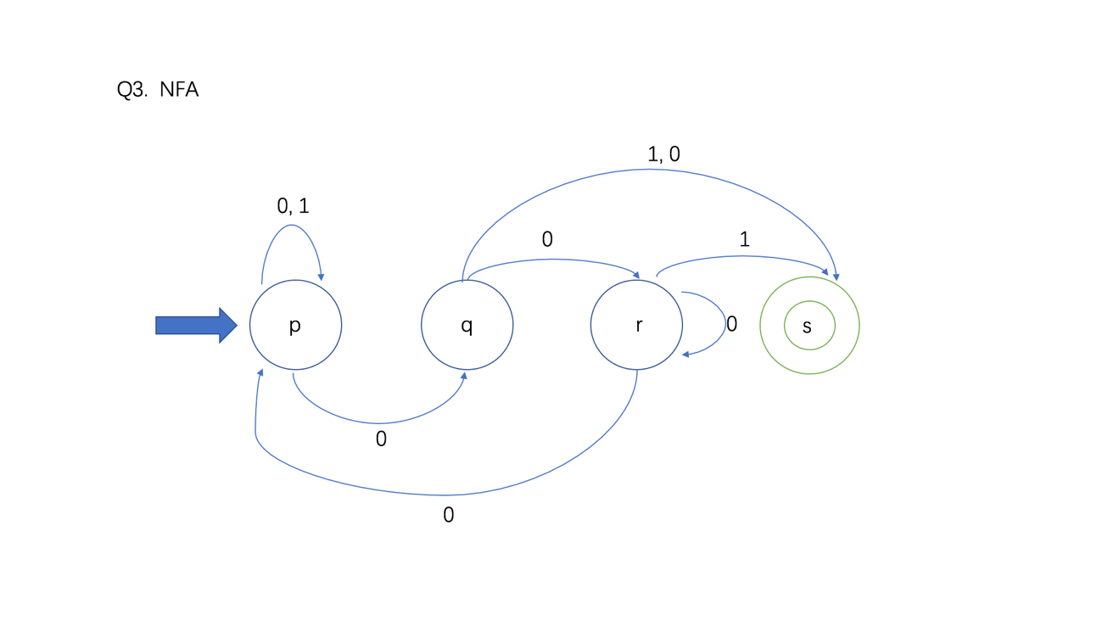

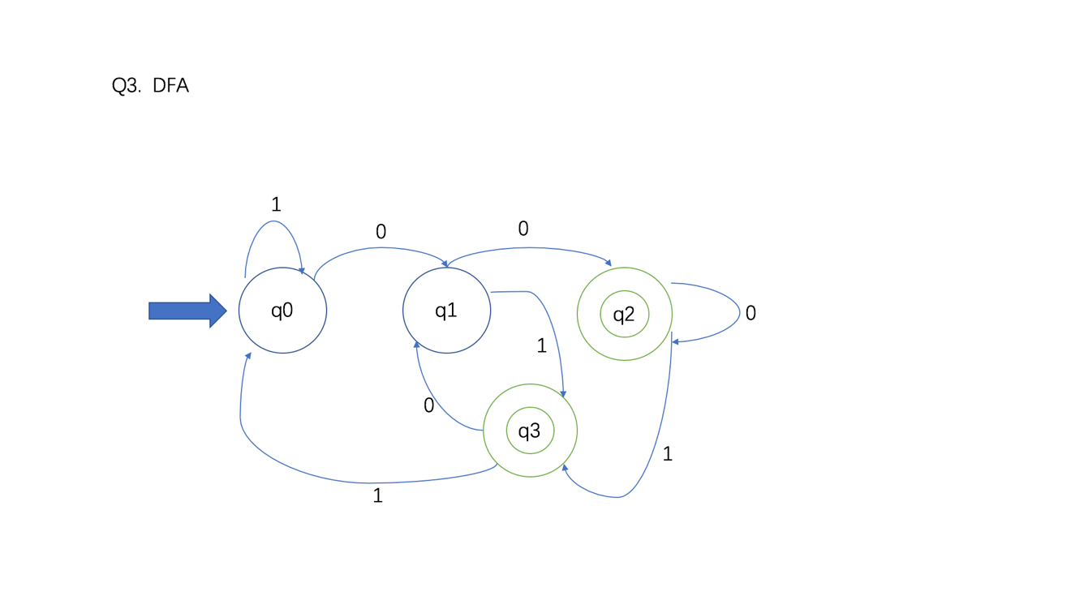

4.

a)

(0+1)* 1 (0+1) (0+1) (0+1) (0+1) (0+1) (0+1)

b)

(0+10)* (11+ $ε$) (0+10)*

c)

(0+10)* (1)*

5.

a)

The statement is False. Disprove by giving counterexample.

Let $\sum{=}\{a, b\}$, R = a, S = b

Proof for ab $∈$ L((a+b)*):

a $∈$ L((a+b)), b $∈$ L((a+b)), so ab $∈$ L((a+b)*)

Proof for ab $∉$ L(a* + b*):

ab $∉$ L(a*) and ab $∉$ L(b*), so ab $∉$ L(a* + b*)

Since ab $∈$ L((a+b)*) but ab $∉$ L(a* + b*), the statement is false.

b)

The statement is False. Disprove by giving counterexample.

Let $\sum{=}\{a, b\}$, R = a, S = b

Firstly, we know that $ε$ $∈$ L((aa*b)*), because there could be zero replication of aa*b.

However, $ε∉$ L((ab + a)*ab) because the language must contain at least “ab”. (since $ε$ $∈$ (ab + a)*)

Since $ε ∈ L($ (ab + a)*)), but $ε∉$ L((ab + a)*ab), the statement is false.

c)

The statement is False. Disprove by giving counterexample.

Let $\sum{=}\{a, b\}$, R = a, S = b

Firstly, we know that a $∈ L$ (a), then a $∈ L$ (a + b). Therefore, a $∈ L($ (a + b)*).

Secondly, a $∉$ L((a*b)), then a $∉$ L((a*b)*).

All string in the language, L((a*b)*) must contain either at least one b or is $ε$.

Since $a ∈ L((a + b)*)$, but $a∉$ L((a*b)*), the statement is false.

d)

The statement is False. Disprove by giving counterexample.

Let $\sum{=}\{a, b\}$, R = a, S = b

Firstly, we know that $ε ∈ L$ (ab + b), then ba $∈ L$ (b(ab + b)*a).

Secondly, we know that $ε ∈ L$ ((aa*b)*) and $ε ∈ L$ ((a)*), then the only possible string of the language, L(aa*b(aa*b)*), of length two is ab, so ba $∉$ L(aa*b(aa*b)*).

Since $ba ∈ L$ (b(ab + b)*a), but $ba∉$ L(aa*b(aa*b)*), the statement is false.

6.

N(k) = $\left\{\begin{aligned}0 if k=0 \\ 0 if k=1 \\ 2 if k=2 \\ 0 if k=3 \\ 2 if k=4 \\ N\left(k-2\right)+2N\left(k-3\right) if k>4\end{aligned}\right.$

Explanation: If k is greater than 4, it is clear that the string that is accepted by the automaton must end with 11 or 010 or 001.

Case 1: if the string that is accepted by the automaton ends with 11. It means that we can get the target string of length k by concatenating each accepted string of length (k-2) with 11.

Case 2: if the string that is accepted by the automaton ends with 010 or 001. It means that we can get the target string of length k by concatenating each accepted string of length (k-3) with 010 or 001.

Therefore, if k is greater than 4, N(k) = N(n-2) + 2N(k-3).

Then N(14) = N(12) + 2N(11)

= N(10) + 2N(9) + 2(N(9)+2N(8))

= N(10) + 4N(9) + 4N(8)

= N(8) + 2N(7) + 4(N(7)+2N(6)) + 4(N(6)+2N(5))

…

= 114

7.

a)

1. Suppose L is regular.

2. Let n be the pumping constant.

3. Choose w = 0n1m0n (Note that w ∈ L and m, n )

4. By PL, w can be factored into xyz such that |xy| ≤ n, |y| > 0 and, for all i ≥ 0, xyiz ∈ L 5. Since |xy| ≤ n and |y| > 0, x = 0p, y = 0q, z = 1m0n where p + q = n, p ≥ 0, q > 0, then p < n.

6. Consider i = 0, then xyiz = xz = 0p1m0n ∈ L. We have obtained a contradiction of the assumed regularity of L. (Since p < n )

7. Hence, L is not regular

b)

1. Suppose L is regular.

2. Let n be the pumping constant.

3. Since L = {w∈{0,1}*|w is palindrome}, we choose w = 0n1m0n (Note that w ∈ L and m, n )

4. By PL, w can be factored into xyz such that |xy| ≤ n, |y| > 0 and, for all i ≥ 0, xyiz ∈ L 5. Since |xy| ≤ n and |y| > 0, x = 0p, y = 0q, z = 1m0n where p + q = n, p ≥ 0, q > 0, then p < n.

6. Consider i = 0, then xyiz = xz = 0p1m0n ∈ L. We have obtained a contradiction of the assumed regularity of L. (Since p < n )

7. Hence, L is not regular

**8.**

Define automata which accepts language L:

M = {Q, S, $\sum{, } δ, F$}

Define reversal automata which accepts LR.

M’ = {Q, S’, $\sum{, } δ^{R}, \{S\}$}

* $∀p,q∈Q,$ (q, $σ, p$) $∈ δ^{R}$ $⟺$ (p, $σ, q$) $∈ δ.$
* $∀f∈F,$ (S’, $ε, f$) $∈ δ^{R}$

$Now S is the new single final states.$

Define M’’ which accepts language $\frac{1}{2}$ (L).

M’’ = (Q, S, $\sum{, } δ, F'$)

F’ = $\bigcup_{w∈L}{q_{i },(where n=\left|w\right|, w=xy, \left(S, w\right)⊢_{ δ}^{\frac{n}{2}}\left(q_{i , }y\right) and \left(S', w^{R}\right)⊢_{ δ^{R}}^{\frac{n}{2}+1}\left(q_{i , }x\right))}$