

Subject:

Video Conference Chatting

Realized by :

FARABY YOUSSEF

1-analysis and conception:

The first step of the conception is to analyze the situation to take into account the requirements, this chapter allows us to identify all the features of our application for each type of users by identifying the functional needs. These functional are modeled by appropriate UML diagrams.

An actor represents a role played by an external entity which interacts directly with the system, He can consult and / or directly modify the state of the system, In the case of our system, we have identified the following actors:

* User: a person that gets access to the application and chooses either to be an admin or to be just a member.
* Admin: creates a room and become its admin he can invite/ban members and gives admin privileges to members, also can broadcast/stop their webcams.
* Member: users that are waiting the invitation from an admin to join his room.

A functional need is an action that a system must be able to perform, in this part, we will list the different needs that the system must provide. In our context the system must allow the following tasks:

* Create a room: the admin can create his room with all the privileges (send invitation, ban members…...).
* Go to salon: When a member wants to assist a conference, he will wait for the invitation from an admin in the salon.
* Add members: the admin has the privilege to add members in his room
* Ban members: the admin has also privilege to ban members.
* Send call: the admin can start the conference.
* Grant privilege: the admin affects admin privileges to members of the group.
* Broadcast and stop webcam: The admin has the privilege to broadcast and stop webcam.
* Accept an invitation: the members accept invitation for joining to the room.

We collect all identified use cases, in a general diagram as in the figure.

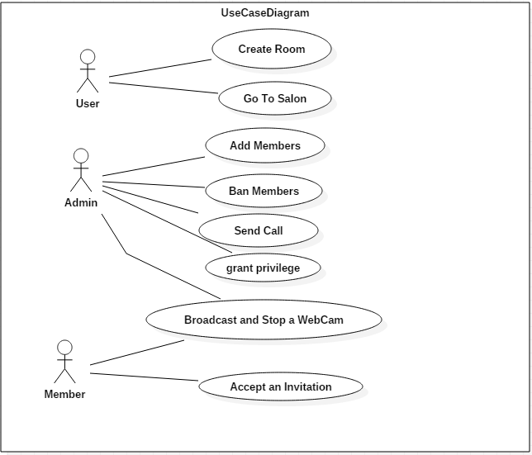

2-Tools:

This chapter is dedicated to the practical part of the realization of our web application. It comprises a description of the development tools used, the choice was mainly based on the free and open source following tools:

EasyRTC OpenSource is:

* A browser client library written in JavaScript. This client handles the signaling and to a large extent insulates applications from ongoing changes in the WebRTC api.
* A signalling server based on Node.js. Node.js runs on platforms as small as a single core Raspberry Pi (first edition) to servers in the cloud.

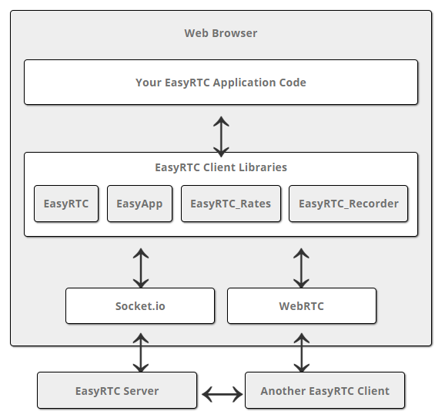

EasyRTC is a full-stack open source WebRTC toolkit suitable for building highly secure, WebRTC applications. It is a bundle of web applications, code snippets, client libraries and server components meticulously written and documented to work right out of the box.WebRTC is a technology that allows two peers to communicate peer-to-peer, that is to say, to exchange data that doesn't go through a server.

Webix :

Webix is a flexible and extremely fast JavaScript UI framework with HTML5 widgets for developing cross-platform HTML5 and CSS3 compatible web and mobile apps. It’s an ideal tool for building rich and powerful apps that can operate on all popular platforms.

3-Realization:

First, the user chooses either to be a group administrator and create a room, or to be a member of a conference and stays in the Waiting room

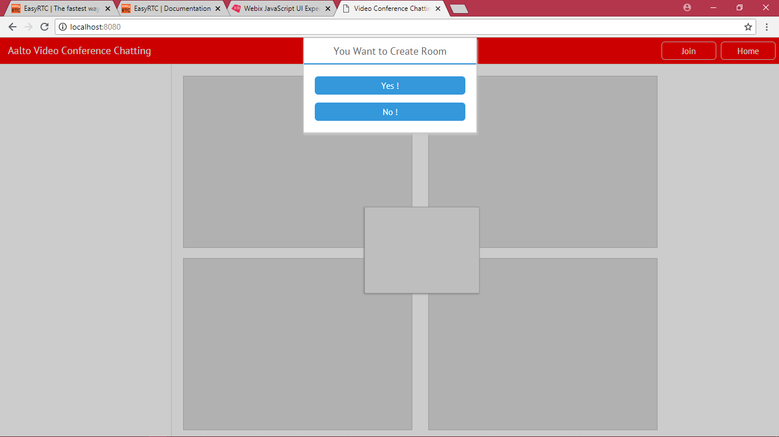

When a user chooses to be member, he waits for an invitation from an admin.

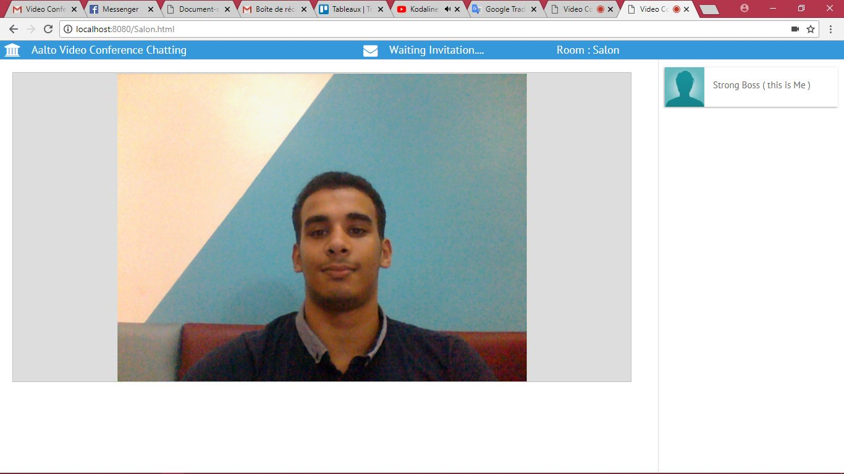

when a user chooses to be an admin of the room, he can send a invitation to members who are waiting in the salon waiting for his invitation.

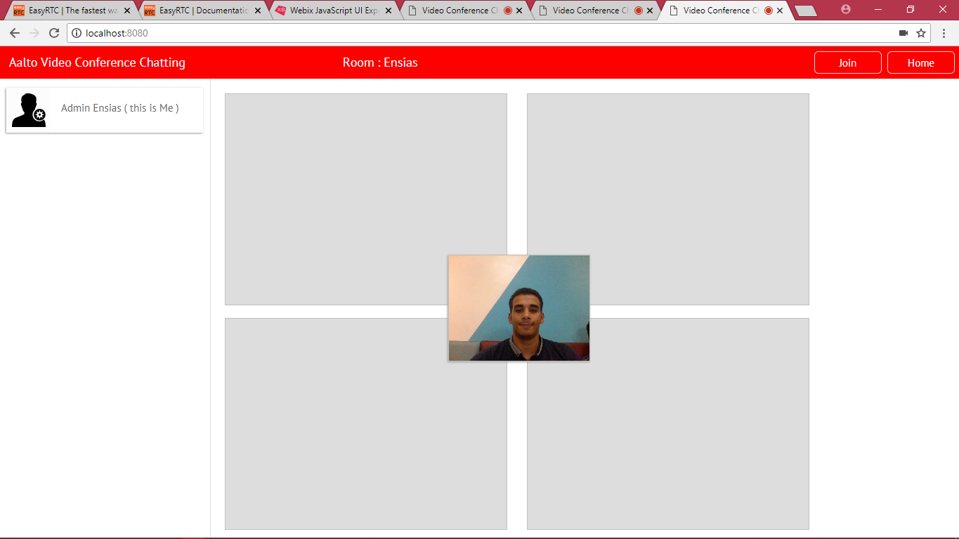

After receiving an invitation from an admin , the member can either accept or deny it , by accepting it he joins the conference room .

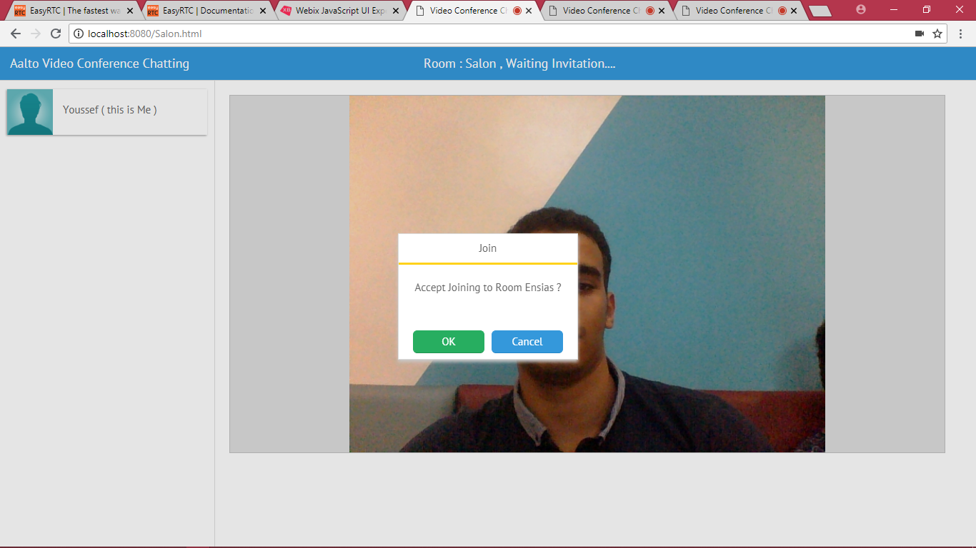

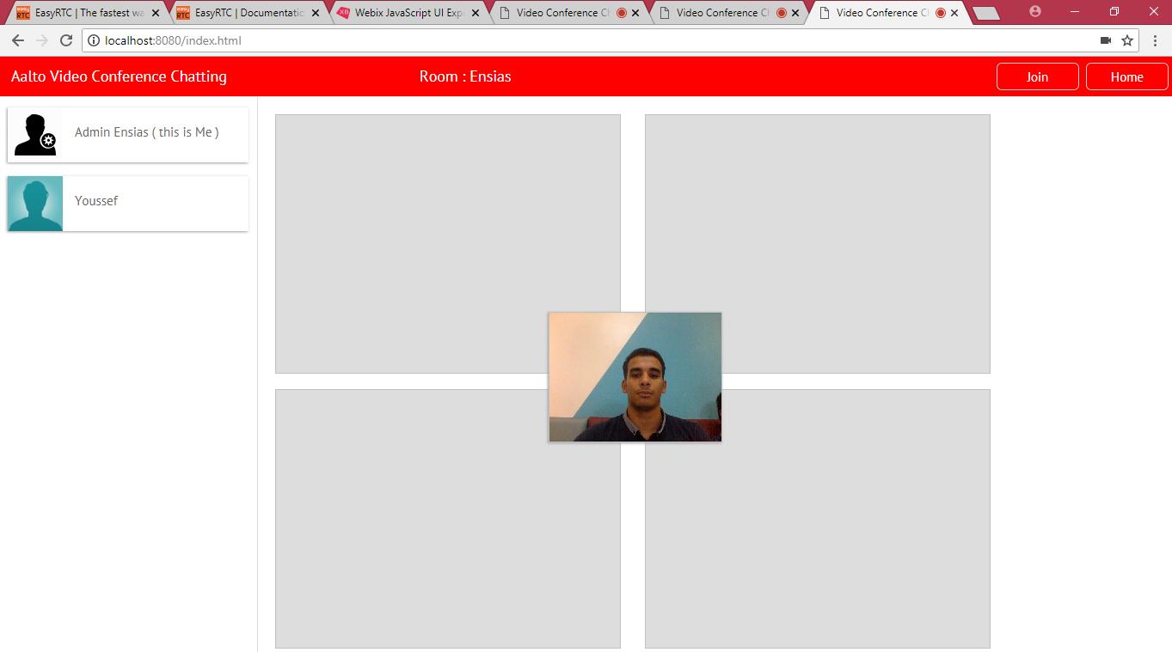

Finally, the admin and the members are gathered in one single room to start the conference, organized by the admin.

