

Subject:

Video Conference Chatting

Realized by:

FARABY YOUSSEF

1. Introduction

This report is a continuation of the progress made last week illustrating the changes concerning the architecture of the task, the following parts well demonstrate these changes.

1. Analyze and Conception

With the help of the following sequence diagrams, we will illustrate the flow of using the application.

The user logs in with a login form, the system verifies the given information, and send the user to a page where he can create a room and display its page.

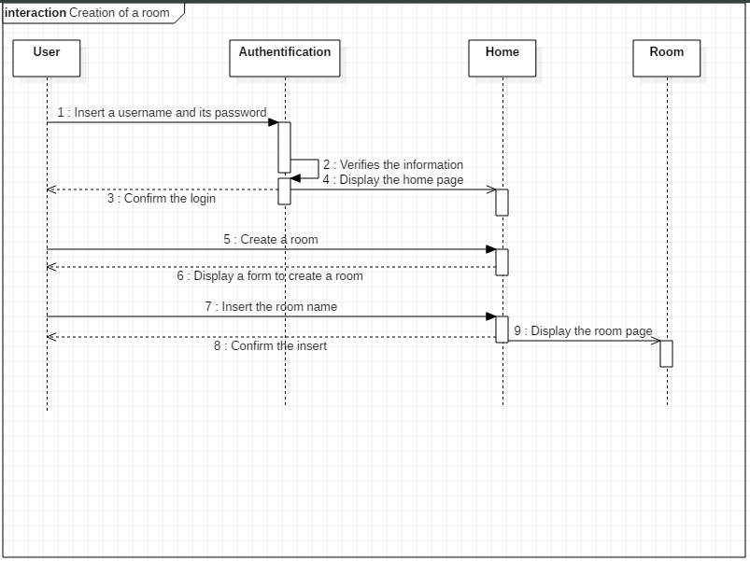

After authenticating, the user can visualize all the rooms he has created ,choose one and add users to his room

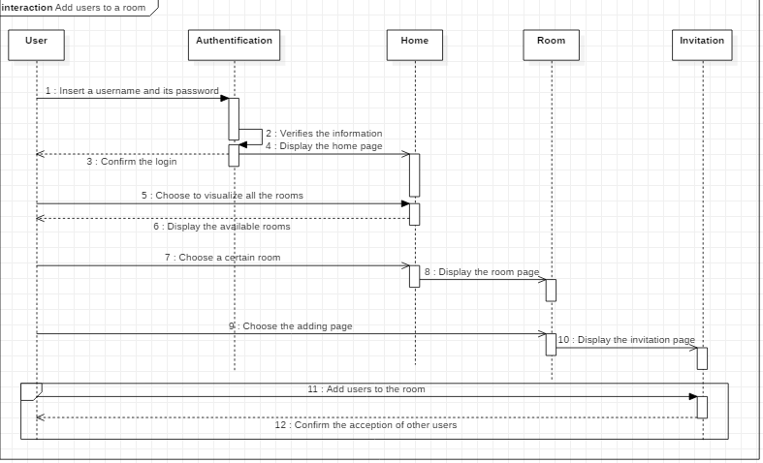

1. Architecture

This chapter is dedicated to the practical part of the realization of our web application. It comprises a description of the development tools used, the choice was mainly based on the free and open source following tools:

The above diagram shows the architecture of the application. As it follows the model-view-controller the front end is developed using bootstrap and AngularJS and in the backend we have Django which is a python framework. In the front end we access data with REST API. To build the web API we need Django-rest-framework.

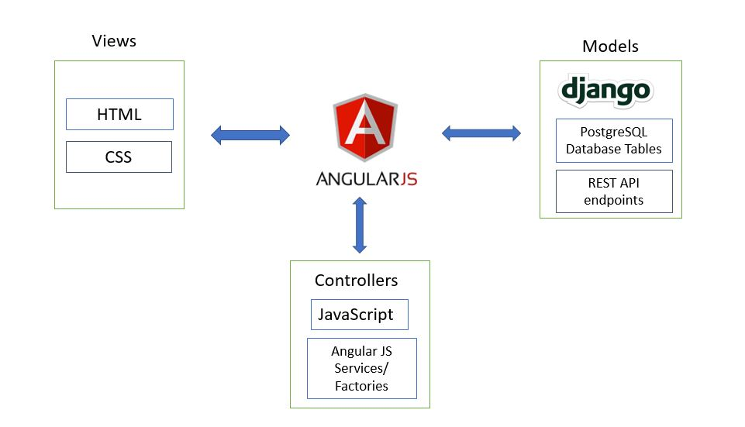

Front-End

* AngularJs

AngularJS is a JavaScript-based open-source front-end web application framework mainly maintained by Google and by a community of individuals and corporations to address many of the challenges encountered in developing single-page applications.

Back-End

Django Rest Framework (DRF) is a library which works with standard Django models to build a flexible and powerful API for your project.

Basic Architecture

A DRF API is composed of 3 layers: the serializer, the viewset, and the router.

Serializer: converts the information stored in the database and defined by the Django models into a format which is more easily transmitted via an API

Viewset: defines the functions (read, create, update, delete) which will be available via the API

Router: defines the URLs which will provide access to each viewset

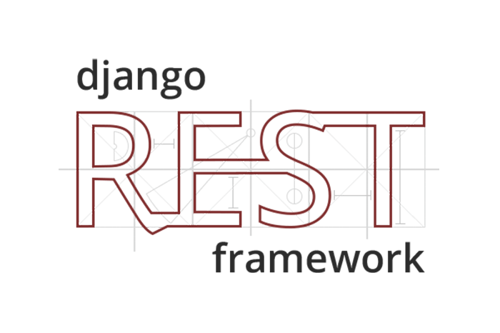

It is mandatory now to build project on 3 scales, a backend rest end point application front end application and an EasyRtc application.

4 - Realization

After defining the user model, Django has a built-in authentication system that coordinate with the user model. With the built-in system we can generate the signup form.

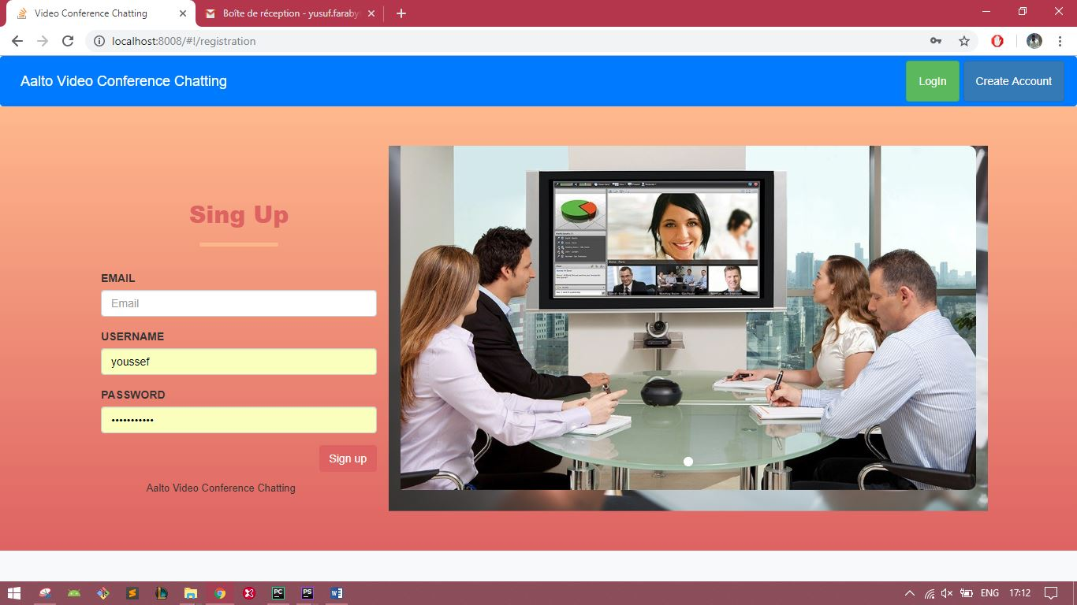

After the registration the user is redirected to the login page which is again handled by the Django authentication system

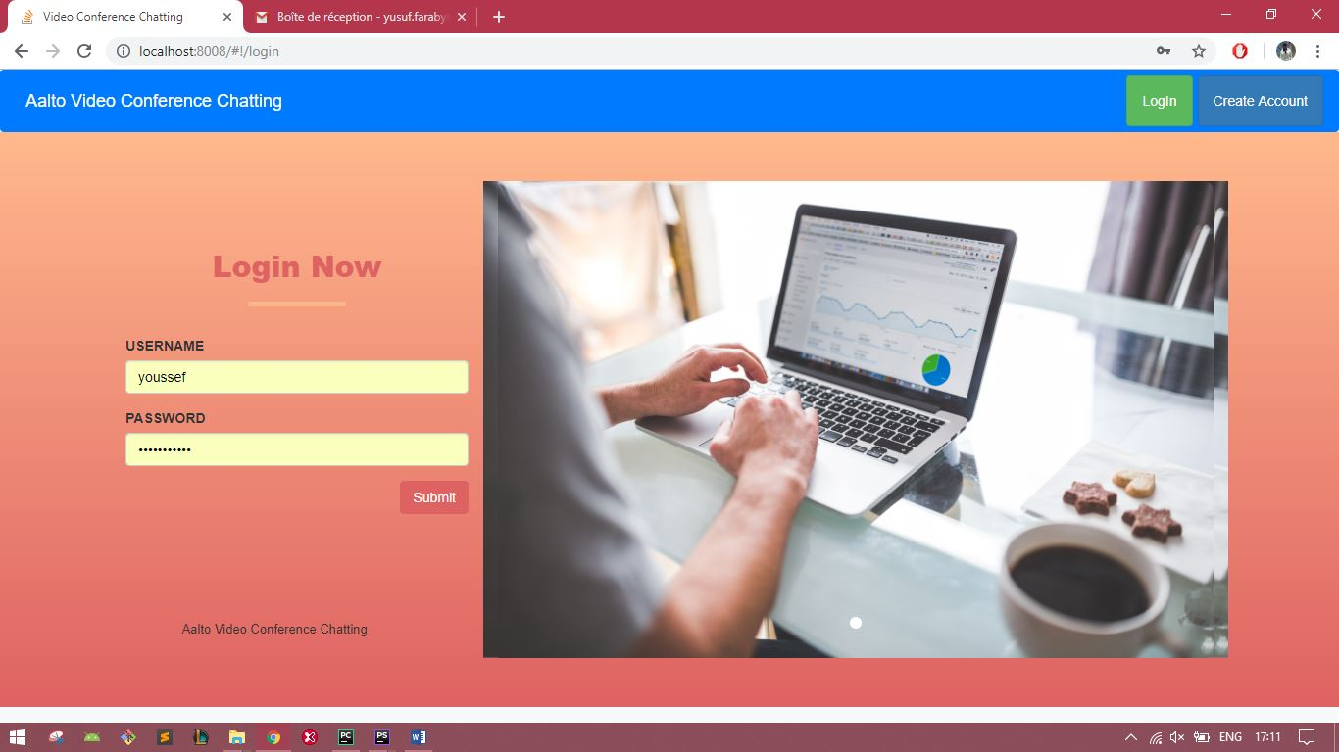

When the user is successfully logged in the app redirects the user to the home. The user has 3 choices, display his rooms, create a new room, join the salon to wait for an invitation from another user.

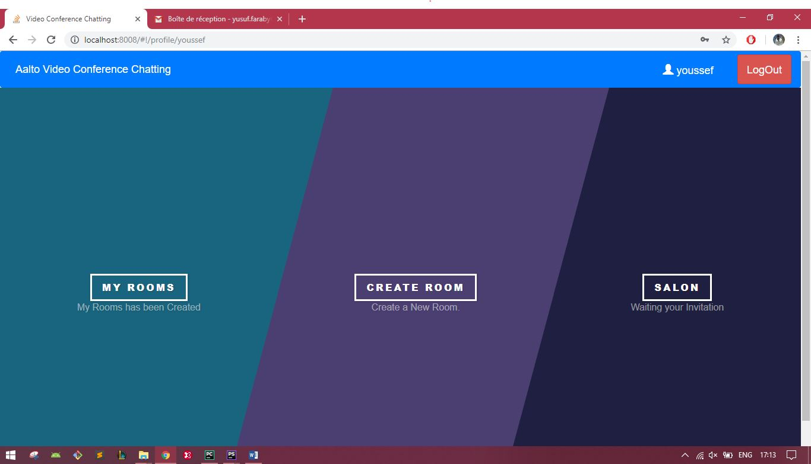

This is the form to create a new room and consult the list of his rooms.

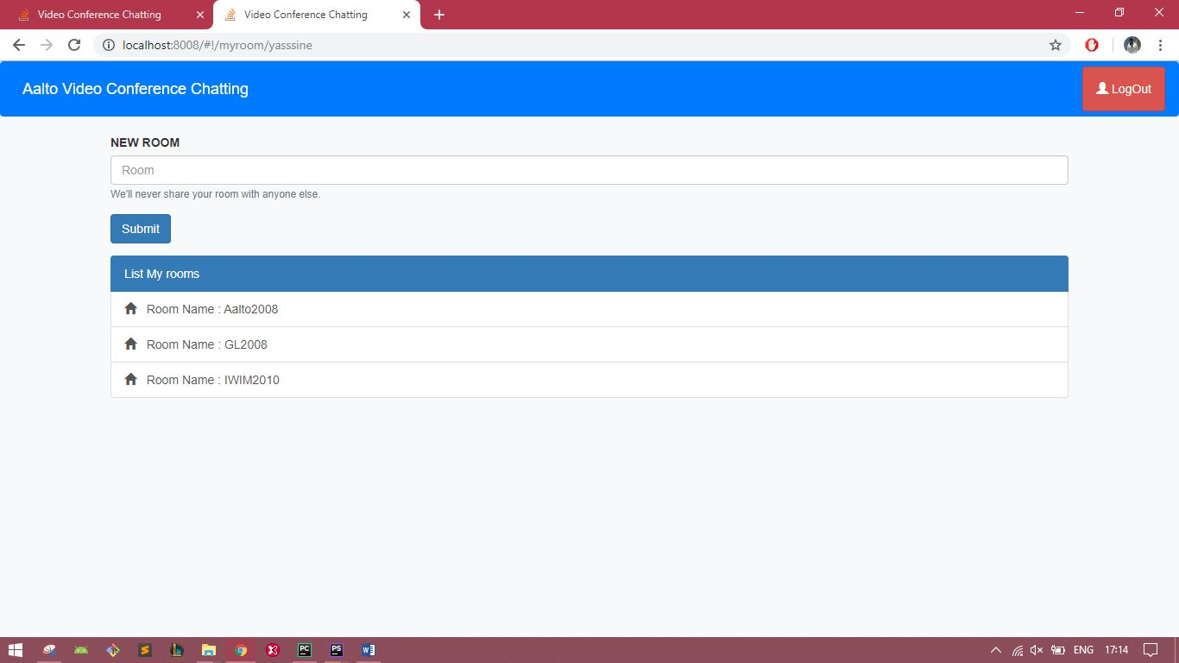

If the user chooses to join his room, he can invite other members and he can Finally be gathered in one single room to start the conference, organized by the him.

