1. To disable the root account password, use the following passwd syntax:

sudo passwd -l root

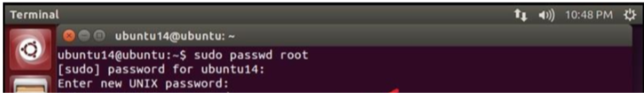

1. However, to disable the root account itself, use the following command:

usermod --expiredate 1

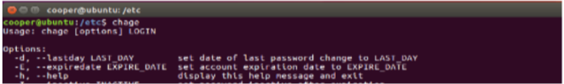

1. You should read more on *Sudo* by reading the man page:

man sudo

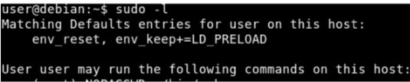

1. To add a user account, use the following syntax, and follow the prompts to give the account a password and identifiable characteristics, such as a full name, phone number, etc.

sudo adduser username

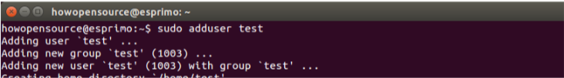

1. To delete a user account and its primary group, use the following syntax:

sudo deluser username

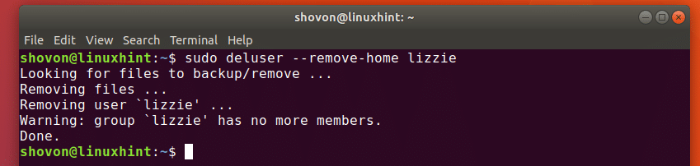

1. To temporarily lock or unlock a user account, use the following syntax, respectively:

sudo passwd -l username

sudo passwd -u username

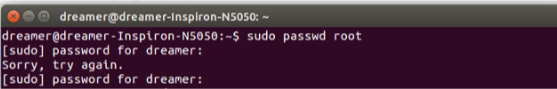

1. To add or delete a personalized group, use the following syntax, respectively:

sudo addgroup groupname

sudo delgroup groupname

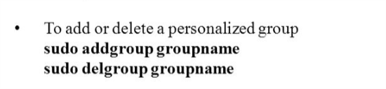

1. To add a user to a group, use the following syntax:

sudo adduser username groupname

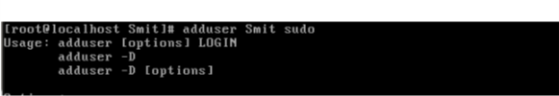

1. To show all groups , use the following syntax:

$ groups

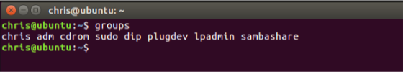

1. To easily view the current status of a user account, use the following syntax:

sudo chage -l username

