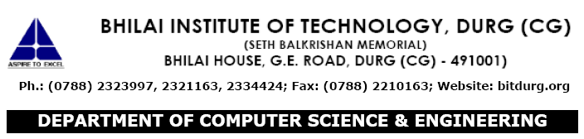

**CERTIFICATE OF COMPLETION**

This is to certify that Mr. Ashish Ekka is bonafide students of B.E. **IVth sem** during Academic Session 2016 – 2017 in the Department of Computer Science and Engineering, Bhilai Institute of Technology, Durg, Chattisgarh has successfully completed all the Experiments of laboratory: **322464(22) GUI programming (VB/Gambus/ Other tools)** within specified time of academic session 2016 – 2017.

**Approved by:**

Head of the Department Prof. In charge

Dr. (Mrs) M. V. Padmavati Prof. Sumit Sar