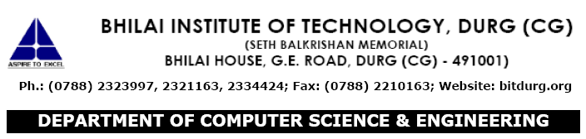

**CERTIFICATE OF COMPLETION**

This is to certify that Mr./Ms <S. D Mishra> is bonafide students of B.E. **III rd sem** during Academic Session 2016 – 2017 in the Department of Computer Science and Engineering, Bhilai Institute of Technology, Durg, Chattisgarh has successfully completed all the Experiments of laboratory: **322361 ( 28 ) Basic Electronics Lab** within specified time of academic session 2016 – 2017.

**Approved by:**

Head of the Department Prof. In charge

Dr. (Mrs) M. V. Padmavati (Mr. S. D. Mishra)