BIT BOYS HOSTEL – GANESH MAHOTSAV 2K17

QUIZ COMPETETION PRELIMS

|  |  |  |  |
| --- | --- | --- | --- |
| Name: |  |  |  |
| Branch/Sem: |  |  |  |
| Phone No: |  |  |  |

# Instructions

1. Attempt all the questions.
2. Tick the correct option to answer.
3. Each question carries 1 mark.
4. There is no negative marking.
5. Max Time: 30 minutes
6. Who is the current railway minister?
7. Mayawati
8. Mamta Banerjee
9. Suresh Prabhu
10. Sashi Tharoor
11. Where is the headquarters of WHO located?
12. Geneva
13. Paris
14. Washington DC
15. London
16. Who is the supreme commander of the Indian Armed Forces?
17. General Of Army
18. Field Marshal
19. President
20. Prime Minister
21. Where is Bhakra Nangal Dam situated?

1. Himachal Pradesh

2. Orrisa

3. Uttrakhand

4. Jammu & Kashmir

1. How many player of Kho-Kho team can play on the field during the match?

1. 10

2. 9

3. 7

4. 8

1. In July 2017, Narendra Modi became the first Prime Minister of India to visit which of the following country:

1. Israel

2. Saudi Arabia

3. Germany

4. Qatar

1. What exactly are the ancient pyramids of Giza?

1. Granaries

2. Lighthouse

3. Tomb

4. Palaces

1. In the context of light, if we mix all the seven colours of rainbow, what be the resultant colour?

1. Maroon

2. White

3. Black

4. Dark Blue

1. Which state was Ram Nath Kovind serving as Governor just prior to his election as the President of India

1. Uttar Pradesh

2. Bihar

3. Jharkhand

4. Rajasthan

1. Which social networking site has the logo of a “Bird”?

1. Snapchat

2. Tumblr

3. Rediff

4. Twitter

1. Which is the nearest star to the Planet Earth?

1. Moon

2. Red Giant

3. Neutron

4. Sun

1. Where was the IIFA 2017 held?

1. Macau

2. Abu Dhabi

3. New York City

4. Venice

1. Capital of Austria is:

1. Berlin

2. Vienna

3. Venice

4. Macau

1. Which of these is not a capital of South Africa:

1. Cape Town

2. Johannesburg

3. Bloemfontein

4. Pretoria

1. Youngest Indian women to win an Olympic Medal is:

1. Sakshi Mallick

2. P.V Sindhu

3. Mary Kom

4. Geeta Phogat

1. Davis Cup is related with which sports?

1. Football

2. Badminton

3. Squash

4. Tennis

1. Which country won the first Cricket World Cup in 1975?

1. Australia

2. Sri Lanka

3. West Indies

4. Zimbabwe

1. First batsman to complete 10,000 runs in test cricket is:

1. Sachin Tendulkar

2. Sunil Gavaskar

3. Mohindra Amarnath

4. Ricky Pointing

1. Where was the 2007 cricket ODI world cup held?

1. South Africa

2. West Indies

3. England

4. Australia / New Zealand

1. Michael Fred Phelps is associated with which of the following sport.

1. Athletics

2. Swimming

3. Shooting

4. Gymnastic

1. How many Oscar did the movie Slumdog Millionaire won?

1. 6

2. 7

3. 8

4. 4

1. Who is the director of the movie “Batman : The Dark Knight”?

1. James Cameron

2. Michael Bay

3. Christopher Nolan

4. Stan Lee

1. Between whom was the 2nd Battle of Panipat was fought?

1. Babur – Ibrahim Lodhi

2. Hemu – Akbar

3. Humayun – Sher Shah Suri

4. Ahmad Shah – Sadashivrao

1. CEO of Amazon:

1. Elon Musk

2. Kunal Bahl

3. Jeff Bezos

4. Evan Spiegel

1. Currency of Thailand

1. Rial

2. Rupiah

3. Dinar

4. Baht

1. Which of the following is not a valid Android version?

1. Oreo

2. Cupcake

3. Donut

4. Honey Lemon

1. Identify the following Logo:

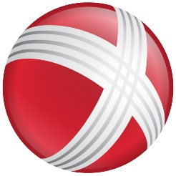

|  |
| --- |
|  |

1. Identify the Personality:

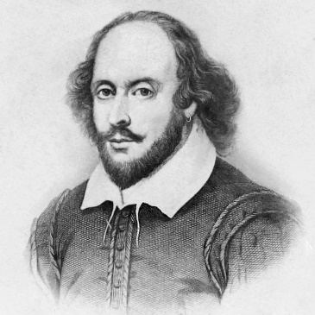

|  |
| --- |
|  |

1. MNREGA stands for:
2. Provide abbreviation for MOAB: