**Temporal variations of the multispectral night sky brightness on Tenerife Island**

Theme: Measurement and Modelling

C. Marseille,1* M. Aubé,1,2,3 , 4 Emilio Cuevas, 1 Norman T. O’Neill

*1 Université de Sherbrooke, Sherbrooke, Canada*

*2 Cégep de Sherbrooke, Sherbrooke, Canada*

*3 Bishops University, Sherbrooke, Canada*

*4 Izaña Atmospheric Research Center (AEMET), Santa Cruz de Tenerife, Spain*

*charles.marseille@usherbrooke.ca*

*\* presenting author*

Light pollution on Tenerife Island is a concern for astronomers inasmuch as it gives rise to artificial sky brightness which impairs astronomical observations. It is known that the short term temporal variation of the sky brightness can depend on the variation of the lighting levels at night but also on the local aerosol content of the atmosphere. Variation of the lighting levels is directly correlated with human activity: this implies that it is, in most cases, similar from one night to another. This, however, is clearly not the case for nighttime variation of aerosol content. In this communication we present the nightly sky brightness evolution over an annual period at three different sites on Tenerife Island: Santa Cruz de Tenerife (Urban site at sea level), Teide Observatory (2390m elevation) and Teide peak Observatory (Terminal of the Teide cable car, 3555m elevation) near the highest peak on the island. A CoSQM radiometer (a Sky Quality Meter (SQM) equipped with 5 visible-band filters) was installed at each location. Multispectral measurements of the sky brightness are related to the spectral properties of the aerosol optical depth that, in turn, are correlated in a first order sense, with the size distribution of the aerosol population. We must, however, first distinguish the effect of possible color-change trends in the nighttime lighting. Given the close vicinity of the 3 sites (less than 40 km apart), similarities in the relative aerosol optical depth variability at each site were observed. With the help of nighttime and daytime aerosol optical depth measurements acquired by sun and moon photometers from each AERONET (AErosol RObotic NETwork) site radiometers, we compare the aerosol optical depth and the sky brightness in typical atmospheric conditions. The effect of the "calima", relatively high mineral dust aerosol loading episodes caused by Saharan dust outbreaks, known to be linked to high aerosol optical depth short term variations, is also analyzed. 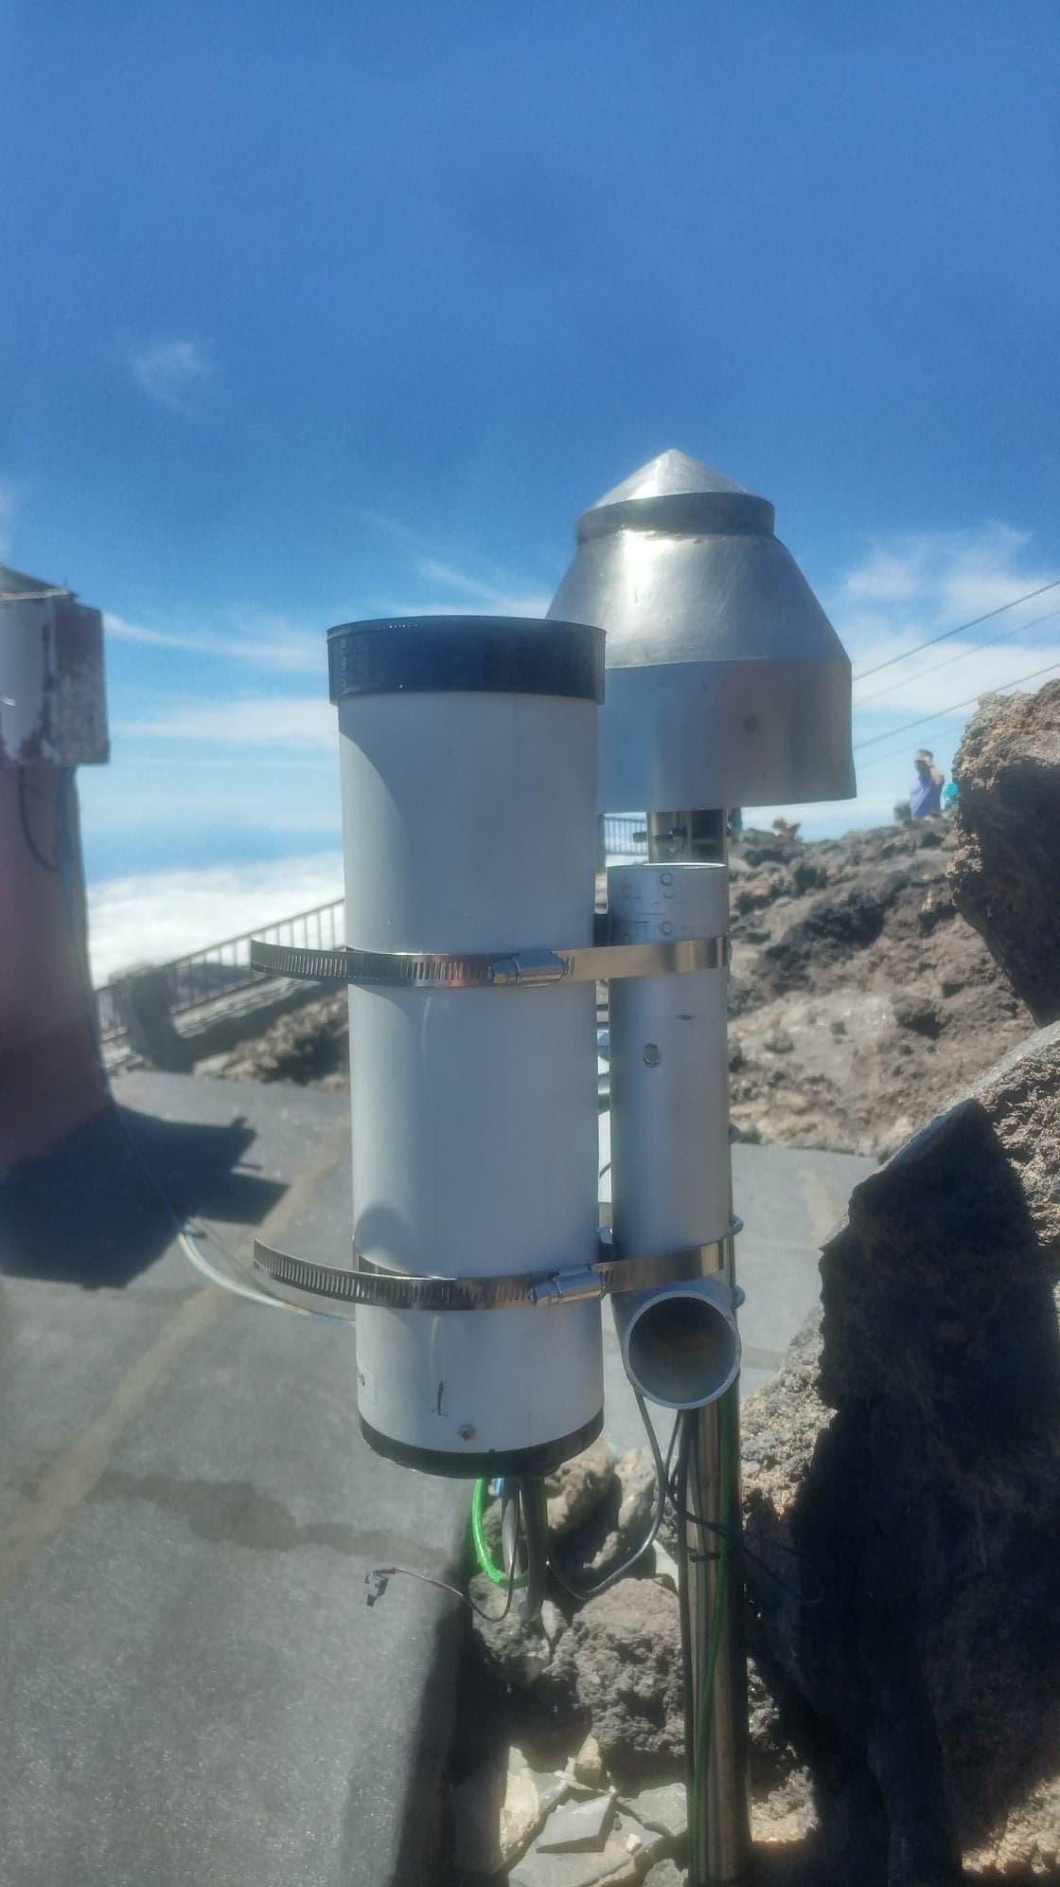

**References**

Sanchez de Miguel, A., Aubé M., Zamorano, J., Kocifaj, M., Roby, J., Tapia, C. (2017). Sky Quality Meter measurements in a colour-changing world, *Mon Not R Astron Soc*, 467(3), 2966-2979.

Aubé, M. CoSQM User manual, <https://w1.cegepsherbrooke.qc.ca/~aubema/index.php/Prof/Cosqm-users-manual>

[Aubé](https://www.spiedigitallibrary.org/profile/Martin.Aube-44809), M., [Franchomme-Fosse](https://www.spiedigitallibrary.org/profile/notfound?author=L._Franchomme-Fosse), L., [Robert-Staehler](https://www.spiedigitallibrary.org/profile/notfound?author=P._Robert-Staehler), P., [Houle](https://www.spiedigitallibrary.org/profile/notfound?author=V._Houle), V., (2005). Light pollution modelling

and detection in a heterogeneous environment: toward a night-time aerosol optical depth retreival method*, Proc. SPIE 5890, Atmospheric and Environmental Remote Sensing Data Processing and Utilization: Numerical Atmospheric Prediction and Environmental Monitoring*, 589012