CAREL – Confidential



**REQUIREMENTS SPECIFICATION**

Gateway Middle End  
rev. 0.05

DRAFT CONFIDENTIAL

Index

[Index 2](#_Toc31638613)

[Revision 3](#_Toc31638614)

[Definitions, acronyms, and abbreviations 4](#_Toc31638615)

[1 Introduction 5](#_Toc31638616)

[1.1 Scope of RS 5](#_Toc31638617)

[2 Hardware Requirement Specification 6](#_Toc31638618)

[2.1 2G Model 6](#_Toc31638619)

[2.2 WiFi Model 8](#_Toc31638620)

[3 Production 9](#_Toc31638621)

[3.1 Labels 9](#_Toc31638622)

[3.2 Packaging 9](#_Toc31638623)

[3.3 GTW000MGP0 - CLOUDGATE BASIC WIRELESS 2G - 1 RS485 9](#_Toc31638624)

[3.4 GTW000MGT0 - CLOUDGATE BASIC WIRELESS 2G - 1 RS485 - THIRD PARTY CLOUD 10](#_Toc31638625)

Revision

|  |  |  |  |
| --- | --- | --- | --- |
| Rev. | Rev. date | Author | Note |
| *0.01* | *xx/09/2019* | *A.Bilato* | Initial draft |
| 0.02 | XX/10/2019 | *A.Bilato* | Added production notes |
| 0.03 | 10/10/2019 | *A.Bilato* | Added request for 2G HW |
| 0.04 | 02/01/2020 | A.Bilato | Revised due to some decision - use 2 PCB, WiFi and 2G  - ESP32 chip |
| 0.05 | 21/01/2020 | A.Bilato | Added note about TTL interface  Removed memory sect.  Added led. |
|  |  |  |  |
|  |  |  |  |
|  |  |  |  |
|  |  |  |  |
|  |  |  |  |
|  |  |  |  |
|  |  |  |  |
|  |  |  |  |
|  |  |  |  |
|  |  |  |  |
|  |  |  |  |

Definitions, acronyms, and abbreviations

GME = Gateway Middle End  
FW = firmware

IoT = Internet of Things

OTA = Over The Air

SW = software

CAREL server = the cloud system of CAREL  
CCL = CAREL Cloud Library

GTW000MGT0 = CLOUDGATE BASIC WIRELESS 2G - 1 RS485 -   
 THIRD PARTY CLOUD

GTW000MGP0 = CLOUDGATE BASIC WIRELESS 2G - 1 RS485

GTW000MWT0 = CLOUDGATE BASIC WIRELESS WI-FI - 1 RS485

1. Introduction
   1. Scope of RS

This is the requirement specification for the Gateway Middle End (GME) that will be available in two version 2G and WiFi, in short, this device will be able to:

1. monitoring one (1) device through an RS485 port, or a TTL serial half duplex port, through Modbus protocol
2. log some variables in the internal memory (RAM) for a very limited time slot,  
   this to reduce the number of transfer to the cloud
3. transfer the logged variables to the CAREL cloud through MQTT
4. Receive some variables values from the CAREL cloud MQTT and transmit it to the connected device.
5. Transfer data to a target via Modbus file transfer
6. receive a device model definition file from the CAREL cloud,  
   this file contain the map of the variables that the GME read from the connected target
7. receive security certificate file from the CAREL cloud

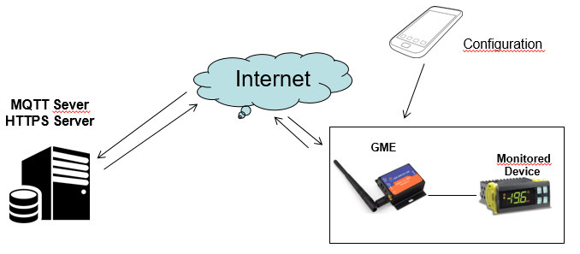

1. Hardware Requirement Specification
   1. 2G Model

As agreed, the new device will be based on a new design with an ESP32-WROVER used as processor and a Quectel M95FA-03-STDN as a modem via AT commands.

The requirements are:

1. A form factor like the USR-GPRS-730 model this to meet the requirements of CAREL customer in term of size.
2. A new polycarbonate (graphic design by CAREL)
3. RS485 with 3 pole removable screw terminal 3.81mm type (or 5.08mm),  
   green color as CAREL standard.
4. A TTL serial port with the same pin out of the GTW000WT.  
   This port work in alternative to the RS485 port.
5. The led.  
   The USR-GPRS-730 enclosure have 5 holes for the led, we refer below to the   
   name of these led to easy understand the correspondence:  
     
   - POWER : connected to the internal power supply indicate that the unit is powered and also that the internal power supply is running properly.  
     
   - GPRS : this led is connected to the Quectel M95FA pin 13 (NETLD) and indicate that the connection to the GSM network is established.  
     
   -WORK/LINK\_A/LINK\_B : are connected to the ESP32-WROVER chip to the pins

|  |  |  |
| --- | --- | --- |
| **Function** | **Pin number** | **Pin name** |
| WORK | 12 | IO27 |
| LINK\_A | 29 | IO5 |
| LINK\_B | 9 | IO33 |

1. The factory reset button is connected to the ESP32-WROVER chip to the pin 25 (IO0). The reset of the M95 will be performed by an IO pin of the ESP32, pin 37 (IO23)
2. The ESP32-WROVER FW recognize the HW by the state of the pin 6 (IO34)  
   (see the same in WiFi model) connected to ground.
3. On the PCB some test points for the JTAG pins need to be provided.  
   See same point on the WiFi model.
4. A side label with some informations (see label documentation <GME_Labeling.ppt>):
   * Product Code
   * Serial number (serialized by USR)
   * IMEI
   * Carel Control Code
   * QR Code
5. Power supply 5..36VDC (like the USR-GPRS-730)
6. Temperature range -10/+60 C
7. Humidity 5..95% (not condensing)
8. Power connector 2 pole removable connector 5.08mm orange color (if possible or green) (Fig.1-A), take into account the polarity.

We maintain, also, the power connector (Fig.1-B), positive polarity at center.

1. A magnetic antenna with up to 3 meters of cable is part of the offer.
2. There are two models:   
   a. One with a SIM card provided by CAREL and installed by USR.  
    The model part number is GTW000MGP0  
     
   b. One without any pre-installed SIM  
    The model part number is GTW000MGT0
3. The HW must be certified for CE/RED, (only Europe support)  
   LVD EN 62368, EMC EN301489 ,RED EN 300328

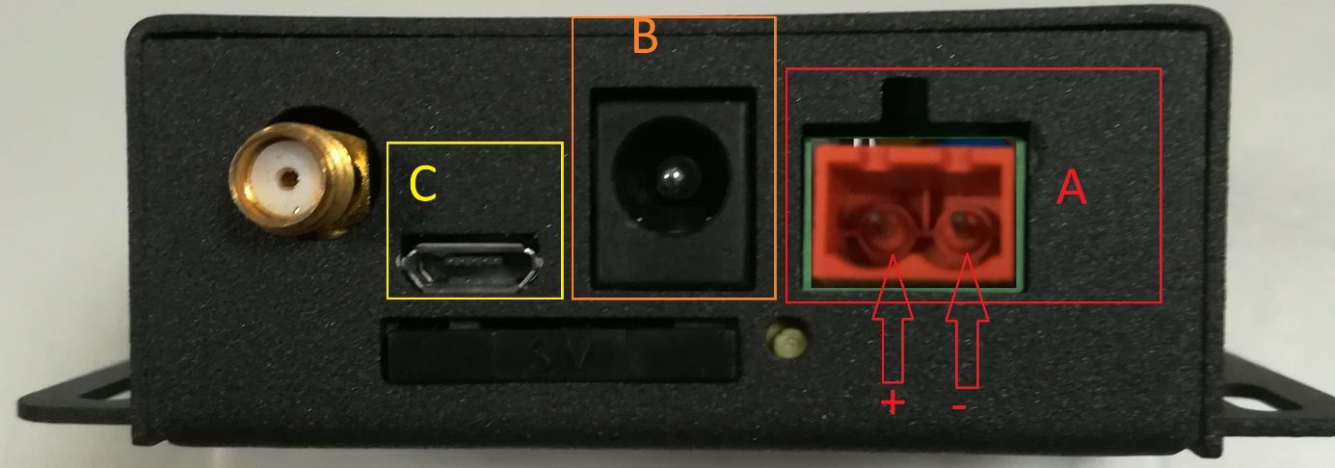

Fig. 1

* 1. WiFi Model

The WiFi model will mount the ESP32-WROVER module with 4MB of FLASH.

The requirements are:

1. A form factor like the GTW000WT model this to meet the requirements of CAREL customer in term of size.
2. The same connectors of the GTW000WT (see Fig.2), RS485 and serial TTL.
3. The leds.  
   The GTW000WT enclosure have 2 holes for the leds, we refer below to the name of these leds :  
   - POWER : connected to the internal power supply indicate that the unit is powered and also that the internal power supply is running properly.

* LINK :  
  if possible we want a bi-color led, so we have the possibilities to have more informations.  
  One of the bicolor led, the green one, is connected to the ESP32-WROVER chip to the pin 12 (IO27), the other one RED to pin 29 (IO5)

1. The factory reset button is connected to the ESP32-WROVER chip to the pins pin 25 (IO0)
2. The ESP32-WROVER FW recognize the HW by the state of the pin 6 (IO34)  
   (see the same in 2G model) pulled up.
3. On the PCB some test points for the JTAG pins need to be provided

|  |  |  |  |
| --- | --- | --- | --- |
| **PIN n** | **Pin ID** |  | **Note** |
| 3 | EN | JTAG EN |  |
| 14 | IO12 | JTAG MTDI |  |
| 16 | IO13 | JTAG MTCK |  |
| 13 | IO14 | JTAG MTMS |  |
| 23 | IO15 | JTAG MTDO |  |

1. Power supply 5..36VDC (like the GTW000WT)
2. Temperature range -10/+60 C
3. Humidity 5..95% (not condensing)
4. A new polycarbonate (graphic design by CAREL)
5. A side label with some informations (see label documentation <GME_Labeling.ppt>):
   * Product Code
   * Serial number (serialized by USR)
   * MAC address
   * Carel Control Code
   * QR Code
6. The ESP32-WROVER module already certified but we need to do the delta test so we need to be certified CE/RED and FCC/IC.  
   LVD EN 62368, EMC EN301489 ,RED EN 300328

FCC ID EMC Part15B, Part15.247, FCC ID certificate

1. The model part number of this new device is GTW000MWT0.

1. Production
   1. Labels

One of the requirement is about the product labels, all the things related to this aspect are listed in the GME\_Labeling.ppt file.

* 1. Packaging

There aren’t special packaging requirements

* GTW000MWT0 - CLOUDGATE BASIC WIRELESS WI-FI - 1 RS485  
  will use the same white carton box of the current GTW000WT.
* GTW000MGT0 and GTW000MGP0 - CLOUDGATE BASIC WIRELESS 2G  
  a white carton box like the above model is fine.

The label applied to the carton box contains the same information present on the   
GTW000WT, obviously update according to the new devices .

Inside the packaging, the following items are required:

1. The device (GTW000MWT0 or GTW000MGT0 or GTW000MGP0)
2. The antenna
3. The technical leaflet
4. Two additional copy of the same label with QR code attached to the device.  
   These are useful because the final user attach one label to the body of the machine and one on the documentations.
   1. GTW000MGP0 - CLOUDGATE BASIC WIRELESS 2G - 1 RS485

This gateway will mount a SIM card supplied by CAREL.  
We will send you batch of SIM card before to place a production order or in another way.

We require a specific test to verify that the SIM is properly installed and working fine.

Our idea about this is quite simple,

* Install the CAREL SIM card
* power on the GTW000MGP0
* wait the connection to the cellular provider for max XX (depend on your network) seconds
* If the led GPRS will light on, the test is passed.

If the test do not pass, the possible reason are:

* Damaged gateway HW
* An error in the installation of the SIM Card, or problem with the SIM card holder.
* Damaged CAREL SIM card or an error in the programmation of the SIM Card;

Unfortunately, we have experienced that in some case the SIM card not work   
due to an error in the programmation, very rare but sometimes happen.

* Trouble with cellular provider   
  (NOTE : the CAREL SIM use the 2G cellular network please be sure that the USR production line is covered by this type of cellular network).
  1. GTW000MGT0 - CLOUDGATE BASIC WIRELESS 2G - 1 RS485 - THIRD PARTY CLOUD

This gateway will not mount a SIM card.

USR will do the usual test to assure that the gateway work, nothing more.