CAREL_M95_Test  
User Guide v.1.0

Initial setup 1

How to start 1

Force to transmit 2

Other test command not directly provided by this program 2

# Initial setup

To use this test program you need a

A1. A GTW000M2W0 gateway modified for the test (connector A & push button)  
 with a SIM card installed

A2. A serial USB/TTL 3V3 converter connected to the connector A

A3. A serial USB/TTL 5V converter connected to the white connector of the   
 gateway to test the WiFi part

A4. A power supply CAREL model PGTA00TRG0

# How to start

B1. Apply the power supply to the gateway, the red led will light on

B2. The module is logically off press shortly the push button,  
 after a while the led  will flash, the module is now active.

B3. Press the “COM search” button, all the available COM port will be listed on the  
 combo box on the right. Select the right COM port in the combo box.

B4. Press the button “Connect”

B5. Press now the button “Get Dev.Id” this to test if the connection work properly.  
 Something like the image below will appear  
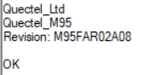

B6. Press “Stop stack” this stop the normal GSM operations, you see an “OK” as a   
positive answer. In case the gateway report an error “..CPIN..” press the button again.  
  
B7. The gateway is now in test mode.

B8. Begin with setting the below parameters  
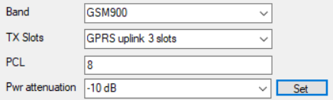

B9. If you need a specific power attenuation, set the one useful for the test and press  
the button “Set”. The gateway respond with “OK”.  
REMEMBER! The gateway store this attenuation value in the non volatile memory  
so that is a persistent value. To reset it select “Restore default value” and press “Set”  
to return to factory power level.

# Force to transmit

To force the gateway in transmission mode follow these steps :

C1. Set the parameters   
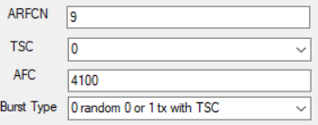

To the values requested by the test.

C2. Press “GO” button, the gateway will reply with an “OK” and start the   
transmission.

C3. To stop the emission press “Power OFF”

C4. To start again with new values do the steps B2..B8 and C1..C2

# Other test command not directly provided by this program

If the program is not enough to test the system and you will require to apply some   
other special AT commands provided by the chipset, is possible to send this command  
following these steps :

D1. Start from the beginning do the step from B1..B8

D2. Type the command you need in the text box near the button “Send AT”  
 ie. AT+CGSN (the carriage return character is added automatically)

D3. press the “Send AT” button and take a look in the answer windows

D4. Is possible to send another command using step D2..D3