CAREL – Confidential



**Gateway Middle End  
  
GTW000MWT0   
  
Test FW installation and use**

*Gateway Middle End*

rev. See revision table

DRAFT

Index

Index 2

Revisione 3

1 Instructions 4

1.1 Prerequisites 4

1.1 Connect the HW 4

1.2 Install the test FW 5

Revisione

|  |  |  |  |
| --- | --- | --- | --- |
| Rev. | Rev. date | Author | Note |
| *0.01* | *26/05/2020* | *A.Bilato* | 1° draft |
|  |  |  |  |
|  |  |  |  |
|  |  |  |  |
|  |  |  |  |
|  |  |  |  |
|  |  |  |  |
|  |  |  |  |
|  |  |  |  |
|  |  |  |  |
|  |  |  |  |
|  |  |  |  |
|  |  |  |  |

1. Instructions

Here below some brief instruction to program the ESP32 inside the Gateway Middle End (GME) with the test FW, and the instruction about how to use the   
test SW on a PC.

* 1. Prerequisites

To run the FW uploader you need to install in your Windows computer the following :

1. Unzip the ESP_RF_test_tool_v2.3.zip in a suitable folder

You need also a :

1. USB/TTL 5V serial converter
   1. Connect the HW

You need to connect the USB/TTL 5V serial converter to the TTL serial port of the GME,  
the wiring in the below schema (Fig.1).

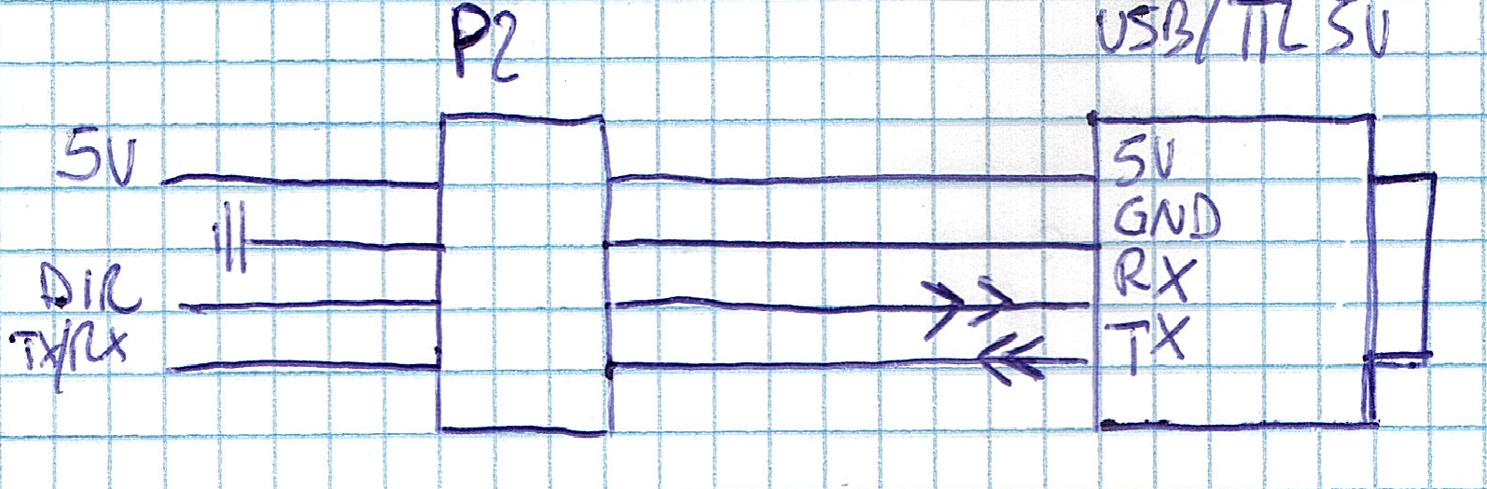  
Fig.1

* 1. Install the test FW

The test FW is the official one coming from Espressif for all the details about it, please, refer to ESP32&ESP8266_RF_Performance_Test_Demonstration__EN.pdf.

There are few differences in behavior of GME compared with the one described in the document, this because the reset pin GPIO0 is not directly available externally but you need to press the button on the GME.

In short to install the FW you follow this steps :

1. Connect the GME with the USD/TTL adapter
2. With a pencil press the button on the GME and apply the power supply
3. Launch “espRFTool_2.3.exe”, a Windows like the one in Fig.1 appear

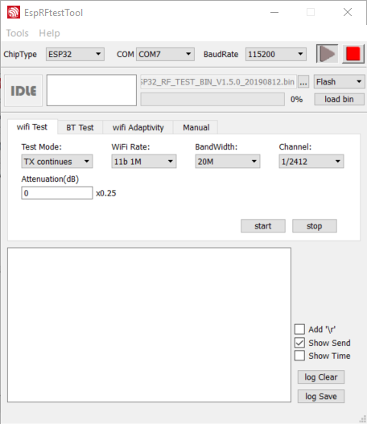 Fig.1

Select the following options :

1. ChipType : ESP32
2. COM : the COM of your USB/TTL adapter
3. Baudrate: 115200
4. […] : select the file ESP32_RF_TEST_BIN_V1.5.0_20190812.bin you will find in  
    the folder where you have unzipped the files
5. Select [Flash] in the combo box on the right of […]
6. Now press the button  to connect the device
7. Press “load bin” , the FW will be uploaded wait till the end
8. Now press 
9. Power off the GME, wait 5 sec. and power on again
10. Now press the button  to connect the device
11. Starting from now the test available in Fig.2 are operative  
    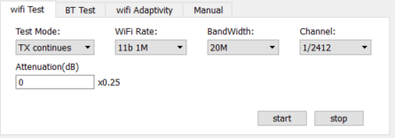Fig.2