CAREL – Confidential



**How to install the GME FW**

*Gateway Middle End*

rev. See revision table

DRAFT

Index

Index 2

Revisione 3

1 Instructions 4

1.1 Prerequisites 4

1.1 Connect the HW 4

1.2 Install the FW 5

1.3 Basic HW/FW check 6

1.4 Notes 6

Erase the ESP32 Flash 6

Speed up the programming time 6

Revisione

|  |  |  |  |
| --- | --- | --- | --- |
| Rev. | Rev. date | Author | Note |
| *0.01* | *30/03/2020* | *A.Bilato* | 1° draft |
|  |  |  |  |
|  |  |  |  |
|  |  |  |  |
|  |  |  |  |
|  |  |  |  |
|  |  |  |  |
|  |  |  |  |
|  |  |  |  |
|  |  |  |  |
|  |  |  |  |
|  |  |  |  |
|  |  |  |  |

1. Instructions

Here below some brief instruction to program the ESP32 inside the Gateway Middle End (GME).

**WARNING!**

The given FW is not official, so something probably will be adjusted, ie. in the batch files probably some number will change but the rest remain the same.

* 1. Prerequisites

To run the FW uploader you need to install in your Windows computer the following :

1. Python 2.7.x
2. Make sure that Python is present in “PATH”
3. Install pySerial V.3.0 or newer
4. Dezip the CAREL GME_Production_Line_Batch.zip file in a folder   
   ie. C:\ GME_Production_Line_Batch

If you have some doubt refer to

<https://github.com/espressif/esptool>

where there are the instructions to install the programming tool.

You need also a :

1. USB/TTL 5V serial converter
2. Mobus Slave simulator like Modscan32.
   1. Connect the HW

You need to connect the USB/TTL 5V serial converter to the TTL serial port of the GME,  
the wiring in the below schema (Fig.1).

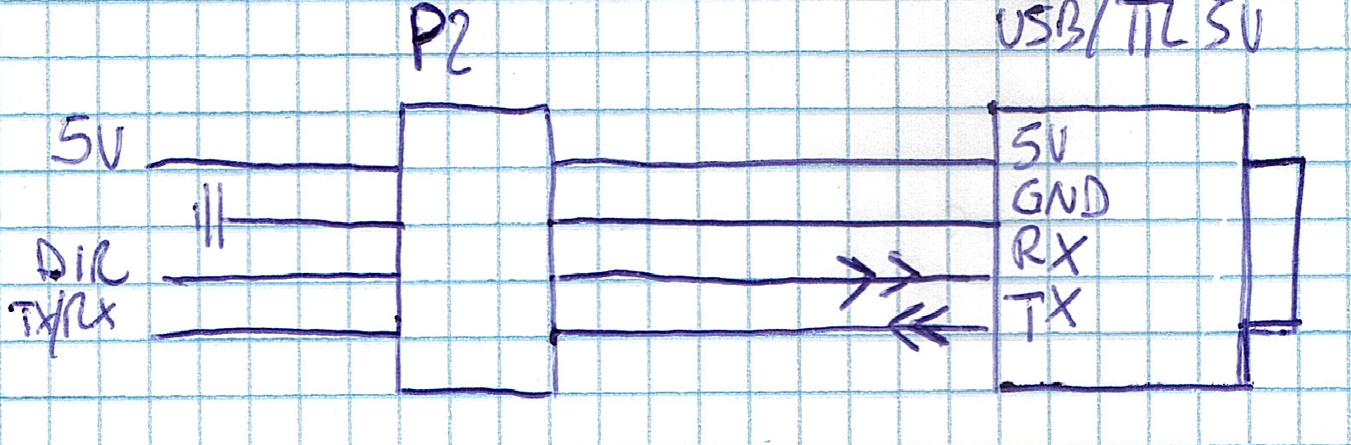  
Fig.1

* 1. Install the FW

1. To install the FW open a Windows command prompt window (cmd.exe),   
   change the working directory to the one where you have unzipped the CAREL files (ie. C:\ GME_Production_Line_Batch).
2. Press the GME button, and apply the power supply
3. Run the batch   
   GME_ESP32_Upload.bat *COMxx* 115200  
   where COMxx is the serial port Windows assigned to you USB/TTL 5V serial converter, 115200 is not the maximum speed but useful to initially test the GME.
4. After a while you will see something similar to the content of Fig.2

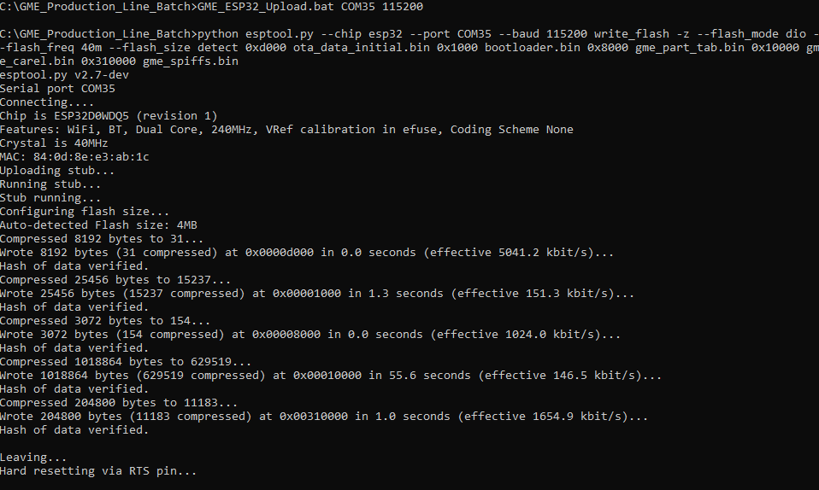

Fig.2

1. Power off the GME
   1. Basic HW/FW check
2. Power on the GME, take a look to the leds, at the beginning you will see 3 sequence of green/red blinking.
3. Use a smartphone and search an AP called “CGATEM_xxyyzz” where xxyyzz are the last 3 digits of the MAC address of the GME, and connect to it.
4. Open a browser (ie. CHROME) and open the URL <http://10.10.100.254>
5. At first time the GME ask for a new Username and password   
   type “Admin” and “12345678” and press “Submit”

The GME store the new credential of the configuration page and prompt for login.

1. The GME ask again for Username and Password use “Admin” and “12345678”
2. The GME prompt now, for some data, to connect to a router or an AP to access the Internet.  
   Select “Scan” and select an AP SSID a suitable to connect to Internet.

Insert also the Password of the AP and press Submit.

1. At this point the GME reboot itself and connect to selected AP, and try to connect to CAREL server.
2. The red led is ON.
3. The test FW of GME will try to read via RS485 some coils and registry.   
   Use a SW like ModSim32 to emulate on a PC, 100 Holding register and 100 Coils to respond to the GME enquiry.
   1. Additional informations

Here below some additional informations

Erase the ESP32 Flash

If you want to erase the entire ESP32 Flash memory and reset also the area where the login data are stored you simply launch the batch

GME_ESP32_eraseflash.bat COMxx

Where COMxx is the same as above.

Speed up the programming time

If you will find that the batch GME_ESP32_Upload.bat work well at 115200 bps, you could try to use the upper baud rate of 921600 bps.

If doesn’t work well try 460800 or 230400.

Determinate the maximum speed is useful to understand the programming time in production line.