CAREL – Confidential



**REQUIREMENTS SPECIFICATION**

CloudGateMini

PLCM 9718

rev. See history

Index

Index 2

1 Revision 4

2 Introduction 5

2.1 Scope of the document 5

2.2 Definitions, acronyms and abbreviations 5

3 Improvement of the web server graphic interface 6

3.1 Preface 6

3.2 Login page 7

3.3 Main Configuration page 8

3.4 Modify Debug page 8

3.5 Added a LogOut button 8

1. Revision

|  |  |  |  |
| --- | --- | --- | --- |
| Rev. | Rev. date | Author | Note |
| *0.1* | xx/09/2021 | A.Chiebao | 1st draft |
| 1.0 | 22/09/2021 | A.Chiebao | 1st revision |
|  |  |  |  |
|  |  |  |  |
|  |  |  |  |
|  |  |  |  |
|  |  |  |  |
|  |  |  |  |

1. Introduction
   1. Scope of the document

This document refers to the realization of some enhancement to the current FW of the CloudGateMini (this improvement will only affect the GTW000MWT0).

* 1. Definitions, acronyms and abbreviations

AP = WiFi access point to connect to

CGM_AP = gateway that act as an access point  
CGM_WIFI = CloudGateMini WiFi

CGM = CloudGateMini  
GSM = refer to 2G/4G/NB IoT connection  
FW = firmware

IoT = Internet of Things

MonDev = the device connected to the GME through the RS485 interface

OTA = Over The Air

SW = software  
MFT = Modbus File Transfer

GTW000MWT0 = the GME-WiFi model

GTW000MGP0 = the GME-2G model with CAREL SIM installed

GTW000MGT0 = the GME-2G model without SIM

GTW000M2W0 = the GME-2G+WiFi model without SIM

1. Improvement of the web server graphic interface
   1. Preface

The request is to make the configuration web pages exposed by the gateway more "friendly" to the customer. To do this it is necessary modify some files (.c/.h) on the firmware side, and also the .html files that generate the web pages.

It was also asked to make the debug page accessible (previously hidden and not directly available by the customer).

The following points detail the various changes required.

* 1. Login page

In the login page add a info table where show the status of the CGM connection.

This reproduces the same signaling of the LEDs in the 2G model.

Anyone, even not knowing the access credentials, can check the status of the CGM.

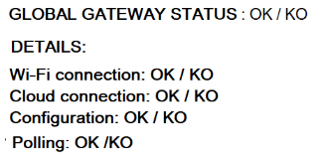

The GLOBAL GATEWAYS STATUS is OK when the first three lines are OK (and logic).

Wifi connection: show if the CGM is/or not connect to the router.

Cloud connection: show if the CGM is/or not connect to the cloud.

Configuration: show if the CGM is/or not figured to the cloud.

Polling: show if the CGM receiving/or not receiving the rs485 data

Added a link to the debug page. In this this case the link are with free access and doesn't need a password.

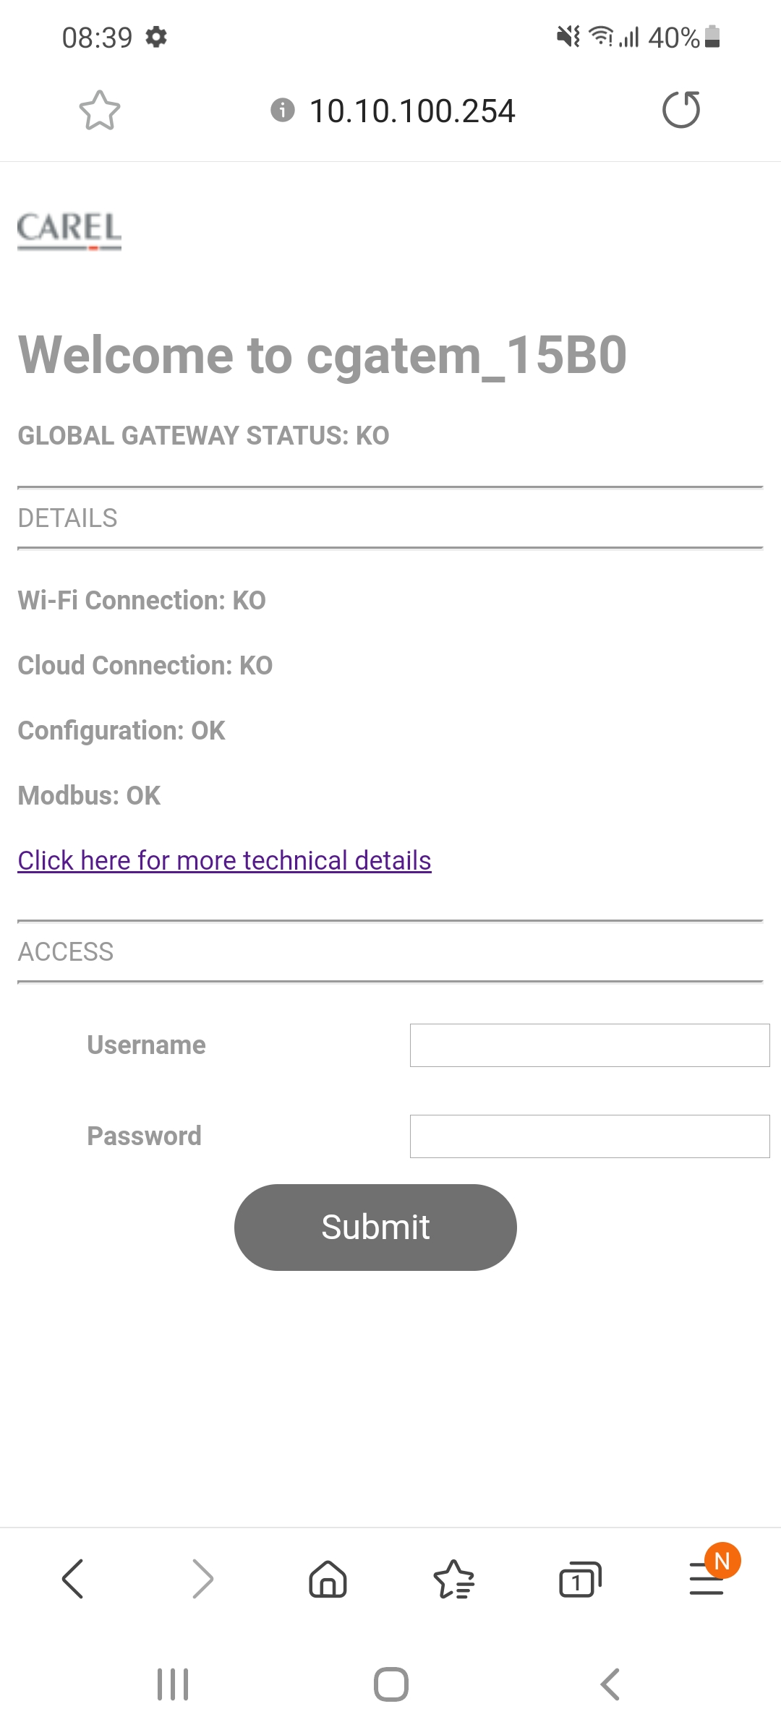

* 1. Main Configuration page
* Show a pop-up for a few seconds to confirm that the configuration has been sended to the CGM. After that the browser will be redirected to the login page.
* ~~Inside the configuration page add a link to infocgm.html (debug page). Currently the link is hidden and if the user does not know the path he cannot access it.~~

Moved in the Login page in order to prevent the accidental configuration of CGM during the search of debug page.

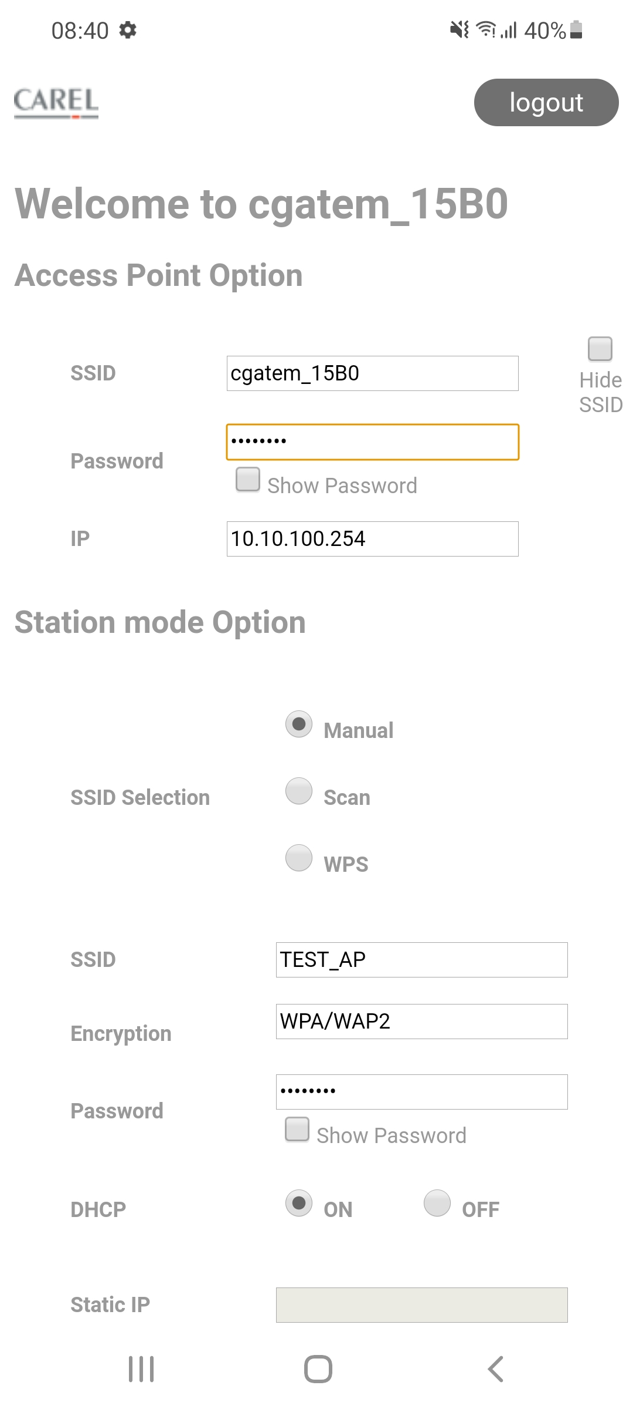

* 1. Modify Debug page
* Make more clearer the difference between the browser time and the CGM time.
* Added a legend to explain better the dynamic info table.

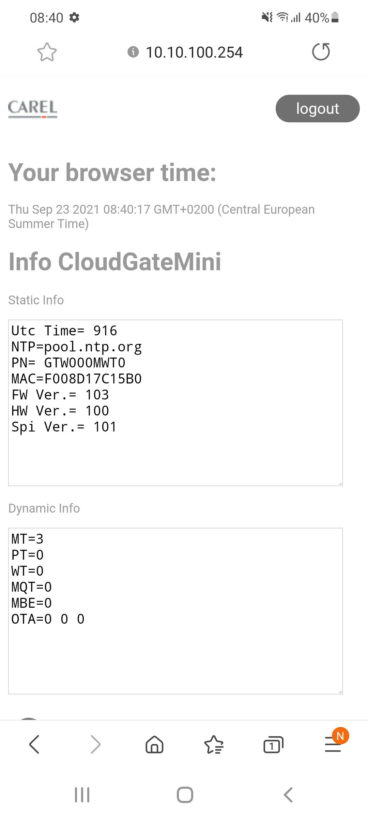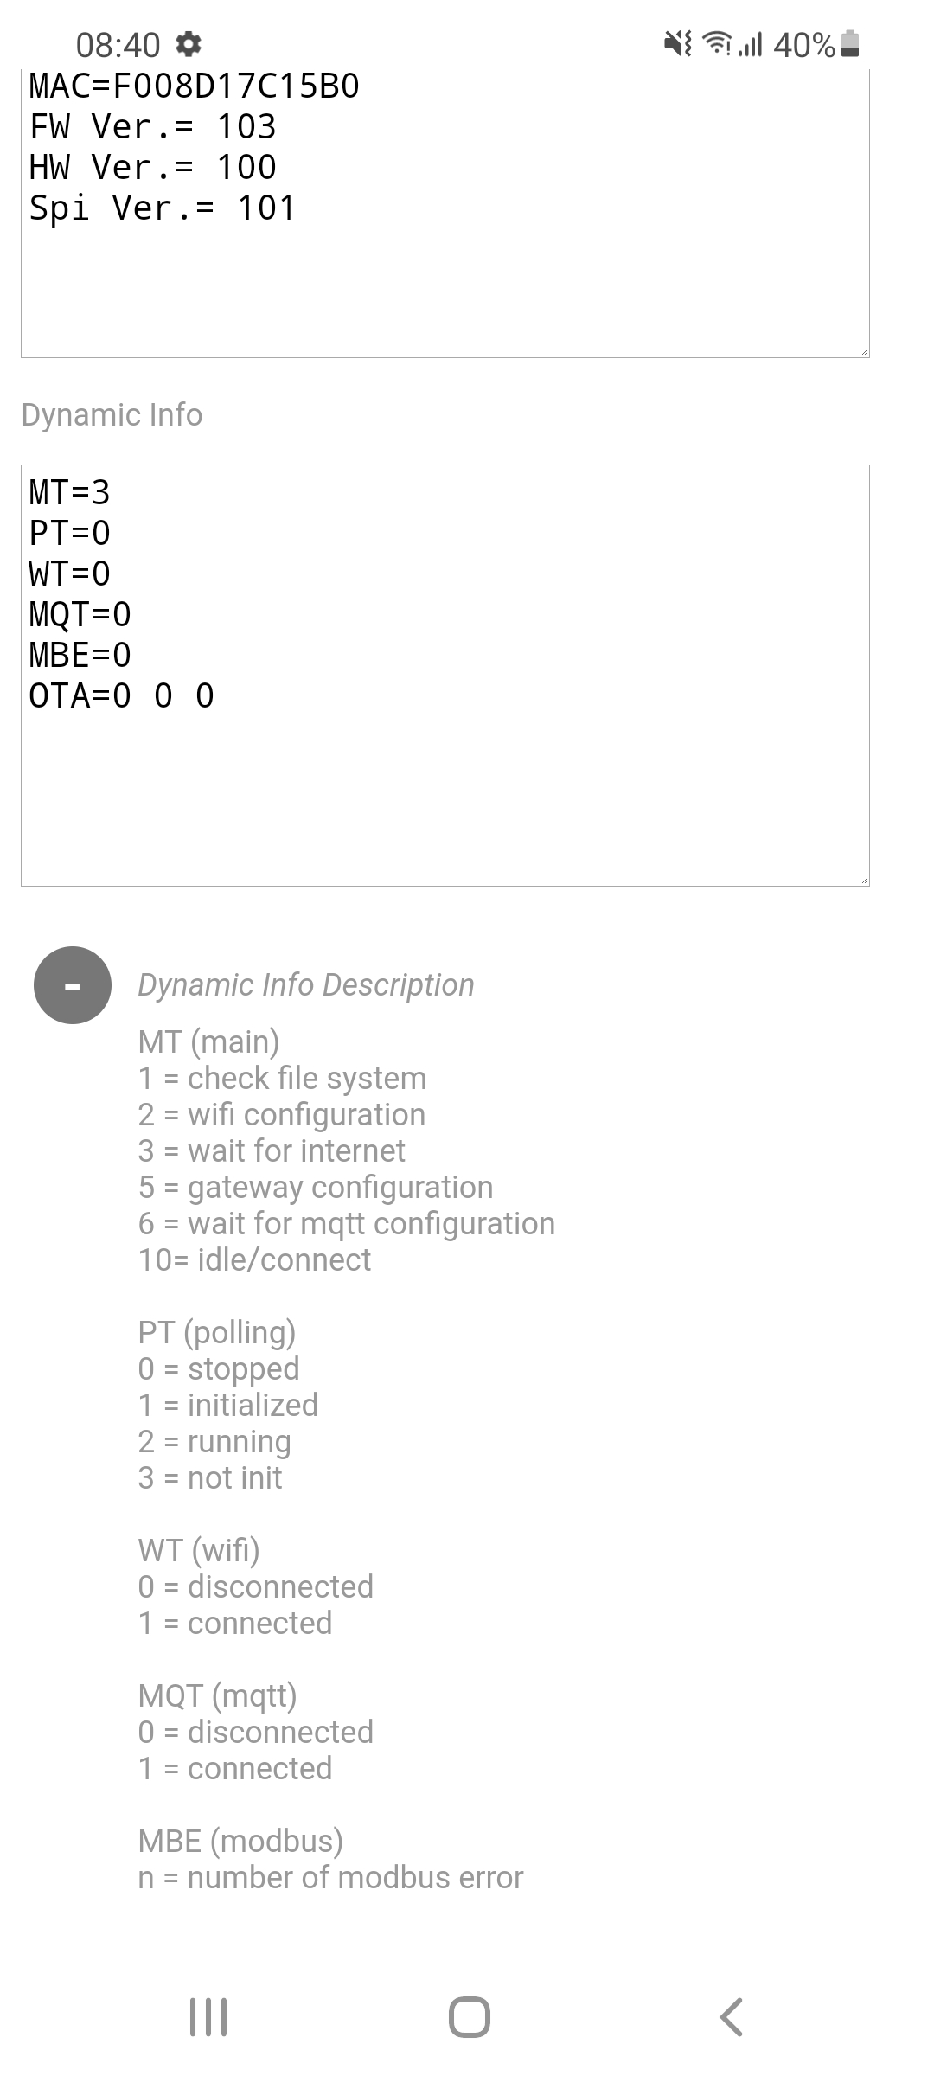

* 1. Added a Logout button

Added logout button to allow the user to exit the pages.

Once pressed, the key always leads to the login page (10.10.100.254).