**Deployment Instruction**

1. Configure Putty on Windows machine with **public IPV4 address** and **private key file** provided by AWS.

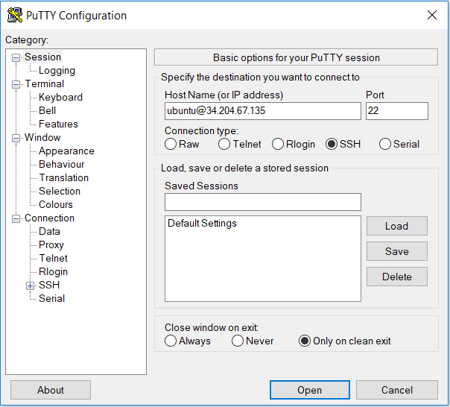

**Figure 1:** Configuring public IP address through Putty on Windows

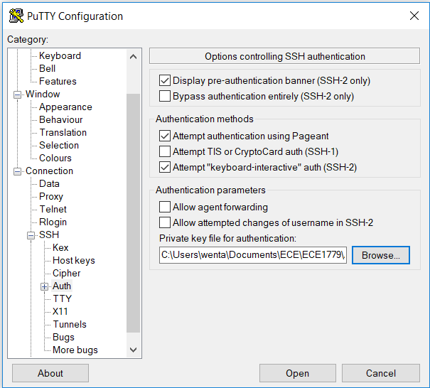

**Figure 2:** Private Key file configuration in Putty

1. Login to A3 (**34.204.67.135**) instance with the above configuration and username **ubuntu** through Putty.
2. Change current working directory with the following command **cd Documents/A3_manager** and verify theexistence ofthe file named **zappa_settings.json**
3. Change current working directory with the following command **cd Documents/A3_user** and verify theexistence ofthe file named **zappa_settings.json**
4. Download the above directories from the A3 EC2 instance to your local machine
5. For python 3, type the command **python3 -m venv flask** to build a virtual environment named flask. For python 2, virtualenv will be needed to install using **pip virtualenv**. After installation, type the command **virtualenv flask** to build the virtual environment.
6. For windows users, change your directory into **A3\flask\Script** and type **activate** to activate the virtual environment.
7. Type **pip install flask**, **pip install boto3** and **pip install zappa** to install the required python modules and enter the required AWS credentials using Amazon Command Line tool.
8. Change the current directory to the directory where the zappa settings located and type **zappa deploy** to deploy the flask application for assignment A3. If there is already a lambda function named dev existed, please type **zappa update dev** to update the functions.
9. At the end of deployment, an URL will be displayed on your monitor. Please copy and paste the URL to your favorite browser to access the web application.