**User Documentation**

**For Regular Users:**

1. Open your favorite browser on your computer by entering **https://tmalpdtnfb.execute-api.us-east-1.amazonaws.com/dev/** in the address bar to access the homepage of the Online Shopping System.

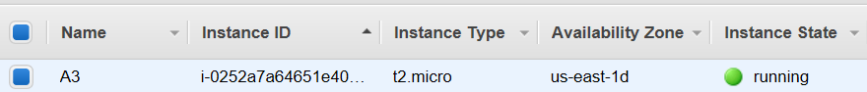

**Figure 1:** List of Amazon EC2 instance in EC2 Management Console

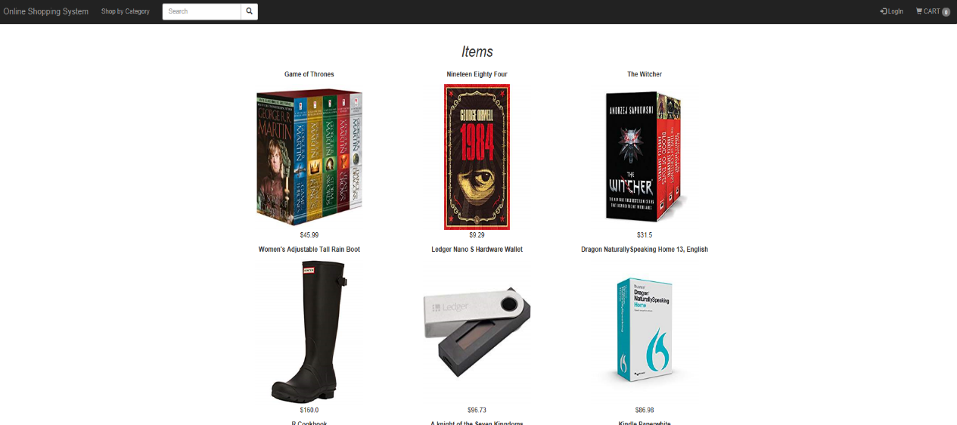

**Figure 2:** Home page of Online Shopping System

1. Click on the **Login** link on the upper right corner of the homepage to access each user’s shopping cart. Once the login success, user will see their username and an empty cart are displayed on the right corner of the homepage.

**Note:** If the user is not registered yet, user must create personal account through signup page.



**Figure 3:** Navigation bar of the homepage

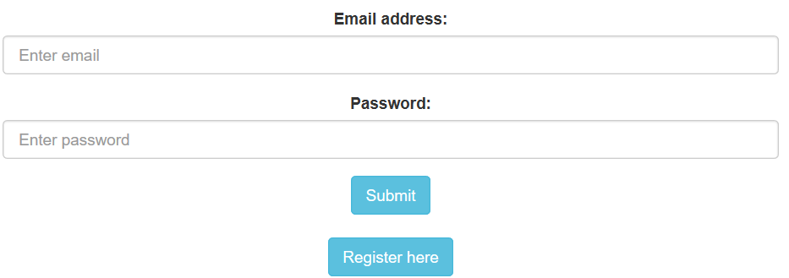

**Figure 4**: login page of users

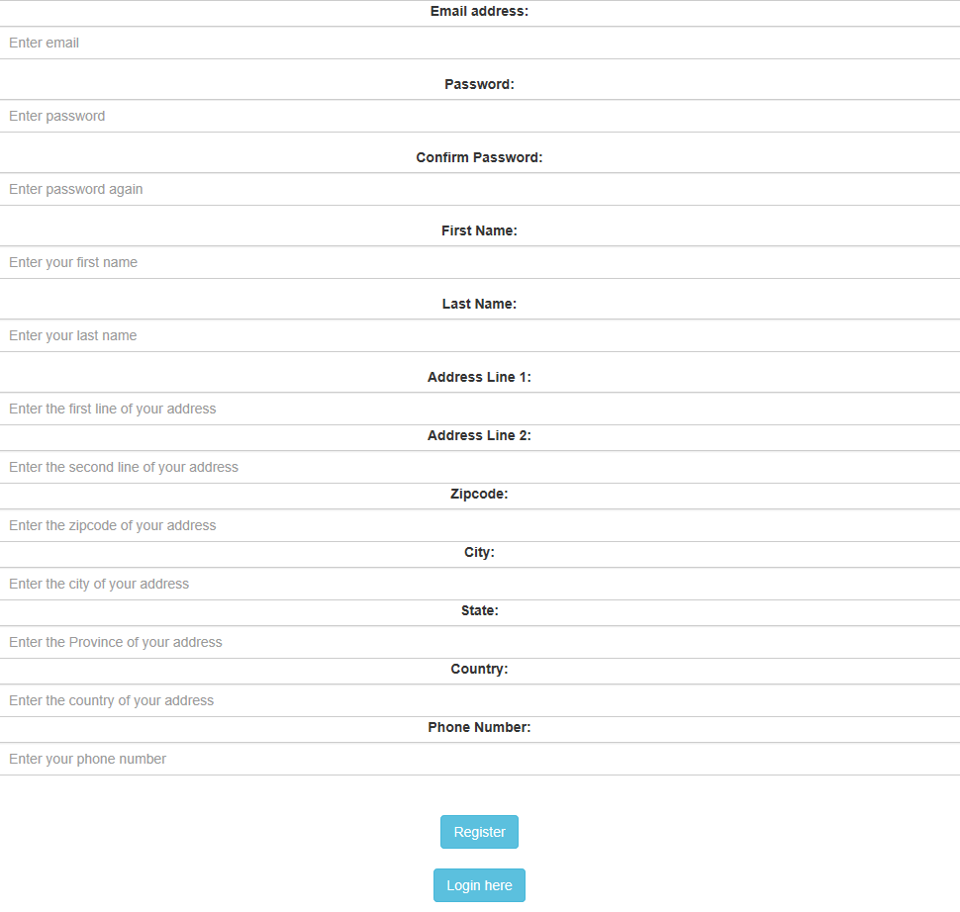

**Figure 5:** register page of users



**Figure 6:** Navigation bar after user login

1. Click the thumbnail of the product picture in the homepage to check each product’s detailed information such as its price and description. Click **Add to Cart** to add the product to your shopping cart. Click **Online Shopping System** to return to the homepage.

**Note:** User can search products by entering its name in the search field of the navigation bar or Click **Shop by Category** to browse products under certain category.

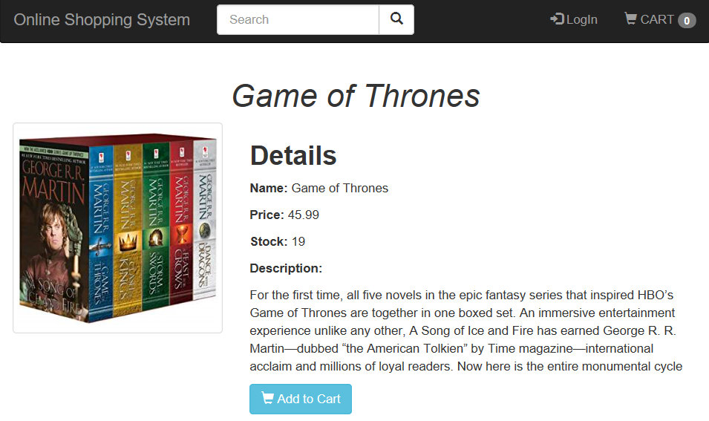

**Figure 7:** The detail description of each product

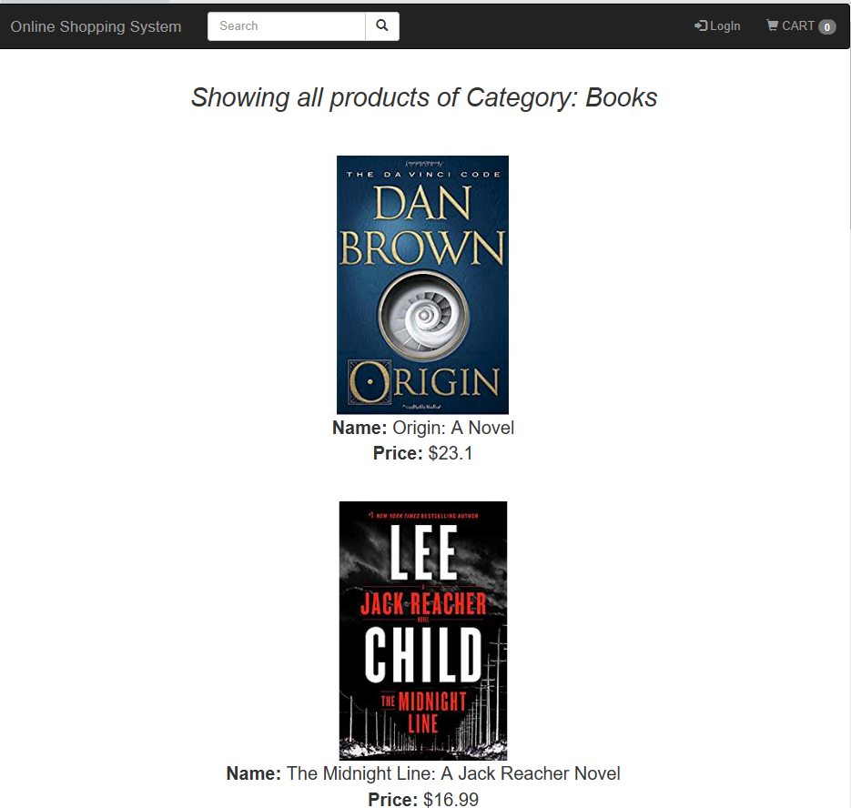

**Figure 8:** Products under the Books category

1. Click on CART icon on the navigation bar to access the current login user’s shopping cart. User can remove all the products or the specific ones. If the user is satisfied with the products in his or her cart, he or she could click **Submit Order** button to put their order.

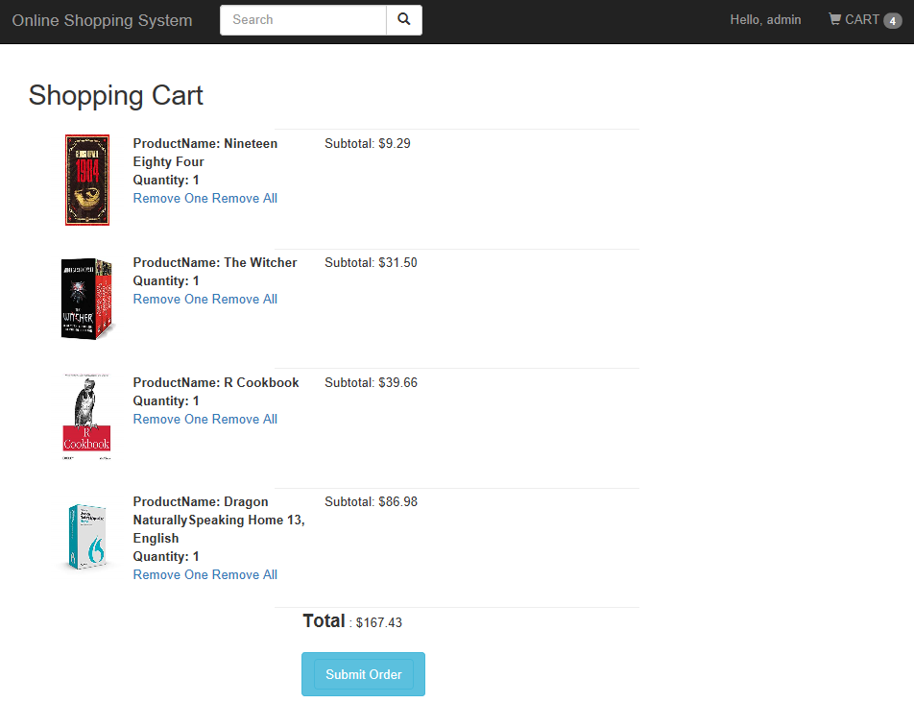

**Figure 9:** Shopping cart page of users

1. Click on the username on the navigation bar to access the user’s dropdown menu and click **Your orders** to access the order user has submitted. The order status will show processing and will become completed once the administrator confirms the order in the backend.

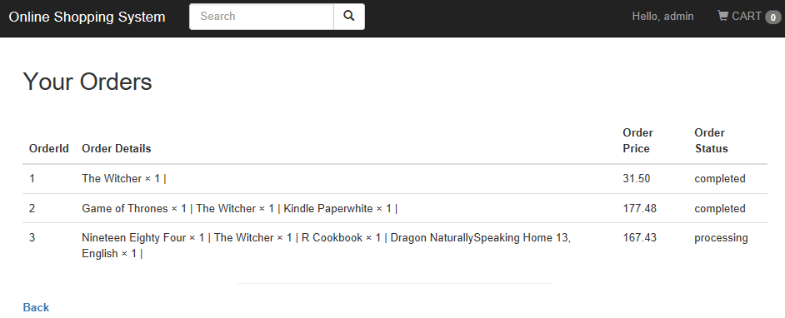

**Figure 10:** Orders table of users

1. Click on the username on the navigation bar to access the user’s dropdown menu and click **sign out** to log out. Once logout, the username and their shopping car displayed on the right corner of the homepage will disappear.

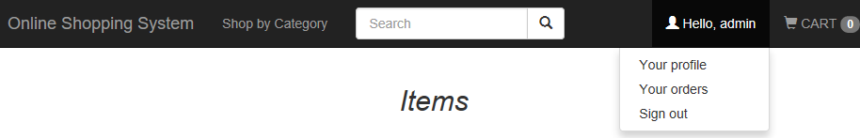

**Figure 11:** Dropdown menu of users

**For Administrator (Manager UI):**

1. Open your favorite browser on your computer by entering **https://n6p71vwb3g.execute-api.us-east-1.amazonaws.com/dev/** in the address bar to access the manager interface.

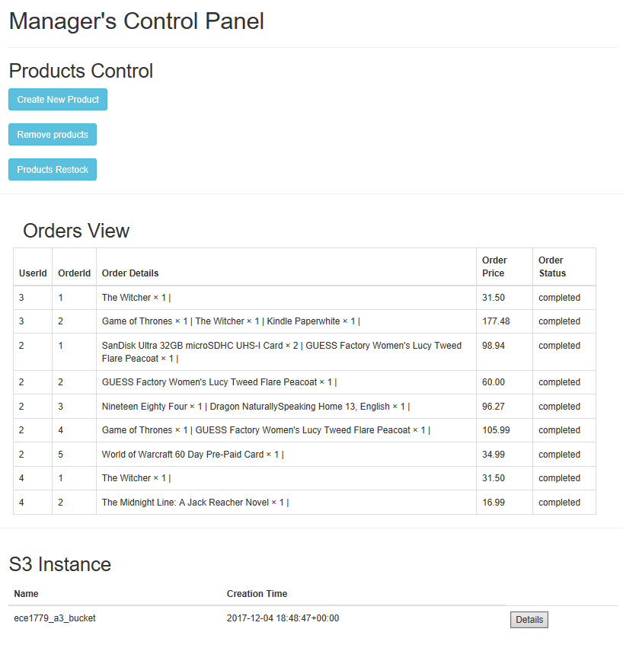

**Figure 12:** The homepage of Manager UI

1. Click on **Create New Product** button to access the add item form. Fill in all the fields with required information and click **Submit** to submit the information.

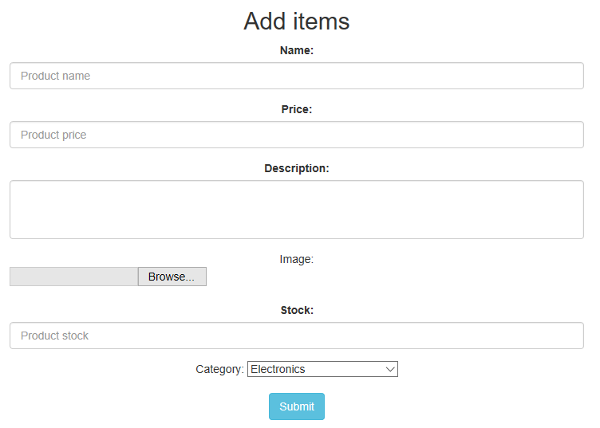

**Figure 13**: The add items form

1. Click on **Remove Products** button to access the remove items page and click on the thumbnail of the specific product to delete it.

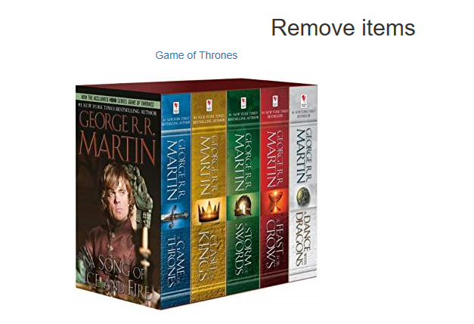

**Figure 14:** Remove items page

1. Click on **Products Restock** button to access the restock inventory page. Select the name of the product you want to restock and enter the amount in the input box. Click **Update** to confirm.

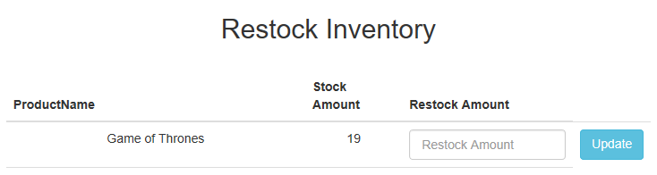

**Figure 15:** The restock inventory page

1. In the orders View table, all the order has been listed. Select the order you would like to process and click the **Mark as Complete** button to process the order as completed.

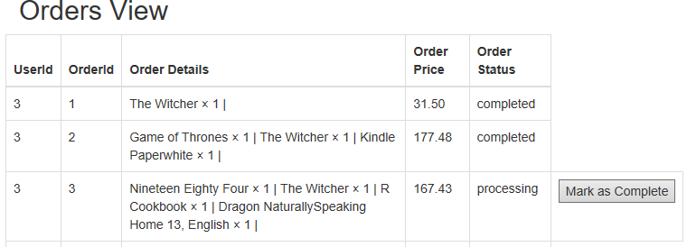

**Figure 16:** The list of orders in the Order View table

1. Click on **Details** button in the S3 instance section to view the details of the S3 bucket named ece1779_a3_bucket.

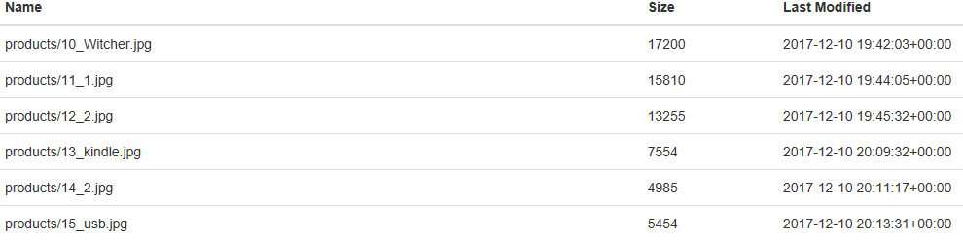

**Figure 17:** The details page of the S3 bucket named ece1779_a3_bucket