Abstract

Easy assignments and note sharing platform for students

Project Ragnarok

E-Classmate 2.3.6 (Name subject to change)

Preface

The project handbook includes all the resources that is needed for the development of the Project Ragnarok. It consists of organizational model, scope, assumptions, roles and responsibilities, system architecture and documentation of the project. The project handbook also helps to outline all non-functional requirement of the project.

The handbook is very helpful for the understanding the purpose of the project. All the stakeholders who are involved or interested in the project is recommended to go through this handbook to get the general understanding of the project

This project handbook is outcome of the all coders involved in the Project Ragnarok and can also serve as a handbook for similar projects in the future. The handbook tries to help to give user or any stakeholder as much as information as possible about the project but if there is any vague implication, they can reach our team for further clarification.

Scope

Project Ragnarok is a project aimed at creating note and assignment sharing portal currently for strengthening skills and deepening understanding regarding technologies used in the project along with remote coding and cooperation experience. It’s twenty-first century and students still use instant messaging apps to share notes, lecture notes and assignments like Facebook Messenger, Viber, WhatsApp to a name a few. 21 new photos received, all jumbled and unmanaged in phone or computer. E-Classmate is here to manage it all for you at one place just for your notes and assignments.

UI

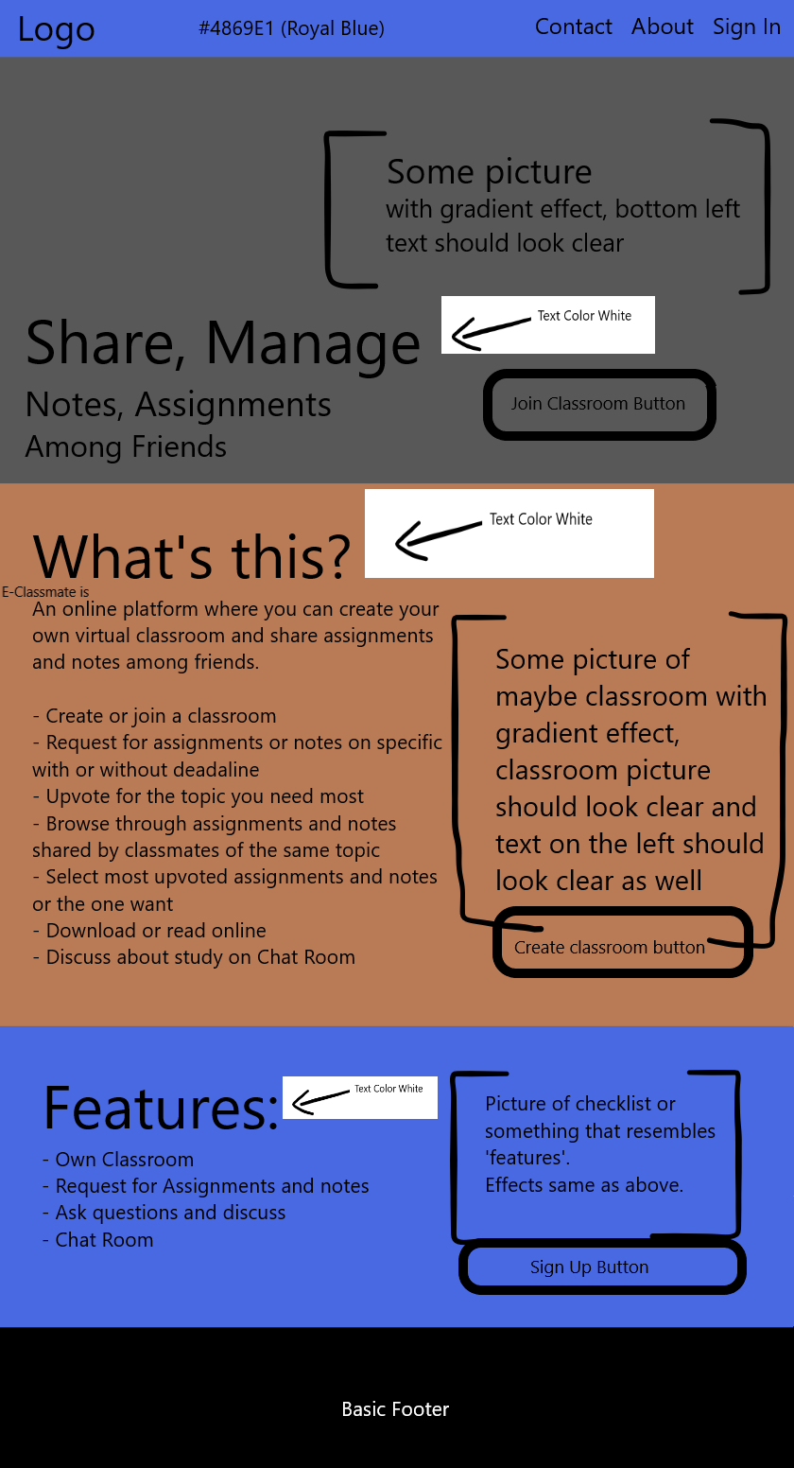 This is the landing page.

It’s best if models for backend and components for front-end are build according to components in the UI. Image below is for signed in users.

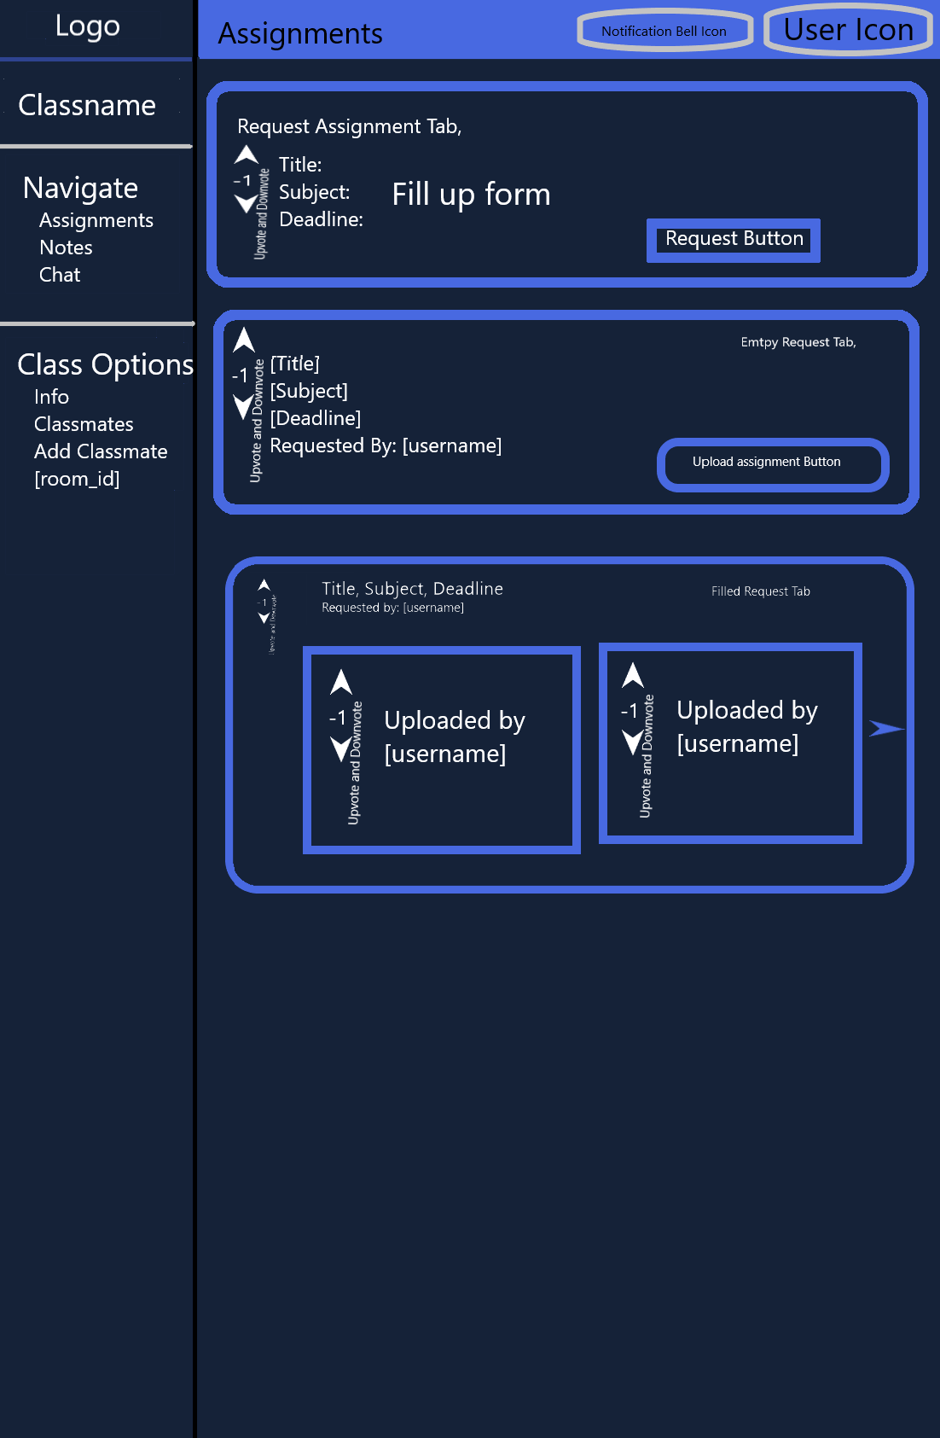

Scrum

Scrum is best methodology to build the product as a team.

1. Stories
2. To-do
3. Emergency
4. In progress
5. Testing
6. Complete

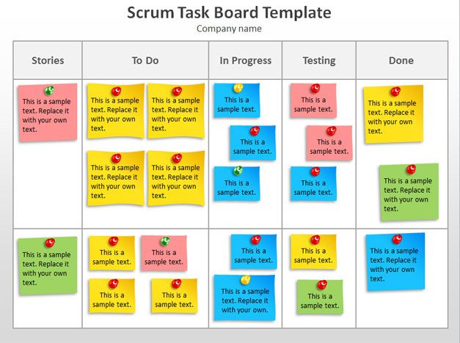

Technologies

Front End:

React

Redux (State Management)

Heroku (Deployment)

Back End:

Django REST Framework

MongoDB (Database)

Google Cloud (Deployment)

Project Info:

Start Date: 12/4/2019

End Date: 1/15/2020 (Estimated)

Testing: 1/21/2020

Backend needs to complete fast till 12/24/2019 so that front can be connected and tested with the progress.

Coders:

1. Binish Joshi (Front End)
2. Pranish Shrestha (Front End)
3. Saman Shrestha (Back End)
4. Suraj Karki (Back End)