**STUDENT ID: 29644364**

**STUDENT NAME: HA TRI NHAN LUONG**

FIT3080 – Assignment 1 Answer Sheet

Question 2:

Performance graph: Data taken from 25 random seeds for each case size and number of agents.

|  |  |  |  |  |  |
| --- | --- | --- | --- | --- | --- |
|  | 5x5 | 6x6 | 8x8 | 10x10 | 15x15 |
| 1 | 0.031171 | 0.043893 | 0.060169 | 0.078549 | 0.106143 |
| 2 | 0.63984 | 1.03819 | 2.986019 | 16.92214 | 22.42167 |
| 3 | 16.42552 | 19.21256 | 21.85412 | 47.25126 | 81.29913 |
|  |  |  |  |  |  |

We can see that the performance somewhat grows exponentially with number of agents.

The problem seems to be increasing linearly with board size for 1 agent, but exponentially for more agents (see ***Extra plots***).

There are cases where the runtime has already been extremely slow (or running out of memory before time limit) for 2 trains thus this implementation should not be used in the real-word at all.

These extremely slow cases are usually when a train needed to take a turn very early on but kept on going straight due to the precedence of move actions, thus it takes a very long time to back track to when it needed to take a turn.

Question 3:

Paper: **Fast and Memory-Efficient Multi-Agent Pathfinding**  
Author: *Ko-Hsin Cindy Wang and Adi Botea*  
PDF: <https://www.aaai.org/Papers/ICAPS/2008/ICAPS08-047.pdf>

In this paper, the author proposed an improved version of A* pathfinding. Unlike our implementation, this version runs individually for each agent (thus avoids exponential growth at each expansion), with some extensions. The first extension is that it creates an alternating one-way direction for each row and column, see the following figure:

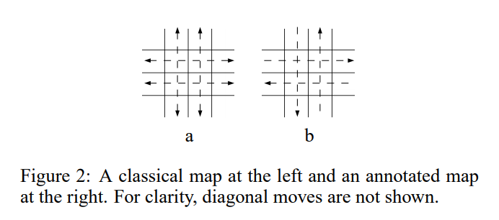

This avoids direct head-to-head collisions. Furthermore, it adds simple local fixing rules to non-head-to-head collisions instead of expansive replanning (such as: for side-on collisions, add rules to give priority to vertical first, horizontal after). When a deadlock is occurred, it simply forces one agent to escape it’s intended path to break the lock, then continue the journey.

From the result given in the paper:

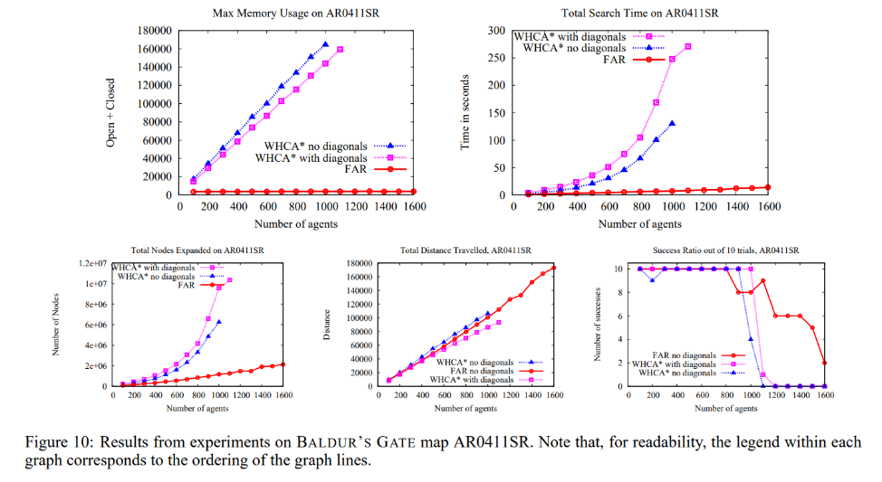

This implementation scales well with the number of agents (works well with even 1000+ agents) compared to our implementation due to the non-expensive collision solving.

**Extra plots:**

*(I was assuming the plots does not count towards to page length limit)*