Integrating SmartTracking (GPS) system in PG

* ***Limitations with GPS (BW-09) devices to integrate with PG:***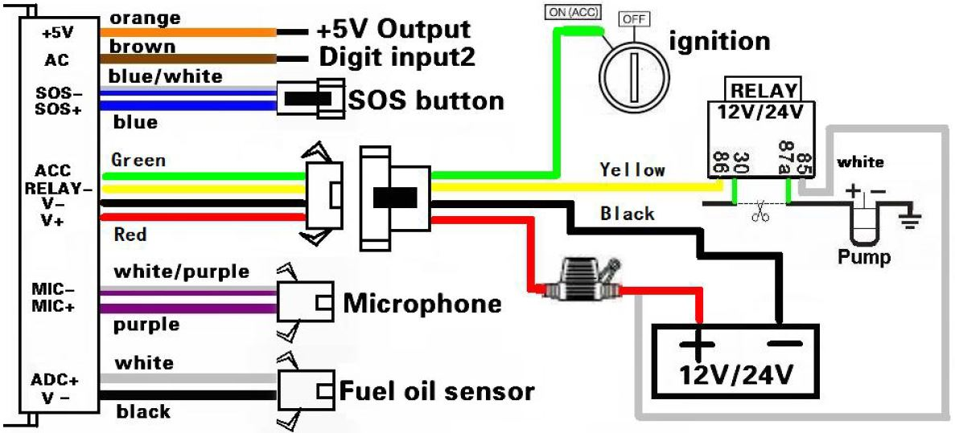

Fig-1: BW-09 wiring diagram

* It requires 9-45V DC to power up but the PG output is 220V AC. In a new PG a 12V battery supply is present but these batteries are no longer functioning as the battery servicing is not maintained regularly. So, the power supply for BW-09 in PG needs to be solved.
* Engine running time measurement needs to be solved with BW-09
* ***Fuel sensor requirements to integrate with PG:***
  + As the fuel tank dimension is dynamic in shapes and volumes (height*width*length), the proper fuel sensor selection is challenging.
  + Approximately a 5” long fuel sensor will set inside of the fuel tank. Since the volume of the fuel tank varies from manufacture to manufacturer the fuel sensor’s reading will not be the same as desired.
* ***A generic view of the problem:***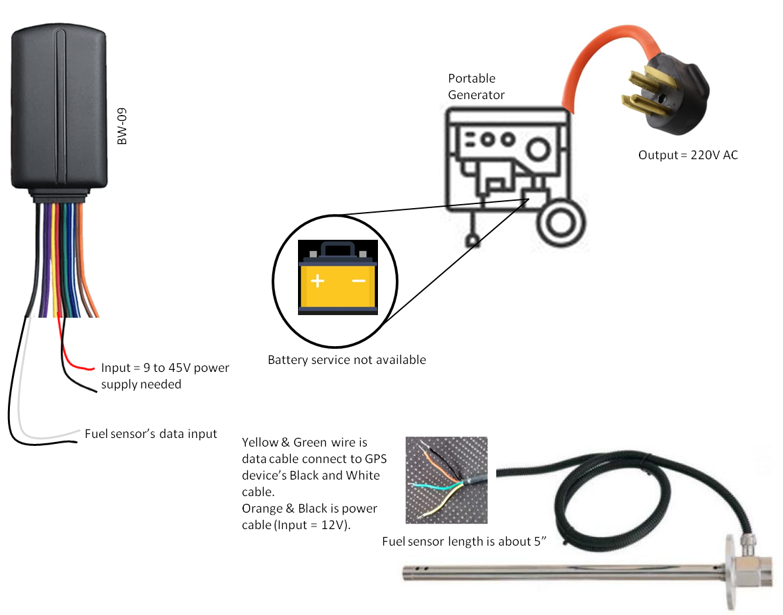

Fig-2: Generic view of installment limitations