**ANNEXURE I**

**Project Title:** Flask WebApp

**Introduction:** A developer always finds a way to do a work in an easy way and that’s why we decided to use Python Frame-Work for our website template.

Flask is a web framework. This means flask provides us with tools, libraries and technologies that allow us to build a web application. It is very light web framework.

We use Template Engine in this. Using a template engine will save us a lot of time when creating our application but also when updating and maintaining it.

**Technology Used:** Python, Flask, HTML, CSS, GitHub (for Collab), Heroku (for Hosting)

**Layout:**

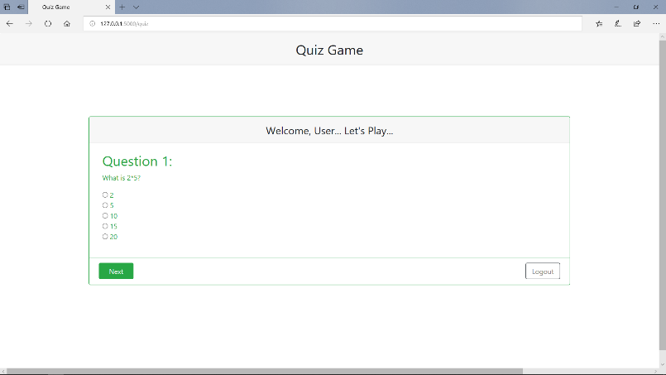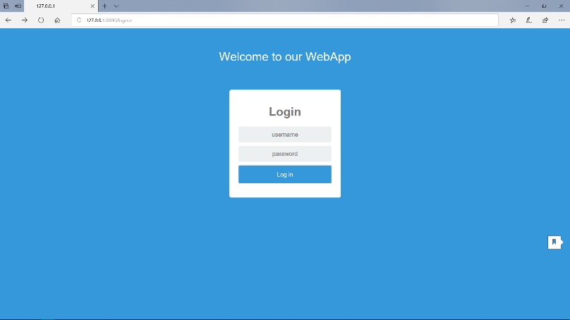 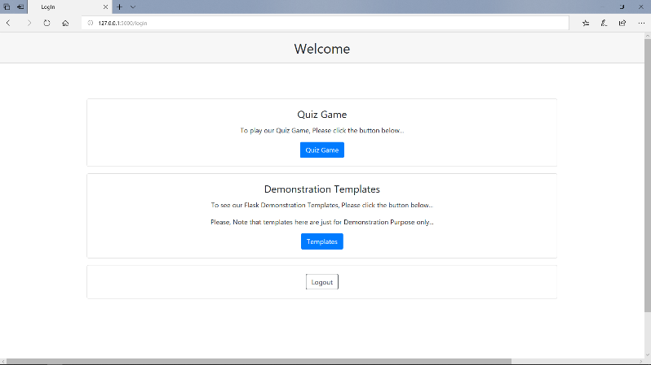

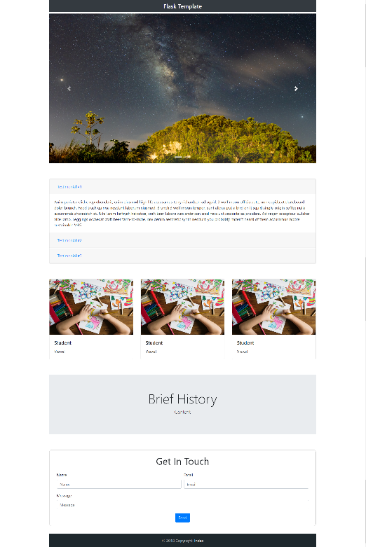

**Project Contents :**

You will find the following folders or files :

* .idea
* static
* templates
* venv
* app.py
* README.md
* About_Project.docx

**Required Libraries and Dependencies:**

Python 3.x, Flask, Git, Heroku, Web Browser

**Submitted By:**

Dhruv Chitkara (1610991268)

Naman Sehgal (1610991550)

Neelesh Vashist (1610991563)

**Department Name:** Computer Science and Engineering