**Diode Application: Half-Wave Rectifier**

Objectives

1. To analyse ripple effect and efficiency of half-wave rectifier with different values of capacitors.
2. To understand the circuit behaviour of half-wave rectifier.

Components

1. 1N4007 Si Diode
2. Capacitors (1uF, 0.1uF and 10uF)
3. Resistor 10KΩ
4. Function generator
5. Oscilloscope

Theory

Rectification is a process of converting an AC into DC. The conversion occurs at high frequency. During positive half cycle, the diode is forward biased and conducts. The current flows through the resistor and voltage is produced. During negative half cycle, the diode is reversed biased and does not conducts as it said to be open circuit. Thus, no current flows across the resistor and the voltage is not produce. Therefore, the dc voltage is sinusoidal during the first half cycle and ac input signal is converted to pulsating output signal as results in half-wave rectification.

Capacitor filters is used to smoothen the output. Capacitor is open to dc and offers low impedance path to ac current, putting a capacitor across the output will make dc components to pass through the load resulting in small ripple voltage. Ripple voltage is the variation of capacitor voltage due to charging and discharging. Thus, the smaller the ripple, the better the filtering action.

Ripple effect:

$$R= \frac{V_{rms}}{V_{dc}}$$

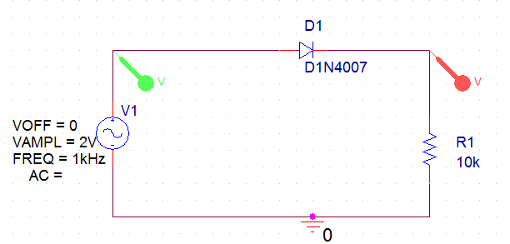 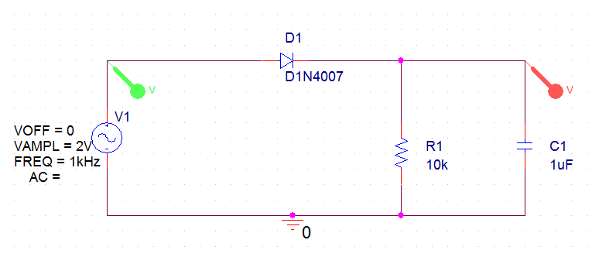

Figure 1 Figure 2

Procedure

1. Construct a circuit as shown in Figure 1 using R = 10KΩ and 1N4007 diode. Use a sinusoidal voltage, Vin with frequency of 1KHz and peak to peak voltage of 2 volts. Vary the value frequency and voltage for input signal.
2. Observe both the input and the output voltage waveforms, using the two channels of the scope. Plot the input and output of the rectifier on the same axis. Estimate the maximum output voltage. Compare the output and input signals in terms of shape, frequency, phase and amplitude.
3. Add a capacitor of 1uF parallel with resistor R as shown in Figure 2. Plot the input and output waveform on the same axis.
4. Change the capacitor values with higher value (10uF) and lower value (0.1uF). Observe the changes in the output waveform.

Observation

1. Determine AC and DC voltage of the output waveform from oscilloscope.
2. Observe the changes of waveform when capacitor is added parallel with resistor.
3. Observe the waveform when varies the values of capacitors.
4. Calculate the ripple effect and its efficiency.

Results

The circuit behaviour of half-wave rectifier is analysed. The input and output of both waveforms are observed. The ripple factor due to addition of different values of capacitor and their efficiency are evaluated.