COM3110/4115/6115:

Text Processing

Text Compression: dictionary

methods + further topics

Rob Gaizauskas

Department of Computer Science

University of She eld

Rob Gaizauskas (U. She eld) COM3110/4115/6115: Text Processing 1 / 16

Overview

Models

Static

Semi-static Adaptive

Coding

Hu man Coding Arithmetic Coding

Further topics:

Dictionary Methods Symbolwise Models Synchronisation

Performance Issues

Rob Gaizauskas (U. She eld) COM3110/4115/6115: Text Processing 2 / 16

Dictionary Methods

Dictionary methods rely on replacing substrings in a text with codewords, or indices, that identify the substring in a dictionary or codebook

Simple example: digram coding | simple method for ASCII text

uses an 8-bit code dictionary where

128 ASCII characters represent themselves 128 codes represent common letter pairs

at worst each 7-bit character is expanded to 8-bits at best character pairs (14 bits) are reduced to 8 bits

Such an approach can be extended to include larger dictionary entries

e.g. common words such as and and the

e.g. common pre xes/su xes, such as pre, tion

Rob Gaizauskas (U. She eld) COM3110/4115/6115: Text Processing 3 / 16

Dictionary Methods (ctd)

However, di cult to get good compression with a general dictionary

words common to many texts tend to be short

dictionary suited to one sort of text, poor for another

Can move to a semi-static scheme where a new codebook is constructed for each text. But some obvious drawbacks:

ine ciencies in transmitting dictionary

hard to decide which words to select for dictionary

Solution: use an adaptive dictionary scheme

most such schemes based on two methods proposed by Ziv and Lempel in 1977/78 (known as LZ77 and LZ78)

key idea: replace substring with a pointer to previous occurrence in same text

Rob Gaizauskas (U. She eld) COM3110/4115/6115: Text Processing 4 / 16



Dictionary Methods: LZ77

LZ77 can be explained most easily in terms of an example of its decoding (example from Witten et al.)

Suppose alphabet is just fa; bg

|  |  |  |  |  |  |  |  |  |  |  |  |  |  |  |  |  |  |  |  |
| --- | --- | --- | --- | --- | --- | --- | --- | --- | --- | --- | --- | --- | --- | --- | --- | --- | --- | --- | --- |
| encoder | <0,0,A> <0,0,B> <2,1,A> <3.2,B> <5,3,B> <1,5,A> | | | | | | | | | | | | | | | | | |  |
|  |  |
| output |  |  |  |  |  |  |  |  |  |  |  |  |  |  |  |  |  |  |  |
|  |  |  |  |  |  |  |  |  |  |  |  |  |  |  |  |  |  |  |
| decoder |  |  |  |  |  |  |  |  |  |  |  |  |  |  |  |  |  |  |  |
|  |  |  |  |  |  |  |  |  |  |  |  |  |  |  |  |  |  |  |
|  |  |  |  |  |  |  |  |  |  |  |  |  |  |  |  |  |  |  |
|  |  |  |  |  |  |  |  |  |  |  |  |  |  |  |  |  |  |  |
| A | | B |  | A | A | |  | B | A | | B | |  |  |  |  |  |  |
| output |  |  |  |  |  |  |  |  |
|  |  |  |  |  |  |  |  |  |  |  |  |  |  |  |  |  |  |  |

Encoder output is a series of triples

rst component indicates how far back in decoded output to look for next phrase

second indicates the length of that phrase

third is next character from input (only necessary when not found in previous text, but included for simplicity)

Rob Gaizauskas (U. She eld) COM3110/4115/6115: Text Processing 5 / 16

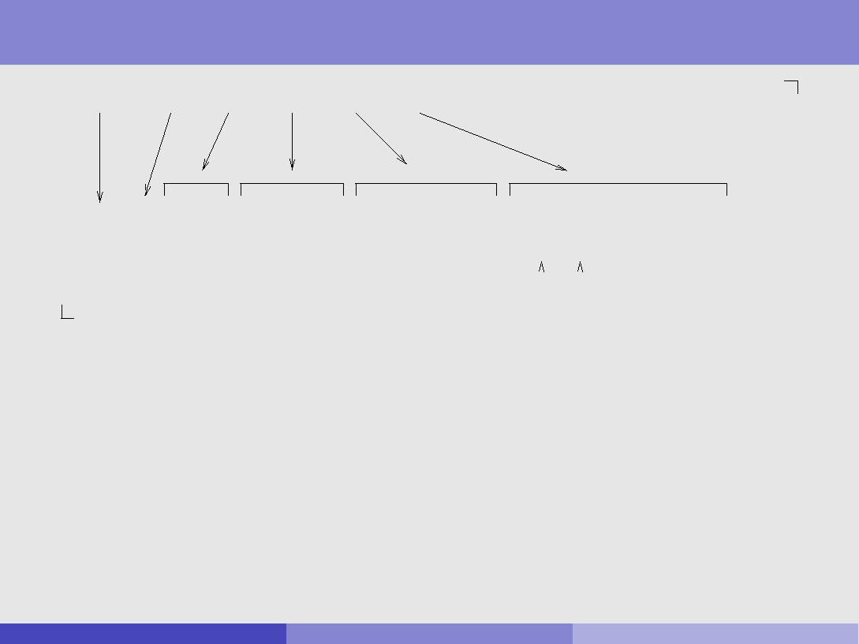

Dictionary Methods: LZ77 (ctd)

<0,0,a> <0,0,b> <2,1,a> <3.2,b> <5,3,b> <1,5,a>

|  |  |  |  |  |  |  |  |  |  |  |  |  |  |  |  |  |  |  |
| --- | --- | --- | --- | --- | --- | --- | --- | --- | --- | --- | --- | --- | --- | --- | --- | --- | --- | --- |
| a | b | a | a | b | a | b | a | a | b | b | b | b |  |  |  |  |  |  |
|  |  |  |  |  |  |  |  |  |  |  |  |  |  |  |  |  |  |  |
|  |  |  |  |  |  |  |  |  |  | copy from | |  | copy to | | | | |  |
|  |  |  |  |  |  |  |  |  |  |  |  |
|  |  |  |  |  |  |  |  |  |  |  |  |

Next, decode characters represented by triple <5,3,b>

go back 5 characters (to 3rd from start) copy 3 characters (aab)

add the 3rd item from triple { b { to this

Next triple, <1,5,a>, is a `recursive reference'

go back one character (b)

sequentially copy the next 5 characters

* + when 2nd char needed, it's available (as a copy of rst) results in the addition of 5 consecutive b's and an a

Rob Gaizauskas (U. She eld) COM3110/4115/6115: Text Processing 6 / 16

Dictionary Methods: LZ77 (ctd)

Various issues must be addressed in implementing an adaptive dictionary method such as LZ77, including . . .

How far back in the text to allow pointers to refer

references further back increase chance of longer matching strings, but also increase bits required to store pointer

typical value is a few thousand characters

How large the strings referred to can be

again, the larger the string, the larger the width parameter specifying it typical value 16 characters

During encoding, how to search window of prior text for longest match with the upcoming phrase

linear search very ine cient

best to index prior text with a suitable data structure, such as a trie, hash, or binary search tree

Rob Gaizauskas (U. She eld) COM3110/4115/6115: Text Processing 7 / 16

Dictionary Methods: gzip

A popular high performance implementation of LZ77 is gzip Uses a hash table to locate previous occurrences of strings

hash accessed by next 3 characters

holds pointers to prior locations of the 3 characters

Pointers and phrase lengths stored using variable length Hu man codes

computed semi-statically by processing 64K blocks of data at a time this much can easily be held in memory, so appears as if single-pass

Pointer triples are reduced to pairs, by eliminating 3rd element

common Hu man coding used to transmit both phrase lengths and characters

this is transmitted rst

if a phrase length was tranmitted, then next unit will be a pointer

Rob Gaizauskas (U. She eld) COM3110/4115/6115: Text Processing 8 / 16

Symbolwise Models

As we have seen, symbolwise methods work by estimating the probabilities of symbols (characters/words) and coding one symbol at a time using shorter codewords for the more likely symbols

So far, only speci c symbolwise model considered (in examples, etc) has been zero order character models

i.e. character models that do not consider left context

not a serious contender for e ective text compression

PPM is a character-based symbolwise model that uses left context

PPM = prediction by partial matching

determines probabilities in a given ( nite) context

but length of context may vary depending on contexts previously seen obtains arguably the best compression performance

Rob Gaizauskas (U. She eld) COM3110/4115/6115: Text Processing 9 / 16

Symbolwise Models: Word-based Models

So far have assumed \symbols" are characters

In word-based models, symbols are \words" (alphanumeric strings) and \non-words" (white-space and punctuation)

Documents are assumed to consist of strictly alternating words and non-words and (typically)

one zero-order model is built for words

another zero-order model is built for nonwords

If an adaptive model is used, a mechanism is needed for previously unseen words/nonwords

e.g. send an escape symbol then spell out the word character by character, using a zero-order model of characters

Rob Gaizauskas (U. She eld) COM3110/4115/6115: Text Processing 10 / 16

Symbolwise Models: Word-based Models (ctd)

\Parsing" text into words-nonwords raises a number of issues

how is punctuation that is part of a word (hyphens, apostrophes) to be handled?

should every numeric string be a separate word?

can lead to huge numbers of words that occur once only

what about ideographic languages?

segmenting text into words much more challenging for these

Word-based models can yield large numbers of symbols

e cient data structure for model important

canonical Hu man code good for static/semi-static versions

Can achieve compression performance close to PPM

with (semi-) static models supports random access

Rob Gaizauskas (U. She eld) COM3110/4115/6115: Text Processing 11 / 16

Synchronisation

Good compression techniques work best on large les

decompression techniques inherently sequential tends to preclude random access

full-text retrieval systems require random access

need to consider special measures to facilitate random access for these applications

Good compression methods make random access di cult, because

use variable length codes

can't start decoding at random point, since may not be on codeword boundary

use adaptive models

cannot determine model without decoding all prior text

No good solution for adaptive modelling

Best to use static models for full text retrieval

Rob Gaizauskas (U. She eld) COM3110/4115/6115: Text Processing 12 / 16

Synchronisation (ctd)

Techniques have been developed for achieving random access in compressed les

Synchronisation points

assume smallest unit of random access in compressed archive is the document

either store bit o set of document or ensure it ends on byte boundary

Self-synchronising codes

design code so that regardless of where decoding starts, comes into synchronisation rapidly and stays there

problematic for full text retrieval

not possible to guarantee how quickly synchronisation will be achieved

Rob Gaizauskas (U. She eld) COM3110/4115/6115: Text Processing 13 / 16

Performance Issues

Performance considerations for compression algorithms include

speed memory

compression rate (% remaining or % removed)

Some methods to compare for performance (from Witten et al.):

tests were performed on a benchmark corpus that included: a novel, fax bitmap, C source code, Excel spreadsheet, executable code, etc.

|  |  |
| --- | --- |
| Method | Description |
|  |  |
| pack | zero-order, character-based, semi-static Hu man coder |
| char | zero-order, character-based, adaptive arithmetic coder |
| ppm | variable-order, character-based, adaptive arithmetic coder |
| hu word | zero-order, word-based, semi-static Hu man coder |
| gzip-f | LZ77-type, semi-static coder, fast option |
| gzip-b | LZ77-type, semi-static coder, best compression |
| compress | LZ78-type, Unix compress utility |
| null | copy input to output (Unix cat) |

Rob Gaizauskas (U. She eld) COM3110/4115/6115: Text Processing 14 / 16

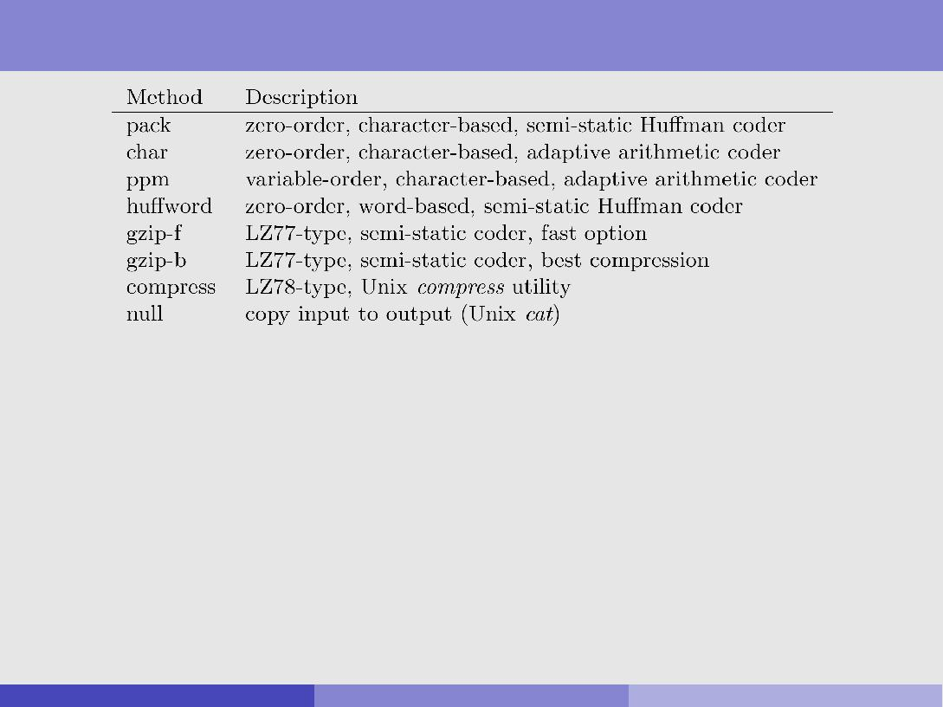

Performance Issues (ctd)

|  |  |  |  |  |
| --- | --- | --- | --- | --- |
| Method | Relative Speed | | Compression | |
|  |  |  |  |  |
|  | Encoding | Decoding | bpc | % Remaining |
|  |  |  |  |  |
| pack | 0.6 | 0.9 | 4.53 | 56.6 |
| char | 2.9 | 4.0 | 4.49 | 56.1 |
| ppm | 5.3 | 5.9 | 2.11 | 26.4 |
| hu word | 2.2 | 0.9 | 2.95 | 36.9 |
| gzip-f | 1.1 | 0.4 | 2.91 | 36.4 |
| gzip-b | 7.0 | 0.3 | 2.53 | 31.6 |
| compress | 1.0 | 0.6 | 3.31 | 41.4 |
| null | 0.2 | 0.2 | 8.00 | 100.0 |

Rob Gaizauskas (U. She eld) COM3110/4115/6115: Text Processing 15 / 16

Performance Issues: gzip

gzip permits 9 degrees of adjustment for speed vs compression:

1 = fastest, 9 = best compression

Figures for Linux gzip compressing Moby Dick on a Pentium 366Mhz:

|  |  |  |  |  |
| --- | --- | --- | --- | --- |
| Setting | | Time | File Size | Compression |
|  |  | (secs) | (bytes) | (% remaining) |
|  |  |  |  |  |
| 1 | (fast) | 0.52 | 581052 | 47.6 |
| 2 |  | 0.57 | 558378 | 45.8 |
| 3 |  | 0.76 | 536778 | 44.0 |
| 4 |  | 0.75 | 524590 | 43.0 |
| 5 |  | 1.07 | 507564 | 41.6 |
| 6 |  | 1.48 | 499886 | 41.0 |
| 7 |  | 1.60 | 498674 | 40.9 |
| 8 |  | 1.92 | 497990 | 40.8 |
| 9 | (best) | 2.01 | 497990 | 40.8 |
| null | | 0.01 | 1220150 | 100.0 |

Rob Gaizauskas (U. She eld) COM3110/4115/6115: Text Processing 16 / 16