**How to Install Magic Leap Applications From a .mpk File**

1. Connect the Leap to the computer using the hub. Make sure it is powered on and connected to a controller.
2. Open the Magic Leap Lab, Icon pictured below:
   1. 
3. 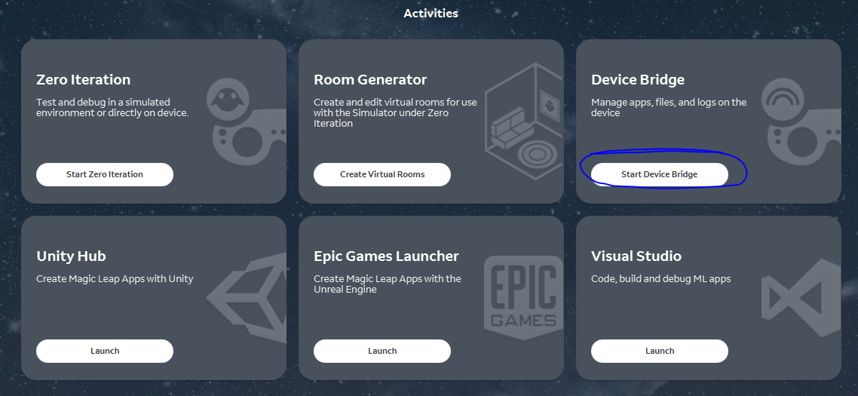Open the Device Bridge by clicking the button circled below:
4. Change to the “Apps” tab. 
5. Click “Install App.” 
6. Navigate to the .mpk you wish to install, in this example it is stored in a GitHub repository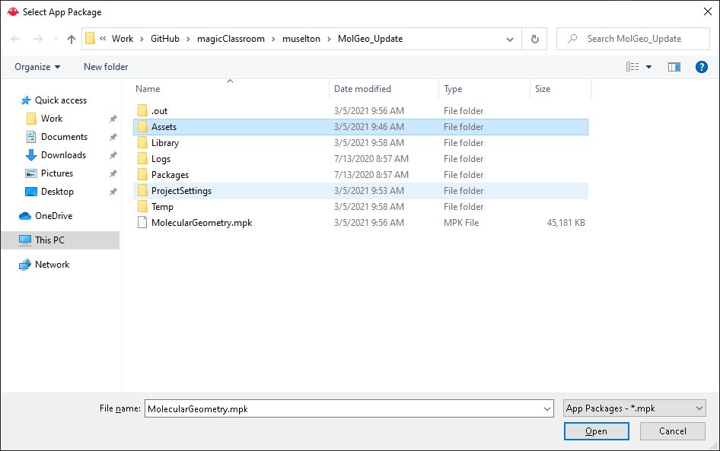
7. Click “Open”. It should start installing. At this point the Magic Leap may require validation to trust the compute. If this happens, put on the headset and answer the prompt on the device.
8. The application should now install.